
The Nervous System – worksheet

Key Terms
Term | Definition
 | A network of cells that acts as the main communication system for the body
 | Main system containing the brain and the spinal cord
 | Sends messages from the senses to the brain/spinal cord. Sends messages from the brain/spinal cord to muscles and glands.
 | Controls muscle movement. Receives information from sensory receptors
 | Automatic (involuntary) control of breathing, heart rate, etc.

Terms to use:
Autonomic nervous system (ANS) Central nervous system (CNS)
Somatic nervous system (SNS) Nervous system (NS) Peripheral nervous system (PNS)

Structure of the Nervous System

The CNS

Relationship between the CNS and the PNS
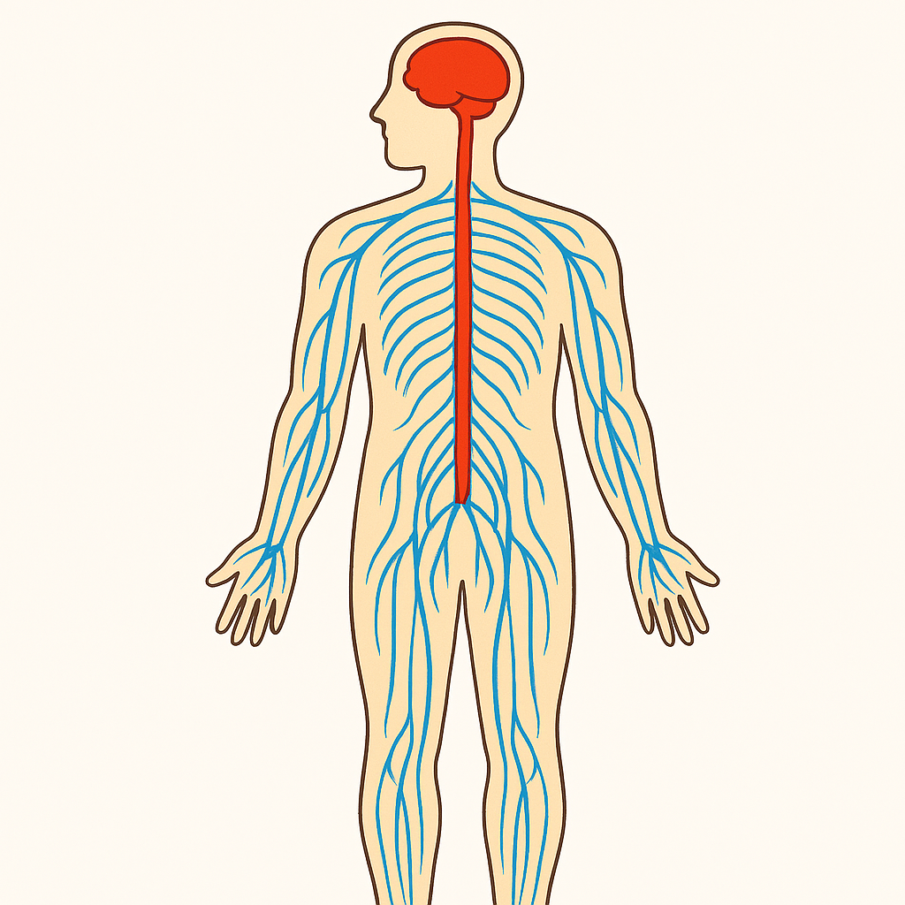

Details of the CNS and brain
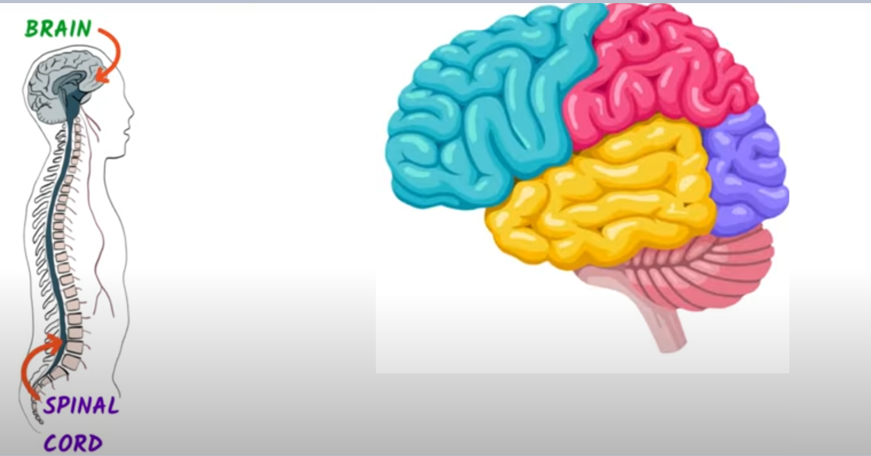

Comparing the CNS structures
Similarities | Differences

The Peripheral Nervous System (PNS)
- PNS transmits messages to/from the CNS via neurons (nerve cells)
- Connects the CNS to limbs and organs
- Has two structures: Somatic Nervous System and Autonomic Nervous System (ANS)
- Autonomic = automatic
Somatic Nervous System | Autonomic Nervous System (ANS)
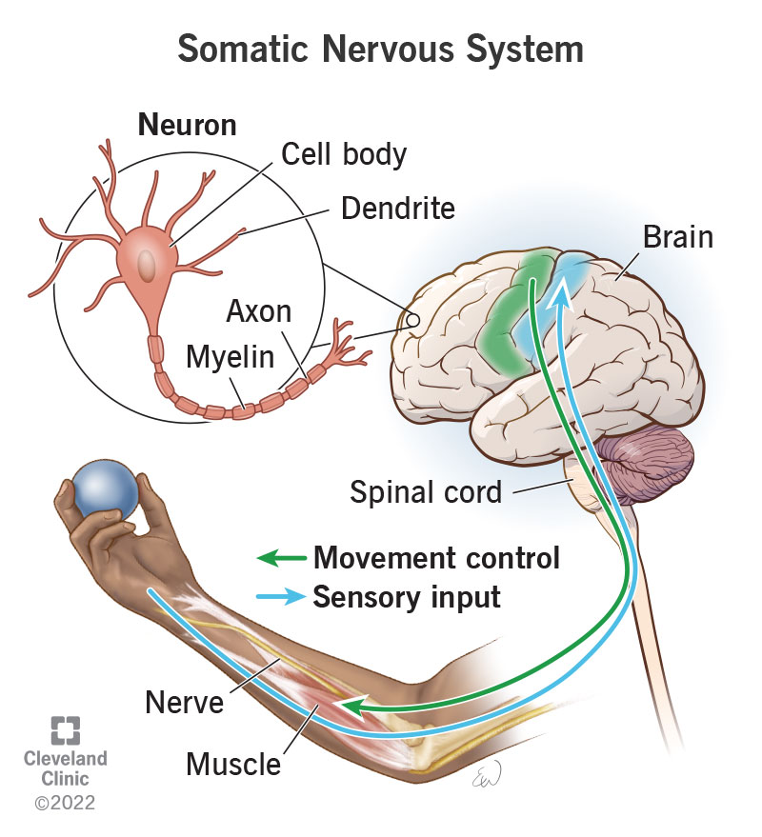

Comparing the PNS structures
Similarities | Differences

Sympathetic versus Parasympathetic Nervous System States
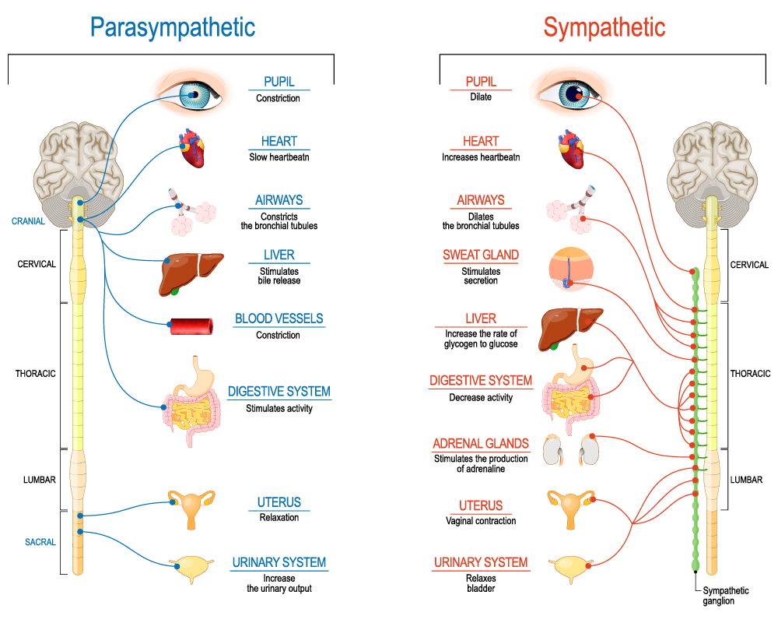
Write down 4 functions

The Endocrine System
A network of _______________________________ across the body that secrete (produce and discharge) chemical
messages called _______________________________.​
Uses _______________________________ _______________________________ to transport hormones around the
body to a specific _______________________________ _______________________________.
The system helps to _______________________________ the activity of cells and _______________________________
in the body.​
It controls vital _______________________________ processes in the body.

Glands – location, function, main hormone produced
Gland | Location in Body | Function | Main Hormone Produced
Hypothalamus | Base of brain, below thalamus | Regulates body functions and controls pituitary gland | Oxytocin – childbirth hormone
Pituitary | Beneath hypothalamus |  | Growth Hormone (GH)
Thyroid | Front of neck, below larynx |  | Thyroxine (T4)
Adrenal | On top of each kidney |  | Adrenaline
Pancreas | Behind stomach, upper abdomen |  | Insulin
Ovaries | Pelvic cavity, either side of uterus (females) |  | Oestrogen
Testes | In scrotum, outside body (males) |  | Testosterone

Hormones – function, biopsychological impact of high and low levels
Hormone | Function | High Levels May Cause | Low Levels May Cause
Oxytocin | Promotes bonding, trust, empathy, social connection. Released during childbirth and intimacy. | Excessive trust or emotional sensitivity; may contribute to overattachment. | Difficulty forming close relationships; reduced empathy or bonding.
Growth Hormone (GH)
Thyroxine (T4)
Adrenaline
Insulin
Oestrogen
Testosterone

The Fight or Flight Response
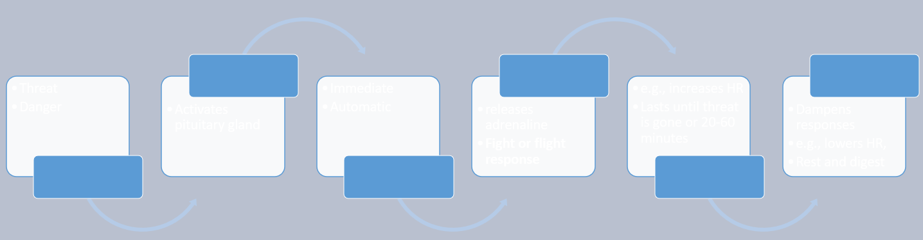

🧠 Endocrine and ANS Working Together: Fight or Flight (Fill-in-the-Blanks)
- When a person perceives a threat, the __________________ activates the __________________ gland.
- This triggers the __________________ branch of the __________________.
- The adrenal medulla releases __________________ into the bloodstream.
- This hormone causes __________________ changes such as increased __________________ and rapid breathing.
- These changes are immediate and __________________, helping the body prepare for action.
- Once the threat has passed, the __________________ branch of the ANS calms the body down.
- This calming response is sometimes called “____________________________________”
🧩 Terms to Use:
- rest and digest adrenaline hypothalamus
- pituitary sympathetic autonomic nervous system
- physiological parasympathetic automatic heart rate

