Neurons and Synaptic Transmission

Key Terms
Term | Definition
 | Nerve cells of the nervous system. Process and transmit electrical and chemical messages
 | Process in which neighboring neurons communication with one another chemically
 | Chemicals that send signals from one neuron to another across the synapse
 | When a neurotransmitter makes the neuron more likely to fire a signal
 | When a neurotransmitter makes the neuron less likely to fire a signal

Terms to use:
inhibition | neuron |neurotransmitter |excitation |synaptic transmission

Structure of a neuron

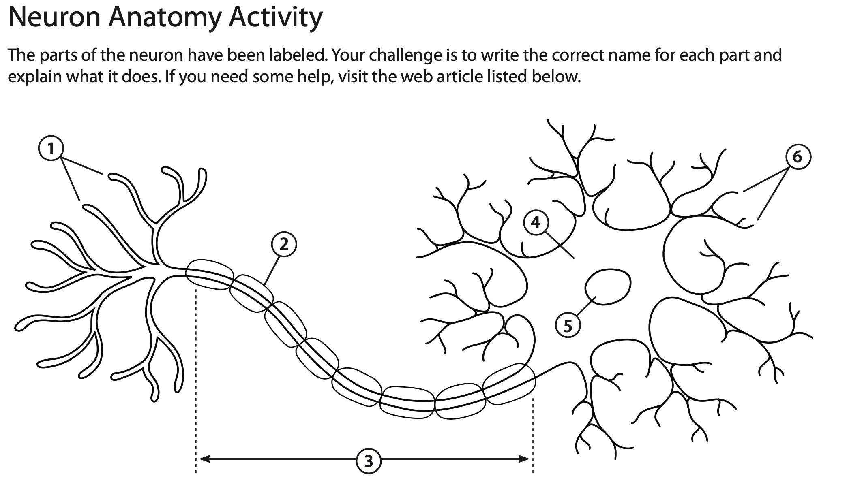
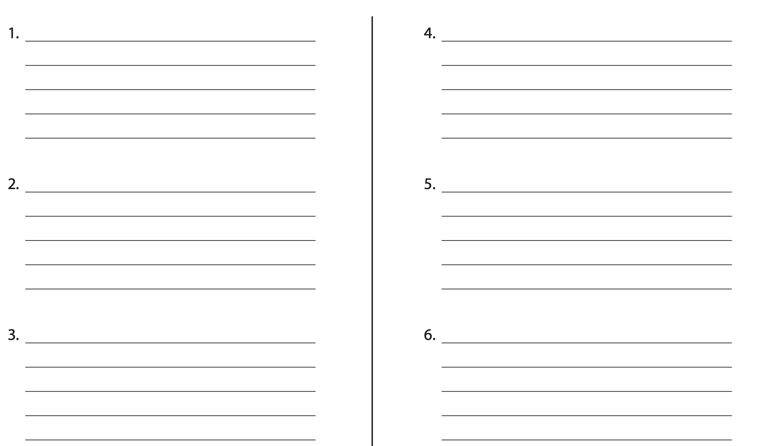

Types of neuron
Sensory | Relay | Motor
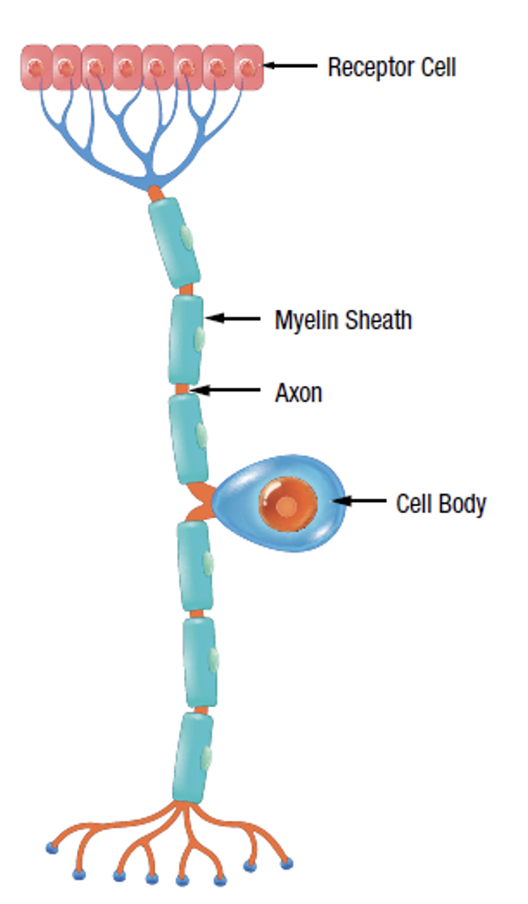 | 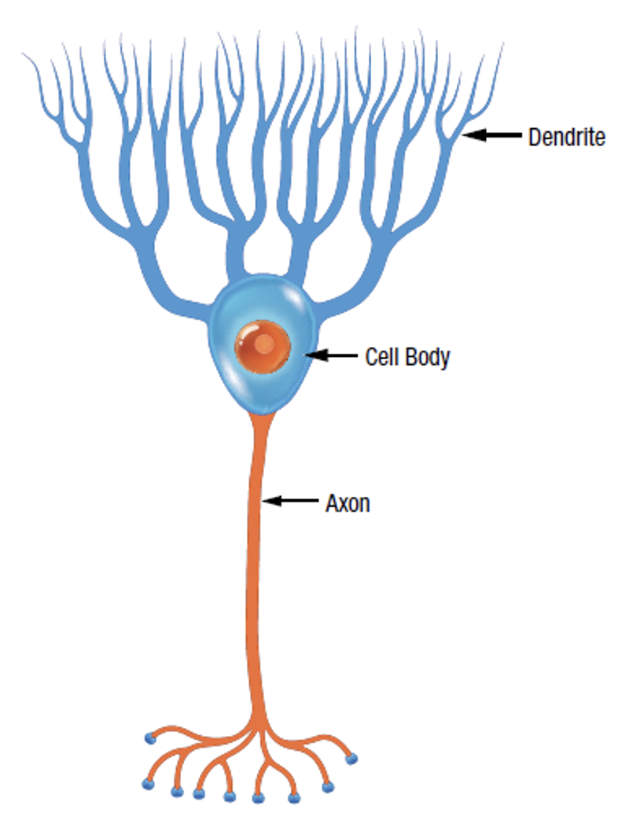 | 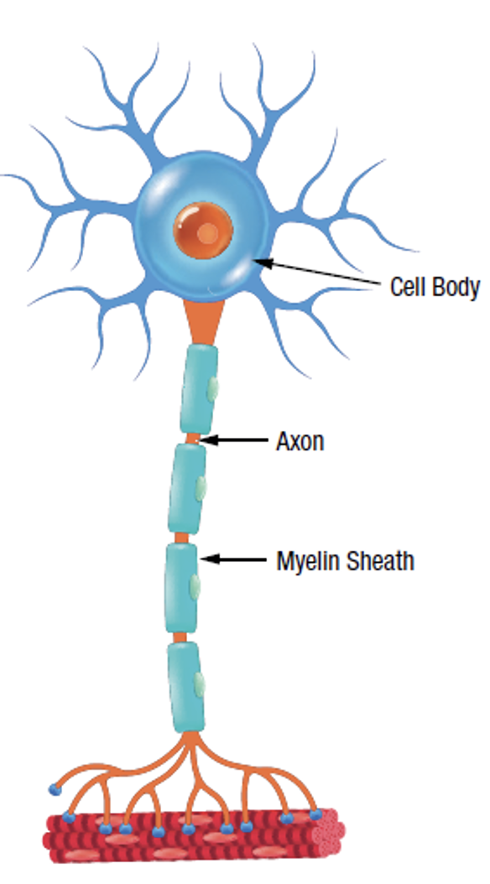

How neurons communicate (synaptic transmission)

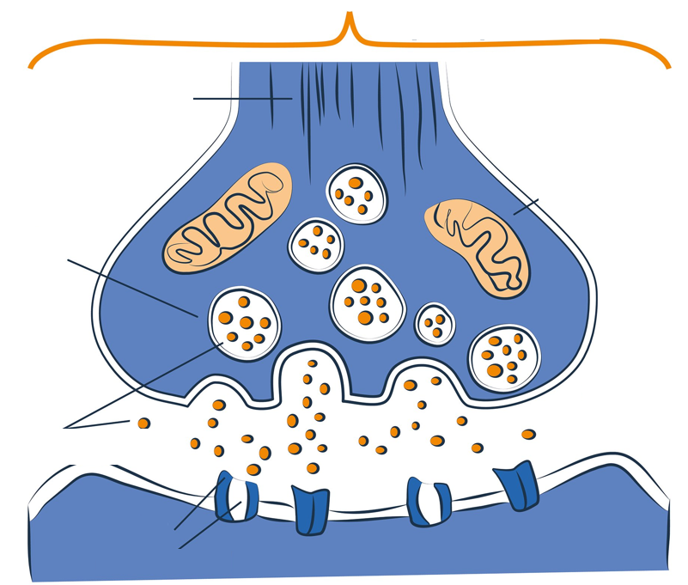
Term | Definition
 | The junction between two neurons where information is transmitted from one neuron to another.
 | The neuron that sends the signal across the synapse.
 | The end of the axon of the presynaptic neuron, which releases neurotransmitters into the synaptic gap.
 | Small sacs in the axon terminal button that contain neurotransmitters.
 | Chemical substances released by synaptic vesicles that transmit signals across a synapse to a receptor on another cell.
 | Molecules on the dendrite of the postsynaptic neuron that bind to neurotransmitters. Initiates a response in the postsynaptic cell.
 | Branch-like extensions of neurons that receive signals from other neurons through receptors.
 | The small space between the presynaptic and postsynaptic neurons where neurotransmitters are released and received.
 | The neuron that receives the signal from the presynaptic neuron through its dendrites.
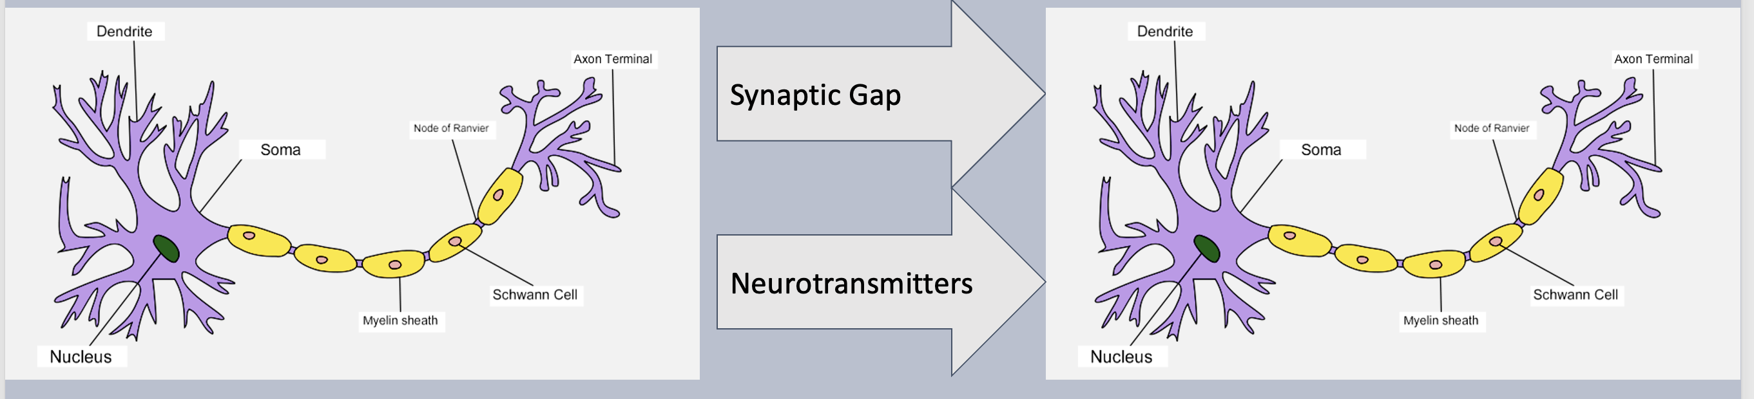

Basic synaptic transmission
- Neurotransmitters ……………………………………. across this gap from the ……………………………………. to the ……………………………………. neuron
- NTs are released from the axon terminal (buttons) of the presynaptic neuron
- They ……………………………………. to receptor cells on the dendrites of the post-synaptic neuron

The Synaptic Transmission Process
- Synaptic transmission is a process where ……………………………………. communicate with each other.
- It occurs at the ……………………………………., which is the ……………………………………. between two neurons (or between a neuron and a ……………………………………. /…………………………………….).
- This process is essential for the ……………………………………. of the nervous system and enables everything from reflexes to complex cognitive functions.

Synaptic transmission is one way!
- Neurotransmitters are only released from the synaptic vesicles of the ……………………………………. neuron
- The receptors for the neurotransmitters are on the ……………………………………. neuron
- The ……………………………………. of the neurotransmitter to the receptor enables the signal to be transmitted on to the next neuron
- ……………………………………. of the neurotransmitters mean they can ……………………………………. go from high to low concentration, so they can only travel from the presynaptic to the postsynaptic membrane.

Action Potential
- Information is passed down the axon of the ……………………………………. neuron as an ……………………………………. impulse.
- This is known as an ……………………………………. …………………………………….
- Once the action potential reaches the …………………………………….of the axon, it needs to be …………………………………….to another neuron or tissue by crossing the …………………………………….……………………………………..
- This is the gap between the …………………………………….neuron and the …………………………………….neuron.
- At the end of the neuron (axon terminal) are …………………………………….…………………………………….that contain ……………………………………..
- These neurotransmitters travel across the …………………………………….and bind to the …………………………………….…………………………………….on the postsynaptic neuron.

Re-uptake
- Any neurotransmitters than do not …………………………………….to the receptor sites of the …………………………………….…………………………………….are broken down
- These neurotransmitters are re-absorbed back into the presynaptic neuron through the …………………………………….…………………………………….

Excitation
- …………………………………….Neurotransmitters make the post-synaptic neuron …………………………………….likely to fire an impulse, e.g., noradrenaline (gets you going!)
- They …………………………………….to the post-synaptic …………………………………….making the post-synaptic cell …………………………………….likely to fire
- Excitatory neurotransmitters …………………………………….brain activity

Inhibition
- …………………………………….neurotransmitters make the post-synaptic neuron …………………………………….likely to fire an impulse, e.g., GABA (calms you down)
- They …………………………………….to the post-synaptic …………………………………….making the post-synaptic cell …………………………………….likely to fire
- Inhibitory neurotransmitters …………………………………….brain activity

Summation
- Excitatory and inhibitory impulses are added together through ‘…………………………………….’
- If the overall effect is ……………………………………., the post-synaptic neuron is …………………………………….likely to fire and impulse
- If the overall effect is ……………………………………., the post-synaptic neuron is …………………………………….likely to fire an impulse
- If inhibitory inputs are ……………………………………., than excitatory they can cancel out excitation and ……………………………………., an ……………………………………., ……………………………………., occurring

