  67. Neurons and Synaptic Transmission
  Name: | ________________________
  Class: | ________________________
  Date: | ________________________

Time: | 72 minutes
Marks: | 56 marks
Comments:

Q1.
The figure below shows a typical motor neuron. Four components of the motor neuron are labelled A, B, C and D.
Typical motor neuron
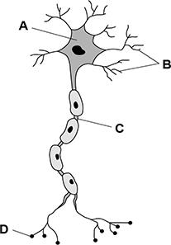
Using the letters given in the figure above, correctly identify the components of the motor neuron in the table below.

Component
A
B
C
D
(Total 4 marks)
Q2.
Explain the process of synaptic transmission.
_______________________________________________________________________
_______________________________________________________________________
_______________________________________________________________________
_______________________________________________________________________
_______________________________________________________________________
_______________________________________________________________________
_______________________________________________________________________
_______________________________________________________________________
(Total 4 marks)
Q3.
Which of the following neurons carries electrical impulses towards the brain?
Shade one box only.

A | Interneuron
B | Motor neuron
C | Relay neuron
D | Sensory neuron
(Total 1 mark)
Q4.
Describe the structure and function of a neuron.
_______________________________________________________________________
_______________________________________________________________________
_______________________________________________________________________
_______________________________________________________________________
_______________________________________________________________________
_______________________________________________________________________
_______________________________________________________________________
_______________________________________________________________________
_______________________________________________________________________
_______________________________________________________________________
_______________________________________________________________________
_______________________________________________________________________
(Total 6 marks)

Q5.
A survey of hospital patients has found that a new drug, Zapurpain, is as effective as other pain medication.
Zapurpain acts like an inhibitory neurotransmitter at the synapse.
Explain how Zapurpain might affect the process of synaptic transmission through inhibition.
_______________________________________________________________________
_______________________________________________________________________
_______________________________________________________________________
_______________________________________________________________________
_______________________________________________________________________
_______________________________________________________________________
_______________________________________________________________________
_______________________________________________________________________
_______________________________________________________________________
_______________________________________________________________________
(Total 4 marks)

Q6.
The diagram below shows three different types of neuron. Use the letters from the diagram to answer the following questions.
Types of neuron
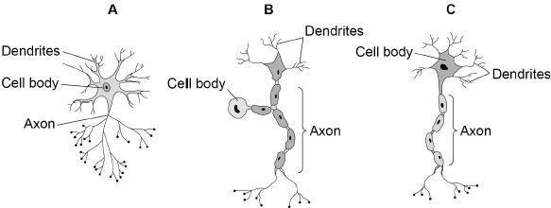
(a) Which neuron is only found in the brain/visual system/spinal cord?

A
B
C
(1)
(b) Which neuron carries nerve impulses from the brain/spinal cord to muscles/glands?

A
B
C
(1)
(c) Which neuron carries nerve impulses between neurons?

A
B
C
(1)
(Total 3 marks)

Q7.
Name the types of neurons labelled A, B and C on the figure below. Write your answers in the boxes provided.
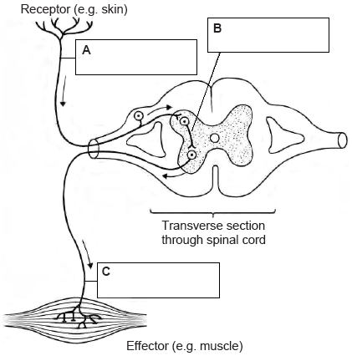
(Total 3 marks)
Q8.
Information can only travel in one direction at a synapse.
Explain why neurons can only transmit information in one direction at a synapse.
_______________________________________________________________________
_______________________________________________________________________
_______________________________________________________________________
_______________________________________________________________________
_______________________________________________________________________
_______________________________________________________________________
(Total 3 marks)

Q9.
Explain the process of synaptic transmission.
_______________________________________________________________________
_______________________________________________________________________
_______________________________________________________________________
_______________________________________________________________________
_______________________________________________________________________
_______________________________________________________________________
_______________________________________________________________________
_______________________________________________________________________
(Total 4 marks)
Q10.
Briefly outline how excitation and inhibition are involved in synaptic transmission.
_______________________________________________________________________
_______________________________________________________________________
_______________________________________________________________________
_______________________________________________________________________
_______________________________________________________________________
_______________________________________________________________________
_______________________________________________________________________
_______________________________________________________________________
(Total 4 marks)

Q11.
Complete the following sentence. Shade one box only.
Sensory neurons carry information

A | away from the brain.
B | both to and from the brain.
C | towards the brain.
D | within the brain.
(Total 1 mark)
Q12.
Label the two areas of the synapse in the diagram below by putting the appropriate letter in each box.

A | Axon
B | Dendrites
C | Neurotransmitters
D | Receptor sites
E | Vesicle
The synapse
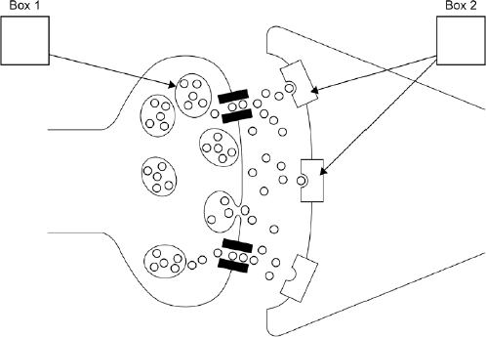
(Total 2 marks)
Q13.
Jeremy is digging in the garden. He feels the spade hit a rock and stops digging immediately.
Explain how sensory, relay and motor neurons would function in this situation.
_______________________________________________________________________
_______________________________________________________________________
_______________________________________________________________________
_______________________________________________________________________
_______________________________________________________________________
_______________________________________________________________________
_______________________________________________________________________
_______________________________________________________________________
_______________________________________________________________________
_______________________________________________________________________
_______________________________________________________________________
_______________________________________________________________________
(Total 6 marks)
Q14.
Outline the structures and processes involved in synaptic transmission.
_______________________________________________________________________
_______________________________________________________________________
_______________________________________________________________________
_______________________________________________________________________
_______________________________________________________________________
_______________________________________________________________________
_______________________________________________________________________
_______________________________________________________________________
_______________________________________________________________________
_______________________________________________________________________
_______________________________________________________________________
_______________________________________________________________________
(Total 6 marks)
Q15.
Raoul has recently been prescribed a drug for a mental illness. He looks on the internet to find out more about the drug but he does not understand the phrase ‘synaptic transmission’.
Write a brief explanation of synaptic transmission in the brain to help Raoul understand how his drug might work.
_______________________________________________________________________
_______________________________________________________________________
_______________________________________________________________________
_______________________________________________________________________
_______________________________________________________________________
_______________________________________________________________________
(Total 3 marks)
Q16.
Briefly outline the process of synaptic transmission.
_______________________________________________________________________
_______________________________________________________________________
_______________________________________________________________________
_______________________________________________________________________
_______________________________________________________________________
_______________________________________________________________________
_______________________________________________________________________
_______________________________________________________________________
(Total 2 marks)

Mark schemes
Q1.
[AO1 = 4]
Award 1 mark for each of the following:

 | Component
A | Cell body/soma
B | Dendrites
C | Node of Ranvier/axon
D | Terminal button/presynaptic terminal/axon terminal
[4]
Q2.
[AO1 = 4]

Level | Marks | Description
2 | 3-4 | Explanation of the process of synaptic transmission is detailed, clear and mostly accurate with use of appropriate scientific terminology.
1 | 1-2 | Explanation of the process of synaptic transmission is incomplete/muddled. Scientific terminology is either absent or inappropriately used.
 | 0 | No relevant content.
Possible content:
• electrical impulses (action potentials) reach the presynaptic terminal
• electrical impulses (action potentials) trigger release of neurotransmitters (or named example) from synapse vesicles
• neurotransmitters diffuse across the synaptic cleft
• neurotransmitters bind to receptors on the postsynaptic membrane.
Credit other relevant material (eg; labelled diagram – direction of transmission should be made clear; excitation/inhibition).
[4]
Q3.
[AO1 = 1]
D – Sensory neuron
[1]
Q4.
[AO1 = 6]

Level | Mark | Description
3 | 5-6 | Description is clear, accurate and detailed. Specialist terminology is used effectively.
2 | 3-4 | Description is mostly clear but lacks detail in places. There is some appropriate use of specialist terminology.  OR only structure/only function of a neuron at level 3.
1 | 1-2 | Description is limited/muddled. The answer lacks clarity and accuracy. Specialist terminology is either absent or inappropriately used.  OR only structure/only function of a neuron at level 1/2.
 | 0 | No relevant content.
Possible content:
• Neurons enable communication within the nervous system
• the cell body (soma) contains the genetic material
• branch-like dendrites extend from the cell body (often with dendritic spines)
• dendrites carry functional information towards the cell body
• dendrites can receive information from other neurons
• axons carry messages away from the cell body
• axons can be myelinated to increase speed of nerve transmission (saltatory conduction between nodes of Ranvier)
• terminal boutons are at the end of axons, these make synaptic connections with other cells
• axon terminals contain neurotransmitters.
Credit other relevant material.
Note: credit references to structure and function of specific neurons (sensory, motor and relay).
Note: information presented in a diagram can be credited.
[6]
Q5.
[AO2 = 4]

Level | Mark | Description
2 | 3-4 | The explanation of how Zapurpain might affect the process of synaptic transmission through inhibition is clear and coherent with effective use of terminology.
1 | 1-2 | The explanation of how Zapurpain might affect the process of synaptic transmission through inhibition is partial/limited/muddled. Terminology may be absent or inappropriately used.
 | 0 | No relevant content.
Possible content:
• Zapurpain mimics the effect of inhibitory neurotransmitters, stimulation of postsynaptic receptors by an inhibitory neurotransmitter result in inhibition (hyperpolarisation) of the postsynaptic membrane
• when an inhibitory neurotransmitter binds to the post-synaptic receptors it makes the post-synaptic cell less likely to fire (IPSP)
• Summation – if inhibitory inputs are higher than excitatory they can cancel out excitation and inhibit an action potential occurring/Zapurpain would decrease the overall activity
• Zapurpain would make the post-synaptic cell less likely to fire
• reducing brain activity may lead to reduced pain.
Credit other relevant material, eg information embedded in a labelled diagram – direction of transmission should be made clear.
[4]
Q6.
(a) [AO1 = 1]
A
1
(b) [AO1 = 1]
C
1
(c) [AO1 = 1]
A
1
[3]
Q7.
[AO1 = 3]
1 mark for each of the following:
A = Sensory Neuron
B = Relay Neuron (accept interneurons / connector neuron)
C = Motor Neuron
[3]
Q8.
[AO1 = 3]
Award 1 mark for each of the following points (up to 3 marks):
• the synaptic vesicles containing the neurotransmitter are only present on / released from the presynaptic membrane
• the receptors for the neurotransmitters are only present on the postsynaptic membrane
• it is the binding of the neurotransmitter to the receptor which enables the signal / information to be passed / transmitted on (to the next neuron)
• diffusion of the neurotransmitters mean they can only go from high to low concentration, so can only travel from the presynaptic to the postsynaptic membrane.
[3]
Q9.
[AO1 = 4]

Level | Marks | Description
2 | 3 – 4 | Knowledge of the process of synaptic transmission is detailed, clear and mostly accurate with use of appropriate scientific terminology.
1 | 1 – 2 | Knowledge of the process of synaptic transmission is incomplete/partly accurate. Scientific terminology is either absent or inappropriately used.
 | 0 | No relevant content.
Possible content:
• electrical impulses (action potentials) reach the presynaptic terminal
• electrical impulses (action potentials) trigger release of neurotransmitters (or named example)
• neurotransmitters cross the synapse from vesicles
• neurotransmitters combine with receptors on the postsynaptic membrane
• stimulation of postsynaptic receptors by neurotransmitters result in either excitation (depolarisation) or inhibition (hyperpolarisation) of the postsynaptic membrane.
Credit other relevant material (eg labelled diagram – direction of transmission should be made clear).
Note: for 4 marks explanation must describe the complete process (beginning, middle and end).
Q10.

[AO1 = 4]

Level | Marks | Description
2 | 3 – 4 | Excitation and inhibition are explained clearly with reference to synaptic transmission. The answer is generally coherent with effective use of terminology.
1 | 1 – 2 | There is limited/partial explanation of excitation and inhibition with reference to synaptic transmission or only excitation or inhibition has been outlined. The answer may lack coherence. Use of terminology may be either absent or inappropriate.
 | 0 | No relevant content.
Possible Content:
• Neurotransmitters can be excitatory or inhibitory (most can be both but GABA is purely inhibitory).
• If the neurotransmitter is excitatory then the post synaptic neuron is more likely to fire an impulse.
• If the neurotransmitter is inhibitory then the post synaptic neuron is less likely to fire an impulse.
• The excitatory and inhibitory influences are summed, if the net effect on the post synaptic neuron is inhibitory, the neuron will be less likely to 'fire' and if the net effect is excitatory, the neuron will be more likely to fire.
Students are likely to name neurotransmitters but this is not essential for full credit.
For full credit there should be some understanding of 'summation.'
Q11.

[AO1 = 1]
C
Q12.

[AO1 = 2]
1 mark each for D and E in correct boxes.
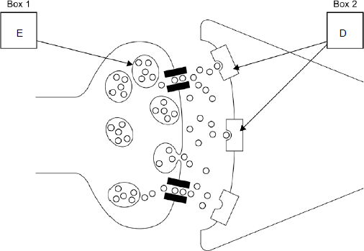
Q13.
[AO2 = 6]

Level | Marks | Description
3 | 5 – 6 | The explanation of how each type of neuron would function in this situation is clear and with effective and generally well-detailed application. The answer is coherent with effective use of terminology.
2 | 3 – 4 | The explanation of how types of neurons would function in this situation is partial. There is partial appropriate application. The answer is generally coherent with some appropriate use of terminology.
1 | 1 – 2 | The explanation of how types of neurons would function in this situation is limited. Application is limited. The answer lacks coherence and/or appropriate use of terminology.
 | 0 | No relevant content.
Possible application as follows:
• Sensory neurons send information from the senses to the brain – here receptors in Jeremy’s hand would sense the jolt of the spade hitting the rock and send that information via the peripheral nervous system to his brain/CNS.
• Relay neurons connect with other neurons, mostly found in the brain/CNS - here they would be involved in analysis of the sensation, what it means, deciding about how to respond to it, thus acting between the sensory and motor neurons.
• Motor neurons send messages via long axons from the brain to the muscles or effectors – here the message from the brain instructs Jeremy’s arm muscles to stop working and stop the digging action.
Credit other relevant application.
Q14.

[AO1 = 6]

Level | Marks | Description
3 | 5 – 6 | Knowledge of both structures and processes involved in synaptic transmission, including reference to both presynaptic and postsynaptic processes, is generally accurate and mostly well detailed. The answer is clear and coherent. Specialist terminology is used effectively.
2 | 3 – 4 | Knowledge of both the structures and processes involved in synaptic transmission is evident. Focus is on pre or postsynaptic processes. There are some inaccuracies. There is some appropriate use of specialist terminology.
1 | 1 – 2 | Knowledge of structures and / or processes involved in synaptic transmission is limited and lacks detail. There are inaccuracies. Specialist terminology is either absent or inappropriately used.
 | 0 | No relevant content.
Content:
The synaptic cleft; pre and postsynaptic membranes; postsynaptic receptor sites, neurotransmitters in vesicles in the presynaptic terminal, release of neurotransmitters into the synaptic cleft when stimulated by nerve impulses (action potentials) arriving at the presynaptic terminal, combination of neurotransmitters with postsynaptic receptors; postsynaptic effects either excitatory (depolarisation) or inhibitory (hyperpolarisation).
Diagrams can describe the structure effectively but text is necessary to explain the processes.
Q15.
[AO2 = 3]
Content:
1 mark for any three of the following points:
• Transmission involves impulses crossing a space or gap between an axon terminus and the adjacent neuron (the synapse/synaptic cleft)
• Neurotransmitters are chemicals released from vesicles on the presynaptic neuron
• They travel/diffuse across the synapse and lock onto receptor sites on receiving/postsynaptic neuron
• Some neurotransmitters increase the rate of firing in the receiving neurons and others decrease the rate of firing
• Psychoactive drugs work by affecting (increasing or inhibiting) the transmission of neurotransmitters across the synapse
For full marks there must be some reference to drugs affecting synaptic transmission.
Credit diagrams in so far as they contribute to the explanation.
Q16.

[AO1 = 2]
Up to 2 marks for an outline of synaptic transmission.
One mark for reference to the release of neurotransmitter into the synapse.
One mark for reference to neurotransmitter binding with receptors on the dendrite or next neuron to binding another impulse.
Credit a diagram that illustrates the process above.

Examiner reports
Q1.
Students generally performed well in this question, labelling a typical neuron.
Q2.
There were some detailed and thorough responses to this question, but others simply involved a general description of the structure of a neuron or a synapse, rather than being clearly focussed on the process of synaptic transmission as the question demanded.
A significant minority of students wrote excessive amounts of relevant content and used all the extra space as well as additional space at the back of the question paper. Although students did not lose marks for this, they did potentially lose valuable time which could have been better spent elsewhere.
Q3.
This question was generally well answered with most students selecting the correct response. The most common incorrect response was distractor C.
Q4.
Overall, descriptions of the structure of a neuron were generally accurate but the function was less well addressed. Although some students muddled terminology, there were some really excellent descriptions relating structure to function with an impressive level of detail. There was a range of approaches to answering this question, some described a reflex arc, others described the structural and functional differences between different types of neuron and others focused on the general structure of a neuron. These were all creditworthy and there were different ways to achieve the 6 marks depending on the depth/breadth of knowledge presented. Unfortunately, some students described the process of synaptic transmission rather than focusing their response on the question given.
Surprisingly few diagrams were seen. Students should be reminded that they can gain credit for information presented in a diagram and should be encouraged to use diagrams to help explain the structure for both clarity and to avoid wasting precious examination time writing lengthy descriptions.
Q5.
This was a challenging question which highlighted a general lack of understanding of inhibition. The majority of responses fitted the level 1 description mainly due to muddling processes and/or using inappropriate terminology. Surprisingly few students discussed IPSPs or the effect of inhibition on summation; those that did this accurately generally achieved full marks. There were some impressive neurobiological responses discussing the impact of inhibition on the permeability of the post-synaptic membrane to chloride and potassium ions and the consequential hyperpolarisation of the membrane and subsequent difficulty reaching threshold to initiate an action potential. However, too many students described inhibition as a slowing down of action potentials, failing to grasp the ‘all or nothing’ principle.
Q6.
This question proved challenging with only half of the students correctly identifying each of the neurons. Students who correctly identified and labelled the neurons in the figure were then able to respond correctly to the questions regarding function. It appears that students were better at knowing the function of each neuron type rather than the structure of each type of neuron.
Q7.
This question was generally well answered with over 80% of students achieving full marks.
Q8.
This question provided an excellent discriminator between students who could recall the process of synaptic transmission and those who genuinely understood the process. A very small number of clear and detailed responses demonstrated sound understanding, but too many students simply explained synaptic transmission instead of using their knowledge to answer the question. Many attempted to address the question but muddled terminology, such as the pre- and post-synaptic membrane, preventing them from achieving the marks. Overall, it appeared that students are learning the required knowledge and terminology but do not understand it well enough to be able to use their knowledge flexibly. Some students gave a biological explanation of why information passes in one direction within a neuron rather than between neurons, focusing on why action potentials are unidirectional, with reference to refractory periods, voltage-gated ion channels and hyperpolarisation. Understanding of the process of synaptic transmission is an area that perhaps teachers need to look at more in the classroom and students should always be prepared to apply their knowledge to explain unfamiliar contexts.
Q9.
This question offered good discrimination. There were some very complex and detailed responses that went beyond the requirements of the specification, although these were not always well focussed. Weaker students mainly struggled with either poor focus on the process of synaptic transmission or a lack of specific detail or inaccuracies, especially regarding the use of scientific terminology. Common misunderstandings included vesicles crossing the synaptic gap, action potentials being excitatory/inhibitory, neurotransmitters being ‘fired’ across the gap and confusion between chemical and electrical transmission. Few made use of a diagram and those that did generally were ineffective in explaining the process.
Q10.

There were some issues with the accuracy of knowledge here and many students produced answers that were very confused. There was only a superficial/limited understanding of how excitation and inhibition are involved in synaptic transmission. Often there was no knowledge that excitation and inhibition occur at the post synaptic membrane and some students suggested that synapses were firing or that excitation caused more neurotransmitter and inhibition caused less. Other responses suggested that excitation referred to more firing and inhibition to less firing but an understanding of the summation of excitatory and inhibitory influences was rare, even in knowledgeable answers. At the simplest level students should be aware of the general idea that transmission is halted if there are more inhibitory effects in total and proceeds if there are more excitatory effects overall.
Q16.

More than half the answers to this question gained no credit. Many students did not appreciate the change that takes place from an electrical to a chemical signal and referred to ‘jumping across.’ A few students mentioned neurotransmitters then completed their answers with reference to binding on the post-synaptic membrane.

