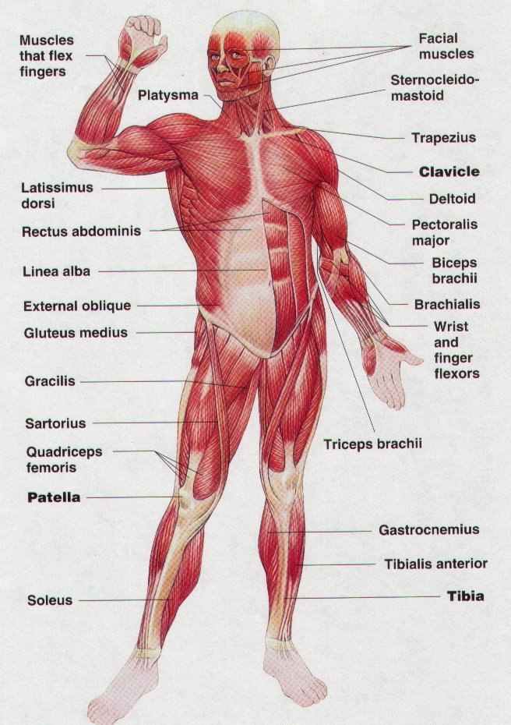

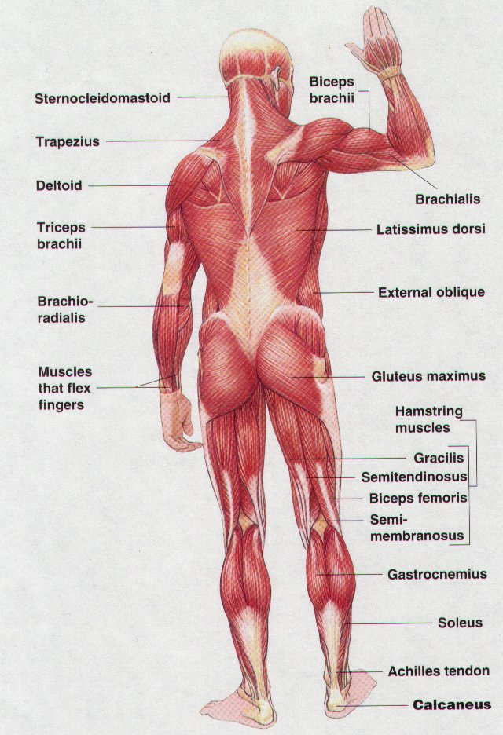

TYPES OF ACTIONS:

ACTION | WHICH JOINTS THE ACTION OCCURS AT | TYPE OF JOINT | MUSCLE THAT CAUSES THIS ACTION
FLEXION

EXTENSION

ADDUCTION

ABDUCTION

ROTATION

CIRCUMDUCTION

PLANTAR FLEXION

DORSI FLEXION

PRONATION

SUPINATION

INVERSION

EVERSION

Describe the Joint and Muscle Action in the following pictures….

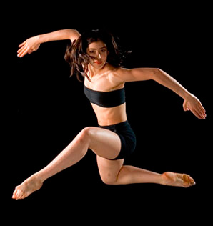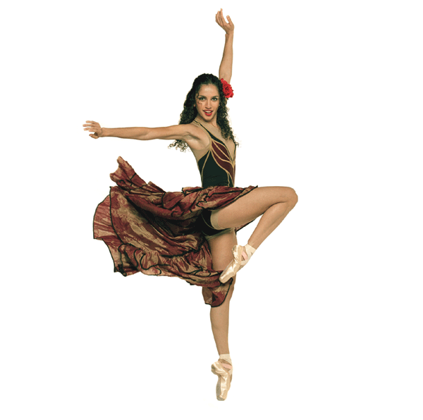

Identify some of the factors of fitness required for these dancers. Describe what training methods may be used to improve and maintain these factors of fitness.
Label the parts of the SYNOVIAL JOINT and explain the function of each.

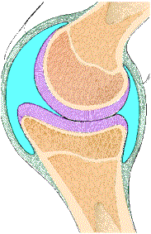
Flexibility & Stretching

Flexibility is: _______________________________________________________________________________

Factors that affect flexibility are:

To improve flexibility we must STRETCH regularly.
For each type of stretching explain what it is and provide 3 examples.
STATIC STRETCHING:

DYNAMIC STRETCHING:

PASSIVE STRETCHING:

BALLISTIC STRETCHING:

PNF: PROPRIOCEPTIVE NEUROMUSCALUR FACILITATION

Complete the following:
For stretching to be benefical to improving flexibility it must be carried out…

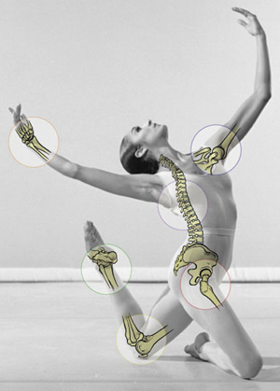
Comon Dance Injuries – Treatment and Prevention

The Foot and Ankle
Structure
The ankle joint connects the lower leg to the foot and, in dance, allows for pointing the toe (plantar flexion) and flexing the foot during plié (dorsiflexion). The ankle also allows for inversion and eversion, producing turn-in and turn-out, respectively. The 26 bones in the foot work in concert with ligamentous support and muscular force to create three separate arches, critical for shock absorption during jumps. Structurally, the ideal foot for ballet is considered to be a flexible “square foot”, which has equal-length first and second toes.

Dancer’s Fracture
“I landed badly from a jump and now it hurts to walk.”
Causes
This is the most common acute fracture seen in dancers. This fracture occurs along the 5th metatarsal, the long bone on the outside of the foot. The typical method of injury is landing from a jump on an inverted (turned-in) foot. The dancer will usually experience immediate pain and swelling. He or she may or may not be able to walk.
Treatment
Treatment typically consists of ice, elevation, and limiting weight bearing activities (rest). A dancer’s fracture will require a period of immobilization while the injury heals. Rehabilitation should follow to rebuild foot and ankle mobility and strength.
Achilles Tendinitis
“My heel and lower calf hurt, particularly while running or jumping.”
Tendinitis can occur in any of the tendons about the ankle. It most commonly occurs, however, in the body’s longest tendon—the Achilles tendon. Able to withstand forces equal to and greater than 1000 pounds, this tendon connects the calf muscles to the heel bone (calcaneus) and is responsible for plantar flexion of the foot to achieve releve and performing jumps. Due to its’ heavy workload in the dancing population, it is prone to inflammation (tendinitis). It unfortunately is also the most frequently ruptured tendon in dancers and non-dancers alike.
Causes
Most cases of Achilles tendonitis are due to overtraining of the dancer, particularly heavy training during a short period of time. Other contributing factors for Achilles inflammation would be:
• Returning to dance after a long period of rest
• A natural lack of flexibility in the calf muscles
• Dancing on a hard surface or a non-sprung floor
Aside from pain over the area of the Achilles, dancers with Achilles tendonitis can also notice:
• Mild pain after dancing that worsens
• Tenderness in the morning located ½” above tendon attachment to heel bone
• Stiffness that fades once tendon is sufficiently warm
• Swelling and inflammation
Treatment
As with all overuse injuries, the sooner the injury is addressed, the more positive the outcome. Rest and ice are immediate treatments for conditions that do not allow for any pain free activity. Active stretching of the Achilles is helpful. However, dancers need to exercise caution with stretching the Achilles beyond the point of comfort. Strengthening exercises should be introduced gradually. For chronic conditions, the use of an overnight splint to assist with dorsiflexion range of motion can be helpful. Orthotic prescription can be helpful to correct any structural imbalances in the foot. However, if a dancer has no correctable faults, orthotics may not assist with symptom relief.

Lateral Ankle Sprain
“I rolled my ankle during class and heard a ‘pop’ sound.”
Ankle sprains are the most common type of ankle injury for dancers. Ankle sprains involve the lateral (outside) structures of the ankle and occur when the ankle is inverted (turned or rolled outwards). A lateral ankle sprain is the result of tears to any of the lateral stabilizing ligaments. Sprains are graded 1st, 2nd, or 3rd degree (3rd degree being the most severe) depending on the involvement and integrity of these ligaments.
Causes
Ankle sprains are usually sustained upon landing jumps, either improperly or landing on an object or another dancer’s foot. It is common for significant sprains to also produce an audible ‘pop’ sound. Other related factors that can contribute to ankle sprains include:
1. working close to the limits of strength
2. a slight loss of balance
3. a lapse in concentration
Upon sustaining an ankle sprain, a dancer will usually notice swelling and pain over the lateral ankle. The severity of these symptoms will vary depending on the severity of the sprain. Some dancers are able to walk, some are unable to bear weight at all. Bruising over the lateral ankle can emerge within 1-3 days following an ankle sprain.
Treatment
As with any injury that involves inflammation, apply the RICE treatment protocol:
• Rest — avoid using the ankle to prevent further damage.
• Ice — apply ice or cold packs to the ankle for 15–20 minutes each hour to help reduce swelling.
• Compression — wrap a tensor bandage around the ankle to help reduce swelling.
• Elevation — elevate above the heart and support the ankle while resting to prevent blood from pooling and increasing swelling.
The severity of the ankle sprain will dictate the amount of protection and immobilization the ankle requires. A Grade 1 sprain may only need the support of an ace wrap bandage or a splint. A Grade 3 sprain may need to be immobilized with a splint and the dancer will likely need to use crutches or a walking boot for ambulation. Ankle sprains should be evaluated by a physician to rule out any fractures. Follow-up treatment with a physical therapist or athletic trainer is crucial to develop strength and balance prior to returning to dance activities and thus reduce the potential for recurring sprains.
Shin splints, stress reactions, and stress fractures:
“I have pain in the front of my shins. It hurts worse during class.”
Shin splints, stress reactions, and stress fractures are all overuse injuries of the lower leg usually associated with forceful, repetitive activities such as running or jumping. Shin splints involve pain at the front of the lower leg in the shin region. The pain is caused by an irritation of either the periosteum (the lining of the tibia, or shin bone) or the muscles and tendons in the area. A stress reaction is defined by accelerated remodelling or re-absorption of bone. A stress fracture is a small crack or cracks that occur as a result of repeated loading of the bone when muscles are fatigued. Fatigued muscles transfer more of the load to the bone. Shin splints or stress reactions can progress to stress fractures if left untreated. Stress fractures can progress to complete bone fractures if left untreated. The feet are the most common site of stress fractures in dancers, and the tibia is the most common place for stress reactions or shin splints.
Causes
All three conditions result in an aching pain that may become more severe during activity. Intensive dance rehearsal and a high percentage of time dancing on pointe or demi-pointe will increase the stress and pressure on the foot and tibia. As muscles become fatigued the dancer may have difficulty maintaining position, and the muscles transfer stress to other soft tissues and bone. When the bone is repeatedly stressed and has low bone mineral density levels, it can eventually result in a stress fracture. Dancing on hard floors increases the risk of stress fractures and stress reactions.
Treatment
Treatment of shin splints may involve various techniques, which include:
• resting the area
• applying ice to control inflammation
• physical therapy/athletic training treatments
• correcting any underlying postural distortions that may aggravate or contribute to the injury (knee hyperextension, weak abdominal muscles, anterior or posterior tilted pelvis, pronation/supination of the foot, etc.)
With stress fractures, rest for the injured area is the only treatment that will allow the bone to heal. It may be necessary to unload the stress for a period of time by using crutches or a walking boot. A lack of pain does not mean that the bone has healed (many people do not report symptoms). A dancer should consult with their physician or clinician prior to returning to dance. Upon return to dance, the dancer should not experience any pain. If the dancer resumes activity too quickly, the stress fracture is more likely to progress to a complete bone fracture.

What is the difference between a strain and a sprain?

