Task 4 Loops

## Task 4a

Copy and complete the below code

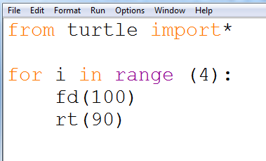

Save as **task4a**

## Task 4b

You learned how to draw a triangle in task 2a. Now, draw a triangle rt (120) but use the for loop to make it more efficient. Save this as **task 4b**

## Task 4c – 4f

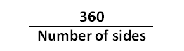Using your new knowledge of for loops complete the below shapes and save as the correct file name.

**Note:** all external angles are calculated with the **formula:**

|  |  |  |  |
| --- | --- | --- | --- |
| **Shape** | **Number sides** | **External angle** | **Save as** |
| Pentagon | 5 | 72 | Task4c.py |
| Hexagon | 6 | 60 | Task4d.py |
| Octagon | 8 | 45 | Task4e.py |
| Decagon | 10 | 36 | Task4f.py |

## Task 4g

Use the for loop to create the star, the angle is 144 degrees

Save as **task 4g**

|  |  |
| --- | --- |
| **fd ()** | **Move the arrow forward** |
| **bk ()** | **Move the arrow backwards** |
| **rt ()** | **Rotate the arrow to the right** |
| **lt ()** | **Rotate the arrow to the left** |
| **pu ()** | **Lift the pen to stop drawing** |
| **pd ()** | **Replace the pen to continue drawing** |
| **fillcolor (“ “)** | **Choose the colour to fill the shape** |
| **begin_fill ()** | **Start to fill the shape before drawing the shape** |
| **end_fill ()** | **Finish the colour fill after drawing the shape** |
| **pencolor (“ “)** | **Change the colour of the pen** |
| **pensize ()** | **Change the thickness of the pen** |