Task 3 – Drawing a triangle

1. **Import Turtle and choose the colour**

***NOTICE THE AMERICAN SPELLING!!***

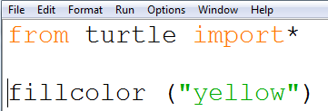

1. **Begin the fill instruction**

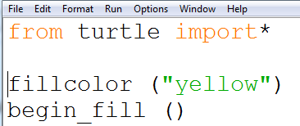

1. **Draw the square**

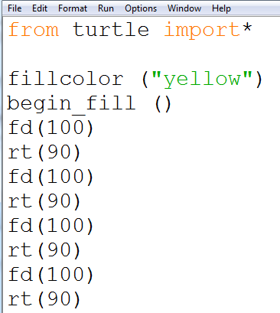

1. **End the colour fill instruction** 