C:\Users\askewc\Documents\SAMs\Geography\OS Map Key A4.tifC:\Users\askewc\Documents\SAMs\Geography\OS Map Key A4.tifC:\Users\askewc\Documents\SAMs\Geography\OS Map Key A4.tif

Accredited logo



Oxford Cambridge and RSA

**GCSE (9–1) Latin**

**J282/06 Literature and Culture**

Prescribed Sources Booklet

**PRESCRIBED SOURCES BOOKLET**

* **It is expected that learners will be familiar with the sources in this booklet and will also have studied sources from elsewhere relevant to the topic studied.**
* Your teacher (GVD) will, in addition, be sending out selected ‘sources from elsewhere’ to enlarge your learning about each sub-topic within ‘The Romans in Britain’ and ‘Myth & Religion’.
* **We’ll start with ‘The Romans in Britain’. You will have some preparation about the first sub-topic (The Roman Army) to do for lesson Thursday 1st October – then**
  + **Roman Roads for lesson Thursday 8th October**
  + **Roman Villas for lesson Thursday 15th October**
  + **Roman Bath (Aquae Sulis) for lesson Thursday 22nd October**
* You will study ‘Myth & Religion’ at the start of the January term - again, taking 4-5 weeks.
* The exam ‘Literature & Culture’ will be ‘based on a number of sources – some taken from this booklet, others chosen by the examiners from the whole range of Roman literature, art & architecture and inscriptions.
* **The Mock Exam (December) will include ‘The Romans in Britain’ only. GVD will set you a mini-Mock on ‘Myth & Religion’ just before February half-term**

**LATIN LITERATURE AND CULTURE:**

**Prescribed Sources Booklet**

1. **The Romans in Britain**
   1. **Roman Army**

*Camp layout, life in camp including training*

* 1. **Roman Roads**

*Construction, principal routes across Britain*

* 1. **Roman Villas**

*Villa buildings, the villa estate*

* 1. **Roman Bath**

*Layout of the bath complex, links with religion*

1. **Myths and Beliefs**
2. **Roman Gods**

*Jupiter, Juno, Mars, Venus, Neptune, Minerva, Apollo, Diana, Vulcan, Vesta, Pluto, Mercury and their roles*

1. **State religion**

*Temple of Jupiter in Pompeii, sacrifices*

1. **Beliefs in the after-life**

*Tombs in Pompeii, beliefs about life after death*

1. **Aeneas, Romulus and Remus**

*The exile from Troy, visit to the underworld, Romulus and Remus found Rome*

1. **The Romans in Britain**

(to be studied by Wallingford students, Sept-Oct 2020)

1. **Roman Army**
2. *Typical Roman Fort*

The diagram shows an oblong overhead view of a Roman fort. A thin black line with rounded corners is punctuated by gaps in the middle of the top of the oblong and also in the middle of the bottom of the oblong. About two-thirds of the way down the both the left and right sides of the oblong are slightly wider gaps.

Around the outside of the thin black lines oblong, at a very small distance is a thicker grey line shaded to look recessed or dug-out. Around the inside of the thin black lines oblong, right up against it, is a thick grey line shaded with lines that might represent planks or paving slabs or earthworks. This interior thick grey line is punctuated at every interior corner and on either side of every gap in the black line and also in the space between gaps and corners by little black boxes, which are fairly regularly spaced.

From the gap in the top of the oblong a clear space labelled 'Via Decumana' descends with three horizontal narrow black rectangles on either side; these rectangles are of equal length. The first two rectangles on either side of the 'Via Decumana' each comprise ten narrow subdivisions with a larger eleventh division at the outer ends (i.e. the ends nearest the oblong' perimeter).The third rectangle on either side has no subdivisions.

Between the gaps in the left and right sides of the oblong is a clear area labelled 'Via Principalis'. Directly above this 'Via Principalis', but below the rows of narrow rectangles described previously, are three large rectangles of each different widths and subdivisions.

Below the 'Via Principalis' is a matching set of narrow black rectangles which are the reverse of those at the top of the oblong. This lower set lie on either side of a clear strip labelled 'Via Praetoria' wich rises from the gap in the bottom of the oblong.

1. *The barrack block at Chesters, Northumberland*

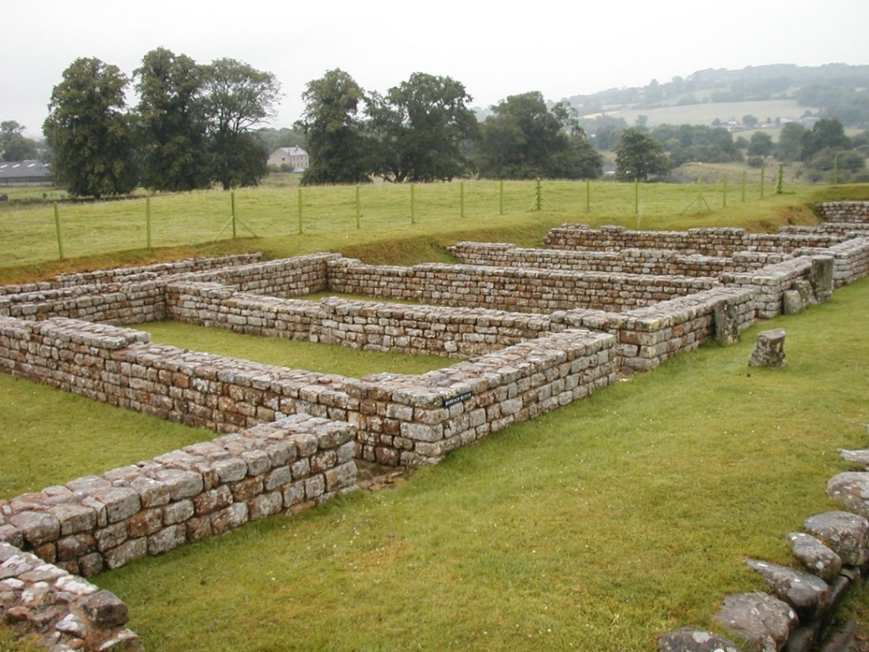

1. So, at the beginning of training, recruits must be taught the military step. For nothing needs to be preserved more on the march or in the battle line than that all soldiers keep in order as they march. This can only be achieved if they learn by constant practice to walk quickly and in step. For an army with broken lines or lacking formation always faces the most serious danger from the enemy… . Younger recruits must be accustomed above all to running, so that they can charge the enemy with greater momentum, and quickly seize advantageous positions, when this is needed, or seize them before the enemy if they want to do the same…

The recruit must be trained for jumping, by which ditches are jumped over or some high obstacle can be overcome, so that, whenever this sort of difficulty occurs, they can cross over without trouble …

Every recruit alike must learn how to swim in the summer months. For it is not always possible to cross rivers by a bridge: an army is often forced to swim both when retreating and when in pursuit. Rivers often tend to overflow because of sudden rain or snow falls, and an inability to swim brings danger not only from the enemy but also from the water itself …

Shields were made from branches in the manner of wicker-work baskets, made round and covered, so that the structure had double the weight than was customary for an ordinary shield. They gave the recruits wooden dummies of double weight instead of swords.

Vegetius, extracts from *Epitoma rei militaris* 1. 9-11 (with omissions)



…OPTIONIS AD SPEM

ORDINIS LVCILI

INGENVI QVI

NAVFRAGIO PERIT

S[ITVS] E[ST]

…of an optio, awaiting promotion to centurion, serving in the century of Lucilius Ingenuus, who died in a shipwreck. ......... he lies.

A space was left for H (HIC) in case the body lost in the shipwreck was found for burial, but the letter was never added.

*RIB 544*, Chester



### RVFVS SITA EQVES C[O]HO[RS] VI

T[H]RACVM ANN[ORVM] XL STIP XXII

HEREDES EX TEST[AMENTO] F[ACIENDVM] CVRAVE[RVNT]

## H[IC] S[ITVS] E[ST]

Here lies Rufus Sita, cavalryman in the sixth cohort of Thracians. He lived for 40 years and served for 22 years. His heirs had this set up, according to his will.

*RIB 121,* Gloucester

1. **Roman Roads**
2. *Map of Roman Britain*

**The map shows the outline of mainland Britain, with the modern borders of England Scotland and Wales. Above the lower third of Scotland, connecting the east and west coasts at the narrowest point, is a ridged or notched line labelled ‘Antonine Wall’. Soth of that, from the Scottish border area on the east coast horizontally across England to the west coast is another ridged line labelled Hadrian’s Wall. 
A line curves from the west of the Antonine Wall to the west of Hadrian’s Wall then extends south to the top of the Welsh border and on to the bottom of the Welsh border. Similarly a line curves south from the east of the Antonine Wall through the middle of Hadrian’s Wall and down the eastern side of England all the way to the south coast, connecting across England with several interconnecting lines that curve only gently, if at all. Some of these lines are labelled, with names such as Dere Street, Ermine Street, Watling Street, Fosse Way and Stane Street. 
At many of the intersections of these interconnecting lines in what is now modern England, and sometimes at points along their length, are round dots, which the map's Key labels 'civitas' or 'capitals'; small black squares are labelled as ‘coloniae, municipa, etc.'. A third category, of white squares is labelled ‘legionary fortresses’. There is also one white square in Scotland not far north of the Antonine Wall and a round dot in south-west Wales.

At the foot of the map is a scale showing from 0 to 150 km in increments of 50km and a fractionally longer scale showing from 0 to 100 miles in increments of 50 miles.**

1. **Roman Villas**
2. *Lockleys Villa*

**The picture shows two diagrams one above the other. The upper diagram is labelled ‘First Roman building, circa 65 AD’ and the lower diagram is labelled ‘Second Roman building, circa 150 AD’.

The First Roman building diagram shows a horizontal rectangle outlined and subdivided in thick black lines; within the rectangle are four subdivisions along its length from left to right. From the left, the first subdivision along the rectangle's length is the narrowest and is itself divided in half, one enclosed space above and a second below. The second subdivision along the rectangle's length is larger than the first, smaller than the third but about the same as the fourth. The third subdivision is the largest and is flanked by the second and fourth, both of equal size on either side.

A short distance beneath the rectangle, stretching from halfway along the length of the first subdivision as far as the right-hand side of the third, is an irregular or uneven line of nine very small square dots, roughly parallel to the rectangle's bottom edge.

The Second Roman building diagram shows the rectangle as above, but minus the row of small square dots and extended in outline with the same thick black lines. The first extension is an adjoining subdivision directly to the left of the original leftmost subdivision and fractionally wider. The top edge of the rectangle also extends or protrudes a little to the left past the end of this new subdivision. Parallel to that protrusion is a second short protrusion leftwards from halfway down the new leftmost side of the rectangle.

Directly below the new leftmost subdivision is an adjoining enclosed extension or subdivision about the same size as the largest subdivision of the original rectangle. Two short protrusions extend down from the bottom of this lower extension. Halfway up the right-hand side of this new lower extension is a very long horizontal protrusion of thick black line parallel to the original rectangle and extending a little past the rightmost end of it. This long protrusion of thick black line ends in, or is capped by, a short vertical protrusion above and below the line, so that the long space created between the original rectangle and the long protrusion is almost completely enclosed with a gap at the top-right corner.

As well as the extensions to the original rectangle described above are three new features, shaded differently to the thick black lines. According to the key, these are all labelled ‘Additions’. One addition is inside the new leftmost subdivision of the original rectangle. It appears as a thick line separating the internal upper third from the bottom two thirds of the new leftmost subdivision.

A second addition forms the bottom and right hand side of an enclosed square, enclosed by the new large bottom subdivision on the left hand side and by the long new horizontal thick black line at its top.

The third addition appears in what was the third and largest subdivision of the original rectangle and consists of a very small interior projection downwards from the upper side of that subdivision.**

1. *Winged-corridor villa*

**The picture is a diagram composed of rectangles drawn in thick black lines and is labelled ‘Winged-corridor villa’. A first long horizontal rectangle has five interior subdivisions of varying sizes along its length. Between the largest, leftmost subdivision and the second there is a gap halfway up the line dividing them. At either end of the ong horizontal rectangle a smaller rectangle hangs down from the bottom side. These two are also connected by a second long horizontal rectangle between them, whose upper edge is the bottom edge of the first, longest horizontal rectangle. This second, connecting horizontal rectangle extends only halfway down the rectangles at either end which it connects. 

Looking at the lower left-hand smaller rectangle, a small exterior rectangle to its own left connects it to a larger, exterior leftmost rectangle, fractionally larger than the largest subdivision in the original long horizontal rectangle. There is a gap in the line between this largest rectangle and the small connecting rectangle.**

1. *North Leigh Villa*

The picture is a diagram composed of rectangles drawn in thick black lines and is labelled ‘Courtyard villa’. 

A large irregular rhombus is enclosed or bordered on all four sides by long narrow rectangles with few dividing interior lines themselves and which are also connected to form an L-shape in the top left. Adjacent to these and surrounding on three sides (the left, the top and the right) is another, outer layer of larger, irregular-sized rectangles, with a great variety of subdivisions and interior and exterior protrusions.

On the bottom edge of the original rhombus, there is a narrow gap in the middle of the long narrow rectangle that forms its edge, with some very small protrusions into the interior of the rhombus. On the immediate left of this gap the edge rectangle has been subdivided into two very small squares with a third extending inwards into the rhombus.

To the left of and adjacent to the extended rhombus (i.e. the expanse of interconnected thick black lines) described above is an area about as tall and half as wide. This area contains a faint grid of vertical and horizontal dotted lines, which is much denser in its bottom third and mostly consists of only two widely spaced vertical dotted lines in its upper two thirds. Interrupted dotted lines appear to connect the faint grid to the extended rhombus of thick black lines.

1. **Bath (Aquae Sulis)**
2. In Britain are hot springs adorned with sumptuous splendour for the use of mortals. Minerva is patron goddess of these.

Solinus, *The Wonders of the World*

1. *The Great Bath*

**The picture is a photograph taken from overhead and at one end showing a rectangular expanse of greenish water bordered by a roofed colonnade. We can see much of  the left hand colonnade and part of the right hand colonnade and also the colonnade at the far end. In front of some of the columns, at their base, are square, blocky protrusions extending a very small way into the water. 

At the far end, the colonnade has square-sided columns at each corner with two rounded columns in between them. In the gaps between these columns at the far end can be seen three large shallowly-recessed closed arches. The leftmost arch and the rightmost arch also have shelves with lumps on stones on them. Between the water and the far wall containing the arches can be seen paving stones. These paving stones lie between and behind the columns.**

DEAE SVLI

L. MARCIVS MEMOR

HARVSP[EX]

D[ONVM] D[EDIT]

To the goddess Sulis. Lucius Marcius Memor haruspex (soothsayer) gave this gift.

*Burn 82,* Bath

**Extended Literature**

1. The climate is foul with frequent rains and mists, but there is no extreme cold. Their day is longer than in our part of the world. The night is bright and, in the furthest part of Britannia, so short that you can barely distinguish the evening from the morning twilight. If no clouds block the view, the sun’s glow, they say, can be seen all night long: it does not set and rise, but simply passes along the horizon. In fact, the flat ends of the earth cannot, with their low shadow, raise the darkness to any height; night therefore fails to reach the sky and its stars.

The soil is productive of crops, except for olives, grapes and other natives of warmer climes, and rich in cattle. Crops are slow to ripen, but quick to grow - both facts due to one and the same cause, the abundant moisture of land and sky. Britannia yields gold, silver and other metals, a reward for victory. The Ocean, too, produces pearls, but they are dusky and mottled. Some think that those who gather them lack skill. Whereas in the Red Seathey are torn alive and breathing from the rocks, in Britannia they are collected as the sea throws them up. I find more plausible a lack of quality in pearls than of greed in us.

The Britanni themselves readily submit to the levy, the tribute and the other obligations of empire, provided that there is no abuse. That they bitterly resent, for they have been broken in to obedience, not to slavery. Divus Julius, the first Roman to enter Britannia with an army, did indeed intimidate the natives by a victory and gained control of the coast, but he can be said to have pointed it out, not handed it over, to posterity. Then came the civil wars, with the weapons of Roman leaders turned against the commonwealth. But even in peace, Britannia was long out of mind. Divus Augustus called this ‘policy’, Tiberius ‘precedent’. Gaius Caesar unquestionably planned an invasion of Britannia, but his quick fancies shifted like a weathervane, and his vast efforts against Germania came to naught. It was Divus Claudius who was responsible for the great undertaking: he sent over legions and auxiliaries and chose Vespasian as his colleague _ the first step towards his future greatness. Nations were subdued, kings were captured and Vespasian was marked out by fate.

Aulus Plautius was the first consular to be appointed governor, and soon after him came Ostorius Scapula – both men with distinguished military records. The nearest parts of Britannia were gradually shaped into a province, and moreover a colony of veterans was founded.Certain states were presented to King Togidumnus,who maintained his unswerving loyalty down to our own times - an example of the long-established Roman custom of employing even kings to make others slaves. Didius Gallus, the next governor, held on to what his predecessors had won, and even pushed a few forts into more advanced positions, so that he could boast of having extended his sphere of duty. Veraniussucceeded Didius, only to die within the year. After him, Suetonius Paulinusenjoyed two years of success, conquering tribes and strengthening garrisons. Emboldened thereby to attack the island of Mona, on the grounds that it was feeding native resistance, he exposed himself to attack in the rear.

For the Britanni, freed from fear by the absence of the legate, began to discuss the woes of slavery, to compare their wrongs and sharpen their sting in the telling. ‘We gain nothing by submission except heavier burdens for shoulders shown to be willing. Once we had one king at a time, now two are clamped on us - the legate to wreak his fury on our lives, the procurator on our property. We subjects are damned in either case, whether our masters quarrel or agree. Their gangs, the centurions of the one and the slaves of the other, mingle violence and insult. Nothing now is safe from their greed, nothing safe from their lust. In battle it is the braver who takes the spoil; as things stand with us, it is mostly cowards and shirkers who rob our homes, kidnap our children and conscript our men, as though it were only for our country that we know not how to die. But what a mere handful our invaders are, if we Britanni reckon up our own numbers! The Germani, reckoning so, threw off the yoke, and they had only a river, not the Ocean, to shield them. We have country, wives and parents to fight for; the Romans have only greed and self-indulgence. They will withdraw, as Divus Julius withdrew, if only we can rival the valour of our fathers. We must not panic at the loss of a battle or two; success may foster a boldness in attack, but suffering gives power to endure. The gods themselves at last show mercy to us Britanni, by keeping the Roman general away and his army exiled in another island. For ourselves, we have already taken the most difficult step - we have begun to plan. And in undertakings like this it is more dangerous to be caught planning than to take the plunge.’

Goaded by such mutual encouragements, the whole island rose in arms under the command of Boudicca a woman of royal descent - for Britanni make no distinction of sex in the appointment of leaders. They hunted down the Roman troops in their scattered posts, stormed the forts and assaulted the colony itself, which they saw as the seat of their enslavement; nor did the angry victors deny themselves any of the savagery characteristic of barbarians. In fact, had not Paulinus, on heating of the revolt, hurriedly come to help, Britannia would have been lost. As it was, be restored it to its old obedience by a single successful action. But many rebels refused to lay down arms, conscious of their guilt and having a special dread of the legate. Fine officer though he was, they feared that he would abuse their surrender and punish with undue severity wrongs that he viewed as personal.

Petronius Turpilianus was thus sent out in his place, as someone more merciful and readier to forgive offences to which he was a stranger. He pacified the previous troubles, but risked no further move before handing over his province to Trebellius Maximus. Trebellius, a bit lazy and lacking military experience, maintained his province by an affable administration. The barbarians now learned like us to condone seductive vices, while the intervention of the civil wars gave a reasonable excuse for inactivity. There was, however, some serious trouble with mutiny, for the troops, accustomed to campaigns, ran riot in peace. Trebellius fled and hid to escape his angry army. Dishonoured and despised, he soon returned to command on sufferance; by a kind of tacit bargain the troops retained their licence, the general his life, and the mutiny stopped short of bloodshed. Vettius Bolanus, likewise, as the civil wars still ran their course, declined to disturb Britannia by enforcing discipline. There was the same lack of action in face of the foe, the same indiscipline in the camp – only Bolanus was a decent man, with no misdeeds to make him hated, and had won affection where he lacked authority.

Tacitus, *Agricola* 12–16

1. The size and the number of parts should be fitted to the villa as a whole, and should be divided into three parts, the landlord’s living quarters, the farmhouse, and the storehouse. The living quarters should in turn be divided into the winter and summer rooms in such a way that the winter bedrooms face the sunrise at the winter solstice, and the winter dining rooms face the sunset at the equinox. Again, the summer bedrooms should face south at the equinox, but the dining rooms of the same season should face the rising sun in the winter. The baths should face sunset in summer, so that they have the light in the afternoon up until evening. Walking areas should be exposed to the midday sun at the equinox, so that they get most sun in winter and least in summer. In the farmhouse will be placed a large, high kitchen, so that the rafters will not be in danger of fire, and so that the household of slaves can conveniently pass time there at every time of the year. For slaves who are not chained, sleeping quarters will be best built facing the midday sun at the equinox. For those who are chained, there will be an underground prison, as healthy as possible, lighted through narrow windows which are far enough above the ground that they cannot be reached by hands.

For cattle there should be cattle sheds that will not be attacked by cold or heat; for tamed animals there should be double stalls, for winter and summer; for the other animals, which need to be kept inside the villa, there should be places partly roofed, partly open to the sky, fenced round with high walls, so that they can rest without being attacked by wild beasts, in the covered areas in winter and in the open areas in summer. But the cattle sheds should be spacious and designed so that no water can flow in and so that water from the sheds will flow away as quickly as possible; this will prevent the foundations of the walls and the hooves of the cattle from rotting. The ox-stalls will need to be ten feet wide, or at least nine feet, a width which will give room for the animal to lie down and for the oxherd to move around the animals. The mangers will not be too high for an ox or a pack animal to be able to eat while standing without difficulty. The quarters for the foreman should be built next to the door, so that he can see who goes in and out, and quarters for the manager over the door for the same reasons. He however should keep a watch on the foreman from close at hand, and next to both of them should be the barn, into which all farm equipment can be collected, and inside the barn a locked room where iron implements can be stored.

For herdsmen and shepherds, rooms should be placed next to their herds and flocks, so that they can easily get out to look after them. However, they should all live as close to each other as possible, lest the diligence of the foreman, going around all the different places, be overstretched, and so that they might be witnesses of each other’s hard work or carelessness.

The storehouse is divided into rooms for oil, for presses, for wine, for boiling down must, hay lofts, chaff lofts, storerooms and granaries, so that those of them on the ground floor can accommodate liquid products for selling such as wine and oil, whilst dry products should be collected in lofts, such as grain, hay, leaves, chaff and other fodder. But granaries, as I have said, should be accessible by ladders and should be ventilated by small windows facing north. For that aspect is most cold and least wet, both of which help to preserve stored grain. The same principle applies on the ground floor to the placing of the wine room. This should be a long way from the baths, oven, manure and other dirty places which give off a foul smell, and equally from cisterns and springs, from which moisture is given off which spoils wine.

Columella, 1.6.1–11: extracts from *On Agriculture; The vil*

**B. Myths and Beliefs**

1. **Roman Gods**
2. Six couches were put out in public; one for Jupiter and Juno, another for Neptune and Minerva, a third for Mars and Venus, a fourth for Apollo and Diana, a fifth for Vulcan and Vesta, and the sixth for Mercury and Ceres.

Livy, *Ad Urbe Condita* 22.10.9

1. *Jupiter and Mercury visit an old couple, Baucis and Philemon.*

Jupiter once came here, disguised as a mortal, and with him

His son, the messenger Mercury, wand and wings set aside,

Looking for shelter and rest, they called at a thousand homesteads

A thousand doors were bolted against them. One house, however

Did make them welcome, a humble abode with a roof of straw

And marsh reed, one that knew its duty to gods and men.

Ovid *Metamorphoses* 8 626–631

1. *Gilt bronze head of Minerva*

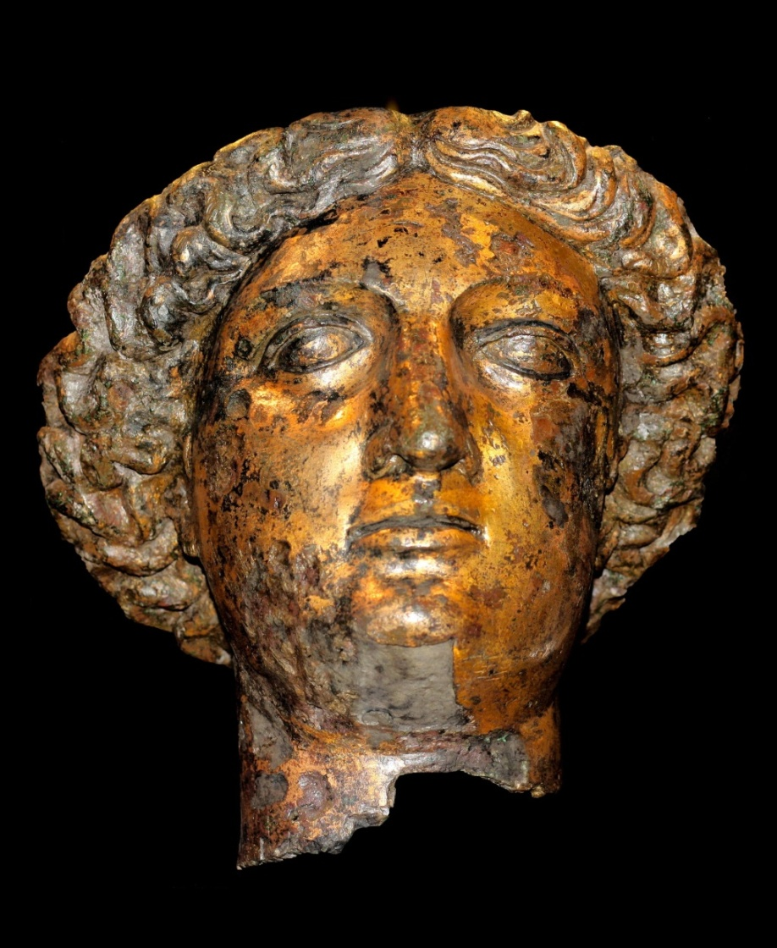

1. **State Religion**
2. *Temple of Jupiter, Pompeii*

**The picture is a photograph taken from the front and to the right of a large stone platform topped by the ruins of a row of six large fluted columns. In front of these columns five steps descend from the large platform to a smaller stone platform, which appears to have been faced in brick, much of it modern brick. At the bottom left of the picture we can see trimmed grass lawn in front of the brick.

The columns on the large platform are built of segments. Five segments remain of the leftmost column, three on the second column from left, probably two segments of the third column from left, three segments of the fourth column from left, four segments of the fourth column from left and twelve segments of the sixth and last column of this row. At the far right of the picture can be seen one segment of a column standing behind that sixth and tallest column. 

In the far background to the right can be seen an old stone building and the capitals of three other columns in the distance. To the left of the large stone platform at the front can be seen a tall archway with square outside corners, apparently built in brick, which reaches just higher than the third segment of the leftmost column on the platform. To the left of that archway, at the far left of the picture, can be seen an apparently modern structure with a flat white top above what is either a grating over a wall (showing sky beyond) or windows reflecting the scenery in front.**

1. *The Emperor Marcus Aurelius makes a sacrifice*

A carved stone relief featuring a crowd of people and a bull. Behind them are two columned buildings, one with a  triangular top that has a relief carved into it. The second building has statues of men and horses on its top.

The figures in the foreground are largely bearded men. At the very front of the relief two men stand, with a small pot supported by crossed wood in the shape of an 'x'. Behind the pot stands a child with long ringlets of hair, holding a box. To the right of the child, a bearded man, much shorter in height than the others, nearly the same height as the child plays a pipe. The final right-hand figure is a man with an uncovered chest wearing a cloth tied at his waist. There is an ax in his hand.

Behind the two shortest figures, there is a bull, its head visible above the figures.


1. **Beliefs in the afterlife**
2. *Tombs, Pompeii*

**A straight path with grass and structures lining each side. The path is sunken in relation to the structures.

The perspective is such that the structures on the left hand side are more clearly visible than on the right hand side. The First building on the left can only be slightly seen and is covered in frosted glass. There appears to be a column on the right hand corner underneath the glass. The second building is made of warm brown stone or brick. There is a column on the corner, behind which a curved arch is set into a wall. Inside the arch is another wall, with a white plaque set into the top of it, and below this a very small square white stone archway. The third features a similar setup, with a wider taller white stone archway, and pairs of columns and arches on each side of the archway rather than a single arch containing an entrance. The fourth structure appears to be a large square stone structure on a pedestal of the same stone. It is largely uniform in appearance, excepting some contrasting stone on the corners. The roof has grass growing from it. The next structures are identical in shape and both covered with glass. They resemble gateways - walls with shallow hipped roofs rising to points and entranceways. 

The area is surrounded by trees.
**

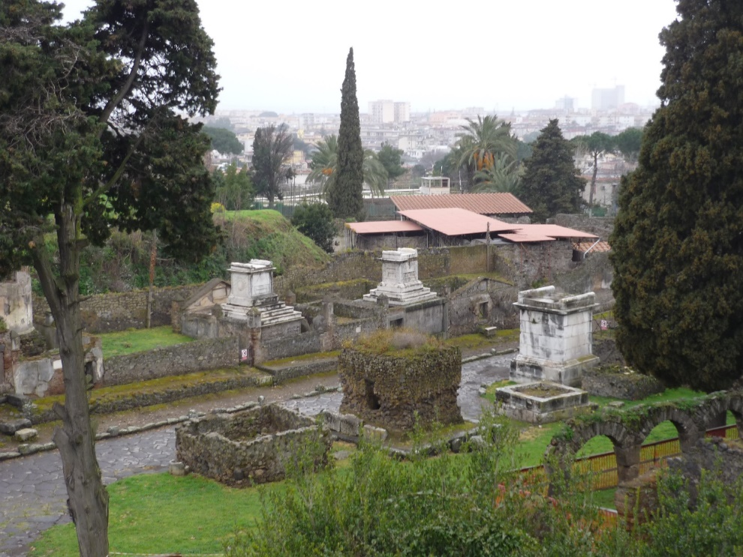

1. Honour is given to tombs as well. Placate the souls of your fathers and bring small gifts to the pyres after they have died down. The dead want only small gifts, piety pleases them more than a rich gift: the gods in the depths of the Styx are not greedy. A tile wreathed in garlands you offer is enough, along with sprinkled corn and a few grains of salt, and bread softened in wine and loose violets. Put these in the jar left in the middle of the road. I do not forbid larger gifts, but a ghost can be placated even by these. Add prayers and appropriate words at the hearths you have set up. This was the custom which Aeneas, fit source of piety, brought to your lands, righteous Latinus. He used to bring solemn gifts to the spirit of his father; from this the peoples learned the pious rites. But once upon time, while they waged long wars with fighting weapons, they abandoned the Parental Days. This did not go unpunished; for it is said that it was from that omen that Rome grew hot with the pyres of the dead outside the city. In fact I scarcely believe this: they say that our ancestors came out of their graves and uttered groans during the silent night, and they say that through the city streets and the wide fields howled ugly spirits, a ghostly crowd. After that, the honours they had neglected were given to the tombs, and the prodigies and funerals came to an end.

Ovid *Fasti* 2.533-570

cara meis vixi virgo vitam reddidi

mortva hic svm cinis is cinis terra [E]st

sin est terra dea ego svm dea mortva non svm

rogo te hospes noli ossa mea violare

mvs vixitannosxiii

I lived, dear to my parents. As a young girl I gave up my life. Here I am, dead. I am ash. The ash is earth. But if earth is a goddess, I am a goddess. I am not dead. I ask you, stranger, do not disturb my bones. Mus (= Mouse) lived 13 years.

*CIL 6. 35887*, Rome

1. **Aeneas, Romulus and Remus**
2. Yet destiny wouldn’t allow Troy’s hopes to be overturned

Along with her walls. Aeneas, the hero whose mother was Venus,

Rescued his household gods and through the flames on his shoulders

He carried a burden as sacred, his venerable father Anchises.

These with his own dear son Ascanius formed the spoil

Which Aeneas the dutiful chose to salvage from all his possessions

Fleeing across the sea with his people in ships…

Ovid, *Metamorphoses* 13 623–628

1. *Aeneas escapes from Troy (as depicted by Bernini, the early 1600s AD)*

*A statue of carved stone featuring three figures. 
A man stands, right foot forward carrying another man atop his right shoulder. At his foot there is a toddler, left foot forward carrying a torch in his right hand. The man being carried has a long beard and curly hair, which he wears covered with a wrapped cloth, his skin is wrinkled and his eyes are wide.. He is seated on the man's shoulder and holds a statuette of a seated woman above the head of his carrier.
The man carrying the second man holds him on his right shoulder, and has his arms wrapped around the right thigh of his burden. He has curly hair and a short beard.
The toddler stands tucked slightly behind both men. He has curly hair and is nude.
The two adult men are also nude, except for cloth covering their respective groins.
*

1. *A she-wolf looks after Romulus and Remus*

A photograph of a metal statue on a stone pedestal.
The statue is of a female wolf, with two infants sat below her torso, one kneeling and the other seated.
The wolf stands facing to the left, with her head tilted toward the viewer. Her ribs are visible, and her tail is tilted down, almost completely obscured by the hind legs.
The infants are reaching up to suckle at the teats on the underside of the wolf. 

1. They walked in the darkness of that lonely night with shadows all about them, through the empty halls of Dis and his desolate kingdom, as men walk in a wood by the sinister light of a fitful moon when Jupiter has buried the sky in shade and black night has robbed all things of their colour. Before the entrance hall of Orcus, in the very throat of hell, Grief and Revenge have made their beds and Old Age lives there in despair, with white faced Diseases and Fear and Hunger, corrupter of men, and squalid Poverty, things dreadful to look upon, and Death and Drudgery besides.

…

Here too are all manner of monstrous beasts, Centaurs stabling inside the gate, Scyllas- half dogs, half women - Briareus with his hundred heads, the Hydra of Lerna hissing fiercely, the Chimaera armed in fire, Gorgons and Harpies and the triple phantom of Geryon. Now Aeneas drew his sword in sudden alarm to meet them with naked steel as they came at him, and if his wise companion had not warned him that this was the fluttering of disembodied spirits, a mere semblance of living substance, he would have rushed upon them and parted empty shadows with steel.

Here begins the road that leads to the rolling waters of Acheron, the river of Tartarus. Here is a vast quagmire of boiling whirlpools which belches sand and slime into Cocytus, and these are the rivers and waters guarded by the terrible Charon in his filthy rags. On his chin there grows a thick grey beard, never trimmed. His glaring eyes are lit with fire and a foul cloak hangs from a knot at his shoulder. With his own hands he plies the pole and sees to the sails as he ferries the dead in a boat the colour of burnt iron. He is no longer young but, being a god, enjoys rude strength and a green old age. The whole throng of the dead was rushing to this part of the bank, mothers, men, great-hearted heroes whose lives were ended, boys, unmarried girls and young men laid on the pyre before the faces of their parents, as many as are the leaves that fall in the forest at the first chill of autumn, as many as the birds that flock to land from deep ocean when the cold season of the year drives them over the sea to lands bathed in sun. There they stood begging to be allowed to be the first to cross and stretching out their arms in longing for the further shore. But the grim boatman takes some here and some there, and others he pushes away far back from the sandy shore.

…

‘The throng you see on this side are the helpless souls of the unburied. The ferryman there is Charon. Those sailing the waters of the Styx have all been buried. No man may be ferried from fearful bank to fearful bank of this roaring current until his bones are laid to rest. Instead they wander for a hundred years, fluttering round these shores until they are at last allowed to return to the pools they have so longed for.’

*Aeneas and the Sibyl sail across the river Styx to the bank opposite*

The kingdom on this side resounded with barking from the three throats of the huge monster Cerberus lying in a cave in front of them. When the priestess was close enough to see the snakes writhing on his neck, she threw him a honey cake steeped in soporific drugs. He opened his three jaws, each of them rabid with hunger, and snapped it up where it fell. The massive back relaxed and he sprawled full length on the ground, filling his cave. The sentry now sunk in sleep, Aeneas leapt to take command of the entrance and was soon free of the bank of that river which no man may recross…

*Aeneas has met his companion Deiphobus in the underworld*

The Sibyl gave her warning in few words: ‘Night is running quickly by, Aeneas, and we waste the hours in weeping. This is where the way divides. On the right it leads up to the walls of great Dis. This is the road we take for Elysium. On the left is the road of punishment for evil-doers, leading to Tartarus, the place of the damned.’

‘There is no need for anger, great priestess,’ replied Deiphobus. ‘I shall go to take my place among the dead and return to darkness. Go, Aeneas, go, great glory of our Troy, and enjoy a better fate than mine.’ These were his only words, and as he spoke he turned on his heel and strode away.

Aeneas looked back suddenly and saw under a cliff on his left a broad city encircled by a triple wall and washed all round by Phlegethon, one of the rivers of Tartarus, a torrent of fire and flame, rolling and grinding great boulders in its current. There before him stood a huge gate with columns of solid adamant so strong that neither the violence of men nor of the heavenly gods themselves could ever uproot them in war, and an iron tower rose into the air where Tisiphone sat with her blood-soaked dress girt up, guarding the entrance and never sleeping, night or day. They could hear the groans from the city, the cruel crack of the lash, the dragging and clanking of iron chains.

…

They entered the land of joy, the lovely glades of the fortunate woods and the home of the blest. Here a broader sky clothes the plains in glowing light, and the spirits have their own sun and their own stars. Some take exercise on grassy wrestling-grounds and hold athletic contests and wrestling bouts on the golden sand. Others pound the earth with dancing feet and sing their songs while Orpheus, the priest of Thrace, accompanies their measures on his seven-stringed lyre, plucking the notes sometimes with his fingers, sometimes with his ivory plectrum.

…

Father Anchises was deep in a green valley, walking among the souls who were enclosed there and eagerly surveying them as they waited to rise into the upper light. It so happened that at that moment he was counting the number of his people, reviewing his dear descendants, their fates and their fortunes, their characters and their courage in war. When he saw Aeneas coming towards him over the grass, he stretched out both hands in eager welcome, with the tears streaming down his cheeks, and these were the words that broke from his mouth: ‘You have come at last,’ he cried. ‘I knew your devotion would prevail over all the rigour of the journey and bring you to your father.

…

And now Aeneas saw in a side valley a secluded grove with copses of rustling trees where the river Lethe glided along past peaceful dwelling houses. Around it fluttered numberless races and tribes of men, like bees in a meadow on a clear summer day, settling on all the many-coloured flowers and crowding round the gleaming white lilies while the whole plain is loud with their buzzing. Not understanding what he saw, Aeneas shuddered at the sudden sight of them and asked why this was, what was that river in the distance and who were all those companies of men crowding its banks.

‘These are the souls to whom Fate owes a second body,’ replied Anchises. ‘They come to the waves of the river Lethe and drink the waters of serenity and draughts of long oblivion. I have long been eager to tell you who they are, to show them to you face to face and count the generations of my people to you so that you could rejoice the more with me …

Extracts from Virgil, *Aeneid,* 6.268f

1. They began to build a settlement, which Aeneas named Lavinium after his wife Lavinia. A child was soon born of the marriage: a boy, who was given the name Ascanius.

The Trojans and the Latins were soon jointly involved in war. Turnus, prince of the Rutuli, to whom Latinus’s daughter Lavinia had been pledged before Aeneas’s arrival, angered by the insult of having to step down in favour of a stranger, attacked the combined forces of Aeneas and Latinus. Both sides suffered in the subsequent struggle: the Rutuli were defeated, but the victors lost their leader Latinus. Turnus and his people, in their anxiety for the future, then looked for help to Mezentius, king of the rich and powerful Etruscans, whose seat of government was at Caere, at that time a wealthy town. Mezentius needed little persuasion to join the Rutuli, as from the outset he had been far from pleased by the rise of the new settlement, and now felt that the Trojan power was growing much more rapidly than was safe for its neighbours.

In this dangerous situation Aeneas conferred the native name of Latins upon his own people; the sharing of a common name as well as a common polity would, he felt, strengthen the bond between the two peoples. As a result of this step the original settlers were no less loyal to their king Aeneas than were the Trojans themselves. Trojans and Latins were rapidly becoming one people, and this gave Aeneas confidence to make an active move against the Etruscans, in spite of their great strength. Etruria, indeed, had at this time both by sea and land filled the whole length of Italy from the Alps to the Sicilian strait with the noise of her name; none the less Aeneas refused to act on the defensive and marched out to meet the enemy. The Latins were victorious, and for Aeneas the battle was the last of his labours in this world. He lies buried on the river Numicus. Was he man or god? However it be, men call him Jupiter Indiges - the local Jove.

Aeneas’s son Ascanius was still too young for a position of authority; Lavinia, however, was a woman of great character, and acted as regent until Ascanius came of age and was able to assume power as the successor of his father and grandfather. There is some doubt - and no one can pretend to certainty on something so deeply buried in the mists of time - about who precisely this Ascanius was. Was it the one I have been discussing, or was it an elder brother, the son of Creusa, who was born before the sack of Troy and was with Aeneas in his escape from the burning city - the Iulus, in fact, whom the Julian family claim as their eponym? It is at any rate certain that Aeneas was his father, and whatever the answer to the other question may be - it can be taken as a fact that he left Lavinium to found a new settlement. Lavinium was by then a populous and, for those days, a rich and flourishing town, and Ascanius left it in charge of his mother (or stepmother, if you will) and went off to found his new settlement on the Alban hills.

This town, strung out as it was along a ridge, was named Alba Longa. Its foundation took place about thirty years after that of Lavinium but the Latins had already grown so strong, especially since the defeat of the Etruscans, that neither Mezentius, the Etruscan king, nor any other neighbouring people dared to attack them, even when Aeneas died and the control of things passed temporarily into the hands of a woman, and Ascanius was still a child learning the elements of kingship. By the terms of the treaty between the Latins and Etruscans the river Albula (now the Tiber) became the boundary between the two territories.

*Livy lists Ascanius’ descendants until he reaches Proca.*

Proca, the next king, had two sons, Numitor and Amulius, to the elder of whom, Numitor, he left the hereditary realm of the Silvian family; that, at least, was his intention, but respect for seniority was flouted, the father’s will ignored and Amulius drove out his brother and seized the throne. One act of violence led to another; he proceeded to murder his brother’s male children, and made his niece, Rhea Silvia, a Vestal, ostensibly to do her honour, but actually by condemning her to perpetual virginity to exclude the possibility of issue. But (I must believe) it was already written in the book of fate that this great city of ours should arise, and the first steps be taken to the founding of the mightiest empire the world has known - next to God’s. The Vestal Virgin ... gave birth to twin boys. Mars, she declared, was their father - perhaps she believed it, perhaps she was merely hoping by the pretence to alleviate her guilt. Whatever the truth of the matter, neither gods nor men could save her or her babes from the savage hands of the king.

The mother was bound and flung into prison; the boys, by the king’s order, were condemned to be drowned in the river. Destiny, however, intervened; the Tiber had overflowed its banks; because of the flooded ground it was impossible to get to the actual river, and the men entrusted to do the deed thought that the flood-water, sluggish though it was, would serve their purpose. Accordingly they made shift to carry out the king’s orders by leaving the infants on the edge of the first flood-water they came to, at the spot where now stands the Ruminal fig-tree - said to have once been known as the fig-tree of Romulus. In those days the country thereabouts was all wild and uncultivated, and the story goes that when the basket in which the infants had been exposed was left high and dry by the receding water, a she-wolf, coming down from the neighbouring hills to quench her thirst, heard the children crying and made her way to where they were. She offered them her teats to suck and treated them with such gentleness that Faustulus, the king’s herdsman, found her licking them with her tongue. Faustulus took them to his hut and gave them to his wife Larentia to nurse. …

By the time they were grown boys, they employed themselves actively on the farm and with the flocks and began to go hunting in the woods; their strength grew with their resolution, until not content only with the chase they took to attacking robbers and sharing their stolen goods with their friends the shepherds. … Brigands, incensed at the loss of their ill-gotten gains, laid a trap for Romulus and Remus. Romulus successfully defended himself, but Remus was caught and handed over to Amulius. The brigands laid a complaint against their prisoner, the main charge being that he and his brother were in the habit of raiding Numitor’s land with an organized gang of ruffians and stealing the cattle. Thereupon Remus was handed over for punishment to Numitor. Now Faustulus had suspected all along that the boys he was bringing up were of royal blood. He knew that two infants had been exposed b ythe king’s orders, and the rescue of his own two fitted perfectly in point of time. Hitherto, however, he had been unwilling to declare what he knew, until either a suitable opportunity occurred or circumstances compelled him. Now the truth could no longer be concealed, so in his alarm he told Romulus the whole story; Numitor, too, when he had Remus in custody and was told that the brothers were twins, was set thinking about his grandsons; the young men’s age and character, so different from the lowly born, confirmed his suspicions; and further inquiries led him to the same conclusion, until he was on the point of acknowledging Remus. The net was closing in, and Romulus acted. He was not strong enough for open hostilities, so he instructed a number of the herdsmen to meet at the king’s house by different routes at a preordained time; this was done, and with the help of Remus, at the head of another body of men, the king was surprised and killed.

Before the first blows were struck, Numitor gave it out that an enemy had broken into the town and attacked the palace; he then drew off all the men of military age to garrison the inner fortress, and, as soon as he saw Romulus and Remus, their purpose accomplished, coming to congratulate him, be summoned a meeting of the people and laid the facts before it: Amulius’ crime against himself, the birth of his grandsons, and the circumstances attending it, how they were brought up and ultimately recognized, and, finally, the murder of the king for which he himself assumed responsibility. The two brothers marched through the crowd at the head of their men and saluted their grandfather asking, and by a shout of unanimous consent his royal title was confirmed. Romulus and Remus, after the control of Alba had passed to Numitor in the way I have described, were suddenly seized by an urge to found a new settlement on the spot where they had been left to drown as infants and had been subsequently brought up.

There was, in point of fact, already an excess of population at Alba, what with the Albans themselves, the Latins, and the addition of the herdsmen: enough, indeed, to justify the hope that Alba and Lavinium would one day be small places compared with the proposed new settlement. Unhappily the brothers’ plans for the future were marred by the same source which had divided their grandfather and Amulius - jealousy and ambition. A disgraceful quarrel arose from a matter in itself trivial. As the brothers were twins and all question of seniority was thereby precluded, they determined to ask the tutelary gods of the countryside to declare by augury which of them should govern the new town once it was founded, and give his name to it. For Palatine hill and Remus the Aventine as their respective stations from which to observe the auspices. Remus, the story goes, was the first to receive a sign - six vultures; and no sooner was this made known to the people than double the number of birds appeared to Romulus. The followers of each promptly saluted their master as king, one side basing its claim upon priority, the other upon number. Angry words ensued, followed all too soon by blows, and in the course of the affray Remus

was killed. …

This, then, was how Romulus obtained the sole power. The newly built city was called by its founder’s name.

Extracts from Livy, *History of Rome,* 1.4–6

**BLANK PAGE**

**BLANK PAGE**

**BLANK PAGE**

Copyright Information:

Adapted from Vegetius, Epitoma rei militaris 1. 9-11 (with omissions).

Adapted from Tacitus, Agricola, 12-16, in H. Mattingly (trans), Tacitus: The Agricola and Germania, pp. 8-13, Penguin Classics, London, 2010.

Columella, On Agriculture 1.6.1-11

B.1.ii: Image of Colosseum, Rome © SkyF. Image supplied by iStock, [www.istockphoto.com](http://www.istockphoto.com)

Juvenal, Satires, 6.103.113.

B.2.i: Image of Large Theatre, Pompeii © LuisPortugal. Image supplied by iStock, [www.istockphoto.com](http://www.istockphoto.com)

Extract from Ecce Romani 4: Tales and Plays, by the Scottish Classics Group, pg 36. Oliver and Boyd, Edinburgh, 1972.

B.3.i: Depiction of the Circus Maximus © DEA PICTURE LIBRARY. Image supplied by Getty, [www.getty.co.uk](http://www.getty.co.uk)

B.3.ii: Image of charioteer, Ostia © SHEILA TERRY. Image supplied by Science Photo Library, [www.sciencephoto.com](http://www.sciencephoto.com)

Adapted from Petronius, Satyricon, 59-63, in J. Sullivan (trans), The Satyricon and Apocolocyntosis,Penguin Classics, London, 2005.

Extract from Ovid, Metamorphosis, 8 626-631, in David Raeburn (trans), Ovid: Metamorphosis, p. 324, Penguin Classics, London, 2004.

C.1.iii: Image of Head of Minerva, Bath © World History Archive. Image supplied by Alamy, [www.alamy.com](http://www.alamy.com)

C.2.ii: The Emperor Marcus Aurelius makes a sacrifice, image by Jean-Pol GRANDMONT / Wikimedia Commons. Reproduced under the terms of the Creative Commons Attribution - Share Alike 3.0 Unported Licence, [www.creativecommons.org](http://www.creativecommons.org)

Ovid, Fasti 2.533-570

Extract from Ovid, Metamorphosis,13 623-628, in David Raeburn (trans), Ovid: Metamorphosis, pp.627-628, Penguin Classics, London, 2004.

C.4.ii: Aeneas escapes from Troy, © The Art Archive. Image supplied by Alamy, [www.alamy.com](http://www.alamy.com)

C.4.iii: A she-wolf looks after Romulus and Remus,© Oleg Senkov. Image supplied by Shutterstock, [www.shutterstock.com](http://www.shutterstock.com)

Adapted from Virgil, Aenied, 6. 268-, in David West (trans), Virgil: The Aenied - A New Prose Translation, pp. 140-155, Penguin Classics, London, 1991.

Adapted from Livy, Early History of Rome, 1.-6, in Aubrey De Selincourt (trans), Livy: The Early History of Rome, pp. 36-40, Penguin Classics, London, 2002.

OCR is committed to seeking permission to reproduce all third-party content that it uses in the assessment materials. OCR has attempted to identify and contact all copyright holders whose work is used in this paper. To avoid the issue of disclosure of answer-related information to candidates, all copyright acknowledgements are reproduced in the OCR Copyright Acknowledgements booklet. This is produced for each series of examinations and is freely available to download from our public website (www.ocr.org.uk) after the live examination series.

If OCR has unwittingly failed to correctly acknowledge or clear any third-party content in this assessment material, OCR will be happy to correct its mistake at the earliest possible opportunity.

For queries or further information please contact the Copyright Team, First Floor, 9 Hills Road, Cambridge CB2 1GE.

OCR is part of the Cambridge Assessment Group; Cambridge Assessment is the brand name of University of Cambridge Local Examinations Syndicate (UCLES), which is itself a department of the University of Cambridge.