Task 2 – Drawing a triangle

**Step 1: Import your turtle and create the base of your triangle**

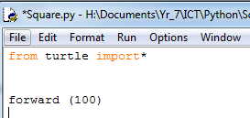 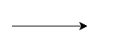

**Step 3: Turn the turtle left**

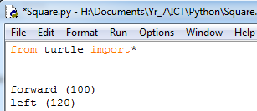 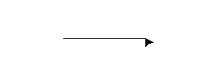

**Step 4: Move the turtle forward**

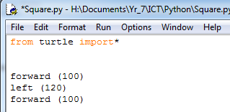 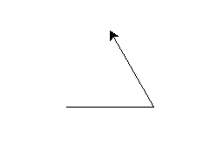

**Step 5: Turn the turtle left**

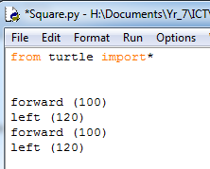 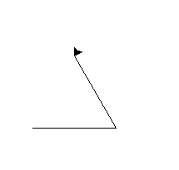

**Step 6: Move the turtle forward to complete the triangle**

