A Level Media Studies Handbook

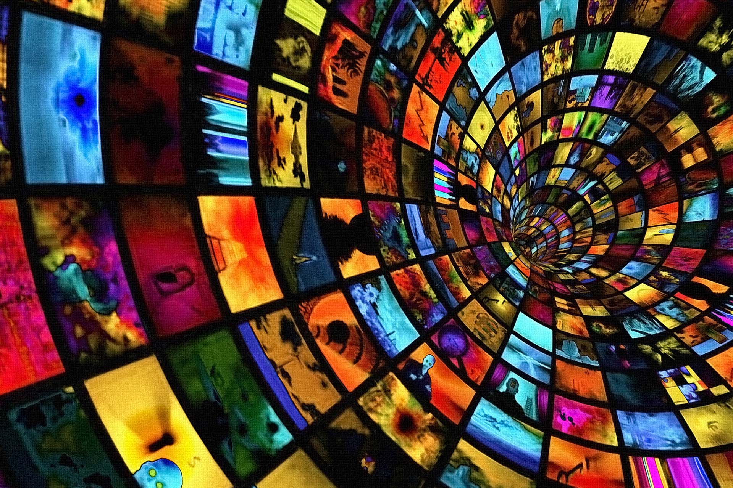

Introduction and Expectations
Welcome to A-level media studies. This handbook has been produced to help you navigate the course and understand the expectations we have of you as students.
By the end of the two years of study, we hope that you will have become students who have perfected the art of questioning things that other people accept as truth. We want you to be able to deconstruct the relationship between the media and our understanding of the world. We hope that you will enjoy studying the course as much as we enjoy teaching this subject.

We expect
- That you will bring this handbook to every lesson
- That you will arrive to lessons on time
- That you will organise your time effectively and meet the deadlines set
- That you will participate fully in every lesson
- That you will contribute your own expertise to the classroom
- That you will come fully equipped to each lesson
- That you will inform us if you have to miss a lesson and make up the work
- That you will make every effort to attend every lesson

It is important during your time in the sixth form that you develop independent study skills. We expect you to undertake four hours minimum of independent study a week, as well as assignments and homework set by your teachers, which should take approximately 1 hour per teacher, although this might vary.

Here are some ideas for independent study:
- Revise the theories and create flashcards
- Learn and use new subject terminology from the glossary
- Visit the websites recommended at the end of the handbook
- Borrow the recommended books from the library and take notes.
- Add annotations to the set texts
- Investigate the set texts independently – read the fact sheets!
- Listen to ‘The Digital Human’ podcasts by Aleks Krotoski
- Listen to ‘The Media Show’ podcasts from Radio 4
- Visit https://media-studies.com for some useful resources
- Organise your folders and prepare for the next lesson carefully
- Take photographs that could be used in creative work
- Take footage that could be used in creative work
- Download iMovie or similar and learn how to use it
- Explore online image editing programs such as Pixlr and Photopea and learn how to use them
- Listen to the news regularly

Course Outline

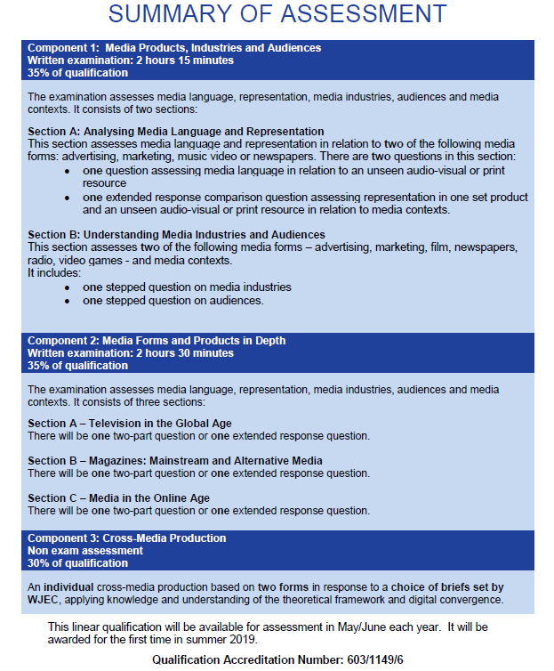
Component 1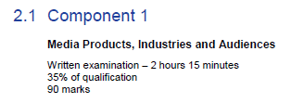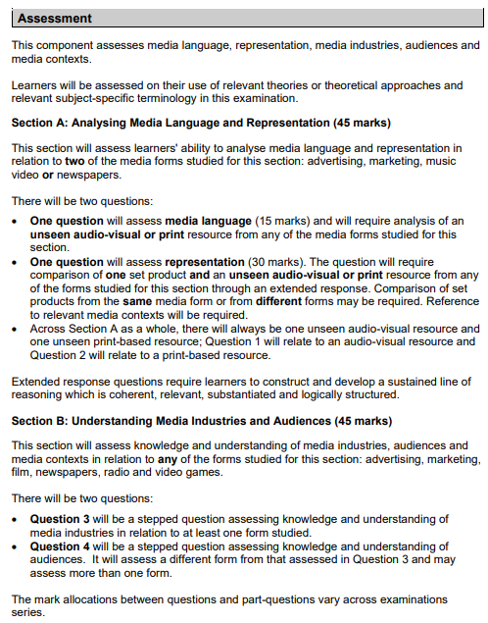
Section A: Media Language and Representation

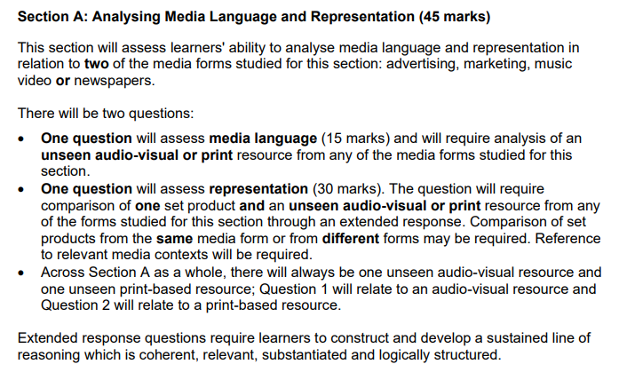

THEORIES LINKED TO MEDIA LANGUAGE | THEORIES LINKED TO REPRESENTATION | THEORIES LINKED TO INDUSTRY | THEORIES LINKED TO AUDIENCE
Structuralism (Levi-Strauss) | Theories of identity (Gauntlett) ADVERTISING AND MUSIC VIDEO ONLY | Regulation (including Livingstone and Lunt) | Cultivation theory (including Gerbner)
Narratology (including Todorov) | Theories of Representation (including Hall) | Cultural Industries (including Hesmondhalgh) | Media Effects (including Bandura)
Genre Theory (including Neale) | Theories of Gender Performativity (including Butler) | Power and media industries (including Curran and Seaton) | Fandom (including Jenkins)
Postmodernism (including Baudrillard) | Theories around ethnicity and postcolonial theory (including Gilroy) ADVERTISING AND MUSIC VIDEO ONLY |  | End of Audience Theory (including Shirky)
Semiotics (Barthes) | Feminist Theories (including bell hooks and Van Zoonen) ADVERTISING AND MUSIC VIDEO ONLY |  | Reception Theory (including Hall)
MEDIA STUDIES FRAMEWORK – Areas of study
COM 1 SECTION A: ADVERTISING, MUSIC VIDEO, NEWSPAPERS

MEDIA LANGUAGE | MEDIA REPRESENTATION | MEDIA INDUSTRIES | MEDIA AUDIENCES
How the different modes and language associated with different media forms communicate multiple meanings | The way events, issues, individuals (including self-representation) and social groups (including social identity) are represented through processes of selection and combination | Processes of production, distribution and circulation by organisations, groups and individuals in a global context | How audiences are grouped and categorised by media industries, including by age, gender and social class, as well as by lifestyle and taste
How the combination of elements of media language influence meaning | The way the media, through re-presentation, construct versions of reality | The specialised and institutionalised nature of media production, distribution and circulation | How media producers target, attract, reach, address and potentially construct audiences
How developing technologies affect media language | The processes which lead media producers to make choices about how to represent events, issues, individuals and social groups | The relationship of recent technological change and media production, distribution and circulation | How media industries target audiences through the content and appeal of media products and through the ways in which they are marketed, distributed and circulated
The codes and conventions of media forms and products, including. the processes through which media language develops as a genre | The effect of social and cultural context on representations | The significance of patterns of ownership and control, including conglomerate ownership, vertical integration and diversification | The interrelationship between media technologies and patterns of consumption and response
The dynamic and historically relative nature of genre | How and why stereotypes can be used positively and negatively | The significance of economic factors, including commercial and not-for-profit public funding, to media industries and their products | How audiences interpret the media, including how they may interpret the same media in different ways
The processes through which meanings are established through intertextuality | How and why particular social groups, in a national and global context, may be under-represented or misrepresented | How media organisations maintain, including through marketing, varieties of audiences nationally and globally | How audiences interact with the media and can be actively involved in media production
MEDIA STUDIES FRAMEWORK – Areas of study
COM 1 SECTION A: ADVERTISING, MUSIC VIDEO, NEWSPAPERS

MEDIA LANGUAGE | MEDIA REPRESENTATION | MEDIA INDUSTRIES | MEDIA AUDIENCES
How audiences respond to and interpret the above aspects of media language | How media representations convey values, attitudes and beliefs about the world and how these may be systematically reinforced across a wide range of media representations | The regulatory impact of contemporary media in the UK | How specialised audiences can be reached, both on a national and global scale, through different media technologies and platforms
How genre conventions are socially and historically relative, dynamic and can be used in a hybrid way | How audiences respond to and interpret media representations | The impact of ‘new’ digital technologies on media regulation, including the role of individual producers | How media organisations reflect the different needs of mass and specialised audiences, including through targeting
The significance of challenging and/or subverting genre conventions | The way in which representations make claims about realism NEWSPAPERS ONLY | How processes of production, distribution and circulation shape media products | How audiences use media in different ways, reflecting demographic factors as well as aspects of identity and cultural capital
The significance of the varieties of ways intertextuality can be used in the media | The impact of industry contexts on the choices media producers make about how to represent events, issues, individuals and social groups NEWSPAPERS ONLY | The impact of digitally convergent platforms on media production, distribution and circulation, including individual producers | The role and significance of specialised audiences, including niche and fan, to the media
The way media language incorporates viewpoints and ideologies | The effect of historical context on representations ADVERTISING AND MUSIC VIDEO ONLY | The role of regulation in global production, distribution and circulation | The way in which different audience interpretations reflect social, cultural and historical circumstances
 | How representations may invoke discourses and ideologies and position audiences | The effect of individual producers on media industries
 | How audience responses to and interpretations of media representations reflect social, cultural and historical circumstances

Section A: Media Language and Representation
‘Tide’: Print advert (1950s)

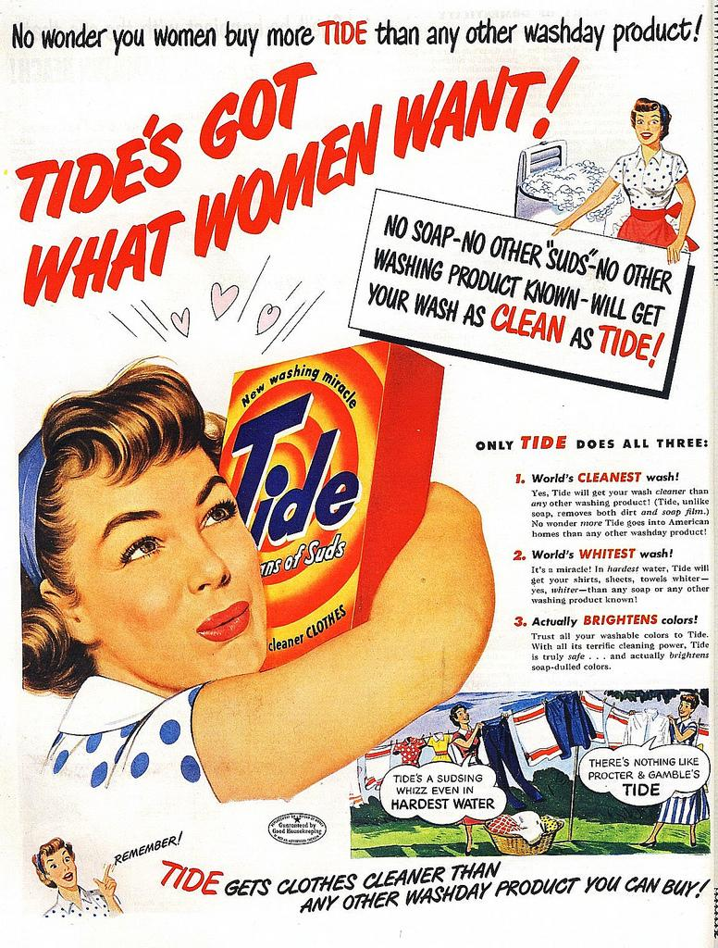
Theories for Tide (advertising and marketing)
Media Language:
- Semiotics (Barthes)
- Structuralism (Levi-Strauss)

Representation:
- Representation Theories (Hall)
- Identity (Gauntlett)
- Feminist Theories (Van Zoonen, bell hooks)
- Theories of Ethnicity and Post-Colonialism (Gilroy)

Section A: Media Language and Representation
‘Super. Human’: Tokyo 2020 Paralympic Games audio-visual advert (2020)



Theories for Super. Human. (advertising and marketing)
Media Language:
- Semiotics (Barthes)
- Structuralism (Levi-Strauss)

Representation:
- Representation Theories (Hall)
- Identity (Gauntlett)
- Feminist Theories (Van Zoonen, bell hooks)
- Theories of Ethnicity and Post-Colonialism (Gilroy)

Section A: Media Language and Representation
‘Kiss of the Vampire’: Film poster (1963)

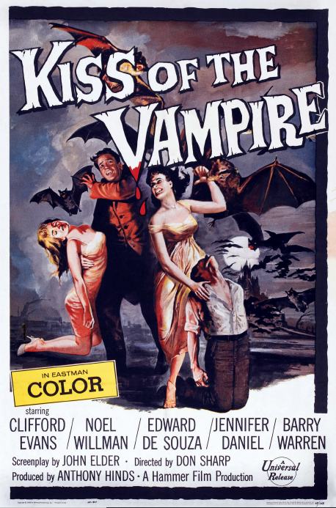
Theories for Tide (advertising)
Theories for Kiss of the Vampire (advertising and marketing)
Media Language:
- Semiotics (Barthes)
- Structuralism (Levi-Strauss)

Representation:
- Representation Theories (Hall)
- Identity (Gauntlett)
- Feminist Theories (Van Zoonen, bell hooks)
- Theories of Ethnicity and Post-Colonialism (Gilroy)

Section A: Media Language and Representation
‘Turntables’: Janelle Monae music video (2020)

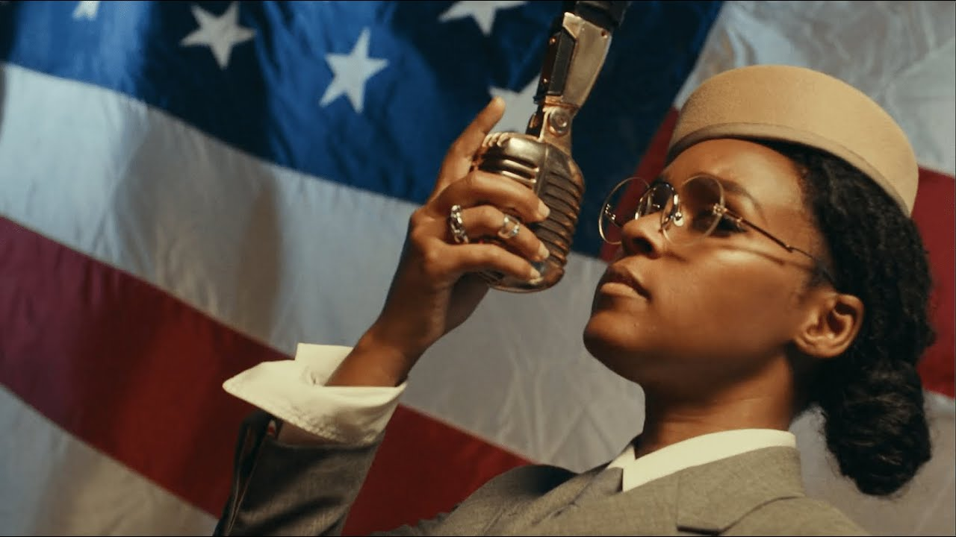

Theories for Turntables (music video)
Media Language:
- Semiotics (Barthes)
- Structuralism (Levi-Strauss)

Representation:
- Representation Theories (Hall)
- Identity (Gauntlett)
- Feminist Theories (Van Zoonen, bell hooks)
- Theories of Ethnicity and Post-Colonialism (Gilroy)

Section A: Media Language and Representation
‘Seventeen Going Under’: Sam Fender music video (2021)



Theories for Seventeen Going Under (music video)
Media Language:
- Semiotics (Barthes)
- Structuralism (Levi-Strauss)

Representation:
- Representation Theories (Hall)
- Identity (Gauntlett)
- Feminist Theories (Van Zoonen, bell hooks)
- Theories of Ethnicity and Post-Colonialism (Gilroy)

Section A: Media Language and Representation
‘Zero Shame’: Daily Mirror front page and article February 1st 2022
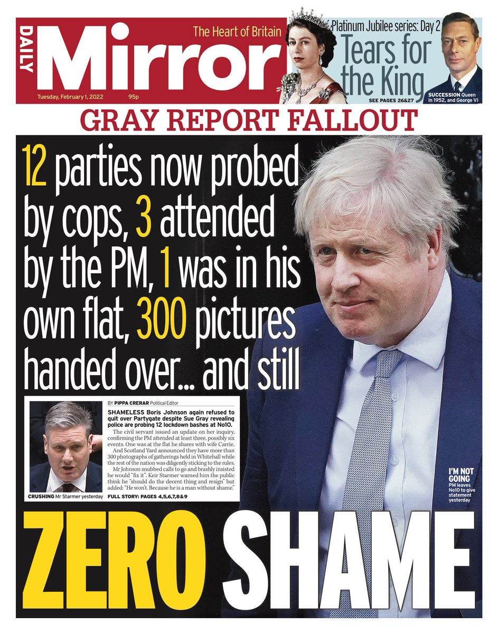

Theories for Daily Mirror Partygate Front Page (newspapers)
Media Language:
- Semiotics (Barthes)
- Structuralism (Levi-Strauss)

Representation:
- Representation Theories (Hall)

Section A: Media Language and Representation
‘Zero Shame’: Daily Mirror front page and article February 1st 2022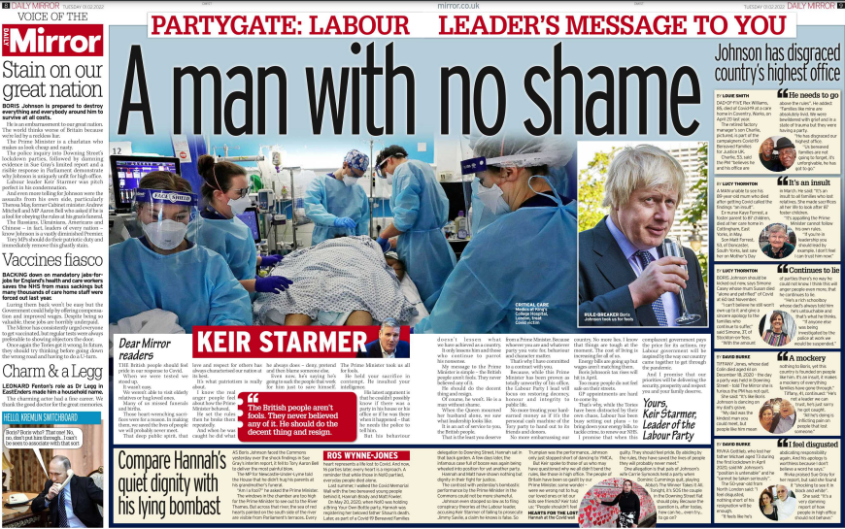
Theories for Daily Mirror Partygate DPS (newspapers)
Media Language:
- Semiotics (Barthes)
- Structuralism (Levi-Strauss)

Representation:
- Representation Theories (Hall)

Section A: Media Language and Representation
‘Police investigate…’: The Times front page February 1st 2022
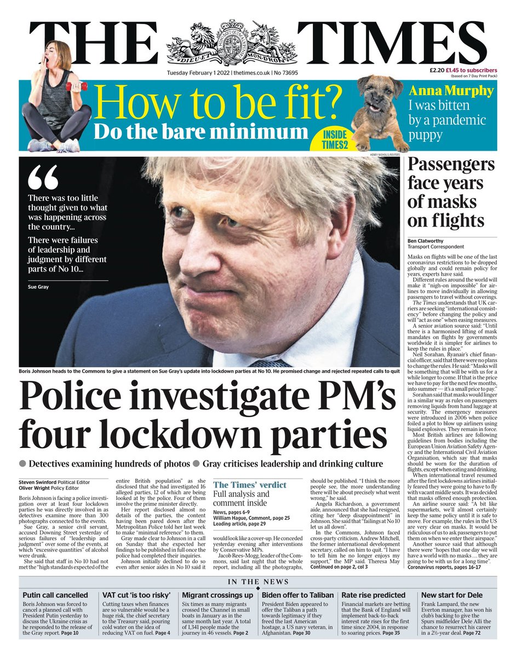
Theories for The Times Partygate Front Page (newspapers)
Media Language:
- Semiotics (Barthes)
- Structuralism (Levi-Strauss)

Representation:
- Representation Theories (Hall)

COM 1 Section B: Media Industries and Audiences

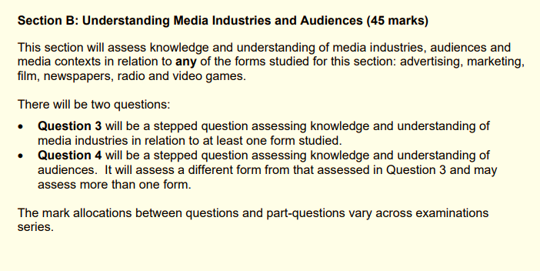

THEORIES LINKED TO MEDIA LANGUAGE | THEORIES LINKED TO REPRESENTATION | THEORIES LINKED TO INDUSTRY | THEORIES LINKED TO AUDIENCE
Structuralism (Levi-Strauss) | Theories of identity (Gauntlett) ADVERTISING AND MUSIC VIDEO ONLY | Regulation (including Livingstone and Lunt) | Cultivation theory (including Gerbner)
Narratology (including Todorov) | Theories of Representation (including Hall) | Cultural Industries (including Hesmondhalgh) | Media Effects (including Bandura)
Genre Theory (including Neale) | Theories of Gender Performativity (including Butler) | Power and media industries (including Curran and Seaton) | Fandom (including Jenkins)
Postmodernism (including Baudrillard) | Theories around ethnicity and postcolonial theory (including Gilroy) ADVERTISING AND MUSIC VIDEO ONLY |  | End of Audience Theory (including Shirky)
Semiotics (Barthes) | Feminist Theories (including bell hooks and Van Zoonen) ADVERTISING AND MUSIC VIDEO ONLY |  | Reception Theory (including Hall)
MEDIA STUDIES FRAMEWORK – Areas of study
COM 1 SECTION B: MEDIA INDUSTRIES AND AUDIENCES

MEDIA LANGUAGE | MEDIA REPRESENTATION | MEDIA INDUSTRIES | MEDIA AUDIENCES
How the different modes and language associated with different media forms communicate multiple meanings | The way events, issues, individuals (including self-representation) and social groups (including social identity) are represented through processes of selection and combination | Processes of production, distribution and circulation by organisations, groups and individuals in a global context | How audiences are grouped and categorised by media industries, including by age, gender and social class, as well as by lifestyle and taste
How the combination of elements of media language influence meaning | The way the media, through re-presentation, construct versions of reality | The specialised and institutionalised nature of media production, distribution and circulation | How media producers target, attract, reach, address and potentially construct audiences
How developing technologies affect media language | The processes which lead media producers to make choices about how to represent events, issues, individuals and social groups | The relationship of recent technological change and media production, distribution and circulation | How media industries target audiences through the content and appeal of media products and through the ways in which they are marketed, distributed and circulated
The codes and conventions of media forms and products, including. the processes through which media language develops as a genre | The effect of social and cultural context on representations | The significance of patterns of ownership and control, including conglomerate ownership, vertical integration and diversification | The interrelationship between media technologies and patterns of consumption and response NOT ADVERTISING
The dynamic and historically relative nature of genre | How and why stereotypes can be used positively and negatively | The significance of economic factors, including commercial and not-for-profit public funding, to media industries and their products | How audiences interpret the media, including how they may interpret the same media in different ways
The processes through which meanings are established through intertextuality | How and why particular social groups, in a national and global context, may be under-represented or misrepresented | How media organisations maintain, including through marketing, varieties of audiences nationally and globally | How audiences interact with the media and can be actively involved in media production NOT ADVERTISING

MEDIA STUDIES FRAMEWORK – Areas of study
COM 1 SECTION B: MEDIA INDUSTRIES AND AUDIENCES
MEDIA LANGUAGE | MEDIA REPRESENTATION | MEDIA INDUSTRIES | MEDIA AUDIENCES
How audiences respond to and interpret the above aspects of media language | How media representations convey values, attitudes and beliefs about the world and how these may be systematically reinforced across a wide range of media representations | The regulatory impact of contemporary media in the UK | How specialised audiences can be reached, both on a national and global scale, through different media technologies and platforms RADIO AND VIDEO GAMES ONLY
How genre conventions are socially and historically relative, dynamic and can be used in a hybrid way | How audiences respond to and interpret media representations | The impact of ‘new’ digital technologies on media regulation, including the role of individual producers | How media organisations reflect the different needs of mass and specialised audiences, including through targeting NOT ADVERTISING
The significance of challenging and/or subverting genre conventions | The way in which representations make claims about realism NEWSPAPERS ONLY | How processes of production, distribution and circulation shape media products NOT RADIO | How audiences use media in different ways, reflecting demographic factors as well as aspects of identity and cultural capital
The significance of the varieties of ways intertextuality can be used in the media | The impact of industry contexts on the choices media producers make about how to represent events, issues, individuals and social groups NEWSPAPERS ONLY | The impact of digitally convergent platforms on media production, distribution and circulation, including individual producers | The role and significance of specialised audiences, including niche and fan, to the media RADIO AND VIDEO GAMES ONLY
The way media language incorporates viewpoints and ideologies | The effect of historical context on representations ADVERTISING AND MUSIC VIDEO ONLY | The role of regulation in global production, distribution and circulation | The way in which different audience interpretations reflect social, cultural and historical circumstances
 | How representations may invoke discourses and ideologies and position audiences | The effect of individual producers on media industries NOT RADIO
 | How audience responses to and interpretations of media representations reflect social, cultural and historical circumstances

Section B: Media Industries and Audiences
‘Tide’: Print advert (1950s)

Theories for Tide (advertising)
Audience:
- Cultivation Theory (Gerbner)
- Reception Theory (Hall)

Industry is not studied for this text

Section B: Media Industries and Audiences
‘Super. Human’: Tokyo 2020 Paralympic Games audio-visual advert (2020)

Theories for Super. Human. (advertising)
Audience:
- Cultivation Theory (Gerbner)
- Reception Theory (Hall)

Industry is not studied for this text

Section B: Media Industries and Audiences
‘Black Panther’: Film 2018 (cross-media study, including film marketing)

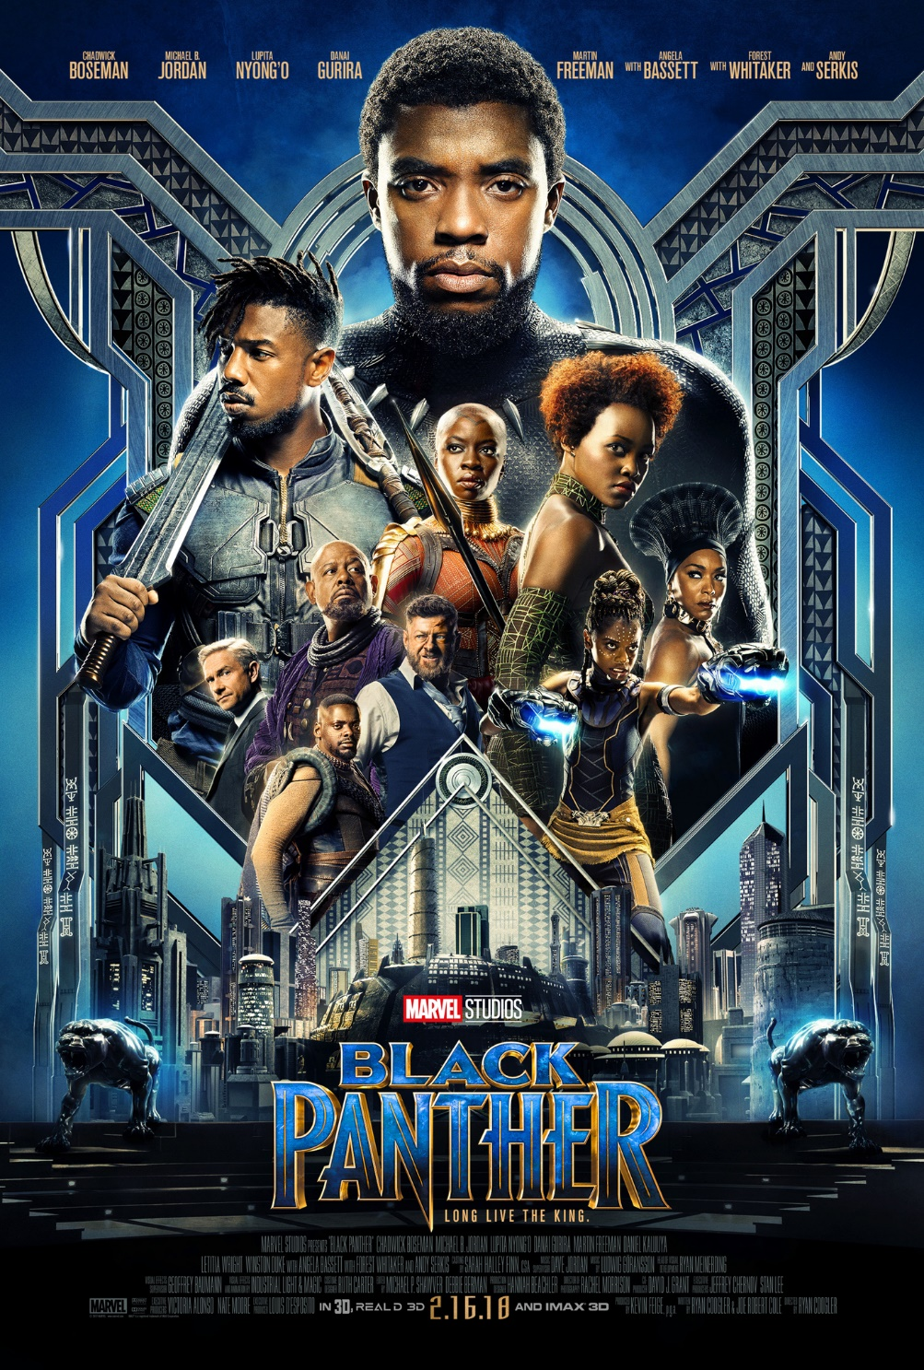
Theories for Black Panther (film)
Industry:
- Power and Media Audiences (Curran and Seaton)
- Regulation (Livingstone and Lunt)
- Cultural Industries (Hesmondhalgh)

Audience is not studied for this text

Section B: Media Industries and Audiences
‘I, Daniel Blake’: Film 2016 (cross-media study, including film marketing)

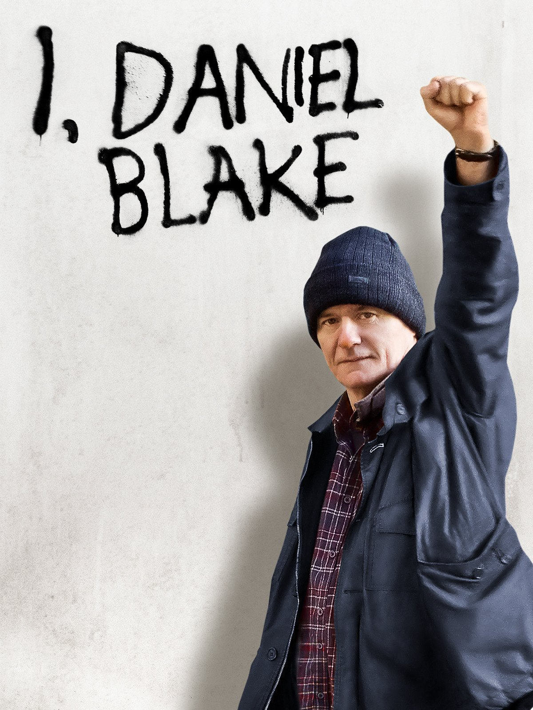
Theories for I, Daniel Blake (film)
Industry:
- Power and Media Audiences (Curran and Seaton)
- Regulation (Livingstone and Lunt)
- Cultural Industries (Hesmondhalgh)

Audience is not studied for this text

Section B: Media Industries and Audiences
Daily Mirror



Theories for The Daily Mirror (newspapers)
Industry:
- Power and Media Audiences (Curran and Seaton)
- Regulation (Livingstone and Lunt)
- Cultural Industries (Hesmondhalgh)

Audience:
- Cultivation Theory (Gerbner)
- Reception Theory (Hall)
- End of Audience (Shirky)

Section B: Media Industries and Audiences
The Times



Theories for The Times (newspapers)
Industry:
- Power and Media Audiences (Curran and Seaton)
- Regulation (Livingstone and Lunt)
- Cultural Industries (Hesmondhalgh)

Audience:
- Cultivation Theory (Gerbner)
- Reception Theory (Hall)
- End of Audience (Shirky)

Section B: Media Industries and Audiences
‘Woman’s Hour’: Radio 4

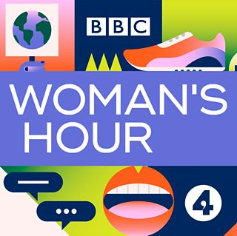

Theories for Woman’s Hour (radio)
Industry:
- Power and Media Audiences (Curran and Seaton)
- Regulation (Livingstone and Lunt)

Audience:
- Reception Theory (Hall)
- Fandom (Jenkins)
- End of Audience (Shirky)

Section B: Media Industries and Audiences
Assassin’s Creed Franchise: video game

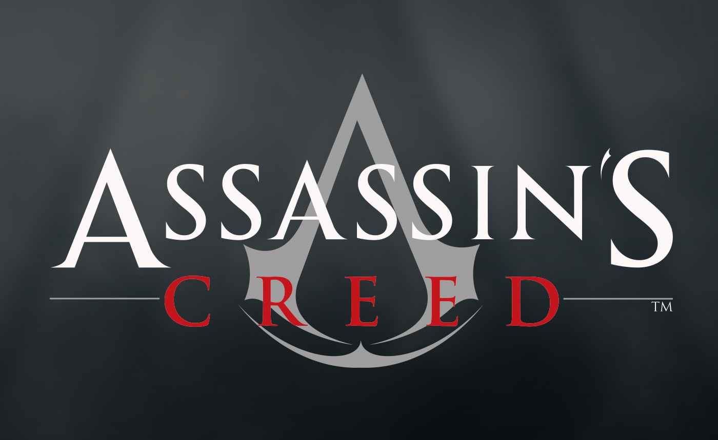

Theories for Assassin’s Creed (video games)
Industry:
- Power and Media Audiences (Curran and Seaton)
- Regulation (Livingstone and Lunt)
- Cultural Industries (Hesmondhalgh)

Audience:
- Media Effects (Bandura)
- Reception Theory (Hall)
- Fandom (Jenkins)
- End of Audience (Shirky)

Component 2
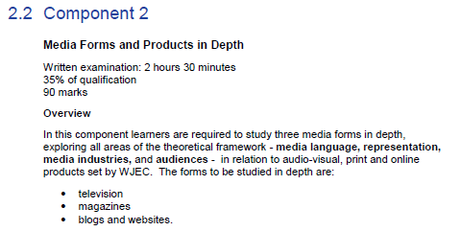
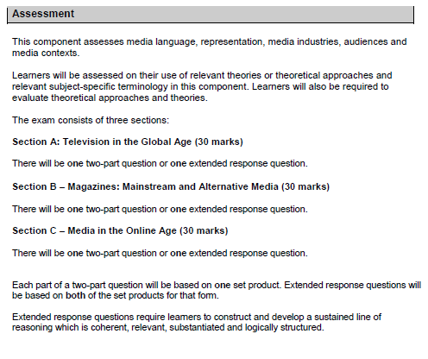

COM 2 Section A: Television in the Global Age



THEORIES LINKED TO MEDIA LANGUAGE | THEORIES LINKED TO REPRESENTATION | THEORIES LINKED TO INDUSTRY | THEORIES LINKED TO AUDIENCE
Structuralism (Levi-Strauss) | Theories of identity (Gauntlett) | Regulation (including Livingstone and Lunt) | Cultivation theory (including Gerbner)
Narratology (including Todorov) | Theories of Representation (including Hall) | Cultural Industries (including Hesmondhalgh) | Media Effects (including Bandura)
Genre Theory (including Neale) | Theories of Gender Performativity (including Butler) KILLING EVE ONLY | Power and media industries (including Curran and Seaton) | Fandom (including Jenkins) KILLING EVE ONLY
Postmodernism (including Baudrillard) KILLING EVE ONLY | Theories around ethnicity and postcolonial theory (including Gilroy) |  | End of Audience Theory (including Shirky)
Semiotics (Barthes) | Feminist Theories (including bell hooks and Van Zoonen) |  | Reception Theory (including Hall)

MEDIA STUDIES FRAMEWORK – Areas of study
COM 2 SECTION A: TELEVISION IN THE GLOBAL AGE

MEDIA LANGUAGE | MEDIA REPRESENTATION | MEDIA INDUSTRIES | MEDIA AUDIENCES
How the different modes and language associated with different media forms communicate multiple meanings | The way events, issues, individuals (including self-representation) and social groups (including social identity) are represented through processes of selection and combination | Processes of production, distribution and circulation by organisations, groups and individuals in a global context | How audiences are grouped and categorised by media industries, including by age, gender and social class, as well as by lifestyle and taste
How the combination of elements of media language influence meaning | The way the media, through re-presentation, construct versions of reality | The specialised and institutionalised nature of media production, distribution and circulation | How media producers target, attract, reach, address and potentially construct audiences
How developing technologies affect media language | The processes which lead media producers to make choices about how to represent events, issues, individuals and social groups | The relationship of recent technological change and media production, distribution and circulation | How media industries target audiences through the content and appeal of media products and through the ways in which they are marketed, distributed and circulated
The codes and conventions of media forms and products, including. the processes through which media language develops as a genre | The effect of social and cultural context on representations | The significance of patterns of ownership and control, including conglomerate ownership, vertical integration and diversification | The interrelationship between media technologies and patterns of consumption and response
The dynamic and historically relative nature of genre | How and why stereotypes can be used positively and negatively | The significance of economic factors, including commercial and not-for-profit public funding, to media industries and their products | How audiences interpret the media, including how they may interpret the same media in different ways
The processes through which meanings are established through intertextuality PEAKY BLINDERS ONLY | How and why particular social groups, in a national and global context, may be under-represented or misrepresented | How media organisations maintain, including through marketing, varieties of audiences nationally and globally | How audiences interact with the media and can be actively involved in media production
MEDIA STUDIES FRAMEWORK – Areas of study
COM 2 SECTION A: TELEVISION IN THE GLOBAL AGE

MEDIA LANGUAGE | MEDIA REPRESENTATION | MEDIA INDUSTRIES | MEDIA AUDIENCES
How audiences respond to and interpret the above aspects of media language | How media representations convey values, attitudes and beliefs about the world and how these may be systematically reinforced across a wide range of media representations | The regulatory impact of contemporary media in the UK | How specialised audiences can be reached, both on a national and global scale, through different media technologies and platforms
How genre conventions are socially and historically relative, dynamic and can be used in a hybrid way | How audiences respond to and interpret media representations | The impact of ‘new’ digital technologies on media regulation, including the role of individual producers | How media organisations reflect the different needs of mass and specialised audiences, including through targeting
The significance of challenging and/or subverting genre conventions PEAKY BLINDERS ONLY | The way in which representations make claims about realism | How processes of production, distribution and circulation shape media products | How audiences use media in different ways, reflecting demographic factors as well as aspects of identity and cultural capital
The significance of the varieties of ways intertextuality can be used in the media PEAKY BLINDERS ONLY | The impact of industry contexts on the choices media producers make about how to represent events, issues, individuals and social groups | The impact of digitally convergent platforms on media production, distribution and circulation, including individual producers | The role and significance of specialised audiences, including niche and fan, to the media
The way media language incorporates viewpoints and ideologies | The effect of historical context on representations | The role of regulation in global production, distribution and circulation | The way in which different audience interpretations reflect social, cultural and historical circumstances
 | How representations may invoke discourses and ideologies and position audiences | The effect of individual producers on media industries PEAKY BLINDERS ONLY
 | How audience responses to and interpretations of media representations reflect social, cultural and historical circumstances

COM 2 Section A: Television in the Global Age
‘Peaky Blinders’ Series 1, Episode 1 (2013): BBC Two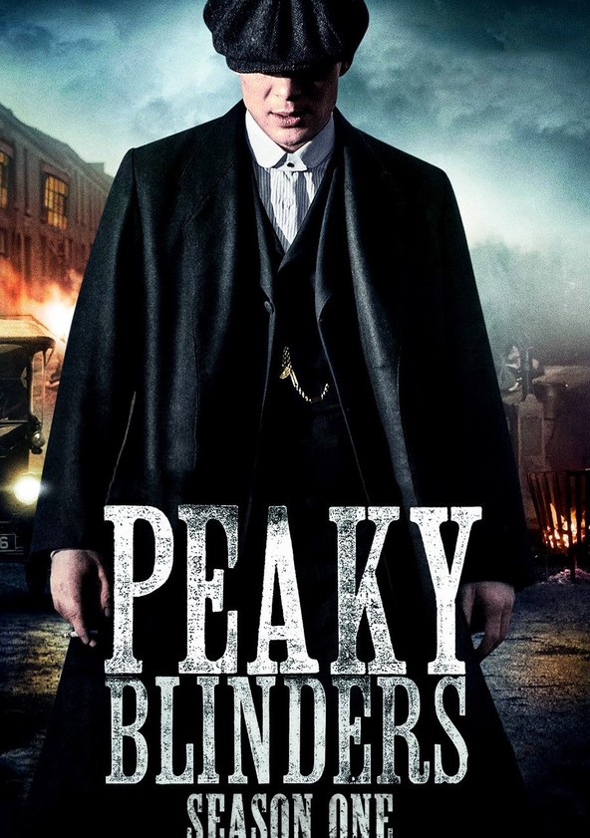
Theories for Peaky Blinders (TV Crime Dramas)
Media Language:
- Narratology (Todorov)
- Genre Theory (Neale)
- Structuralism (Levi-Strauss)
- Postmodernism (Baudrillard)

Representation:
- Representation Theories (Hall)
- Feminist Theories (Van Zoonen, bell hooks)

Industry:
- Regulation (Livingstone and Lunt)
- Cultural Industries (Hesmondhalgh)

Audience:
- Reception Theory (Hall)
- Fandom (Jenkins)

COM 2 Section A: Television in the Global Age
‘The Bridge’ Series 3, Episode 1 (2015): SVT1 (Sweden), DR1 (Denmark), BBC Four
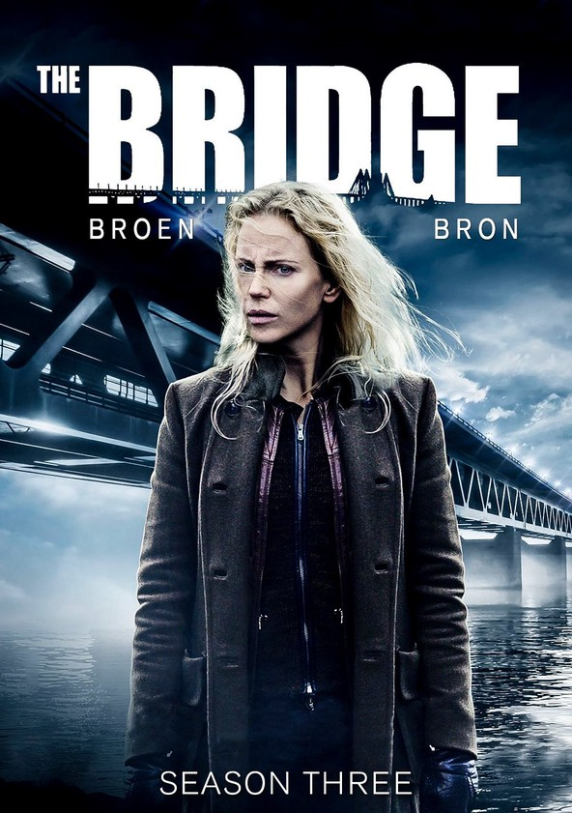
Theories for The Bridge (TV Crime Dramas)
Media Language:
- Narratology (Todorov)
- Genre Theory (Neale)
- Structuralism (Levi-Strauss)

Representation:
- Representation Theories (Hall)
- Feminist Theories (Van Zoonen, bell hooks)
- Theories of Gender Performativity (Butler)

Industry:
- Regulation (Livingstone and Lunt)
- Cultural Industries (Hesmondhalgh)

Audience:
- Reception Theory (Hall)
- Fandom (Jenkins)

COM 2 Section B: Magazines – Mainstream and Alternative Media

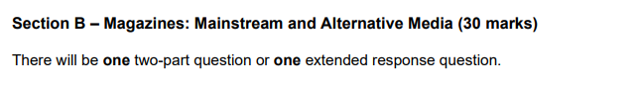

THEORIES LINKED TO MEDIA LANGUAGE | THEORIES LINKED TO REPRESENTATION | THEORIES LINKED TO INDUSTRY | THEORIES LINKED TO AUDIENCE
Structuralism (Levi-Strauss) | Theories of identity (Gauntlett) | Regulation (including Livingstone and Lunt) | Cultivation theory (including Gerbner)
Narratology (including Todorov) | Theories of Representation (including Hall) | Cultural Industries (including Hesmondhalgh) | Media Effects (including Bandura)
Genre Theory (including Neale) | Theories of Gender Performativity (including Butler) | Power and media industries (including Curran and Seaton) | Fandom (including Jenkins)
Postmodernism (including Baudrillard) | Theories around ethnicity and postcolonial theory (including Gilroy) |  | End of Audience Theory (including Shirky)
Semiotics (Barthes) | Feminist Theories (including bell hooks and Van Zoonen) |  | Reception Theory (including Hall)

MEDIA STUDIES FRAMEWORK – Areas of study
COM 2 SECTION A: MAGAZINES – MAINSTREAM AND ALTERNATIVE

MEDIA LANGUAGE | MEDIA REPRESENTATION | MEDIA INDUSTRIES | MEDIA AUDIENCES
How the different modes and language associated with different media forms communicate multiple meanings | The way events, issues, individuals (including self-representation) and social groups (including social identity) are represented through processes of selection and combination | Processes of production, distribution and circulation by organisations, groups and individuals in a global context | How audiences are grouped and categorised by media industries, including by age, gender and social class, as well as by lifestyle and taste
How the combination of elements of media language influence meaning | The way the media, through re-presentation, construct versions of reality | The specialised and institutionalised nature of media production, distribution and circulation | How media producers target, attract, reach, address and potentially construct audiences
How developing technologies affect media language | The processes which lead media producers to make choices about how to represent events, issues, individuals and social groups | The relationship of recent technological change and media production, distribution and circulation THE BIG ISSUE ONLY | How media industries target audiences through the content and appeal of media products and through the ways in which they are marketed, distributed and circulated
The codes and conventions of media forms and products, including. the processes through which media language develops as a genre | The effect of social and cultural context on representations | The significance of patterns of ownership and control, including conglomerate ownership, vertical integration and diversification | The interrelationship between media technologies and patterns of consumption and response
The dynamic and historically relative nature of genre | How and why stereotypes can be used positively and negatively | The significance of economic factors, including commercial and not-for-profit public funding, to media industries and their products | How audiences interpret the media, including how they may interpret the same media in different ways
The processes through which meanings are established through intertextuality | How and why particular social groups, in a national and global context, may be under-represented or misrepresented | How media organisations maintain, including through marketing, varieties of audiences nationally and globally | How audiences interact with the media and can be actively involved in media production
MEDIA STUDIES FRAMEWORK – Areas of study
COM 2 SECTION A: MAGAZINES – MAINSTREAM AND ALTERNATIVE

MEDIA LANGUAGE | MEDIA REPRESENTATION | MEDIA INDUSTRIES | MEDIA AUDIENCES
How audiences respond to and interpret the above aspects of media language | How media representations convey values, attitudes and beliefs about the world and how these may be systematically reinforced across a wide range of media representations | The regulatory impact of contemporary media in the UK | How specialised audiences can be reached, both on a national and global scale, through different media technologies and platforms THE BIG ISSUE ONLY
How genre conventions are socially and historically relative, dynamic and can be used in a hybrid way | How audiences respond to and interpret media representations | The impact of ‘new’ digital technologies on media regulation, including the role of individual producers | How media organisations reflect the different needs of mass and specialised audiences, including through targeting
The significance of challenging and/or subverting genre conventions | The way in which representations make claims about realism THE BIG ISSUE ONLY | How processes of production, distribution and circulation shape media products | How audiences use media in different ways, reflecting demographic factors as well as aspects of identity and cultural capital
The significance of the varieties of ways intertextuality can be used in the media | The impact of industry contexts on the choices media producers make about how to represent events, issues, individuals and social groups | The impact of digitally convergent platforms on media production, distribution and circulation, including individual producers THE BIG ISSUE ONLY | The role and significance of specialised audiences, including niche and fan, to the media THE BIG ISSUE ONLY
The way media language incorporates viewpoints and ideologies | The effect of historical context on representations | The role of regulation in global production, distribution and circulation | The way in which different audience interpretations reflect social, cultural and historical circumstances
 | How representations may invoke discourses and ideologies and position audiences | The effect of individual producers on media industries
 | How audience responses to and interpretations of media representations reflect social, cultural and historical circumstances

COM 2 Section B: Magazines – Mainstream and Alternative Media
‘Vogue’ (July 1965): Conde Nast

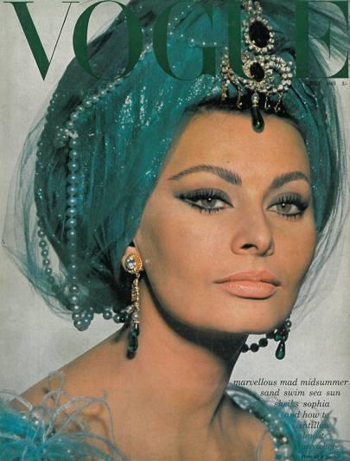
Theories for Vogue (magazines)
Media Language:
- Semiotics (Barthes)
- Structuralism (Levi-Strauss)

Representation:
- Identity (Gauntlett)
- Feminist Theories (Van Zoonen, bell hooks)

Industry:
- Power and Media Audiences (Curran and Seaton)
- Cultural Industries (Hesmondhalgh)

Audience:
- Cultivation Theory (Gerbner)
- Reception Theory (Hall)

COM 2 Section B: Magazines – Mainstream and Alternative Media
‘The Big Issue’ (Oct 17th – 23rd 2016): Dennis and The Big Issue Ltd

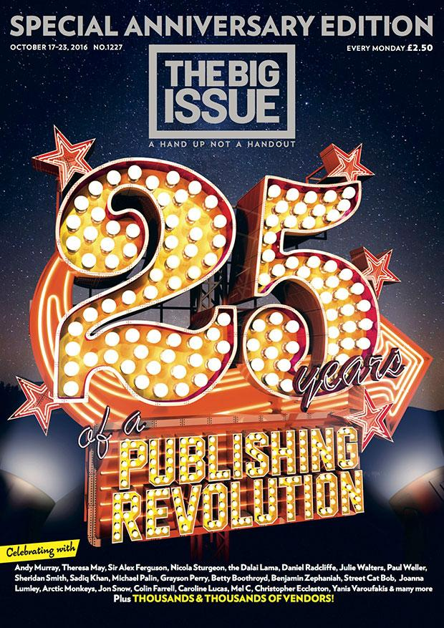

Theories for The Big Issue (magazines)
Media Language:
- Semiotics (Barthes)
- Structuralism (Levi-Strauss)

Representation:
- Identity (Gauntlett)
- Feminist Theories (Van Zoonen, bell hooks)

Industry:
- Power and Media Audiences (Curran and Seaton)
- Cultural Industries (Hesmondhalgh)

Audience:
- Cultivation Theory (Gerbner)
- Reception Theory (Hall)

COM 2 Section C: Media in the Online Age



THEORIES LINKED TO MEDIA LANGUAGE | THEORIES LINKED TO REPRESENTATION | THEORIES LINKED TO INDUSTRY | THEORIES LINKED TO AUDIENCE
Structuralism (Levi-Strauss) | Theories of identity (Gauntlett) | Regulation (including Livingstone and Lunt) | Cultivation theory (including Gerbner)
Narratology (including Todorov) | Theories of Representation (including Hall) | Cultural Industries (including Hesmondhalgh) | Media Effects (including Bandura)
Genre Theory (including Neale) | Theories of Gender Performativity (including Butler) ZOE SUGG ONLY | Power and media industries (including Curran and Seaton) | Fandom (including Jenkins) ZOE SUGG ONLY
Postmodernism (including Baudrillard) | Theories around ethnicity and postcolonial theory (including Gilroy) ATTITUDE ONLY |  | End of Audience Theory (including Shirky)
Semiotics (Barthes) | Feminist Theories (including bell hooks and Van Zoonen) |  | Reception Theory (including Hall)

MEDIA STUDIES FRAMEWORK – Areas of study
COM 2 SECTION C: MEDIA IN THE ONLINE AGE

MEDIA LANGUAGE | MEDIA REPRESENTATION | MEDIA INDUSTRIES | MEDIA AUDIENCES
How the different modes and language associated with different media forms communicate multiple meanings | The way events, issues, individuals (including self-representation) and social groups (including social identity) are represented through processes of selection and combination | Processes of production, distribution and circulation by organisations, groups and individuals in a global context | How audiences are grouped and categorised by media industries, including by age, gender and social class, as well as by lifestyle and taste
How the combination of elements of media language influence meaning | The way the media, through re-presentation, construct versions of reality | The specialised and institutionalised nature of media production, distribution and circulation | How media producers target, attract, reach, address and potentially construct audiences
How developing technologies affect media language | The processes which lead media producers to make choices about how to represent events, issues, individuals and social groups | The relationship of recent technological change and media production, distribution and circulation | How media industries target audiences through the content and appeal of media products and through the ways in which they are marketed, distributed and circulated
The codes and conventions of media forms and products, including. the processes through which media language develops as a genre | The effect of social and cultural context on representations | The significance of patterns of ownership and control, including conglomerate ownership, vertical integration and diversification | The interrelationship between media technologies and patterns of consumption and response
The dynamic and historically relative nature of genre | How and why stereotypes can be used positively and negatively | The significance of economic factors, including commercial and not-for-profit public funding, to media industries and their products | How audiences interpret the media, including how they may interpret the same media in different ways
The processes through which meanings are established through intertextuality | How and why particular social groups, in a national and global context, may be under-represented or misrepresented ATTITUDE ONLY | How media organisations maintain, including through marketing, varieties of audiences nationally and globally | How audiences interact with the media and can be actively involved in media production
MEDIA STUDIES FRAMEWORK – Areas of study
COM 2 SECTION C: MEDIA IN THE ONLINE AGE

MEDIA LANGUAGE | MEDIA REPRESENTATION | MEDIA INDUSTRIES | MEDIA AUDIENCES
How audiences respond to and interpret the above aspects of media language | How media representations convey values, attitudes and beliefs about the world and how these may be systematically reinforced across a wide range of media representations | The regulatory impact of contemporary media in the UK | How specialised audiences can be reached, both on a national and global scale, through different media technologies and platforms ATTITUDE ONLY
How genre conventions are socially and historically relative, dynamic and can be used in a hybrid way | How audiences respond to and interpret media representations | The impact of ‘new’ digital technologies on media regulation, including the role of individual producers | How media organisations reflect the different needs of mass and specialised audiences, including through targeting
The significance of challenging and/or subverting genre conventions | The way in which representations make claims about realism ATTITUDE ONLY | How processes of production, distribution and circulation shape media products | How audiences use media in different ways, reflecting demographic factors as well as aspects of identity and cultural capital
The significance of the varieties of ways intertextuality can be used in the media | The impact of industry contexts on the choices media producers make about how to represent events, issues, individuals and social groups | The impact of digitally convergent platforms on media production, distribution and circulation, including individual producers | The role and significance of specialised audiences, including niche and fan, to the media
The way media language incorporates viewpoints and ideologies | The effect of historical context on representations | The role of regulation in global production, distribution and circulation | The way in which different audience interpretations reflect social, cultural and historical circumstances
 | How representations may invoke discourses and ideologies and position audiences | The effect of individual producers on media industries ZOE SUGG ONLY
 | How audience responses to and interpretations of media representations reflect social, cultural and historical circumstances

COM 2 Section C: Media in the Online Age
For 2025: JJ Olatunji / KSI JJ Olatunji - YouTube



Theories for KSI (online media)
Media Language:
- Semiotics (Barthes)
- Structuralism (Levi-Strauss)
- Postmodernism (Baudrillard)

Representation:
- Representation Theories (Hall)
- Identity (Gauntlett)
- Theories of Gender Performativity (Butler)

Industry:
- Regulation (Livingstone and Lunt)
- Cultural Industries (Hesmondhalgh)

Audience:
- Cultivation Theory (Gerbner)
- Fandom (Jenkins)
- End of Audience (Shirky)

COM 2 Section C: Media in the Online Age
For 2024 and 2025: Attitude https://www.attitude.co.uk/

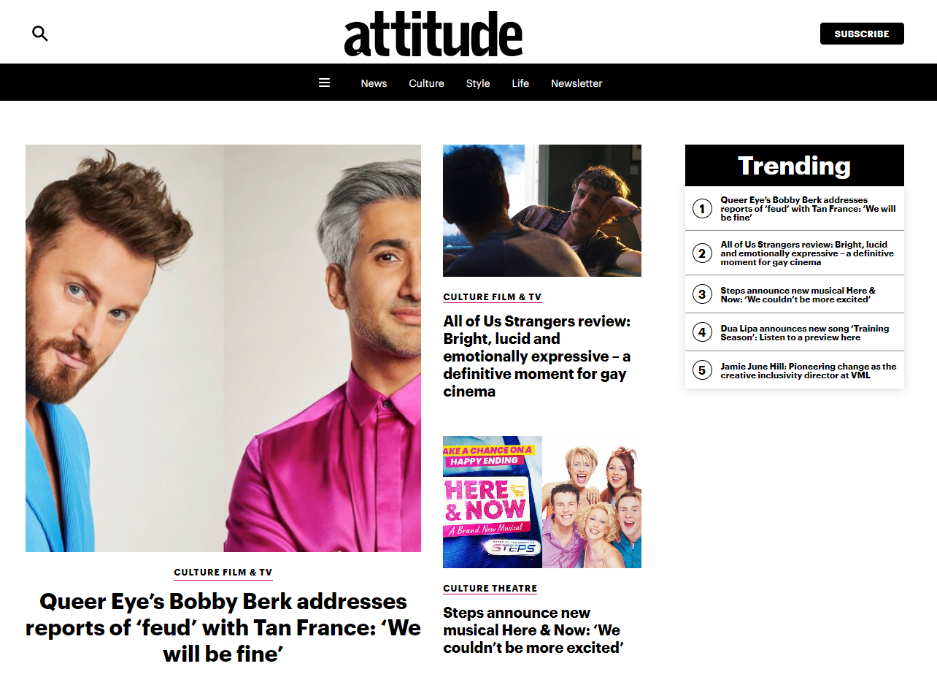

Theories for Attitude (online media)
Media Language:
- Semiotics (Barthes)
- Structuralism (Levi-Strauss)
- Postmodernism (Baudrillard)

Representation:
- Representation Theories (Hall)
- Identity (Gauntlett)
- Ethnicity and Post-colonial theory (Gilroy)

Industry:
- Regulation (Livingstone and Lunt)
- Cultural Industries (Hesmondhalgh)

Audience:
- Cultivation Theory (Gerbner)
- End of Audience (Shirky)

Component 3
CROSS-MEDIA PRODUCTION

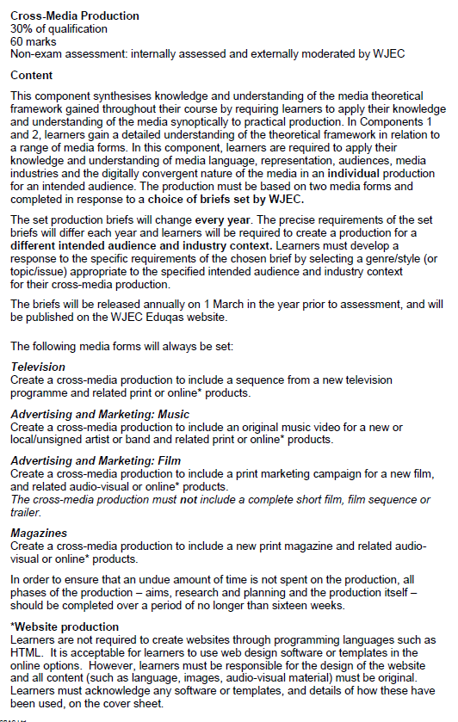

Assessment Grid for Component 3: bands 4 and 5

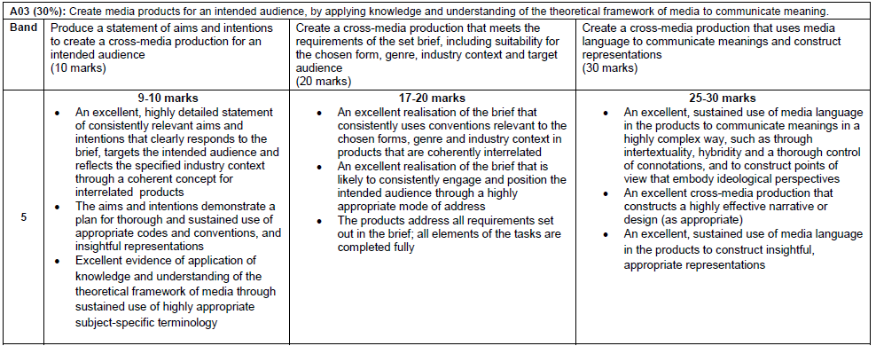
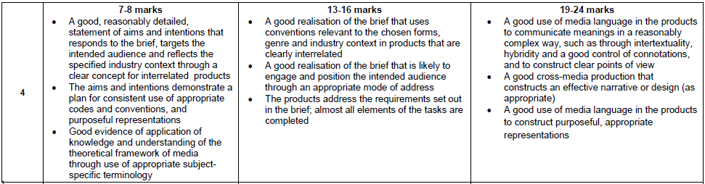

Assessment Grid for Component 3: bands 2 and 3

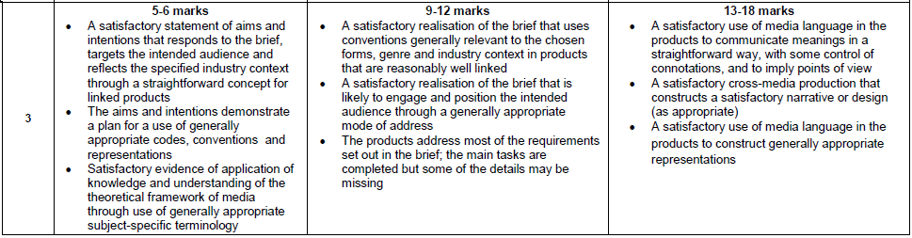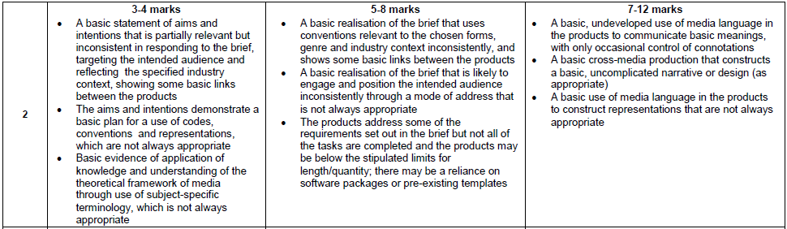

Assessment Grid for Component 3: bands 1 and 0

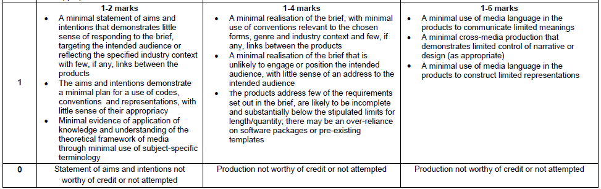
You must submit:
- A statement of aims and intentions (10 marks)
- A completed CROSS-MEDIA production in response to a brief set by the board, which is released on 1st March. This will consist of two pieces of work. See previous page for an outline of this. (20 + 30 marks = 50 marks altogether)
- A completed cover sheet, signed at 4 key points in the process

You will also undertake extensive research and planning work.
- Research and planning work is not submitted, but it has to be authenticated by the teacher and must be kept by the teacher. The teacher is required to make this work available to Eduqas should this be requested.

The Media Studies Framework

L | L STANDS FOR LANGUAGE  Media language is the language in which media products communicate through their forms, codes and conventions and techniques. It includes colour choices, design choices, symbolic codes of clothing, gesture etc. You need to be able to analyse media language.
R | R STANDS FOR REPRESENTATIONS  How does the media production represent people, places, social groups and events? Does it leave certain people or places out? If so, what is the effect of that? You need to be able to analyse this.
I | I STANDS FOR INDUSTRIES  Every media text is produced, distributed and circulated by somebody, or some organisation. Who are the people and organisations behind the media? What is their influence? You need to know this.
A | A STANDS FOR AUDIENCE  Media productions are designed to target, reach and address audiences. Audiences respond to media productions in various ways and sometimes audiences become producers of media. You need to understand all of these processes.

MEDIA FRAMEWORK AND CONTEXT QUESTIONS
CONTEXT Qs
When was the text produced?
What country was it produced in?
What historical events were happening at or around the time of production? Do they influence the text?
What were the values of the society that it was produced in? Do they influence the text?
Who held power in the society the text was produced in and how is this reflected or challenged in the text?
What moral values were popular at the time of production and how are they reflected or challenged in the text?
LANGUAGE Qs
What codes and conventions can you identify in the text (SEE CHECKLISTS TO HELP WITH THIS)
What genre is the text?
What is the combined effect of the codes and conventions?
What are the genre signifiers in the text?
How are the codes and conventions being used to appeal to a particular audience?
Is the text typical of its genre? Explain why/why not.
REPRESENTATION Qs
How are people, places and events represented in the text?
Is it a fair representation?
How is the representation of the people, places or events constructed using codes and conventions?
What is the link between the representation and the target audience?
Why is the person, place or event represented in this way?
Is the representation stereotypical, and if so, what is the impact of that over time?
AUDIENCE Qs
Who is the main target audience for the text and how do you know?
Are there any secondary audiences?
How are the codes and conventions in the text used to appeal to the target audience?
How successful is the text in appealing to the target audience?
Are there any audience theories that would be applicable to this text?
Why is this particular audience being targeted?
INDUSTRY Qs
Which industries or organisations were involved in the production and distribution of the text?
Do these industries produce any other media products?
Why has the industry or organisation made this media text?
How is the industry or organisation funded and why is this important?
What regulations and rules does the industry or organisation have to follow?
Is the industry or organisation linked to any political parties or governments?

Media Language analysis checklists

These lists are not exhaustive. There will always be more to learn in media studies. Notice the number of different terms that can be used to describe the same thing in media. Google is your friend here – look words up. The glossary in your handbook is specifically provided by the exam board, so use that as your main reference. Keep practising analysis, little and often, from different checklists. This can be done whilst watching telly, diving in to an internet rabbit-hole and so on.

In all cases, say WHY a particular feature has been used. This is where you get marks, particularly if you can link your ideas to all parts of the CLAIR framework. The third column in each chart gives you some ideas of possible effects.

Use these charts in conjunction with the theories associated with Media Language (see the theories section that follows these checklists).

Note: YouTube is a brilliant resource for seeing examples of a lot of these things and for learning more. For example, editing is only briefly described here, even though it is a very important way of helping to pace a film, or drawing attention to certain things, or creating mystery and codes of enigma.

CHECKLIST 1: TECHNICAL CODES

Technical Codes in Moving Image Products
Camera Shots
Close-ups (CU) | A shot that contains the whole of a person’s head, but nothing else. | Used to create emotion and tension. The close-up on a character’s face makes the audience feel involved with the character as they can clearly read the emotions on the face.
Extreme close-ups (XCU) | A shot that contains a section of a person’s head, perhaps just the eyes or the mouth. | This shot withholds information from the audience and this can create suspense as the audience wait to find out what is going on.
Long shots (LS) | A full-length shot of a person. | These shots are used when more information about the character or part of their surroundings is required. This helps the audience gain more understanding of what is going on.
Medium close-ups (MCU) | A shot from the waist up. Sometimes known as ‘newsreader shots’. | This shot can be related to a specific genre: the news. It allows the audience to see the face clearly, but it isn’t uncomfortably close. It mimics the kind of distance you would choose if you were chatting to a colleague or friend. It has a friendly, open feel.
Establishing shots | A wide shot of a landscape or scene, for example, the skyline of New York. Often used at the beginning of films. | Establishing shots are a quick way of giving important information to an audience, such as where the action is about to take place.

Camera Angles
High-angle | A shot taken from above. Different high angles include a ‘bird’s eye view’ or ‘crane shot’. | A high-angle shot has the effect of making the subject feel small and vulnerable. It can also suggest high production values as the equipment required to create these shots can be expensive (planes, helicopters, cranes etc.). They can also be used to allow the audience to follow the action closely, for example, a car chase scene in an action movie.
Low-angle | A shot taken from below. Includes ‘worm’s eye view’ shots. | A low-angle shot of a character or object will create a sense of power and dominance in the subject.

CHECKLIST 1: TECHNICAL CODES
Technical Codes in Moving Image Products
Camera Movements
Tracking shot | When the camera follows the character or action, often on a mini rail track, hence the name. This can also be known as a dolly or trolley shot. | The audience feels as if they are involved in the action, almost walking alongside.
Zoom | When the camera moves from a long shot towards the subject, or the reverse, known as a zoom out. | The effect is to focus the audience’s attention on something, increasing their engagement with the subject.
Panning shot | When the camera turns from one side of the shot to the other, like a head turning from left to right. Only the top part of the camera moves, unlike a tracking shot where the whole camera moves. | It is often used to show location and to give a lot of information to an audience. In a ‘whip pan’ the camera moves at high speed, causing a blurring effect and suggesting pace and action.
Tilt/canted shot | Like a panning shot, but the camera moves up and down rather than side to side. | This can be used to create mystery, for example if the camera starts on the feet and then tilts upwards towards the face.
Push/pull shot | When a zoom in (using the focus on the camera) is combined with a track out. There’s a great example in Jaws. | This is a very dramatic technique that creates a dizzying sense of the world shifting in a very unnatural way. In Jaws, it signals the moment that the protagonist realises someone is being attacked in the water.

Editing
Editing | The process of selecting and ordering shots in order to convey meanings to the audience. | Editing styles are often linked with genre. For example, a fast-paced editing style is often associated with action movies.
Transitions | The different ways that one shot can transition in to the next shot, for example, fade, dissolve, jump cut. | Different transition types are used to create different effects. A fade is slow and thoughtful. A jump cut is fast and unobtrusive, allowing the action to maintain pace.

CHECKLIST 1: TECHNICAL CODES

Technical Codes in Print Products
Layout and design | The layout is where things are put on the page. The design refers to the overall ‘look’ of the media text. | Layouts and design features often correspond to certain genres. For example, adverts for banking and insurance often use navy blue colours. Magazines will often try to develop a ‘house-style’ – a set of design features that are used in every issue to create brand identity.
Camera shots | Print products can’t use some of the camera techniques that moving image products can (for example, tracking shots), but others are the same, for example, a close-up shot. | The effects of different shot types and angles are similar to moving images, but the effect can be heightened as there is only one image, rather than a series.
Lighting | There are different lighting techniques (e.g. high-key, diffuse, backlit), all of which have different effects. | Lighting from the side casts strong shadows, creating mystery. Diffuse lighting creates a naturalistic effect. High-key lighting draws attention to certain areas of the image.
Codes of colour | Colours are strongly related to meanings. Colours can convey strong messages about the product and often about the potential target audience. | The colour pink has been used very successfully in marketing to divide up the market in to genders. This can potentially double the market share. See ‘Let Toys be Toys’ campaign for some very interesting work on gender division in toys.
Graphics | This includes logos and graphic (drawn) representations of things. It can also refer to charts and diagrams. | Typography is a sub-section of graphic design and it refers to the shape of letters. Different letter styles can be strongly associated with different genres.
Post-production techniques | Photoshop, Facetune etc. | It is very rare indeed to see a photo or image that is not changed during post-production. Some celebrities have publicly condemned the practice, claiming it leads to unrealistic expectations of beauty.

CHECKLIST 2: AUDIO CODES
Sound in a media text can be either DIEGETIC or NON-DIEGETIC. See the glossary for explanations of these terms.
Dialogue | Speech/talking carried out by the subjects of the media text. | Dialogue imparts information about characters and their relationships with others. The mode of address used by the speakers, as well as their vocabulary (or ‘lexis’), can help to signify a genre. For example, the presenters of Radio 4’s Today programme speak in a recognisably formal and educated way.
Sound effects | Explosions, creaking doors, footsteps, heartbeats etc. etc. … | Not all genres use sound effects and so they can be a useful indicator of genre, or a ‘genre signifier’. Horror movies and action movies use them a lot. Sound effects can be central to the creation of atmosphere, particularly tension or fear.
Music | Music, usually used non-diegetically, is crucial to the building of atmosphere and the manipulation of audience response. | Music choices will convey narrative information to the audience. Music suggests genre.
Voice-overs | Non-diegetic speech designed to give information to the audience. | Voice-overs can give important clues to genre.

CHECKLIST 3: VISUAL CODES

Codes of Clothing | Clothing is a way of establishing the identity of a character or a brand. For example, news readers always dress very formally.
Codes of expression | Facial expressions communicate meaning quickly. They are usually interpreted easily by an audience and can be used to manipulate emotions.
Codes of gesture | Gestures are non-verbal and often cross language and cultural barriers. Emotion is easy to convey with a gesture. The body language and gestures of a performer allow them to send messages about their brand identity.
Technique | Different visual design techniques can be associated with meaning. For example, the use of black and white photography might suggest sophistication.
Codes of colour | Colours can transmit messages and in some cases are key parts of the product’s construction. For example, in fragrance advertisements they can suggest the type of fragrance being marketed even though the audience cannot smell the product. Pastel colours might suggest a floral fragrance, whereas purples and reds might suggest a heavier perfume.
Image selection | Images are selected to communicate messages. The choice of model or celebrity on the front of a magazine says something about the brand values and the audience appeal.
Iconography | Some objects take on meanings that are significant. For example, Westminster Tower has come to signify British democracy and the Houses of Parliament. The Eiffel Tower symbolises love.
Mise-en-scene | Mise-en-scene refers to everything you can see within the frame of a shot.
Graphics | Graphics refers to anything that is illustrated or drawn or animated. They can include opening credits to TV Programmes, charts used in news programmes and written logos used on adverts. Graphics are usually produced by computers. They can give strong clues as to genre and target audience.

CHECKLIST 4: LINGUISTIC CODES
Puns | A play on words, often used in tabloid newspaper headlines. | ‘Yule be sorry this Christmas!’  ‘There will be hell toupee!’
Alliteration | Where the initial letter is repeated in a sentence. Often used in advertising to attract attention. | ‘The best four by four by far’ – Land Rover
Hyperbole | An exaggeration. | ‘I’ve told you a million times to be quiet.’
Imperative | A command. | ‘Take control of your hair!’ A highly persuasive technique, relying on dissatisfaction. ‘Get that beach body now!’
Quotation | Words spoken by someone else. | ‘To be or not to be…’ Using a quotation suggests real life and relatability. It can also add authenticity if an expert is quoted for example.
Colloquialisms | Words that are not formal English. | Yo fam check out me low bags. Them fresh creps is peng. You mugged me off.  Colloquialisms are often inventive and can be strongly associated with a particular group or locality. They can be used to target a specific audience.
Lexis | Vocabulary | A media product that wishes to appeal to an educated audience will use a wide lexis, with sophisticated vocabulary. Subject specific lexis can be used in particular media products such as fishing magazines.
Formal Mode of Address | Formal tone with sophisticated vocabulary | A formal mode of address is associated with particular genres such as TV news.
Informal Mode of Address | Colloquial vocabulary and personal pronouns | Used to imply a friendly relationship with the audience.
Direct Mode of Address | Where the product communicates directly with the audience. In linguistic terms this means using the word ‘you’ or ‘we’. This can be reinforced with an image that makes direct eye contact with the audience. | This direct communication engages and involves the audience. It suggests a friendly, open and honest relationship.
Indirect Mode of Address | Where the product does not communicate directly with the audience. In films for example, it is unusual for characters to talk directly to the cinema audience. | This type of address is associated with particular genres, e.g. film, drama etc. where the reality created by the product requires the audience to remain separate as observers. ‘Breaking the Fourth Wall’ is an interesting way to subvert this convention.

CHECKLIST 5: GENRE
Another key element of media language is genre. A genre is a category or type of media. We recognise different genres through a set of ‘genre signifiers’, in other words, clues that tell us what kind of media we are consuming. For example, we know we are watching a typical action movie if we can see lots of special effects, specifically explosions; if the story involves a car chase; if the setting is urban; if the characters include a muscle-bound hero; if the editing is fast and the music loud… Genres can be subverted or can evolve over time to match the changing tastes of audiences. It is also possible to have hybrid genres or sub-genres. The genre signifiers for any genre can be broken down in the following ways:

Genre signifier | Definition | Examples and explanations
Narrative type | How the ‘story’ is told. | All media products have a story to tell. In film and TV, this is easy to spot, and how the story is told is easy to match to a genre. For example, a soap opera always finishes on a cliff hanger. Scenes will alternate between different characters. An advert also tries to tell a story – ‘buy our perfume and you will find romance’ is an example. A youtuber constructs a narrative about their life: ‘I’m a young, successful, but friendly person. In fact, I’m your mate. I’m just like you, really (but a bit better). I’m not really being sponsored by a cosmetics company…’ These ‘stories’ are conveyed through many different layers of media language: linguistic codes, codes of colour etc. As a media studies student, your job is to recognise how these ‘stories’ are constructed and to explain why they are constructed in that way.
Character types | Different types of character, often associated with genre. | In soaps a clear genre signifier is the use of stock characters: the evil one, the matriarch, the stroppy (sometimes pregnant) teenager and so on. In an action movie, it’s the gun-toting muscly one.
Iconography and setting | Iconography refers to props that help to define a genre, for example the backwards baseball cap of early rap artists. Settings can be associated with genre. | Settings and iconography are often key genre signifiers. Action movies are often set in recognisable city locations. Science fiction relies heavily on setting to create an alternative universe.
Technical codes | See ‘checklist 1’ for a list of technical codes. | An example of technical codes being key genre signifiers is a newspaper. The design and layout for example instantly make a newspaper distinct from other types of print media. This look is often replicated on news websites, in order to reflect the genre.
Audio codes (where appropriate) | See ‘checklist 2’ for a list of audio codes. | Particular sound effects are key genre signifiers. Music is also a genre signifier: think of the type of music used for news programmes.

CHECKLIST 6: NARRATIVE

Narrative techniques in Audio-Visual Products

Manipulation of time and space | Replays, slow-motion and freeze frames with graphics help to tell the ‘story’ in sports. Space can be manipulated by taking us to various different locations, quickly.
Split-screen narratives | This technique is sometimes used in TV dramas or films. It was used regularly in ‘24’ to reflect the real-time element of the programme. It can serve to build tension as the audience gains a sense of multiple characters and the interplay between them.
Three-strand narratives | This is a common narrative structure used in TV dramas, for example ‘Casualty’. At the beginning of the episode three narrative strands will be introduced, for example, a continuing problematic relationship between regular characters, an accident outside of the hospital setting and an incident in the casualty department.
Flexi-narrative | This is a complex narrative, often with layers of interweaving narratives. In ‘The Missing’ the first episode moved between three different time periods and ended with a cliff-hanger to ensure that the audience watched the next episode.

Narrative conventions in Audio-Visual Products

Flashbacks | These allow the audience to have more information. This technique might also be a way to show what a character is remembering.
Point-of-view shots | These allow the audience to see the action from different perspectives. The camera may position the audience as the eyes of the murderer or the victim for example, or might move between the two. A media studies student has to decide why a director has chosen this shot and what response he or she is hoping for from the audience.
Apparently impossible positions | This is where the camera gives the audience a view of the action from an unusual position, for example high in the air.
Privileged spectator position | When the camera shows aspects of the narrative that other characters cannot see. An example might be a character taking a knife out of her pocket. The audience can then anticipate what might happen next.
Voice-over | Used to move the action on or to fill in missing information.
Enigma codes | Any way of telling the story that leaves the audience with unanswered questions. Trailers use enigma codes a lot, to encourage audiences to see the whole film.
CHECKLIST 6: NARRATIVE

Narrative conventions in Print Products

Headlines | Give a brief yet often dramatic summary of a news story.
Cover lines | Used on magazine front covers to give clues as to what is inside the magazine. In order to find out more, the magazine has to be purchased.
Images and captions | The image that appears on the print product can develop the narrative. This may be through technical codes, the mode of address, the code of clothing or the way in which the audience is positioned by the look of the subject. An image without a caption is open and the interpretation is up to the audience. Once there is text with the image (a caption, or anchorage), then the audience will interpret the image in a different way. Photographs often capture particular moments in time and a good photograph can be deconstructed and analysed to reveal a story.
Linguistic codes | The language used on a print media product will convey messages about the genre of the product and its narrative features. Techniques such as hyperbole and enigma can be used to attract and intrigue a potential audience.
Enigma codes | The creator of a product might withhold information and ’tease’ the audience so that they will access the whole product in order to find the narrative in its entirety. Headlines, cover lines and images can all serve this purpose.

Theories: Media Language

Semiotics - Roland Barthes
- the idea that texts communicate their meanings through a process of signification
- the idea that signs can function at the level of denotation, which involves the ‘literal’ or common-sense meaning of the sign, and at the level of connotation, which involves the meanings associated with or suggested by the sign
- the idea that constructed meanings can come to seem self-evident, achieving the status of myth through a process of naturalisation.

Narratology - Tzvetan Todorov
- the idea that all narratives share a basic structure that involves a movement from one state of equilibrium to another
- the idea that these two states of equilibrium are separated by a period of imbalance or disequilibrium
- the idea that the way in which narratives are resolved can have particular ideological significance.

Genre theory - Steve Neale
- the idea that genres may be dominated by repetition, but are also marked by
difference, variation, and change
- the idea that genres change, develop, and vary, as they borrow from and overlap with one another
- the idea that genres exist within specific economic, institutional and industrial contexts.

Structuralism - Claude Lévi-Strauss
- the idea that texts can best be understood through an examination of their underlying structure
- the idea that meaning is dependent upon (and produced through) pairs of oppositions
- the idea that the way in which these binary oppositions are resolved can have particular ideological significance.

Postmodernism - Jean Baudrillard
- the idea that in postmodern culture the boundaries between the ‘real’ world and the world of the media have collapsed and that it is no longer possible to distinguish between reality and simulation
- the idea that in a postmodern age of simulacra we are immersed in a world of images which no longer refer to anything ‘real’
- the idea that media images have come to seem more ‘real’ than the reality they supposedly represent (hyperreality).

Theories: Representation
Theories of representation - Stuart Hall
- the idea that representation is the production of meaning through language, with
language defined in its broadest sense as a system of signs
- the idea that the relationship between concepts and signs is governed by codes
- the idea that stereotyping, as a form of representation, reduces people to a few
simple characteristics or traits
- the idea that stereotyping tends to occur where there are inequalities of power, as
excluded groups are constructed as different or ‘other’ (e.g. through ethnocentrism).

Theories of identity - David Gauntlett
- the idea that the media provide us with ‘tools’ or resources that we use to construct our identities
- the idea that whilst in the past the media tended to convey singular, straightforward messages about ideal types of male and female identities, the media today offer us a more diverse range of stars, icons and characters from whom we may pick and mix different ideas.

Feminist theory - Liesbet van Zoonen
- the idea that gender is constructed through discourse, and that its meaning varies
according to cultural and historical context
- the idea that the display of women’s bodies as objects to be looked at is a core
element of western patriarchal culture
- the idea that in mainstream culture the visual and narrative codes that are used to
construct the male body as spectacle differ from those used to objectify the female body.

Feminist theory - bell hooks
- the idea that feminism is a struggle to end sexist/patriarchal oppression and the
ideology of domination
- the idea that feminism is a political commitment rather than a lifestyle choice
- the idea that race and class as well as sex determine the extent to which individuals
are exploited, discriminated against or oppressed.

Theories of gender performativity - Judith Butler
- the idea that identity is performatively constructed by the very ‘expressions’ that are
said to be its results (it is manufactured through a set of acts)
- the idea that there is no gender identity behind the expressions of gender
- the idea that performativity is not a singular act, but a repetition and a ritual.

Theories around ethnicity and postcolonial theory - Paul Gilroy
- the idea that colonial discourses continue to inform contemporary attitudes to race
and ethnicity in the postcolonial era
- the idea that civilisationism constructs racial hierarchies and sets up binary oppositions based on notions of otherness.

Theories: Audience
Media effects - Albert Bandura
- the idea that the media can implant ideas in the mind of the audience directly
- the idea that audiences acquire attitudes, emotional responses and new styles of
conduct through modelling
- the idea that media representations of transgressive behaviour, such as violence or
physical aggression, can lead audience members to imitate those forms of
behaviour.

Cultivation theory - George Gerbner
- the idea that exposure to repeated patterns of representation over long periods of
time can shape and influence the way in which people perceive the world around
them (i.e. cultivating particular views and opinions)
- the idea that cultivation reinforces mainstream values (dominant ideologies).

Reception theory - Stuart Hall
- the idea that communication is a process involving encoding by producers and
decoding by audiences
- the idea that there are three hypothetical positions from which messages and
meanings may be decoded:

  - the dominant-hegemonic position: the encoder’s intended meaning (the
preferred reading) is fully understood and accepted
  - the negotiated position: the legitimacy of the encoder’s message is
acknowledged in general terms, although the message is adapted or
negotiated to better fit the decoder’s own individual experiences or context
  - the oppositional position: the encoder’s message is understood, but the
decoder disagrees with it, reading it in a contrary or oppositional way.

Fandom - Henry Jenkins
- the idea that fans are active participants in the construction and circulation of textual
meanings
- the idea that fans appropriate texts and read them in ways that are not fully
authorised by the media producers (‘textual poaching’)
- the idea that fans construct their social and cultural identities through borrowing and
inflecting mass culture images, and are part of a participatory culture that has a vital
social dimension.

‘End of audience’ theories - Clay Shirky
- the idea that the Internet and digital technologies have had a profound effect on the
relations between media and individuals
- the idea that the conceptualisation of audience members as passive consumers of
mass media content is no longer tenable in the age of the Internet, as media
consumers have now become producers who ‘speak back to’ the media in various
ways, as well as creating and sharing content with one another.

Theories: Industries

Power and media industries - Curran and Seaton
- the idea that the media is controlled by a small number of companies primarily driven
by the logic of profit and power
- the idea that media concentration generally limits or inhibits variety, creativity and
quality
- the idea that more socially diverse patterns of ownership help to create the conditions
for more varied and adventurous media productions.

Regulation - Sonia Livingstone and Peter Lunt
- the idea that there is an underlying struggle in recent UK regulation policy between
the need to further the interests of citizens (by offering protection from harmful or
offensive material), and the need to further the interests of consumers (by ensuring
choice, value for money, and market competition)
- the idea that the increasing power of global media corporations, together with the rise
of convergent media technologies and transformations in the production, distribution
and marketing of digital media, have placed traditional approaches to media
regulation at risk

Cultural industries - David Hesmondhalgh
- the idea that cultural industry companies try to minimise risk and maximise audiences
through vertical and horizontal integration, and by formatting their cultural products
(e.g. through the use of stars, genres, and serials)
- the idea that the largest companies or conglomerates now operate across a number
of different cultural industries
- the idea that the radical potential of the internet has been contained to some extent
by its partial incorporation into a large, profit-orientated set of cultural industries

Theories: Various
Maslow’s Hierarchy of Needs
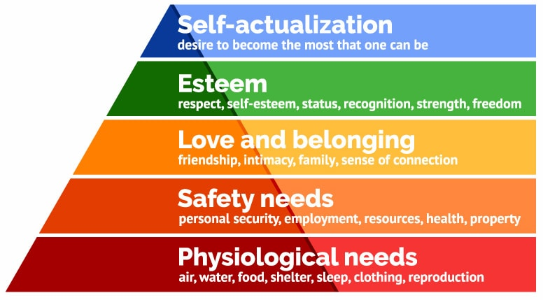
Blumler and Katz: Uses and Gratifications model
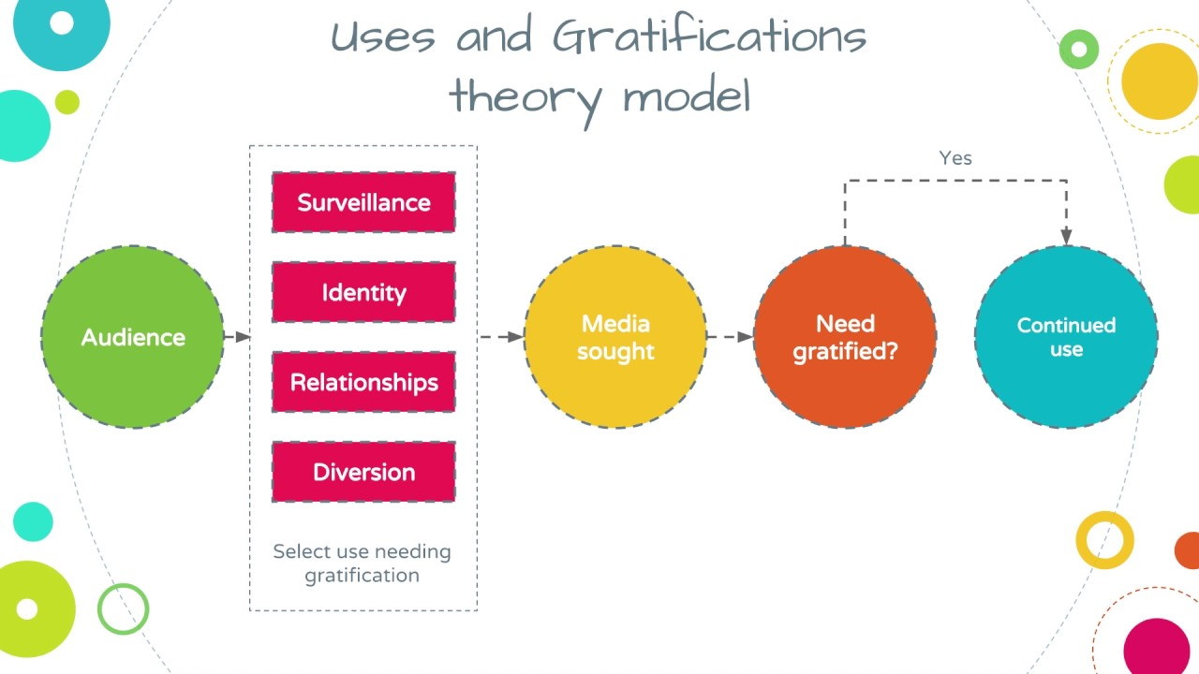

Theory: Galtung and Ruge News Values

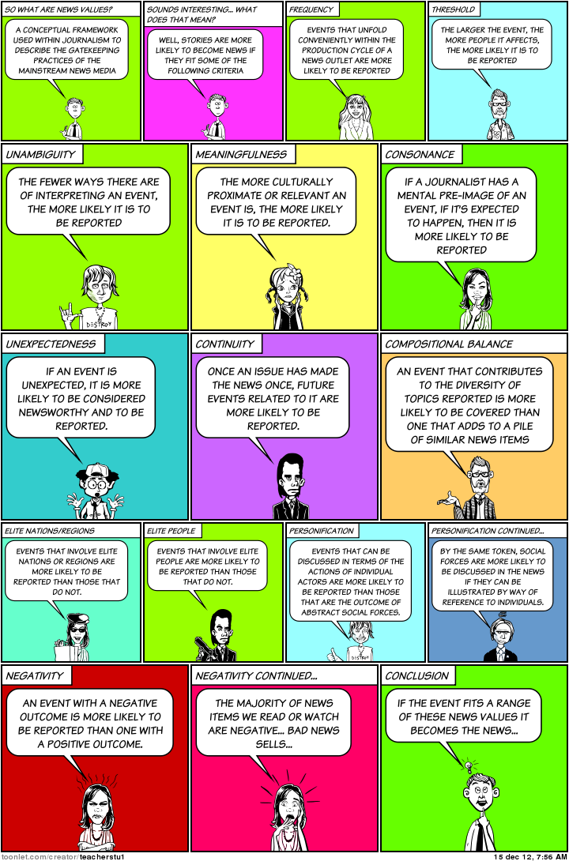

Audience categorisation: 4Cs Psychographic Profiling

Profile type | Characteristics
Mainstreamers | This is the largest group, who tend to be domestic, conform, and are conventional and sentimental. They seek security and favour value-for-money family brands.
Aspirers | This group is typically formed of younger people. They seek status, are materialistic, concerned with image and appearance.
Succeeders | This group is typically higher management and professional, who are confident and seek control. They are goal-minded, organised and work hard.
Resigned | This group comprises mainly older people, who are interested in the past and the traditional. They seek to survive and have rigid and authoritarian values.
Explorers | This group consists of a younger demographic, such as students. They are individualistic, have energy and seek new experiences.
Strugglers | This group consists of a lower demographic, such as low-income groups. They seek escape, buy alcohol, junk food and lottery tickets. They have few resources other than physical skills. They can be alienated and disorganised.
Reformers | This group are individuals with social awareness and independent judgement. They are anti-materialistic, but have good taste and social awareness

4Cs = Cross Cultural Consumer Characterisation

Audience categorisations: Socio-economic groups

A | Upper Middle Class | Higher managerial, administrative or professional job employment | Accountants, Civil or Electrical Engineers, Doctors, Clergy, lawyers, scientists, architects, pharmacists, vets
B | Middle Class | Intermediate managerial, administrative or professional job employment | Teachers, marketing and sales managers, nurses, journalists
C1 | Lower Middle Class | Non-manual skilled occupations | Office workers, secretaries, cashiers, driving instructors, restaurant managers
C2 | Skilled Working Class | Manual skilled occupations | Carpenters, joiners, plumbers, electricians, decorators, hairdressers
D | Working Class | Manual semi-skilled occupations | Care assistants, bar staff, farm workers, assembly line workers
E | Casual/ Lowest Grade Workers | Unskilled manual occupations and the unemployed | Builders, refuse collectors, cleaners, porters

MEDIA TERMINOLOGY

TERM | DEFINITION | R | A | G
ACTION CODE | Something that happens in the narrative that tells the audience that some action will follow, for example in a scene from a soap opera, a couple are intimate in a bedroom and the camera shows the audience the husband's car pulling up at the front of the house.
ACTIVE AUDIENCE | Audiences actively engage in selecting media products to consume and interpreting their meanings.
ANCHORAGE | The words that accompany an image (still or moving) contribute to the meaning associated with that image. If the caption or voice-over is changed then so may the way in which the audience interprets the image. An image with an anchor is a closed text; the audience are given a preferred reading. A text without an anchor is an open text as the audience can interpret it as they wish. The same image of a school in a local newspaper could include a negative or a positive headline, which may change the way in which the same image is viewed by the reader.
APPEAL | The way in which products attract and interest an audience, e.g. through the use of stars, familiar genre conventions etc.
ARC OF TRANSFORMATION | The emotional changes a character goes through in the process of the narrative. The events in the story mean that they will 'transform' by the end of the story.
ASPIRATIONAL | In terms of a media text, one that encourages the audience to want more money, up-market consumer items and a higher social position.
ATTRACT | How media producers create appeal to audiences to encourage them to consume the product.
AUDIENCE  CATEGORISATION | How media producers group audiences (e.g. by age, gender ethnicity) to target their products.
AUDIENCE CONSUMPTION | The way in which audiences engage with media products (e.g. viewing a TV programme, playing a video game, reading a blog or magazine). Methods of consumption have changed significantly due to the development of digital technologies.
AUDIENCE INTERPRETATION | The way in which audiences 'read' the meanings in, and make sense of, media products.
AUDIENCE POSITIONING | The way in which media products place audiences (literally or metaphorically) in relation to a particular point of view. For example, audiences may be positioned with a particular character or positioned to adopt a specific ideological perspective.
AUDIENCE RESPONSE | How audiences react to media products e.g. by accepting the intended meanings (preferred reading).
AUDIENCE SEGMENTATION | Where a target audience is divided up due to the diversity and range of programmes and channels. This makes it difficult for one programme to attract a large target audience.
AUDIO | How sound is used to communicate meaning - voice-over, dialogue, music, SFX, etc.
AVATAR | A player's representation of themselves within a game.
BACK STORY | Part of a narrative which may be the experiences of a character or the circumstances of an event that occur before the action or narrative of a media text. It is a device that gives the audience more information and makes the main story more credible.
BINARY OPPOSITES | Where texts incorporate examples of opposite values; for example, good versus evil, villain versus hero. These can be apparent in the characters, narrative or themes.

BRAND IDENTITY | The association the audience make with the brand, for example Chanel or Nike, built up over time and reinforced by the advertising campaigns and their placement.
BROADSHEET | A larger newspaper that publishes more serious news, for  example The Daily Telegraph has maintained its broadsheet format.
CAMERA ANGLES | The angle of the camera in relation to the subject. For example, a high angle shot (shot of a character from above) may make them appear more vulnerable.
CAMERA SHOTS | The type of shot and framing in relation to the subject, for example, close-up shots are often used to express emotion.
CAPTION | Words that accompany an image that help to explain its meaning.
CHANNEL IDENTITY | That which makes the channel recognisable to audiences and different from any other channel. Presenters, stars, programme genres and specific programmes all contribute to a channel's identity.
CIRCULATION | The dissemination of media products to audiences/users – the method will depend on the media form e.g. circulation of print magazines, broadcast of television programmes etc.
CONNOTATION | The suggested meanings attached to a sign, e.g., the red car in the advert suggests speed and power.
CONVENTIONS | What the audience expects to see in a particular media text, for example the conventions of science fiction films may include: aliens, scientists, other worlds, gadgets, representations of good and evil, etc. Useful headings to discuss conventions are: characters, setting, iconography, narrative, technical codes and representation.

CONVERGENCE | The coming together of previously separate media industries and/or platforms; often the result of advances in technology whereby one device or platform contains a range of different features. The mobile phone, for example, allows the user to download and listen to music, view videos, tweet artists etc. All this can be done through one portable device.
COVER LINES | These suggest the content to the reader and often contain teasers and rhetorical questions. These relate to the genre of the magazine.
CROSS-PLATFORM | In media terms, a text that is distributed and exhibited across a range of media formats or platforms. This may include film, television, print, radio and the Internet.
CULTURAL CAPITAL | The media tastes and preferences of an audience, traditionally linked to social class/background.
DEMOGRAPHIC CATEGORY | A group in which consumers are placed according to their age, sex, income, profession, etc. The categories range from A to E where categories A and B are the wealthiest and most influential members of society.
DENOTATION | The literal meaning of a sign, e.g. the car in the advert is red.
DIEGETIC SOUND | Sound that comes from the fictional world, for example sound of a gun firing, the cereal being poured into the bowl in an advert, etc.
DISCOURSE | The topics, language and meanings or values behind them within a media text. The discourse of lifestyle magazines, for example, tends to revolve around body image and narcissism.
DISTRIBUTION | The methods by which media products are delivered to audiences, including the marketing campaign. These methods will depend on the product (for example, distribution companies in the film industry organise the release of the films, as well as their promotion).

DIVERSIFICATION | Where media organisations who have specialised in producing media products in one form move into producing content across a range of forms.
EDITING | The way in which the shots move from one to the other (transitions), e.g. fade, cut, etc. Fast cutting may increase the pace and therefore the tension of the text, for example.
ENCODING AND DECODING | Media producers encode messages and meanings in products that are decoded, or interpreted, by audiences.
ENIGMA CODE | A narrative device which increases tension and audience interest by only releasing bits of information, for example teasers in a film trailer or narrative strands that are set up at the beginning of a drama/film that make the audience ask questions; part of a restricted narrative.
EQUILIBRIUM | In relation to narrative, a state of balance or stability (in Todorov's theory the equilibrium is disrupted and ultimately restored).
ETHNOCENTRIC | A belief in the superiority of one's own ethnic group or culture. For example, a newspaper will be more concerned to cover stories that are closely related to the reader and their concerns. Tabloid and local papers only tend to cover international news stories if they can relate them specifically to their readers.
ETHOS | The beliefs, values and customs of, for example, media organisations. In television, for example, what the channel believes in and what it sees as its role. The ethos is usually set out in the channel's charter.
FAN | An enthusiast or aficionado of a particular media form or product.
FEATURE | In magazine terms, the main, or one of the main, stories in an edition. Features are generally located in the middle of the magazine, and cover more than one or two pages.
FLEXI NARRATIVE | A more complex narrative structure with layers of interweaving storylines. This challenges the audience and keeps them watching.
FOUR CS | This stands for Cross Cultural Consumer Characteristics and was a way of categorising consumers into groups through their motivational needs. The main groups were Mainstreamers, Aspirers, Explorers, Succeeders and Reformers.
FRANCHISE | An entire series of, for example, a film including the original film and all those that follow.
GATE KEEPERS | The people responsible for deciding the most appropriate stories to appear in newspapers. They may be the owner, editor or senior journalists. They will only let the stories most appropriate for the ideology of the paper 'through the gate'.
GENRE | Media texts can often be grouped into genres that all share similar conventions. Science fiction is a genre, as are teenage magazines, etc.
GLOBAL | Worldwide - e.g. a media product with global reach is a product that is distributed around the world.
HEGEMONY | This derives from the theory of cultural hegemony by Antonio Gramsci. Hegemony is the dominance of one group over another, often supported by legitimating norms and ideas. For example, the dominant social position in society is taken by men and the subordinate one by women.
HORIZONTAL INTEGRATION | Where a media conglomerate is made up of different companies that produce and sell similar products, often as a result of mergers. For example a company with interests in film, TV, magazines newspaper.

HOUSE STYLE | The aspects that make a magazine recognisable to its readers every issue. The house style is established through the choice of colour, the layout and design, the font style, the content and the general 'look' of the publication.
HYBRID GENRE | Media texts that incorporate elements of more than one genre and are therefore more difficult to classify are genre hybrids. Dr Who, for example, is a science fiction/fantasy television drama.
HYPODERMIC NEEDLE MODEL | Generally acknowledged to be an out of date media effects theory which suggests that an audience will have a mass response to a media text. The idea is that the media product injects an idea into the mind of an audience who are assumed to be passive and as a result will all respond in the same way.
ICONOGRAPHY | The props, costumes, objects and backgrounds associated with a particular genre; for example, in a police series you would expect to see, uniforms, blue flashing lights, scene of crime tape and police radios.
IDEOLOGY | A set of messages, values and beliefs that may be encoded into media products.
INDEPENDENT FILM | A film made outside of the financial and artistic control of a large mainstream film company. A truly independent film will be privately conceived and funded. However, few films made are really 'independent'. This more commonly refers to a film that is made by a smaller film company on a low budget.
INDEPENDENT RECORD LABEL | A record label that operates without the funding of, and that is not necessarily linked to, a major record label.
INTELLECTUAL PROPERTY | A legal concept which refers to creations of the mind for which the owner's rights are recognised. These rights cover such intangible assets as music, literary and artistic works; discoveries and inventions; and words, phrases, symbols, and designs.
INTERACTIVE AUDIENCE | The ways in which audiences can become actively involved with a product, for example by posting a response to a blog or live tweeting during a television programme.
INTERTEXTUAL | Where one media text makes reference to aspects of another text within it. For example, referencing a scene from a film in a television advertisement. Audiences enjoy recognising intertextual references.
INTERTEXTUALITY | Where one media product intertextually references another.
LAYOUT AND DESIGN | The way in which a page has been designed to attract the target audience. This includes the font styles used, the positioning of text and images and the use of colour.
LINEAR NARRATIVE | Where the narrative unfolds in chronological order from beginning to end.
LUDOLOGY | The study of games and those who play them, relevant to video games.
MASCULINITY | The perceived characteristics generally considered to define what it is to be a man. These can change according to sociological and cultural variations
MASS AUDIENCE | The traditional idea of the audience as one large, homogenous group.
MEDIA CONGLOMERATE | A company that owns other companies across a range of media
MEDIA FORMS | Types of media products, for example television, newspapers, advertising.
MEDIA LANGUAGE | The specific elements of a media product that communicate meanings to audiences, e.g. visual codes, audio codes, technical codes, language.
MEDIA PLATFORM | The range of different ways of communicating with an audience, for example newspapers, the Internet, and television.
MEDIATION | The way in which a media text is constructed in order to represent a version of reality; constructed through selection, organisation and focus.

MISE-EN-SCENE | In analysis of moving image products, how the combination of images in the frame creates meaning; how individual shots in a film or photograph have been composed.
MISREPRESENTATION | Certain social groups (usually minority groups) may be represented in a way that is inappropriate and not based on reality.
MMORPG | Massively multi-player online role-playing game.
MODE OF ADDRESS | The way in which a media text 'speaks to' its target audience. For example, teenage magazines have a chatty informal mode of address; the news has a more formal mode of address.
NARRATIVE | The 'story' that is told by the media text. All media texts, not just fictional texts, have a narrative. For example, magazines have a clear beginning, middle and end. Most narratives are linear and follow a specific structure (see Todorov).
NEWS AGENDA | The list of stories that may appear in a particular paper. The items on the news agenda will reflect the style and ethos of the paper.
NICHE AUDIENCE | A relatively small audience with specialised interests, and backgrounds.tastes,
NON-DIEGETIC SOUND | Sound that comes from outside the fictional world, for example a voiceover, romantic mood music etc.
NON-LINEAR NARRATIVE | Here the narrative manipulates time and space. It may begin in the middle and then include flashbacks and other narrative devices.
OPEN WORLD | In an open world computer game the player can move freely though the virtual world and is not restricted by levels and other barriers to free roaming.
OPINION LEADERS | People in society who may affect the way in which others interpret a particular media text. With regard to advertising, this may be a celebrity or other endorser recommending a product.

PASSIVE AUDIENCE | The idea (now widely regarded as outdated) that audiences do not actively engage with media products, but passively consume and accept the messages that producers communicate.
PATRIARCHAL CULTURE | A society or culture that is male dominated.
PICK AND MIX THEORY | Suggested by British sociologist and media theorist, David Gauntlett. He asserted the autonomy of the audience and challenged the notion that audiences are immediately affected by what they read. He maintains that audiences are more sophisticated than this and will select aspects of the media texts that best suit their needs and ignore the rest.
PLURALITY | In a media context, this refers to a range of content to suit many people.
POLITICAL BIAS | Where a newspaper may show support for a political through its choice of stories, style of coverage, cartoons, etc. It may be subtle and implicit or explicit as in the case of the tabloid newspapers on election day. party
PRIVILEGED SPECTATOR POSITION | Where the camera places the audience in a superior position within the narrative. The audience can then anticipate what will follow.
PRODUCTION | The process by which media products are constructed.
PRODUCTS | Media texts, including television programmes, magazines, video games, newspapers etc. as well as online, social and participatory platforms.
PUBLIC SERVICE BROADCASTER | A radio and television broadcaster that is financed by public money (e.g. the licence fee in the UK) and is seen to offer a public service by catering for a range of audiences and providing information, as well as entertainment.
REALISM | A style of presentation that claims to portray 'real life' accurately and authentically.
REGULATOR | A person or body that supervises a particular industry.
REPERTOIRE OF ELEMENTS | Key features that distinguish one genre from another.
REPRESENTATION | The way in which key groups or aspects of society are presented by the media, e.g. gender, race, age, the family, etc. Literally, a re-representation or constructed version of that which is shown.
SELECTION AND COMBINATION | Media producers actively choose elements of media language and place them alongside others to create specific representations or versions of reality.
SEXUAL OBJECTIFICATION | The practice of regarding a person as an object to be viewed only in terms of their sexual appeal and with no consideration of any other aspect of their character or personality.
SIGN/CODE | Something which communicates meaning, e.g., colours, sounds. The meaning of the sign changes according to the context, e.g., the colour red can mean passion, love, danger or speed depending on how and where it is used.
SIMULCAST | The streaming of live radio programmes from the website at the same time as they are broadcast on the radio.
SPECIALISED AUDIENCE | A non-mass, or niche, audience that may be defined by a particular social group (for example young, aspirational females) or by a specific interest (for example skydiving).
SPLASH | The story that is given the most prominence on the front of a newspaper page
STEREOTYPE | An exaggerated representation of someone or something. It is also where a certain group are associated with a certain set of characteristics, for example all Scotsmen are mean, blondes are dumb, etc. Stereotypes can be quick ways of communicating information in adverts and dramas, e.g. the rebellious teenager in a soap opera, as they are easily recognisable to audiences.
STRIPPED | A technique used in radio and television whereby a certain programme is broadcast at the same time every day. In radio this attracts an audience who associate a particular programme with their daily routine, for example driving home from work.
SUB-GENRE | Where a genre is sub-divided into smaller categories each which has their own set of conventions. For example, the television drama genre can be sub-divided into teen drama, hospital drama, costume drama, etc. of
SUBJECT-SPECIFIC LEXIS | The specific language and vocabulary used to engage the audience. Subject-specific lexis used on the front cover of the magazine will make the reader feel part of the group who belong to the world of that magazine. For example, terminology used on the front covers of gaming magazines.
SYNERGY | The combination of elements to maximise profits within a media organisation or product. For example, where a film soundtrack sells the film and the film sells the soundtrack.
TABLOID | Refers to the dimensions of a newspaper; a tabloid is smaller and more compact in size. However, there are further connotations attached to the term and it also tends to refer to a newspaper whose content focuses on lighter news, for example celebrity gossip, sport and television.
TARGET AUDIENCE | The people at whom the media text is aimed.
TECHNICAL CODES | These are the way in which the text has been produced to communicate meanings and are part of media language.
TEXTUAL POACHING | The way in which audiences or fans may take particular texts and interpret or reinvent them in different ways e.g. by creating fan fiction.
UNDERREPRESENTATION | Certain social groups (usually minority groups) may be rarely represented or be completely absent from media products.
USES AND GRATIFICATIONS THEORY | Suggests that active audiences seek out and use different media texts in order to satisfy a need and experience different pleasures.

VERTICAL INTEGRATION | Vertically integrated companies own all or most of the production and distribution for the product. For example, a film company that also owns a chain of multiplex cinemas to exhibit the film and merchandise outlets.
VIEWPOINTS | Different perspectives in relation to values, attitudes, beliefs or ideologies.
VIRAL MARKETING | Where the awareness of the product or the advertising campaign is spread through less conventional ways including social networks and the Internet. Viral marketing is so named because many of the messages use 'hosts' to spread themselves rapidly, like a biological virus.
VISUAL CODES | The visual aspects of the product that construct meaning and are part of media language, for example clothing, expression, and gesture.
'WINDOW ON THE WORLD' | The idea that media texts, particularly those that present aspects of reality, for example news programmes, are showing the audience the 'real' world as it happens.

THE REVISION PYRAMID

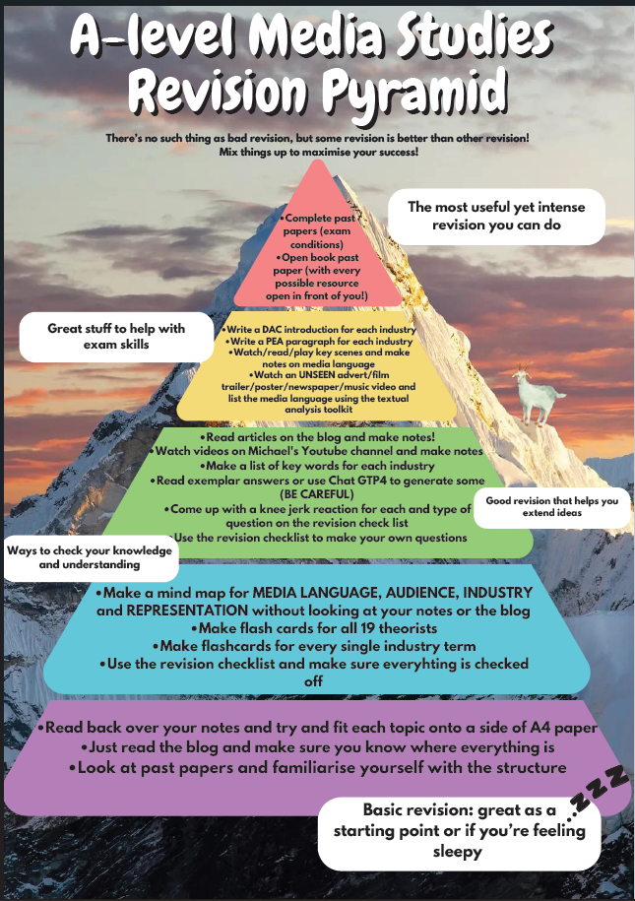
COMMAND WORDS
Command words are the words and phrases used in exams and other assessment tasks that tell students how they should answer a question. The following command words are from Ofqual’s official list. Their meanings are relevant to this subject.

Analyse
Separate information into components and identify its characteristics (examine in detail, to explain and interpret)

Compare
Identify similarities and/or differences

Consider
Review and respond to the information given

Define
Specify a meaning

Evaluate

Judge a statement or situation from the evidence provided

Explain
Set out purposes or reasons

Give
Produce an answer

How far/how valid/how useful/etc
Make a judgment to draw a conclusion

Identify
Name or otherwise characterise

State
Express something clearly

To what extent
Judge the importance of/ or success of/ or merit of something

What
Specify/select something

Which
Specify/select something from a range of possibilities

Why
Give a reason or purpose
SAMPLE PAPERS: COMPONENT 1

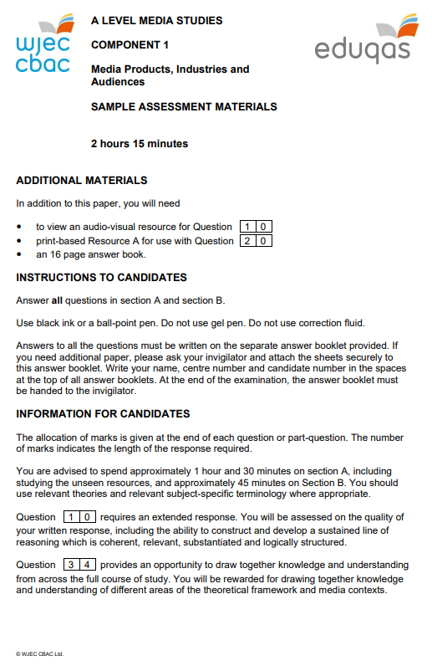
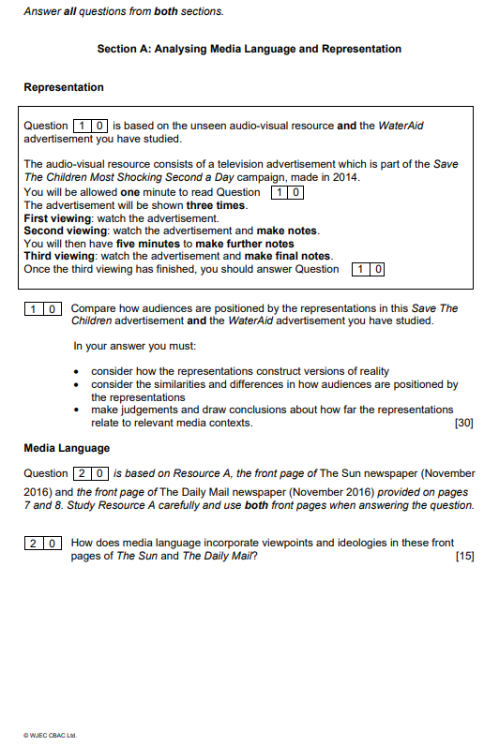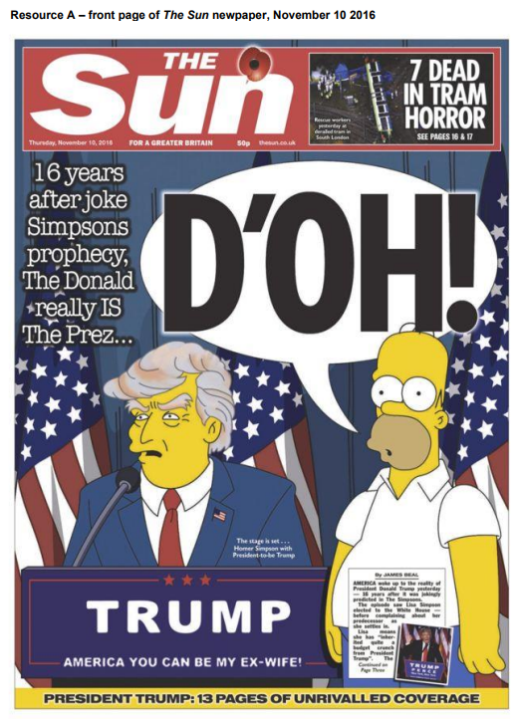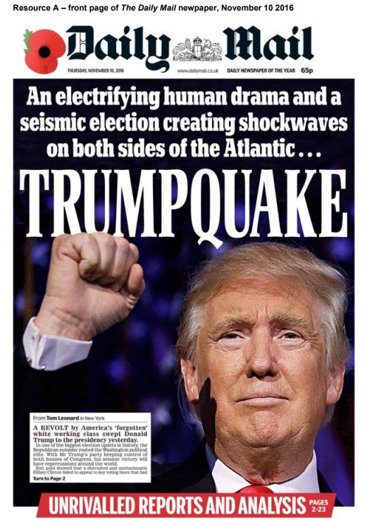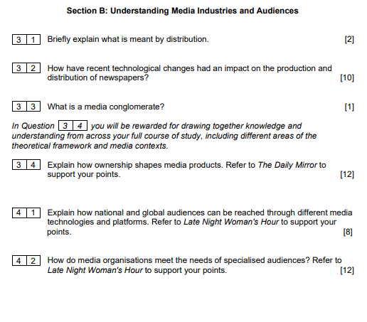

SAMPLE PAPERS: COMPONENT 2
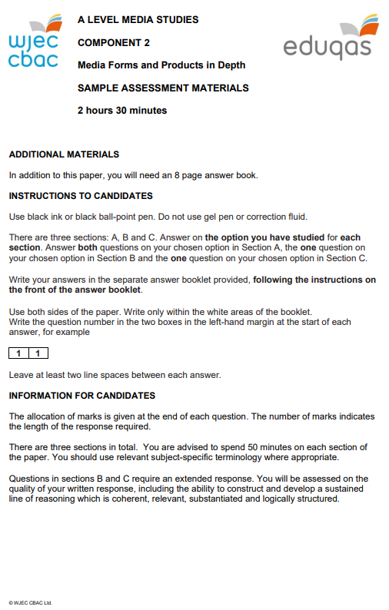
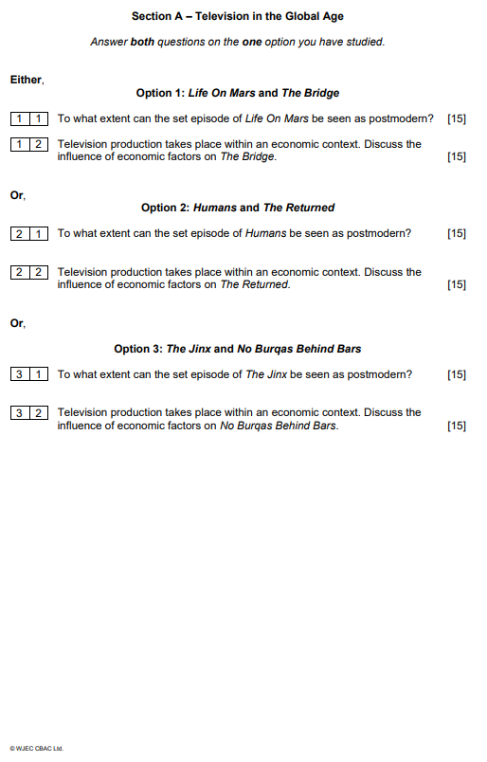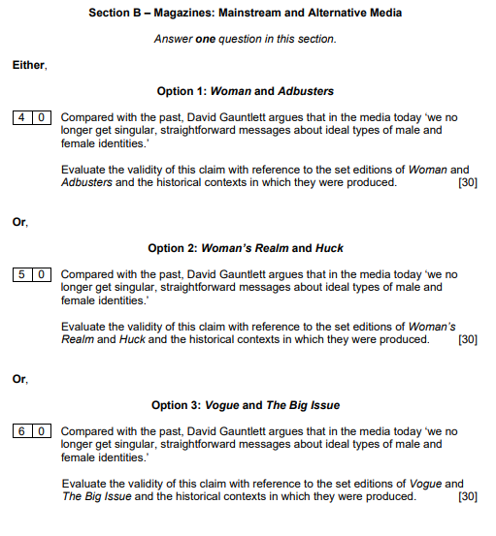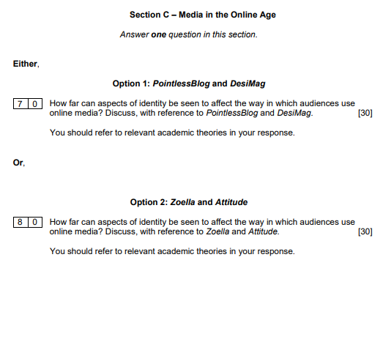

Useful reading lists and websites

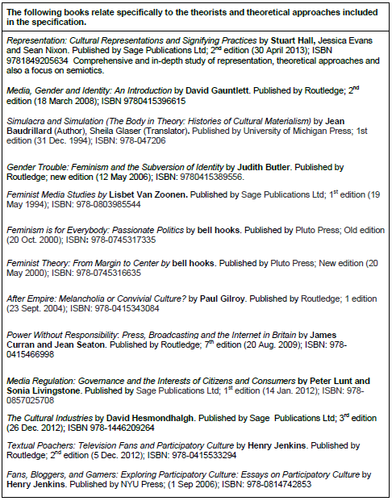
Useful reading lists and websites

