MEDIA STUDIES GRADE BOUNDARIES FROM DIFFERENT YEARS
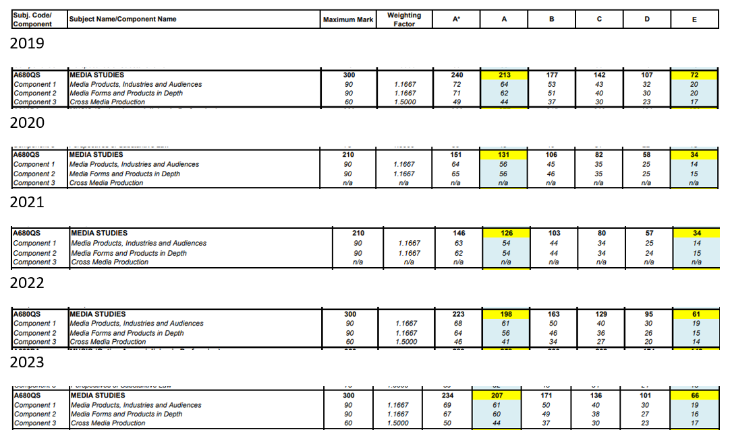

OVERALL RANGES AND PERCENTAGES BASED ON HARSHEST BOUNDARY
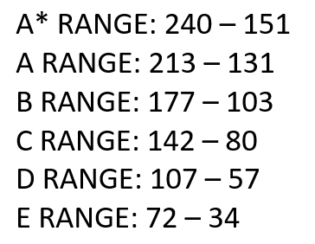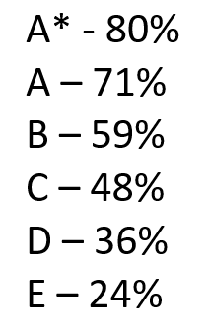
COM 1 PERCENTAGES BASED ON HARSHEST BOUNDARY (WILL WORK FOR COM 2, WHICH IS SLIGHTLY LESS HARSH, BUT SAME TOTAL / 90)
A* - 72/90 = 80%
A – 64/90 = 71%
B – 53/90 = 59%
C – 43/90 = 48%
D – 32/90 = 36%
E – 20/90 = 23%

COM 3 NEA PERCENTAGES BASED ON HARSHEST BOUNDARY (OUT OF 60 TO AVOID WEIGHTING ERROR)
A* - 50/60 = 83%
A – 44/60 = 73%
B – 37/60 = 62%
C – 30/60 = 50%
D – 23/60 = 38%
E – 17/60 = 28%

