**WALLINGFORD SCHOOL MEDIA DEPARTMENT**

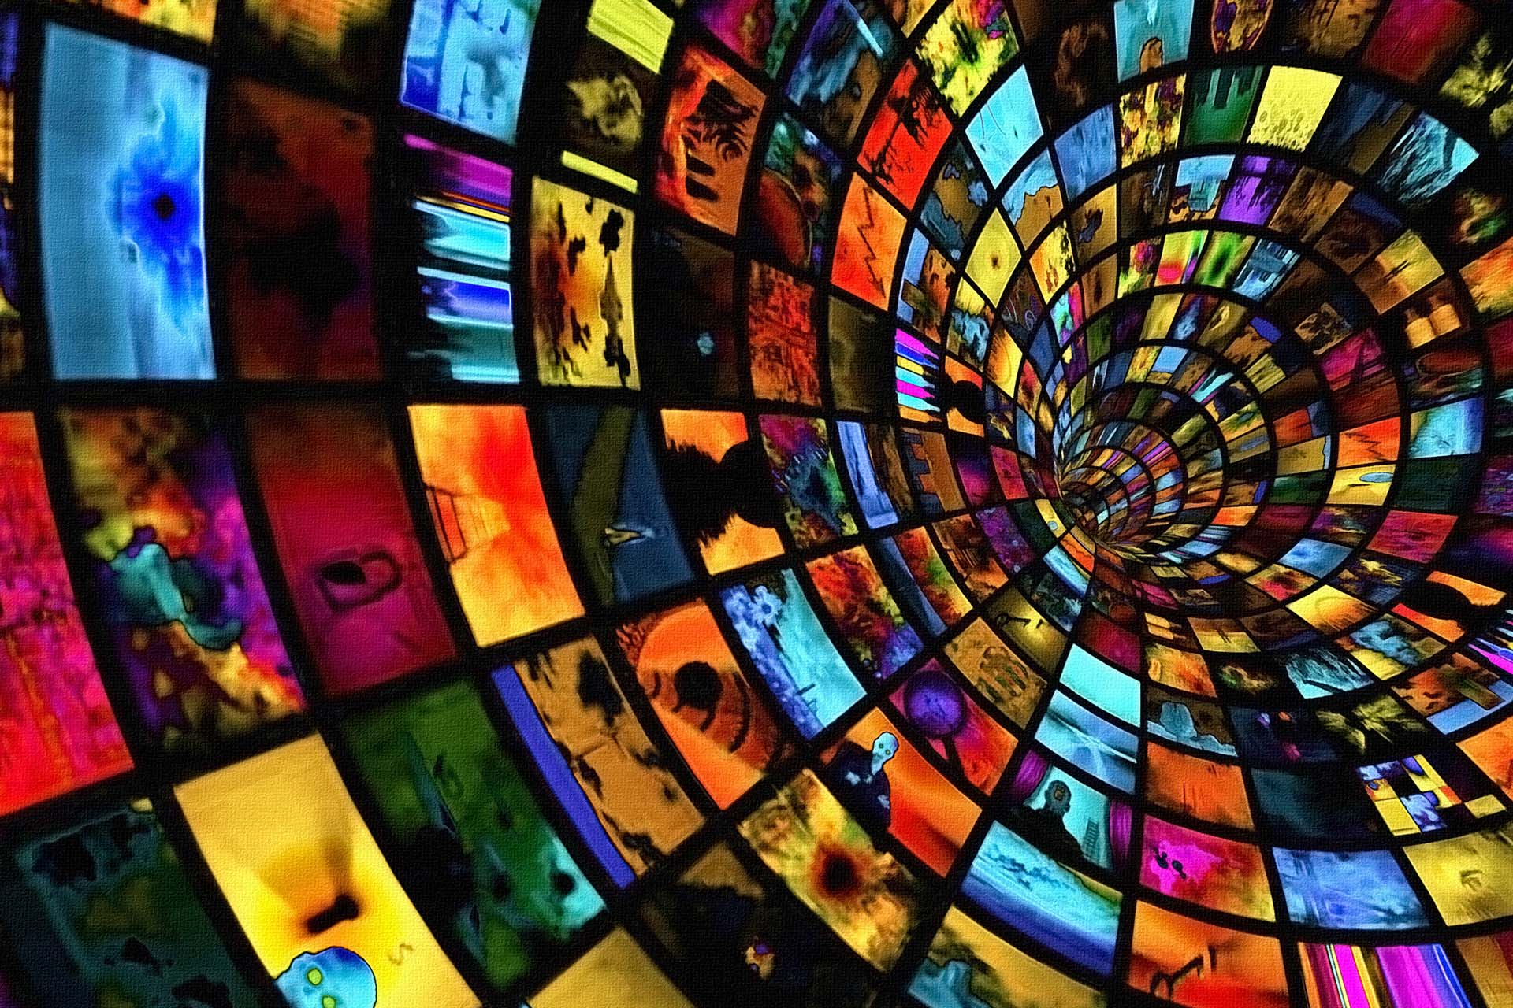

A-Level

Media Studies

**NEA Guidance booklet 2024**

**A-level Media Studies NEA Brief 2024**

**DESCRIPTION OF PRODUCTION**

You will be creating a cross-media production for a new magazine in a genre (or sub-genre) of your choice.

* Create original print pages for a new magazine (TASK 1) and associated online or audio/audio-visual material (**EITHER** TASK 2A **OR** TASK 2B) to promote the same magazine.

**Industry information**

* You should create a cross-media production for a publishing organisation that operates internationally (such as Hearst or Conde Nast)

**Audience information**

* Your cross-media production should target an audience of 18 – 35 year olds with an interest in your chosen genre.

**OTHER TASKS**

* You will also have to hand in a Statement of Aims
* You will have to undertake Research and Planning

**HOW IS IT ASSESSED?**

* The production is worth 50 marks
* The statement of aims is worth 10 marks
* The research and planning is not assessed, but must be done

**Task 1**

**Print**

Create

* a front cover for a UK edition of your magazine,
* A front cover for an edition of the magazine in another country
* double-page feature article from either of these issues

**Length: 4 pages**

**Your print production must construct representations of at least one social group and include a minimum of 6 original images as detailed below.**

**Each front cover:**

• Original title and masthead for the magazine

• Strapline

• Cover price and barcode

• Original main cover image appropriate to the genre (additional original images may be included if appropriate); the front cover should include an image of at least one person (each edition should feature a DIFFERENT cover model)

• A lead cover line relating to the main image

• At least three additional cover lines

**Note: no images or cover lines should be repeated across the two front covers**

**Double page feature article (or extract from a longer article):**

• Article on a topic or issue appropriate to the genre of magazine and target audience, approximately 400 words in length and relating to a cover line on the front cover

• Headline, standfirst and by-line

• Column layout appropriate to the genre

• One main image and additional smaller/minor images (all original and different from the images on the covers); these should be captioned and credited

• At least one pull quote and/or sidebar containing additional information relevant to the main article

• Page numbers should appear on each page

**Task 2**

**Create a sequence from either a podcast or YouTube channel video, produced by your magazine, about the launch of the non-UK version of the magazine.**

**Length: 2 minutes – 2 minutes 30 seconds**

**The sequence must construct representations of at least one social group.**

**Podcast:**

• Introduction/overview of the item by the presenter

• Interview with the editor of the non-UK version of the magazine

• Introduction in a studio setting and footage in at least one other location, such as an international office of the magazine or a photoshoot

• A range of audio elements (including dialogue, voiceover, a sound bed and/or jingle)

• Editing of sound

**OR**

**YouTube channel video:**

• Introduction/overview of the item by the presenter

• Interview with the editor of the non-UK version of the magazine

• Introduction in a studio setting and footage in at least one other location, such as an international office of the magazine or a photoshoot

• A range of camera shots and angles

• Editing of footage and on-screen graphics

**TIMELINE AND DEADLINES**

|  |  |  |
| --- | --- | --- |
| **TASK** | **DEADLINE** | **TICK** |
| Research completed |  |  |
| Informal review point done |  |  |
| Planning completed |  |  |
| ‘Completion of planning’ review point done |  |  |
| Statement of Aims and Intentions written |  |  |
| ‘Statement of Aims’ review point done |  |  |
| UK magazine front cover completed |  |  |
| International magazine front cover completed |  |  |
| Magazine double page feature completed |  |  |
| ‘Production Process Task 1’ review point done |  |  |
| Either Podcast or YouTube video completed |  |  |
| ‘Production Process Task 2’ review point done |  |  |
| Revisit ‘Statement of Aims and Intentions’ |  |  |
| Ensure all planning and research is handed in |  |  |
| Print out magazine pages in colour, high quality with names and candidate numbers on |  |  |
| Check all links work for audio / audio-visual content |  |  |
| Check all paperwork is signed |  |  |
| ‘Completion of Cross-Media Production’ review point done |  |  |

**RESEARCH GUIDE**

|  |  |  |  |
| --- | --- | --- | --- |
| **Task** | **Detail** | **Outcome – in folder** | **Date** |
| 1. **Industry Research** | * Research major international publishing organisations (e.g. Hearst, Conde Nast) * How big are they? * What types of magazines? * Specific genres? * How will your magazine fit in? | Info sheet on different publishers  Screenshotted examples of magazines they have produced |  |
| 1. **Audience Research** | * What do people in this age range enjoy? * What magazines might they read? * How do they read? * Which magazines do they recognise made by your chosen publisher? * What do they think of your ideas? (presenting preliminary ideas to a focus group may help you to decide which is better) | Summary of audience demographic  Questionnaire  Results analysis |  |
| 1. **Mag Front cover analysis (UK)** | At least 3 UK magazine covers with similar genre. | Annotated analysis  Written summary including key ideas that inspire you |  |
| 1. **Mag Front cover analysis (International)** | At least 3 **matching** international magazine covers from a similar genre | Annotated analysis  Written summary including key ideas that inspire you |  |
| 1. **Mag double-page feature analysis** | At least 2 double page spreads | Annotated analysis of media language, including layout  Written summary including key ideas that inspire you |  |
| 1. **Podcast research** | Analysis of 2 different podcasts that are linked to the magazines you have analysed in your research | Written analysis that covers: presenter style, audio effects, language used, podcast structure, editing |  |
| 1. **YouTube channels research** | Analysis of 2 different YouTube channels that are linked to the magazines you have analysed in your research | Written analysis that covers: presenter style, audio effects, visual effects, language used, structure, editing |  |
| 1. **Initial ideas** | Spend time mind mapping and considering different ideas  **START TAKING LOADS OF PHOTOS! You will need at least 6 original images and they should represent a ‘social group’ so they need to have people in them** | Mind maps/brain storms  List of potential titles |  |

**PLANNING GUIDE**

|  |  |  |  |
| --- | --- | --- | --- |
| **Task** | **Detail** | **Outcome – in folder** | **Date** |
| **INFORMAL REVIEW POINT** | | |  |
| 1. **Draft of front covers** | Draft your front covers – perhaps do 2 versions of each and ask your target audience which they prefer. **Make sure you include everything mentioned on page 3** | Drafts of front covers  Cover photo ideas |  |
| 1. **Draft of layout of DPS** | Draft the layout of your double-page spread. **Make sure you include everything stipulated on page 3** | Drafts of layout |  |
| 1. **Draft the copy for your DPS** | Write the article for your double-page spread. Pay attention to linguistic codes and ensure they are appropriate for your audience and the genre. **Make sure the word count is correct: approx. 400 words. See page 3 for further details** | A full plan of your article |  |
| **DON’T FORGET: EITHER CHOOSE PODCAST OR YOUTUBE VIDEO** | | | |
| 1. **Podcast planning** | <https://www.voices.com/blog/planning-your-podcast/>  Read the above for some good ideas  Google ‘how to plan a podcast’ for more  **Make sure your planning includes the details from page 4** | Timeline for podcast with key sound ideas and segues  Scripts for the different sections  Editing ideas |  |
| 1. **Youtube planning** | [Before You Shoot - How to Plan a YouTube Video (cyberlink.com)](https://www.cyberlink.com/blog/youtube-video-editing/40/planning-a-youtube-video)  Read through the above to get some brilliant practical advice.   * Create a storyboard * Create a script * Create a timeline   **Make sure you include all the things on page 4** | Storyboard – labelled and explained as appropriate.  Script  Timeline with key sound ideas and segues  Editing ideas |  |
| **‘COMPLETION OF PLANNING’ REVIEW POINT** | | |  |
| **WRITE STATEMENT OF AIMS** | | |  |
| **‘STATEMENT OF AIMS’ REVIEW POINT** | | |  |

**PRODUCTION CHECKLIST: MINIMUM REQUIREMENTS**

|  |  |  |  |
| --- | --- | --- | --- |
| **TASK 1: MAGAZINE FRONT COVER, DOUBLE-PAGE REATURE ARTICLE, ‘NEXT ISSUE’ PAGE** | | | |
| **FRONT COVER UK (DO NOT REPEAT ANYTHING ACROSS THE TWO COVERS)** | |  | |
|  | Original title and masthead for the magazine |  | |
|  | Strapline |  | |
|  | Cover price and barcode |  | |
|  | Original main cover image appropriate to the genre (additional original images may be included if appropriate); the front cover should include an image of at least one person (each edition should feature a different cover model) |  | |
|  | A lead cover line relating to the main image |  | |
|  | At least three additional cover lines |  | |
| **FRONT COVER INTERNATIONAL (DO NOT REPEAT ANYTHING)** | |  | |
|  | Original title and masthead for the magazine | |  | |
|  | Strapline | |  | |
|  | Original main cover image appropriate to the genre (additional original images may be included if appropriate); the front cover should include an image of at least one person (each edition should feature a different cover model) | |  | |
|  | A lead cover line relating to the main image | |  | |
|  | At least three additional cover lines | |  | |
| **DOUBLE PAGE FEATURE ARTICLE** | |  | |
|  | Article on a topic or issue appropriate to the genre of magazine and target audience, approximately 400 words in length and related to a cover line on the front cover |  | |
|  | Headline |  | |
|  | Standfirst |  | |
|  | By-line |  | |
|  | Column layout appropriate to the genre |  | |
|  | One main image and additional smaller images (all original and different from the images on the covers); these should be captioned and credited |  | |
|  | At least one pull quote and/or a sidebar containing additional information relevant to the main article |  | |
|  | Page numbers should appear on each page |  | |
| **‘PRODUCTION PROCESS TASK 1’ REVIEW POINT** | |  | |

Notes: you can use fake names for anything e.g. the photographer’s name, the celebrity’s name etc.

**PRODUCTION CHECKLIST: MINIMUM REQUIREMENTS**

|  |  |  |
| --- | --- | --- |
| **TASK 2: AUDIO / AUDIO VISUAL**  **EITHER PODCAST OR YOUTUBE VIDEO** | | |
| **PODCAST** | |  |
|  | Introduction / overview of the item by the presenter |  |
|  | Interview with the editor of the non-uk version of the magazine |  |
|  | Introduction in a studio setting and further recording in at least one other location, such as at a photoshoot for the magazine, or at the magazine’s international offices |  |
|  | A range of audio elements:   * Dialogue * Voiceover * Soundbed * Jingle |  |
|  | Editing of sound |  |
|  | Length 2 mins – 2 mins 30 seconds |  |
| **YOUTUBE CHANNEL VIDEO** | |  |
|  | Introduction / overview of the item by the presenter |  |
|  | Interview with the editor of the non-uk version of the magazine |  |
|  | Introduction in a studio setting and further recording in at least one other location, such as at a photoshoot for the magazine, or at the magazine’s international offices |  |
|  | A range of camera shots and angles |  |
|  | Editing of footage and on-screen graphics |  |
|  | Length 2 mins – 2 mins 30 seconds |  |
| **‘PRODUCTION PROCESS TASK 2’ REVIEW POINT** | |  |

Notes: don’t forget to continue to construct representations of social group

**Information from Eduqas**

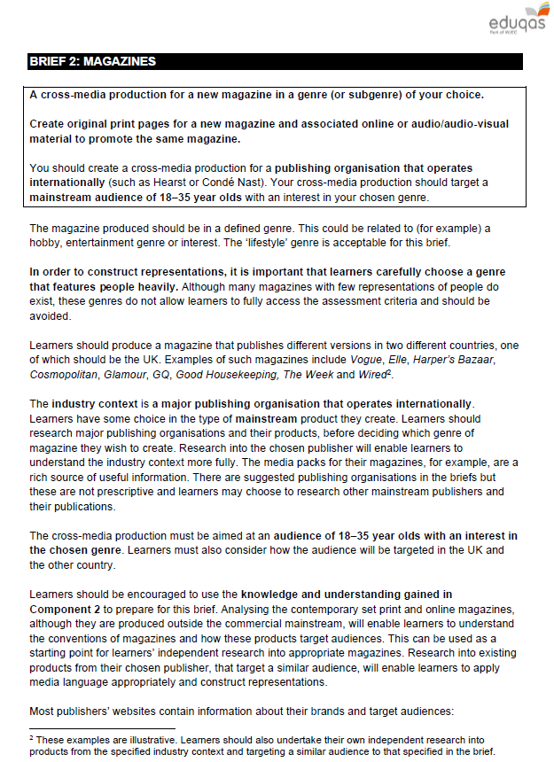

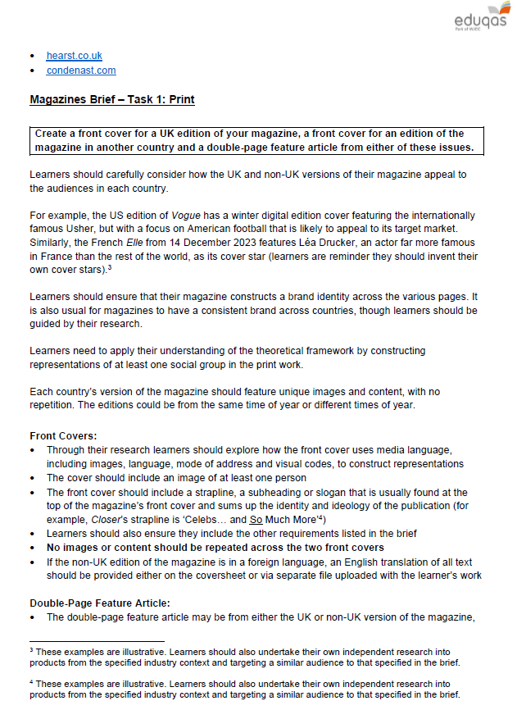

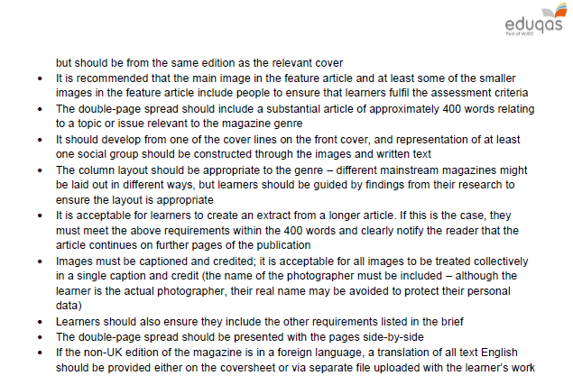

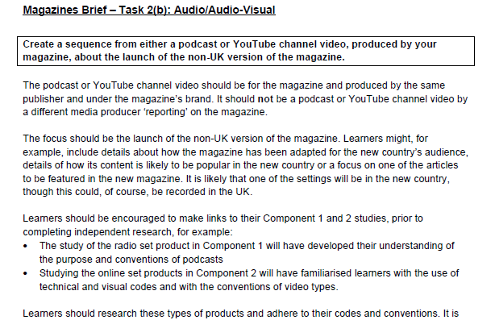

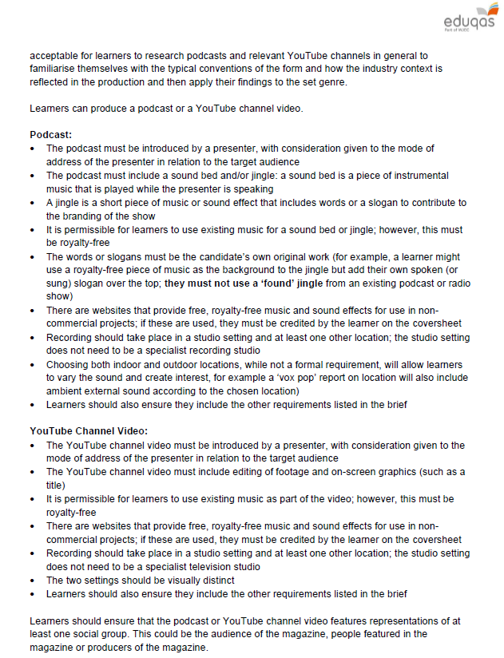

## Assessment Grid for Component 3: bands 4 and 5

## Assessment Grid for Component 3: bands 2 and 3

## Assessment Grid for Component 3: bands 1 and 0

**You must submit:**

* **A statement of aims and intentions** (10 marks)
* **A completed CROSS-MEDIA production** in response to a brief set by the board.
* This will consist of two pieces of work. (50 marks altogether – 20 marks for how well both pieces fulfil the brief and 30 marks for how good the design is)
* **A completed cover sheet**, signed at 4 key points in the process

You will also undertake extensive research and planning work.

* Research and planning work is not submitted, but it has to be authenticated by the teacher and must be kept by the teacher. The teacher is required to make this work available to Eduqas should this be requested.

**Paperwork that you will have to submit**

