Lesson 1 task

# Task 1a

Below is the code for a square – write this code and save it as **task1a**

This code will draw **each side 100 pixels in length**

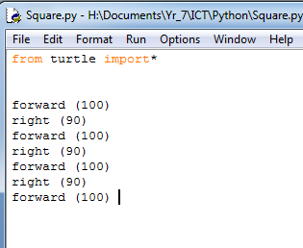

# Task 1b

Create a new program that has a square where each side equals **180** pixels. Save this as **task 1b**

# Task1c

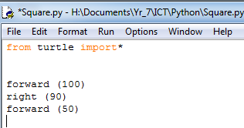

1. Complete the code so that it creates a rectangle **task1c**
2. Change the code so that shorter sides are now 60 and your larger sides are 180. Save this code as **task 1d**