Lesson 1 extension

Below are some extra commands that you can use with the turtle:

|  |  |
| --- | --- |
| **forward ()** | **Move the arrow forward** |
| **backward ()** | **Move the arrow backwards** |
| **right ()** | **Rotate the arrow to the right** |
| **left ()** | **Rotate the arrow to the left** |
| **penup ()** | **Lift the pen to stop drawing** |
| **pendown ()** | **Replace the pen to continue drawing** |
| **fillcolor (“ “)** | **Choose the colour to fill the shape** |
| **begin_fill ()** | **Start to fill the shape before drawing the shape** |
| **end_fill ()** | **Finish the colour fill after drawing the shape** |
| **pencolor (“ “)** | **Change the colour of the pen** |
| **pensize ()** | **Change the thickness of the pen** |

**1e)** Using the **pen up** and **pen down** functions, draw a square and a rectangle that will appear on the turtle screen together with **a space between** both shapes

Save as **task1e**

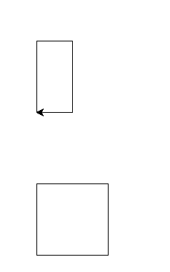

**Lift the pen with penup()**

**You will need to move the arrow**

**Then put the pen down**

**pendown()**

## Extension

**1h)** Using the instruction circle(100),

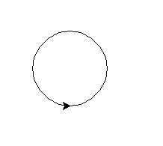

**1i)** Can you see if you can use the skills that you have now learned to draw a face?

