Task 4 Extension

## Task 4h

Recreate this program, changing each shape so that it has a different fill colour. Save as **task 4h**

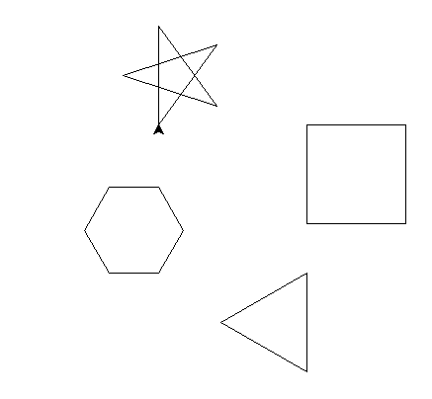

***Hints:***

You must use for loops to make the code as efficient as possible.

You can use copy and paste to speed up the coding.

You may need the instructions sheet to remember how to colour the shapes and how to move the turtle without drawing.

## Task 4i

Recreate this program in **no more than 11 lines of code.**

***Hint***: start with backward(200) to fit all the squares on the page.

***Hint***: you will need to use a **for loop inside a for loop** (this is called a nested for loop)

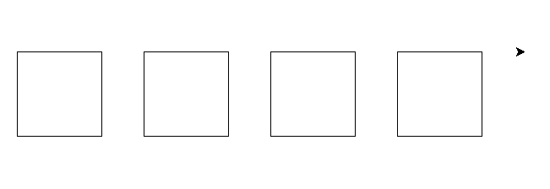

# Super extension

## Task 4j

Recreate this program, save as **task 4j**

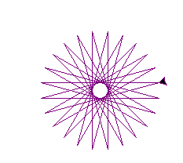

***Hint:*** This star has 25 sides and goes   
through 360ᵒ 11 times!!

25 x 360

11