Task 4 Using a for loop

# Import turtle and add the loop instruction

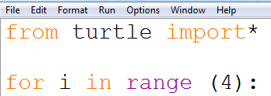

# Now add the drawing instruction

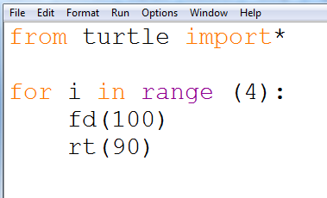

Notice the indent after the colon

Press F5 to run the code

Save your program and name it: *task4a*