|  |  |
| --- | --- |
| **fd ()** | **Move the arrow forward** |
| **bk ()** | **Move the arrow backwards** |
| **rt ()** | **Rotate the arrow to the right** |
| **lt ()** | **Rotate the arrow to the left** |
| **pu ()** | **Lift the pen to stop drawing** |
| **pd ()** | **Replace the pen to continue drawing** |
| **fillcolor (“ “)** | **Choose the colour to fill the shape** |
| **begin_fill ()** | **Start to fill the shape before drawing the shape** |
| **end_fill ()** | **Finish the colour fill after drawing the shape** |
| **pencolor (“ “)** | **Change the colour of the pen** |
| **pensize ()** | **Change the thickness of the pen** |

## Task 2f

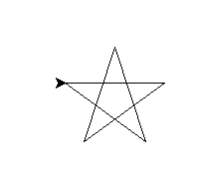 Create a 5 pointed star the angle is 144 degrees

Save this as **task 2f**

## Task 2g

Create an isosceles triangle

* The base is 40
* The height is 100
* Two angles of 100 and one angle of 160

***Hint***: turn left / right first before moving forward.

Save this as **task 2g**

# Super extension

## Task h

Create a church using the isosceles triangle from 2f and your knowledge of rectangles.   
  
Once you have done this add colour to your church and stars in the sky.

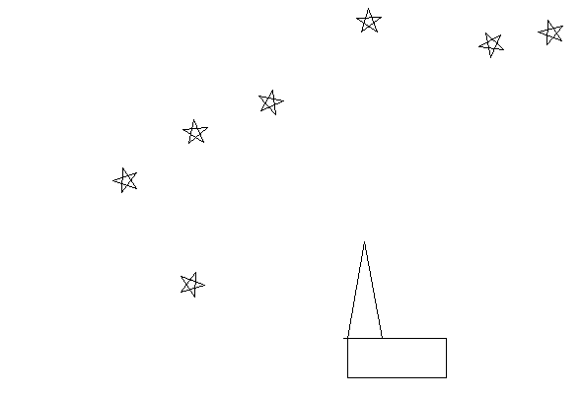Save this is as **task 2h**