AS DANCE

FLESH AND BLOOD

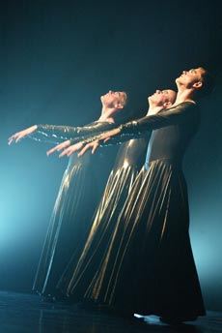

CHOREOGRPAHER: Lea Anderson
ACCOPMANIMENT: The Victims of Death

To start with there's the music, performed by a live rock band called (oh joy) The Victims of Death, for whom the description "heavy metal" scarcely does justice to the 500 tons of industrial steel they seem to employ in the opening 10 minutes. The score calms down later on, and meanders down some quite melodious byways of folk fiddle and saxophone that are almost sweet. On stage, all is Rocky Horror gothickery: a fug of dry ice, women in Morticia Addams make-up, and long, swirling dresses of an extraordinary metallic fabric that changes from pewter to bronze to phosphorous green under Simon Corder's extraordinary lighting. At one point, knee-level blades of pure white light seem to slice right through the dancers' bodies. As for the choreography, Flesh and Blood contains no more than two or three ideas, which it teases out for nearly an hour. But they are marvellously strong ideas: images from religious art - kneeling, swooning, levitating - and more obliquely, women swivelling like demented salamanders belly- down on the floor, women prowling the stage like chatelaines who suspect insurrection in the west wing, women performing what could be ritual self-examination for vampire bites. Brought off with the edgy speed and precision of an animated cartoon, the effect of these curious routines is mesmeric. I don't see quite where the "flesh and blood" come in, but I do see why the work should be studied.

The audience are enthusiastic, but Flesh & Blood takes a while to get into. I had forgotten how hard Anderson's tense little movements can be to watch. It's as if all the energies of the piece - inspired by images of religious obsession - are collected in the performers' solar plexuses. Or do we feel the contracture of the gestures more acutely because the performers are men?
While the boys look monkish in their dresses, the women look crisp in men's suits and shoes, with hair gelled up high into Tintin quiffs. They dance pretty crisp too, and smoke and laugh and toss the microphone around like a ball. Their gestures, drawing on classic American male stereotypes, are exaggerated but they never become cartoonish. The high point of their performance, for me, was 'Elvis Legs' - a deconstruction, chop-up and reassembly of 'Elvis's favourite leg and arm movements'. Brilliant.
The performance asks some interesting questions. Do women - or men - write more forgivingly or more demandingly for their own sex? Is one sex subconsciously accorded more space? The pieces reveal themselves gradually, but with some surprising new kinks. The music is great, too.
