**Explorer task – Pixel art picture**

Can you put together a set of instructions to create one of the following pictures in a spreadsheet?

If you prefer, you can create your own small picture first and then put together the instructions for that.

* Can you work out how to resize a column?
* **Top tip:** If you select several columns at the same time you can resize them all together

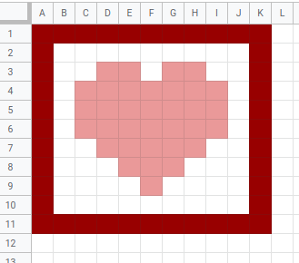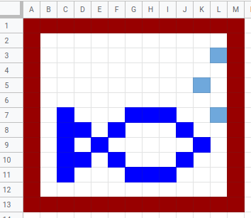

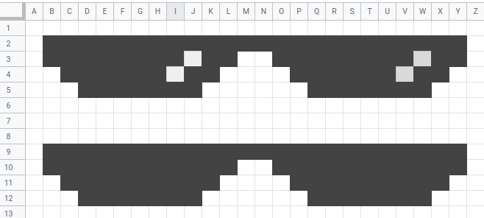

Write your instructions here:

|  |
| --- |
|  |

This resource is available online at [ncce.io/sprs-1-a3-w](http://ncce.io/sprs-1-a3-w). Resources are regularly updated — please check that you are using the latest version.

This resource is licensed under the Open Government Licence, version 3. For more information on this licence, see [ncce.io/ogl](http://ncce.io/ogl).