**Micro:bit Challenge – Fortune teller**

Brief:

* Display a random Y or N when button A pressed

*Difficulty level: 2*

Blocks that may help you:

Macintosh HD:Users:adamn:Desktop:Screen Shot 2016-04-21 at 09.53.57.png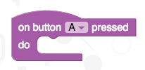

Macintosh HD:Users:adamn:Desktop:Screen Shot 2016-04-21 at 09.54.04.png

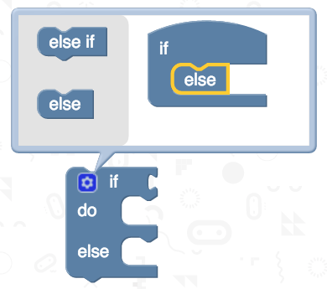



Macintosh HD:Users:adamn:Desktop:Screen Shot 2016-04-21 at 09.53.51.png

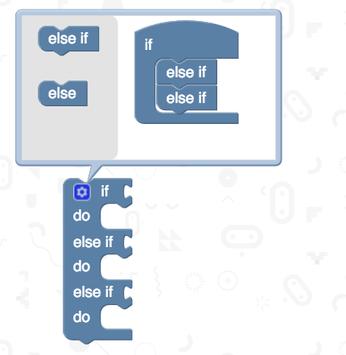Additional challenges:

* Change the Y and N to more interesting responses
* Change the random statement to pick numbers from 0 to 3 and have 4 possible messages

Macintosh HD:Users:adamn:Desktop:Screen Shot 2016-04-21 at 11.12.42.png

Based on an idea from Code Club

*Remember:*

save your work!