**Micro:bit Challenge – Mood badge**

Brief:

* Display a neutral image when switched on/reset
* Display a happy/positive image when button A pressed
* Display a sad/negative image when button B pressed

*Difficulty level: 1*

Blocks that may help you:

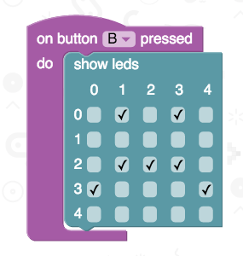

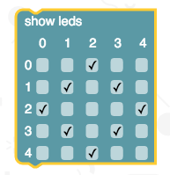

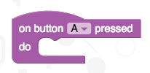

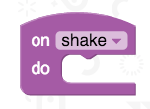

Additional challenges:

* Reset the image to neutral when the micro:bit is shaken
* 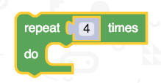Animate the images so they alternate between happy and neutral several times
* Convert your code to Touch Develop and change the timings

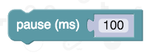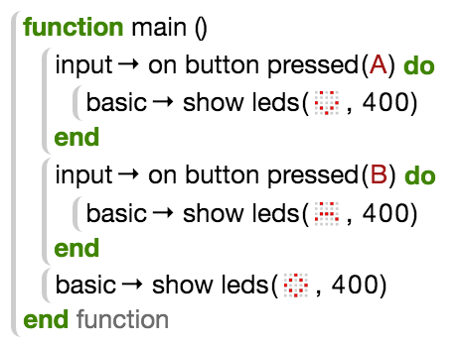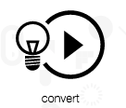

*Remember:*

save your work!

Based on an idea from Code Club