**Micro:bit Challenge – Rate your mates**

*Remember:*

save your work!

Brief:

* Press button A to display a ‘neutral’ icon
* Press button A&B to display a ‘thinking’ icon
* Pause for a second
* Display a random number between 0 and 100
* Pause again then display your ‘neutral’ icon

*Difficulty level: 1*

Blocks that may help you:

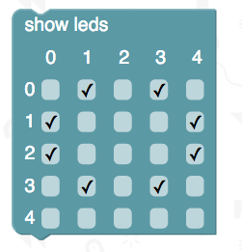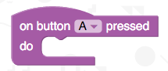

Macintosh HD:Users:adamn:Desktop:Screen Shot 2016-04-23 at 08.23.04.png

Macintosh HD:Users:adamn:Desktop:Screen Shot 2016-04-23 at 08.23.15.png

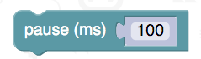

Macintosh HD:Users:adamn:Desktop:Screen Shot 2016-04-23 at 08.23.10.png

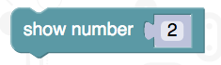

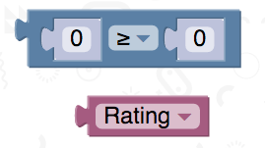Additional challenges:

* If the rating is 75 or more display a ‘heart’ icon
* If the rating is under 25 display a sad face
* 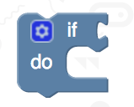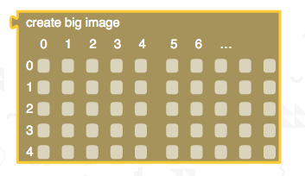Create a bigger scrolling image or an animation for scores 75 and above or below 25

Based on an idea from Code Club