**Micro:bit Challenge – What’s the score**

Brief:

* Display a score
* Increase the score by 1 each time button A pressed
* Reset the score to 0 when button A&B pressed
* Decrease the score by 1 when button B pressed

*Difficulty level: 2*

Blocks that may help you:

Macintosh HD:Users:adamn:Desktop:Screen Shot 2016-04-30 at 13.04.52.png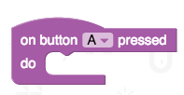

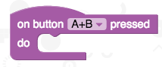

Macintosh HD:Users:adamn:Desktop:Screen Shot 2016-04-30 at 13.04.58.png

Additional challenges:

* 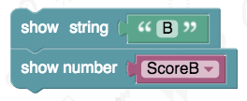Change the programming for button B and add a second variable to keep score for a second team
* Display the score continuously. Eg. repeating “A 1 B 3”
* Macintosh HD:Users:adamn:Desktop:Screen Shot 2016-04-30 at 13.10.14.pngNow button B is used for the second team, see if you can find a way to change from adding 1 each time to subtracting 1, so you can correct a score

Macintosh HD:Users:adamn:Desktop:Screen Shot 2016-04-30 at 13.11.20.pngMacintosh HD:Users:adamn:Desktop:Screen Shot 2016-04-30 at 13.10.25.png

*Remember:*

save your work!