**Micro:bit Challenge – Target number**

*Remember:*

save your work!

Brief:

* Press button A to start
* Display a message stating 5 as the target number
* Make the micro:bit count from 0 to 10
* User presses button B when target displays
* Display a message to say “win” or “lose”

*Difficulty level: 2*

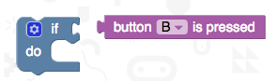Blocks that may help you:

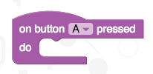

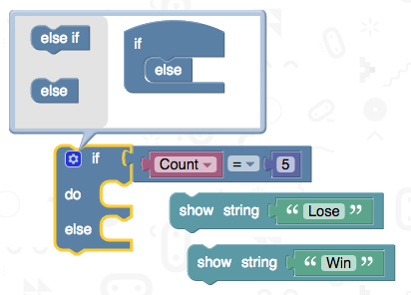

Macintosh HD:Users:adamn:Desktop:Screen Shot 2016-04-30 at 15.45.43.png

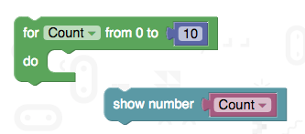

Macintosh HD:Users:adamn:Desktop:Screen Shot 2016-04-30 at 15.44.43.pngAdditional challenges:

* Stop the count after button B pressed
* Changed to a different fixed target number
* Macintosh HD:Users:adamn:Desktop:Screen Shot 2016-04-30 at 13.24.47.pngMacintosh HD:Users:adamn:Desktop:Screen Shot 2016-04-30 at 13.24.37.pngPick and display a random target number before you start
* Change the counting speed to make it harder  
  (You will need to convert to Touch Develop script)

Macintosh HD:Users:adamn:Desktop:Screen Shot 2016-04-30 at 13.24.55.png