Bandlab Instructions

* Go to [https://edu.bandlab.com/sign-up](https://mail.wallingfordschool.com/owa/redir.aspx?C=Q4N2kCyKVs_es6NMm35fJtJEo8R2KqaGE6N--dMf2IWw4nY-nDjaCA..&URL=https%3a%2f%2fedu.bandlab.com%2fsign-up)
* Enter your name, email and password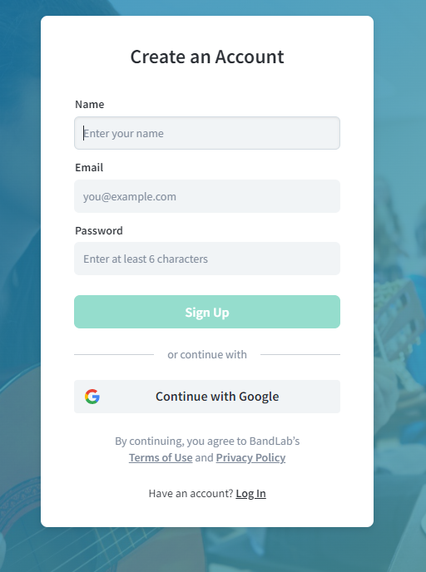
* Click on the folder in the top right then select create project