Lesson 3 homework: Screen designs
Provide designs for any two of the screens that will be part of your app. Your designs must be annotated with the id you intend to use, and it should be clear whether each item is a button, label, text input, image, etc. There should also be an indication of colour and/or fonts.

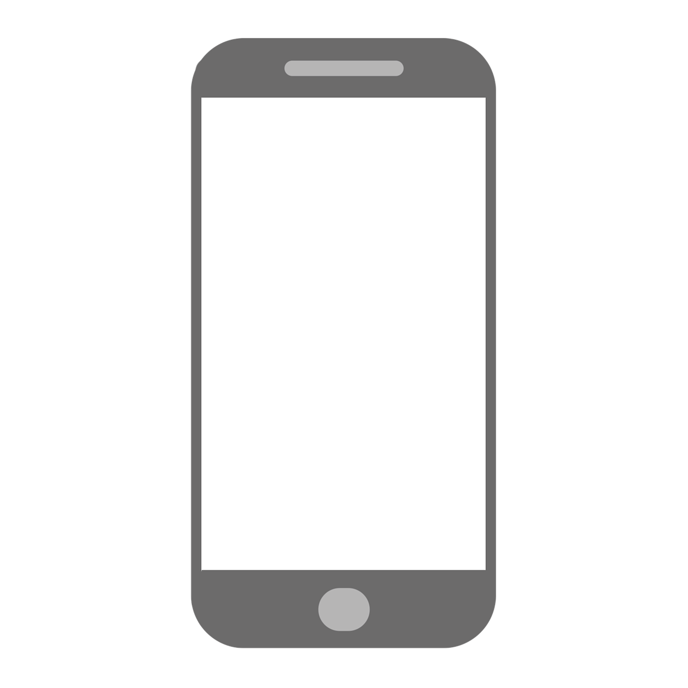

Resources are updated regularly — the latest version is available at: ncce.io/tcc.

This resource is licensed under the Open Government Licence, version 3. For more information on this licence, see ncce.io/ogl.

