Adobe Express Instructions

Click on this link <https://express.adobe.com/sp/>

Select sign up with email and use your school email address

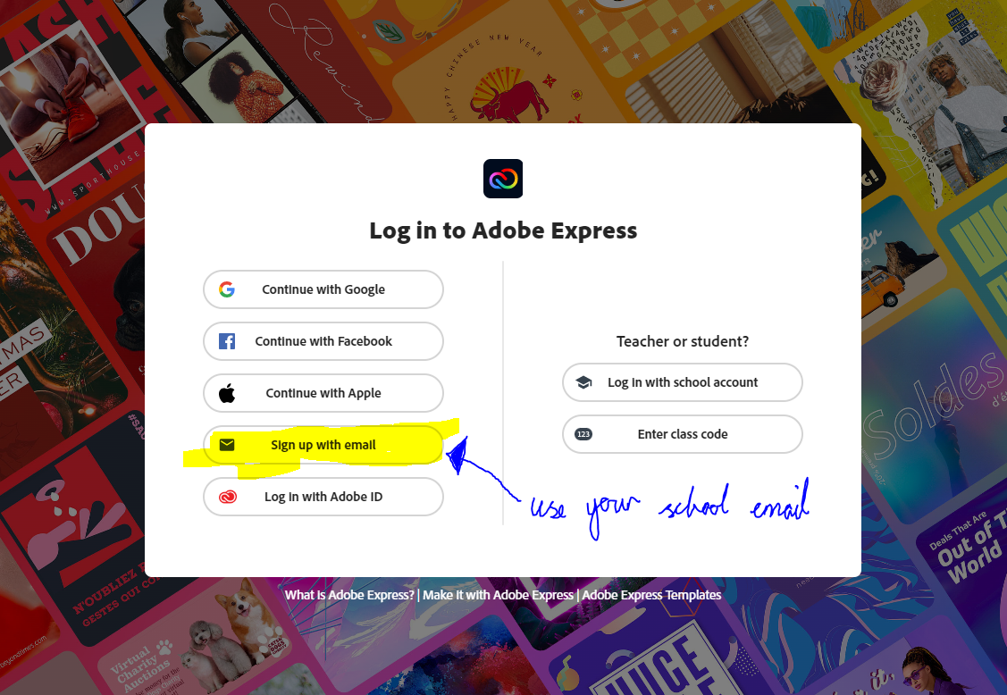

Enter in your details

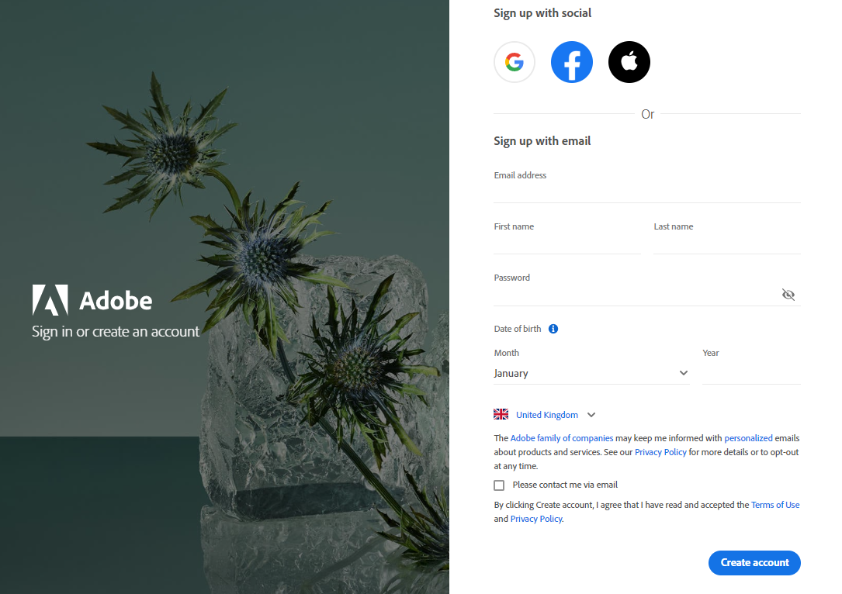

It should bring you to this page ­now you are ready to start creating!

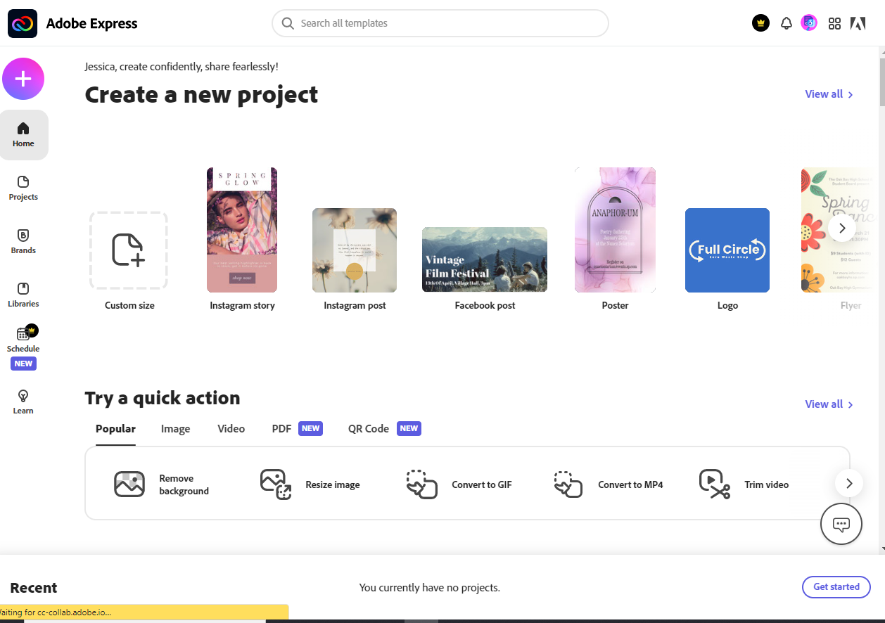

Watch the link below to see how you can create your video

<https://www.youtube.com/watch?v=7VJf-RwoIbQ>