**Electrical Storms Quiz**

1. About what temperature can bolts of lightning reach?
2. What other names can be used to describe an electrical storm?
3. What happens when air becomes “ionised”?
4. What are the four main kinds of electrical storm?
5. Draw a box about 8cm x 8cm and draw a diagram inside to show what happens to a cloud before a storm takes place. Make sure that you add labels and make your diagram as clear as possible.
6. In your own words, briefly explain what has to happen before lightning can reach the ground. If you wish, you can use pictures to help you.
7. 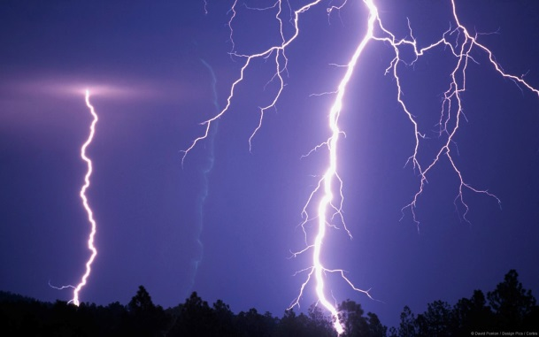Why does lightning tend to hit things that are sticking up from the ground?
8. From how far away can lightning be seen?
9. What is St Elmo’s Fire?
10. What is thunder caused by?
11. Name two kinds of the severe weather phenomena that can be caused by storms.
12. Create a poster which helps people to understand how to keep themselves safe during a storm. Make sure that it is colourful, neat and easy to understand.

