Binary to Decimal:

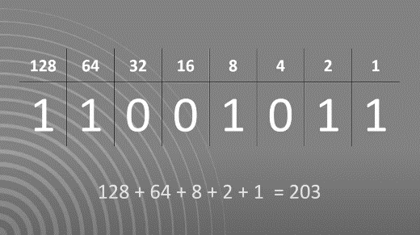

Add all the columns that have a 1 in them. This will give you your decimal value.

128+64+8+2+1 = 203

Decimal to Binary:

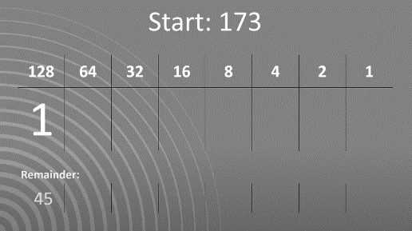If your number is bigger than the column heading put a 1 then take it away: (173 > 128)

173 – 128 = 45

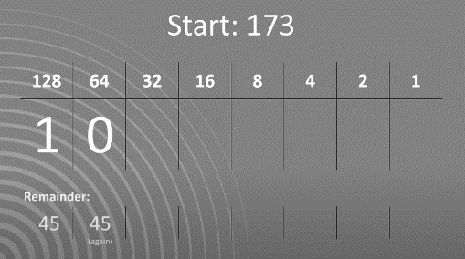Put this in the remainder

If your number is smaller than the column heading put a 0 and leave the remainder the same. (45 < 64)

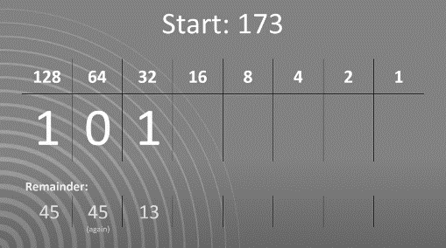

45 > 32 so write 1 and do 45 – 32 = 13

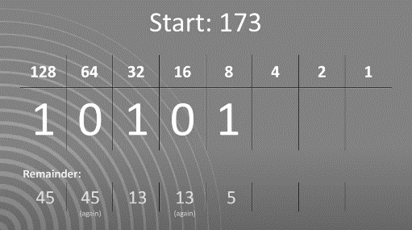

13 < 16 so write a 0 and leave the remainder the same

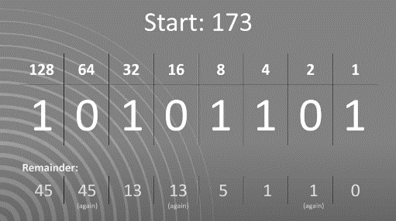

Continue until the remainder is 0 then fill all the remaining columns with 0s.

Your binary number is 10101101

Binary to Decimal:



Add all the columns that have a 1 in them. This will give you your decimal value.

128+64+8+2+1 = 203

Decimal to Binary:

If your number is bigger than the column heading put a 1 then take it away: (173 > 128)

173 – 128 = 45

Put this in the remainder

If your number is smaller than the column heading put a 0 and leave the remainder the same. (45 < 64)



45 > 32 so write 1 and do 45 – 32 = 13



13 < 16 so write a 0 and leave the remainder the same



Continue until the remainder is 0 then fill all the remaining columns with 0s.

Your binary number is 10101101