Logic Gates Task Sheet

Save this Word document in your STEM folder. You will need to email a copy of it to your STEM teacher at the end of the lesson.

Click on the link below to open the Academo Logic Gate Simulator:

<https://academo.org/demos/logic-gate-simulator/>

Answer the questions below using the online simulator. Remember to regularly save your work.

1. Set up this system of logic gates

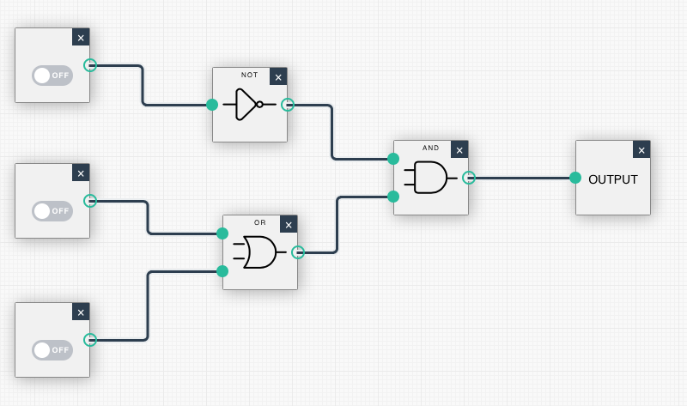

C

B

A

What is the output for the following inputs:

|  |  |  |  |
| --- | --- | --- | --- |
| A | B | C | Output |
| 1 | 1 | 1 |  |
| 1 | 0 | 0 |  |
| 0 | 1 | 0 |  |
| 0 | 1 | 1 |  |

1. Set up this system of logic gates

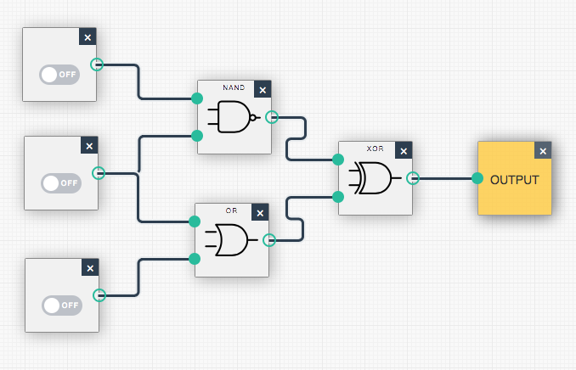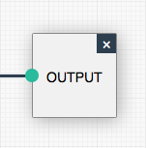

A

B

C

|  |  |  |  |
| --- | --- | --- | --- |
| A | B | C | Output |
| 0 | 0 | 0 |  |
| 1 | 0 | 1 |  |
| 1 | 0 | 0 |  |
| 0 | 0 | 1 |  |

What is the output for the following inputs:

|  |  |  |  |
| --- | --- | --- | --- |
| A | B | C | Output |
| 0 | 0 | 0 |  |
| 1 | 0 | 0 |  |
| 1 | 0 | 1 |  |
| 1 | 1 | 1 |  |

Challenge 1:

Using this collection of logic gates, set up a system that gives the outputs in the table below. Attach a screen shot of your system in the space below.

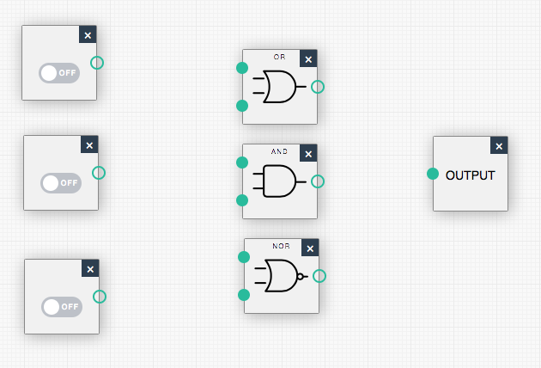

A

B

C

|  |  |  |  |
| --- | --- | --- | --- |
| A | B | C | Output |
| 0 | 0 | 0 | 1 |
| 1 | 0 | 0 | 0 |
| 0 | 1 | 0 | 0 |
| 0 | 0 | 1 | 1 |
| 1 | 1 | 0 | 0 |
| 1 | 0 | 1 | 0 |
| 0 | 1 | 1 | 0 |
| 1 | 1 | 1 | 0 |

Your system

Challenge 2:

Using this collection of logic gates, set up a system that gives the outputs in the table below: Attach a screen shot of your system in the space below.

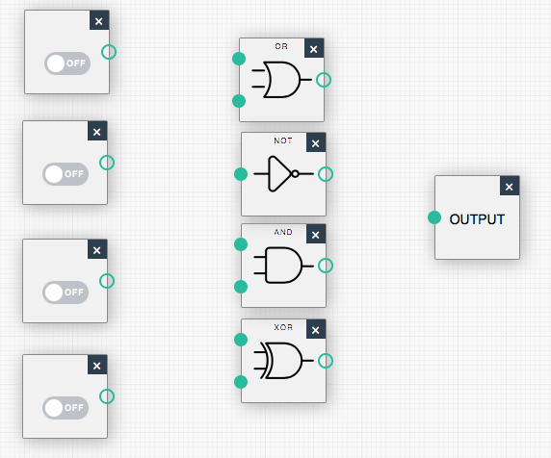

A

B

C

D

|  |  |  |  |  |
| --- | --- | --- | --- | --- |
| A | B | C | D | Output |
| 0 | 0 | 0 | 0 | 1 |
| 1 | 0 | 0 | 0 | 1 |
| 0 | 1 | 0 | 0 | 1 |
| 0 | 0 | 1 | 0 | 1 |
| 0 | 0 | 0 | 1 | 1 |
| 1 | 1 | 0 | 0 | 0 |
| 1 | 0 | 1 | 0 | 1 |
| 1 | 0 | 0 | 1 | 1 |
| 0 | 1 | 1 | 0 | 1 |
| 0 | 0 | 1 | 1 | 1 |
| 1 | 1 | 1 | 0 | 1 |
| 1 | 1 | 0 | 1 | 1 |
| 1 | 0 | 1 | 1 | 1 |
| 0 | 1 | 1 | 1 | 1 |
| 1 | 1 | 1 | 1 | 0 |

Your system:

Challenge 3:

Set up a **4 input** system with **at least 4 logic gates** in the system and **1 output**. The system should give an output of 1 the same amount of times as it gives an output of 0.

Attach a screen shot of your system in the space below.

Your system: