GCSE / A Level French Grammar Transition Booklet

[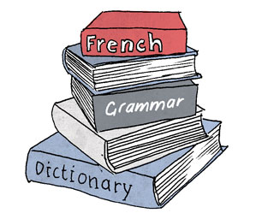](http://www.google.co.uk/url?sa=i&rct=j&q=&esrc=s&frm=1&source=images&cd=&cad=rja&uact=8&ved=0CAcQjRw&url=http://frenchinbrighton.co.uk/resources/textbooks/index.html&ei=UvNeVfyXDOrR7Abj8IDoAQ&psig=AFQjCNFbTygrRT_se54_35tVetwZkD1zWQ&ust=1432371892473167)

**Contents**

1 Nouns

2 Adjectives

3 Possessive Adjectives

4 Adverbs

5 Verbs - Present Tense

6 Verbs - Perfect Tense

7 Verbs - Imperfect Tense

8 Verbs - Future Tense

9 Verbs - Conditional Tense

10 Reflexive Verbs

11 Negatives

12 Object Pronouns

13 Relative Pronouns

14 Spellings and Accents

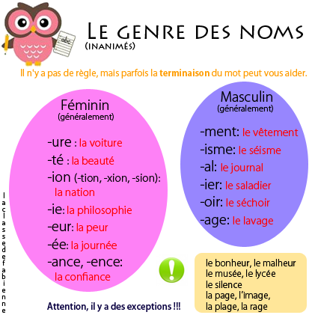**Nouns**

Nouns in French are either masculine **(un / le)** or feminine **(une / la)**. You can check the gender of a noun in a dictionary, but sometimes the ending of a noun can help you work out its gender.

**Task 1 – Here are some useful nouns for the AS French course. Find out how to write them in French AND what gender each noun is.**

problem government

soap opera TV viewer

marriage divorce

Most French nouns add **–s** to make them plural. Those ending in **–s**, **-x** or **–z** stay the same. Nouns ending in **–al** change to **–aux** and **–eau** or **–eu** add **–x**.

**Task 2 – Translate these plural nouns into French**

newspapers birds castles

gases children voices

countries horses bottles

**Adjectives**

Most adjectives in French go after the noun they describe, e.g. **une table bleue**. BUT some adjectives go before the noun. Can you list some here?

**BAGS**

**Task 3 - Some adjectives which come before the noun they describe are**:

[](http://www.google.co.uk/imgres?imgurl=http://images.clipartpanda.com/pocketbook-clipart-thumbhandbag_purse_red.gif&imgrefurl=http://pixgood.com/handbags-clipart.html&h=158&w=180&tbnid=k5iHV_i_ztgjqM:&zoom=1&docid=kOWgilEW53uHAM&ei=nNdVVfmLLurW7Qat2oKgBw&tbm=isch&ved=0CG4QMyhHMEc)

In French adjectives have to agree with the noun they are describing. For most adjectives you add an **–e** in the feminine version, an **–s** in the masculine plural version and **–es** in the feminine plural version, e.g.

Un stylo vert

Une table vert**es**

Des stylos vert**s**

|  |  |  |  |  |
| --- | --- | --- | --- | --- |
|  | **Masculine** | **Feminine** | **Masculine plural** | **Feminine plural** |
| **-er** | premier |  |  |  |
| **-if** | sportif |  |  |  |
| **-al** | local |  |  |  |
| **-eux** | sérieux |  |  |  |
| **-el** | officiel |  |  |  |
| **-c** | public |  |  |  |
| **-on** | bon |  |  |  |

Des tables vert**es**

**Task 4 – Some Adjectives are Irregular and do not follow the pattern above. What happens to these adjectives?**

**Possessive Adjectives**

A possessive adjective must agree with its noun.

**Task 5 – Complete the table below**

|  |  |  |  |
| --- | --- | --- | --- |
|  | **Masculine** | **Feminine** | **Plural** |
| **My** | mon |  |  |
| **Your** | ton |  |  |
| **His/her** | son |  |  |
| **Our** | notre |  |  |
| **Your** | votre |  |  |
| **their** | leur |  |  |

**Adverbs**

An adjective describes a noun and an adverb describes a verb, e.g. the journey was slow (adjective) and he drove slowly (adverb).

French adverbs are formed from the feminine form of an adjective plus -**ment**.

e.g. franc/franche = frank franchement = frankly

**Task 6 – Work out these French adverbs**

probably normally

generally slowly

quickly softly

**Task 7 – Use each of these words in a sentence**

bon mauvais

bien mal

**Verbs – Present Tense**

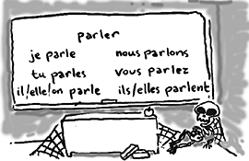The Present Tense is used to describe what is happening now or what usually happens. We have 2 present tenses in English (“I eat” and “I am eating”), French has only one (“je mange”).

On the left you can see the Present Tense verb endings for **–er** verbs. The good news is that most French verbs are regular **–er** verbs and are conjugated in this way.

Some verbs end in **–ir** and are conjugated like this:

|  |  |  |  |
| --- | --- | --- | --- |
| **FINIR – to finish** | | | |
| Je | **finis** | Nous | **finissons** |
| Tu | **finis** | Vous | **finissez** |
| Il/elle | **finit** | Ils/Elles | **finissent** |

And some verbs end with **–re** and are conjugated like this:

|  |  |  |  |
| --- | --- | --- | --- |
| **VENDRE – to sell** | | | |
| Je | **vends** | Nous | **vendons** |
| Tu | **vends** | Vous | **vendez** |
| Il/elle | **vend** | Ils/Elles | **vendent** |

You can tell if a verb is regular if it says “**v reg**” in the dictionary after it.

**Task 8 – Look up these Regular Verbs in the dictionary. Are they –er, -ir, -re verbs?**

to wait to vomit

to slow down to invest

to begin to stop

to lose to hear

to choose to obey

**Task 9 – Translate these verbs in the Present Tense**

I am listening He chooses

They start We sell

She loses You stop

We obey They are slowing down

The Present Tense is also used in French with “depuis” to say how long you have been doing something.

e.g. J’apprends le français depuis 5 ans I’ve been learning French for 5 years

**Task 10 – How would you write…?**

He’s been eating a cheese sandwich for 2 hours.

They’ve been choosing an ice cream for 5 minutes.

**Irregular Verbs**

Some verbs in French do not follow these patterns. Unfortunately these irregular verbs are some of the most commonly used verbs and need to be learnt by heart.

[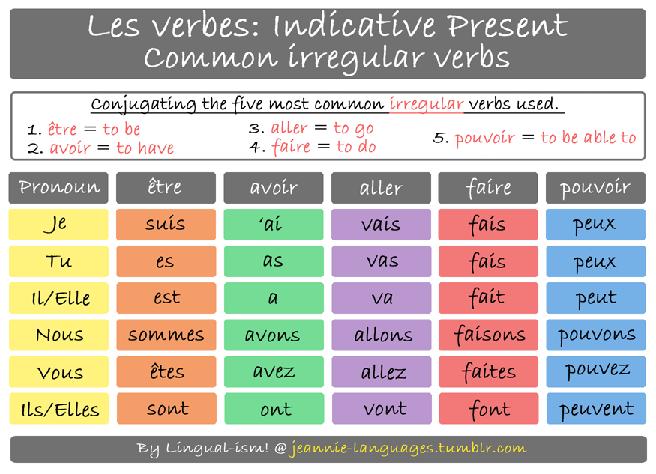](http://www.google.co.uk/url?sa=i&rct=j&q=&esrc=s&frm=1&source=images&cd=&cad=rja&uact=8&ved=0CAcQjRw&url=http://jeannie-languages.tumblr.com/post/52030978663/the-five-most-common-irregular-verbs-used&ei=TgJWVd2HJY2X7Qbd1oH4Cg&psig=AFQjCNHowBjmwuE4Uv-vq9p4qzrEKxYOHQ&ust=1431785638087461)

**Task 11 – Other Irregular Verbs. Complete the tables below.**

|  |  |  |  |
| --- | --- | --- | --- |
| **VOULOIR – to want** | | | |
| Je |  | Nous |  |
| Tu |  | Vous |  |
| Il/elle |  | Ils/Elles |  |

|  |  |  |  |
| --- | --- | --- | --- |
| **DEVOIR – to have to / must** | | | |
| Je |  | Nous |  |
| Tu |  | Vous |  |
| Il/elle |  | Ils/Elles |  |

|  |  |  |  |
| --- | --- | --- | --- |
| **METTRE – to put** | | | |
| Je |  | Nous |  |
| Tu |  | Vous |  |
| Il/elle |  | Ils/Elles |  |

|  |  |  |  |
| --- | --- | --- | --- |
| **PRENDRE – to take** | | | |
| Je |  | Nous |  |
| Tu |  | Vous |  |
| Il/elle |  | Ils/Elles |  |

|  |  |  |  |
| --- | --- | --- | --- |
| **SAVOIR – to know (a fact)** | | | |
| Je |  | Nous |  |
| Tu |  | Vous |  |
| Il/elle |  | Ils/Elles |  |

|  |  |  |  |
| --- | --- | --- | --- |
| **CONNAITRE – to know (a place/person)** | | | |
| Je |  | Nous |  |
| Tu |  | Vous |  |
| Il/elle |  | Ils/Elles |  |

[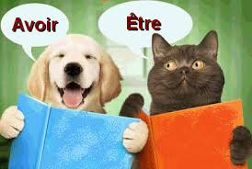](http://www.google.co.uk/url?sa=i&rct=j&q=&esrc=s&frm=1&source=images&cd=&cad=rja&uact=8&ved=0CAcQjRw&url=http://cartespostales.chezmaya.com/v2/component/zoo/item/avoir-et-etre.html&ei=CP5VVfy7CISe7gaurICoAw&bvm=bv.93564037,d.ZGU&psig=AFQjCNECMlhW2PUawnNy8hC_IY-sUC2zdA&ust=1431785323234375)

1. [](http://www.google.co.uk/url?sa=i&rct=j&q=&esrc=s&frm=1&source=images&cd=&cad=rja&uact=8&ved=0CAcQjRw&url=http://cartespostales.chezmaya.com/v2/component/zoo/item/avoir-et-etre.html&ei=CP5VVfy7CISe7gaurICoAw&bvm=bv.93564037,d.ZGU&psig=AFQjCNECMlhW2PUawnNy8hC_IY-sUC2zdA&ust=1431785323234375)

**Perfect Tense**

The perfect tense is used in French to talk about completed actions that happened in the past. It is the equivalent of both “I ate” and “I have eaten” in English.

You need 3 things in order to form the Perfect Tense correctly in French:

**Subject** **Auxiliary Verb** **Past Participle**

J’ ai mangé I have eaten / I ate

Il a fait He has done / He did



The most common mistake English speakers make with the Perfect Tense is missing out the Auxiliary Verb! It is really important to know the verbs AVOIR and ETRE in order to form the Perfect Tense correctly (see **Irregular Verbs**).

Most verbs use AVOIR but some use ETRE in the Perfect Tense. All Reflexive verbs take ETRE as well as the following verbs:

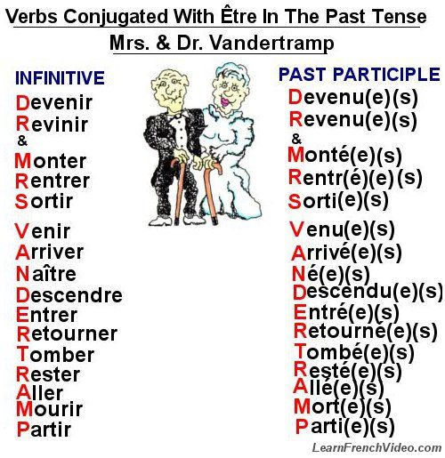

Verbs which take être as the auxiliary verb have an additional –e, -s or –es to agree with the subject.

[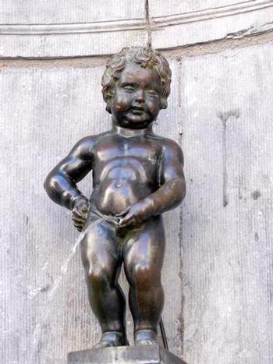](http://www.google.co.uk/url?sa=i&rct=j&q=&esrc=s&frm=1&source=images&cd=&cad=rja&uact=8&ved=0CAcQjRw&url=http://www.brussels.be/artdet.cfm?id%3D4843%26agendaid%3D1426&ei=LOVeVfi4CuOP7Ab5oYGYCw&bvm=bv.93990622,d.ZGU&psig=AFQjCNEgnnfjOB4ThalGesxwpBOMjrfvsA&ust=1432368798035344)Past Participles (pipis!) of regular verbs are formed like this:

**-er verbs -é e.g. J’ai joué**

**-ir verbs -i e.g. J’ai fini**

**-re verbs -u e.g. J’ai vendu**

**Task 12 – Irregular Past Participles**

What are the past participles of the following common verbs?

avoir boire connaître

devoir dire écrire

être faire lire

mettre ouvrir pouvoir

prendre recevoir savoir

vivre voir vouloir

When you are forming the Perfect Tense you need to think about the following 4 questions…

**1 What is the subject of the sentence?**

**2 Does the verb I want to use take avoir / être ?**

**3 What is the past participle?**

**4 If I have used être, do I need to add –e, -s or –es to the past participle?**

**Task 13 – Now translate these verbs in the Perfect Tense**

I bought

I read

He went

He wrote

They ate

They returned

She took

She stayed

The teachers arrived

The teachers swam

You drank

You entered

**Imperfect Tense**

The Imperfect Tense is used for:

* A general description in the past (It was interesting…)
* A continuous or interrupted action in the past (I was reading when…)
* A repeated or habitual action in the past (I used to play tennis…)

[](http://www.clker.com/cliparts/d/4/a/3/1280782850356230332flower%20stem%20white.svg.med.png)To form the Imperfect Tense, take **the stem** which is the nous form of the present tense without the –ons.

Avoir: nous avons **av-**

Finir: nous finissons **finiss-**[](http://www.google.co.uk/url?sa=i&rct=j&q=&esrc=s&frm=1&source=images&cd=&cad=rja&uact=8&ved=0CAcQjRw&url=http://www.clker.com/clipart-67623.html&ei=DOpeVcK2PKbV7gaY6YGoCA&psig=AFQjCNFMnYK3IW1smLyQpxnVdEEz13Km7w&ust=1432370000479470)

Then add the endings shown below to the **stem**:

|  |  |  |
| --- | --- | --- |
| **Subject** | **Endings** | **Examples** |
| je | -ais | Je faisais |
| tu | -ais | Tu avais |
| Il/elle/on | -ait | Il /elle / on finissait |
| Nous | -ions | Nous regardions |
| vous | -iez | Vous achetiez |
| Ils/elles | -aient | Ils/elles prenaient |

**Task 14 – Now translate these verbs in the Imperfect Tense**

I was watching

I was drinking

I used to eat

He used to take

She used to be

They used to like

You used to do

They were buying

[](http://www.google.co.uk/url?sa=i&rct=j&q=&esrc=s&frm=1&source=images&cd=&cad=rja&uact=8&ved=0CAcQjRw&url=http://imgbuddy.com/magic-crystal-ball-clipart.asp&ei=9eteVbvcE4_e7AbooIKICg&psig=AFQjCNFl0zS7zj_lgGSOeJrbFBtOmD6kng&ust=1432370543961670)**Future Tense**

The future tense is used to make predictions and statements about the future: to say something “will” happen.

The good news is most verbs have a regular future tense! ☺ Take the infinitive (for –re verbs remove the final –e!) and add these endings:

|  |  |  |  |  |
| --- | --- | --- | --- | --- |
|  | **endings** | **regarder** | **choisir** | **répondre** |
| je | -ai | regarderai | choisirai | répondrai |
| tu | -as | regarderas | choisiras | répondras |
| Il/elle/on | -a | regardera | choisira | répondra |
| Nous | -ons | regarderons | choisirons | répondrons |
| Vous | -ez | regarderez | choisirez | répondrez |
| Ils/elles | -ont | regarderont | choisiront | répondront |

Some key verbs use an irregular future stem instead of the infinitive, but the endings are still regular:

|  |  |  |
| --- | --- | --- |
| aller | ir - | J’irai |
| avoir | aur- | J’aurai |
| devoir | devr- | Je devrai |
| être | ser- | Je serai |
| faire | fer- | Je ferai |
| pouvoir | pourr- | Je pourrai |
| savoir | saur- | Je saurai |
| venir | viendr- | Je viendrai |
| voir | verr- | Je verrai |
| vouloir | voudr- | Je voudrai |

**Task 15 – Now translate these sentences in the Future Tense**

I will be richer

She will eat more vegetables

They will be able to speak French

1. [](http://www.google.co.uk/url?sa=i&rct=j&q=&esrc=s&frm=1&source=images&cd=&cad=rja&uact=8&ved=0CAcQjRw&url=http://imgbuddy.com/magic-crystal-ball-clipart.asp&ei=9eteVbvcE4_e7AbooIKICg&psig=AFQjCNFl0zS7zj_lgGSOeJrbFBtOmD6kng&ust=1432370543961670)
2. [](http://www.google.co.uk/url?sa=i&rct=j&q=&esrc=s&frm=1&source=images&cd=&cad=rja&uact=8&ved=0CAcQjRw&url=http://imgbuddy.com/magic-crystal-ball-clipart.asp&ei=9eteVbvcE4_e7AbooIKICg&psig=AFQjCNFl0zS7zj_lgGSOeJrbFBtOmD6kng&ust=1432370543961670)

**Conditional Tense**

1. [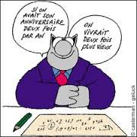](http://www.google.co.uk/url?sa=i&rct=j&q=&esrc=s&frm=1&source=images&cd=&cad=rja&uact=8&ved=0CAcQjRw&url=http://sites.psu.edu/ammara4frenchiness/tenses-and-verbs/&ei=Ee9eVc_RMMiR7AaWmIBg&psig=AFQjCNGraQGAjjHUDA773YCzgcgdAvbUig&ust=1432371337355877)
2. [](http://www.google.co.uk/url?sa=i&rct=j&q=&esrc=s&frm=1&source=images&cd=&cad=rja&uact=8&ved=0CAcQjRw&url=http://sites.psu.edu/ammara4frenchiness/tenses-and-verbs/&ei=Ee9eVc_RMMiR7AaWmIBg&psig=AFQjCNGraQGAjjHUDA773YCzgcgdAvbUig&ust=1432371337355877)
3. [](http://www.google.co.uk/url?sa=i&rct=j&q=&esrc=s&frm=1&source=images&cd=&cad=rja&uact=8&ved=0CAcQjRw&url=http://sites.psu.edu/ammara4frenchiness/tenses-and-verbs/&ei=Ee9eVc_RMMiR7AaWmIBg&psig=AFQjCNGraQGAjjHUDA773YCzgcgdAvbUig&ust=1432371337355877)

[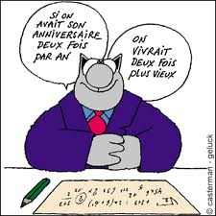](http://sites.psu.edu/ammara4frenchiness/wp-content/uploads/sites/2397/2013/04/images.jpg)The Conditional Tense is used to say what “would”, “could” or “should” happen or how something would be.

To form the conditional you take the infinitive and add the following endings (The same endings as the imperfect tense!):

|  |  |  |  |  |
| --- | --- | --- | --- | --- |
|  | **endings** | **regarder** | **choisir** | **répondre** |
| je | -ais | regarderais | choisirais | répondrais |
| tu | -ais | regarderais | choisirais | répondrais |
| Il/elle/on | -ait | regarderait | choisirait | répondrait |
| Nous | -ions | regarderions | choisirions | répondrions |
| Vous | -iez | regarderiez | choisiriez | répondriez |
| Ils/elles | -aient | regarderaient | choisiraient | répondraient |

The irregular verbs in the conditional tense are the same ones as the future tense:

|  |  |  |
| --- | --- | --- |
| aller | ir - | J’irais |
| avoir | aur- | J’aurais |
| devoir | devr- | Je devrais |
| être | ser- | Je serais |
| faire | fer- | Je ferais |
| pouvoir | pourr- | Je pourrais |
| savoir | saur- | Je saurais |
| venir | viendr- | Je viendrais |
| voir | verr- | Je verrais |
| vouloir | voudr- | Je voudrais |

**Task 16 – Now translate these sentences in the Conditional Tense**

I would be richer

She would eat more vegetables

They would be able to speak French

**Reflexive Verbs**

Reflexive verbs are conjugated in the same way as other verbs in all the tenses, but they have a reflexive pronoun between the subject and the verb:

**Se laver – to wash yourself**

Je **me** lave Nous **nous** lavons

Tu **te** laves Vous **vous** lavez

Il/Elle/On **se** lave Ils / Elles **se** lavent

Infinitives of reflexive verbs in the dictionary begin with **se** or **s’** and have a “**vr**” next to them to help you identify them. Providing you remember to add the reflexive pronoun they are very straightforward to use. The only tense which sometimes causes problems is the Perfect Tense. Reflexive Verbs take être and the past participle agrees with the subject:

Je **me** suis lavé (e) Nous **nous** sommes lavé (e)s

Tu **t’**es lavé (e) Vous **vous** êtes lavé (e)s

Il/Elle/On **s’**est lavé (e)(s) Ils / Elles **se** sont lavé (e)s

**Task 17 – Look up these verbs in a dictionary. Are they reflexive verbs or not?**

to look after to dream

to encourage to sit down

to shower to worry

[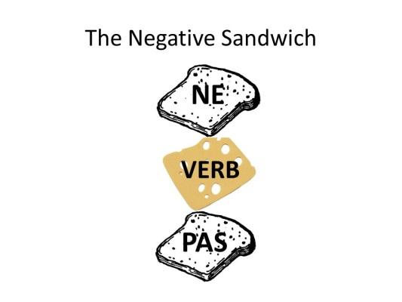](http://www.google.co.uk/url?sa=i&rct=j&q=&esrc=s&frm=1&source=images&cd=&cad=rja&uact=8&ved=0CAcQjRw&url=http://slideplayer.fr/slide/1158110/&ei=NwRfVejDMqTg7Qb524L4CA&bvm=bv.93990622,d.ZGU&psig=AFQjCNHbfI17FlBJrmfafCXpeFCWWsN8DA&ust=1432376739400830)**Negatives**

In French to make a sentence negative you put a ne…pas around the verb (or the auxillary verb in the perfect tense)…

Je **ne** fais **pas** de sport

Je **n**’ai **pas** fait de sport hier

Other negative expressions work in exactly the same way.

|  |  |  |
| --- | --- | --- |
| Ne … plus | No longer / no more | Je **ne** fume **plus** |
| Ne … jamais | never | Je **ne** joue **jamais** au rugby |
| Ne… rien | Nothing | Ils **ne** font **rien** |
| Ne …personne | No-one, nobody | Elle **n**’aime **personne** |
| Ne …que | Only | Je **n**’ai **qu**’une soeur |
| Ne … ni … ni … | Neither … nor … | Il **n**’aime **ni** le tennis **ni** le cricket |

**Task 18 – Translate these sentences**

I never drink Coke

I have never drunk Coke

He no longer eats meat

They see nothing

They saw nothing

**Object Pronouns**

An object pronoun replaces a noun that is the object of the sentence and it goes before the verb, unlike in English.

e.g. I love them = Je les aime

A direct object pronoun (le / la / les) replaces a noun linked directly to the verb.

e.g. Tu aimes les haricots? Je les adore!

**Task 19 – Translate these sentences**

Sport? I love it!

The teachers? I hate them!

Mme McGarrick? I can see her!

Benedict Cumberbatch? I love him.

Soap operas? I watch them all the time.

Apples? I never eat them.

**Relative Pronouns**

Relative pronouns are words like “who”, “which” and “that”, used to connect two parts of a sentence.

**Qui** is the most common relative pronoun. It represents someone or something that is the subject of the verb that follows:

L’homme qui est très beau (The man who is very handsome)

**Que** represents someone or something that is the object of the sentence:

L’homme que j’ai vu hier (The man whom I saw yesterday)

In practice this means that **qui** is followed by a verb and **que** by a noun/subject pronoun.

NB: que is contracted to qu’ before a vowel, but qui is never contracted!

**Task 20 – Is “qui” or “que” needed in each sentence?**

1. Le match _______ j’ai vu samedi était extraordinaire.

2.  Le livre _______ j’ai acheté est japonais.

3.   Mon père, _______ est docteur, travaille à Nice.

4.  C’est une voiture ______ est très populaire en Allemagne.

5.   La voiture _______ il a achetée est toute neuve.

6.   C’est une fille ________ fait toujours ses devoirs correctement.

7.            C’est la voiture ________ a gagné le concours à Detroit.

**Spellings and Accents**

Some of the most commonly misspelt words at A-level French are:

le problème (the problem)

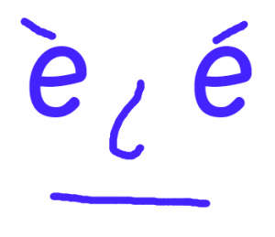

beaucoup de (lots of)

tout le temps (all the time)

le travail (work)

Je travaille (I work)

les vacances (holidays)

Par exemple (for example)

Je préfère (I prefer)

Mon sport préféré (my favourite sport)

**Task 21 – Put the words above into some sentences below (making sure to spell them correctly!)**