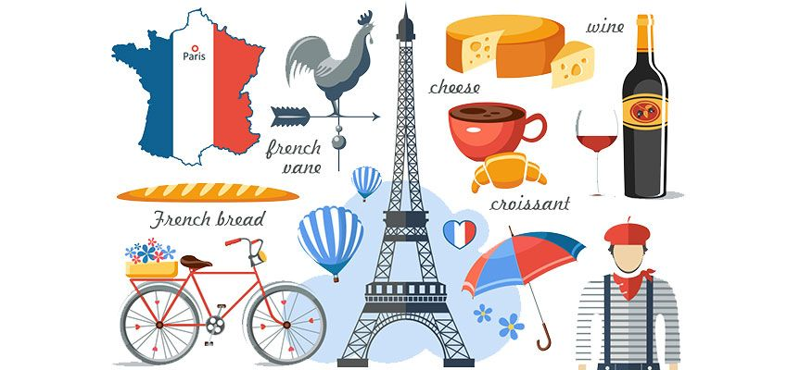

***A-level French***

***at Wallingford School***

|  |  |
| --- | --- |
| ***Exam board*** | *Edexcel*  <https://qualifications.pearson.com/en/qualifications/edexcel-a-levels/french-2016.html> |
| ***Exams*** | *Paper 1 (40%) Listening, Reading and Translation*  *Paper 2 (30%) Translation and Essays*  *Paper 3 (30%) Speaking (including an Individual Research Project)* |
| ***Topics*** | *Year 12 – Family, Education, World of Work, Music, Media, Festivals*  *Film – La Haine*  *Year 13 – Immigration, Integration, The Far Right, Occupation (1940-1945), The Vichy Regime, The French Resistance*  *Novel – No et Moi* |

***Please contact Mrs McGarrick on*** [***mcgarrickt@wallingfordschool.com***](mailto:mcgarrickt@wallingfordschool.com) ***if you have any questions about A-level French!***

***Transition Work***

*When studying A-level French you will need to develop a sound understanding of French and Francophone culture.*

**1. Les évènements clés**

Faites des recherches sur les évènements qui ont eu lieu à ces dates. Quelle est leur importance pour l’histoire et la société française ? *(Research the events which took place on these dates. What is their importance in history and for French society ?)*

|  |  |
| --- | --- |
| **Date** | **Informations** |
| 1789 |  |
| le 18 juin 1815 |  |
| le 11 novembre 1918 |  |

|  |  |
| --- | --- |
| le 25 août 1944 |  |
| le 25 mars 1957 |  |
| mai 1968 |  |
| octobre à novembre 2005 |  |
| le 7 janvier 2015 |  |
| le 13 novembre 2015 |  |

**2. Les personnages importants**

Pourquoi ces personnes sont-elles connues ? *(Why are these people famous ?)*

|  |  |
| --- | --- |
| Image result for charles de gaulle  Charles de Gaulle |  |
| Image result for napoleon  Napoléon Bonaparte |  |
| Image result for marie curieMarie Curie |  |
| Image result  Coco Chanel |  |
| Related imageLouis Pasteur |  |
| Image result for jeanne d'arc  Jeanne d’Arc |  |
| Zinedine zidane photography art prints for sale  Zinedine Zidane |  |

**3. La politique française**

1. Qui est le président de la France ?

_________________________________________________

1. Il a été élu quand et il représente quel parti politique ?

_________________________________________________

Faites des recherches sur les partis principaux. Ils sont de gauche ou de droite ? Quelles sont leurs politiques ? *(Research these political parties. Are they on the left or right ? What are their policies ?)*

|  |  |
| --- | --- |
| **Renaissance** |  |
| **Les Républicains** |  |
| **Le Parti Socialiste** |  |
| **Rassemblement National** |  |
| **La France Insoumise** |  |

**4. Le cinéma / la télé**

Watch a French film / TV series on Netflix / Amazon Prime / Walter Presents (Channel 4’s foreign language service) and write a review of it in French. Some suggestions include the following, but there are many others!

*Les Intouchables Un Secret*

*Entre les Murs Les Choristes*

*Au revoir les enfants Bienvenue chez les Ch’tis*

*Amélie L’Agence*

*Un chat à Paris Persepolis*

*Résistance Dix Pour Cent*

**5. Les infos**

Watch 3 of *Les Infos Animées* videos on [www.1jour1actu.com](http://www.1jour1actu.com) and write down in English what you understood of each one.

**6. A Level Topics**

Get ready for the first 2 topics (**Music** and **Family**) we will be studying for A-level French by completing the following activities.

**Music**

1. Read this blog and listen to the suggested musicians: <http://blog.linguascope.com/6-french-singers-you-must-listen-to-now/> and then write a **paragraph in French** giving your opinion about each musician.

2. Research one of the following famous French musicians. Make a **poster in French** including this information: details of their life, musical genres, famous songs/concerts, who influenced them, why they are considered important: Edith Piaf, Jean-Michel Jarre, Stromae, Jacques Brel, Charles Aznavour, MC Solaar (or someone else!)

**Family**

Watch 2 of the following films which are about families and write a **comparison in French** of the different families presented in the films:

*Il a déjà tes yeux*

*La Famille Bélier*

*Les 400 Coups*

*Le Fabuleux Destin d’Amélie Poulain*

*Un Secret*

**Grammar**

*Grammar is very important at A-level French. We will give you lots of support improving your grammar throughout the A-level course, but consolidating GCSE grammar is an important thing to do now!*

**Grammar**

Complete the activities in the **GCSE/A-level grammar transition booklet** (separate document).

**Suggested purchases for September**

* A lever-arch ring binder
* Subject dividers
* Plastic wallets
* A big French dictionary
* A nice notebook for vocabulary