Health and Social Care – Level 3
Pearson BTEC National Health & Social Care
Books you will be provided with:
Pearson BTEC National Health & Social Care Student Book 1 and Student Book 2.
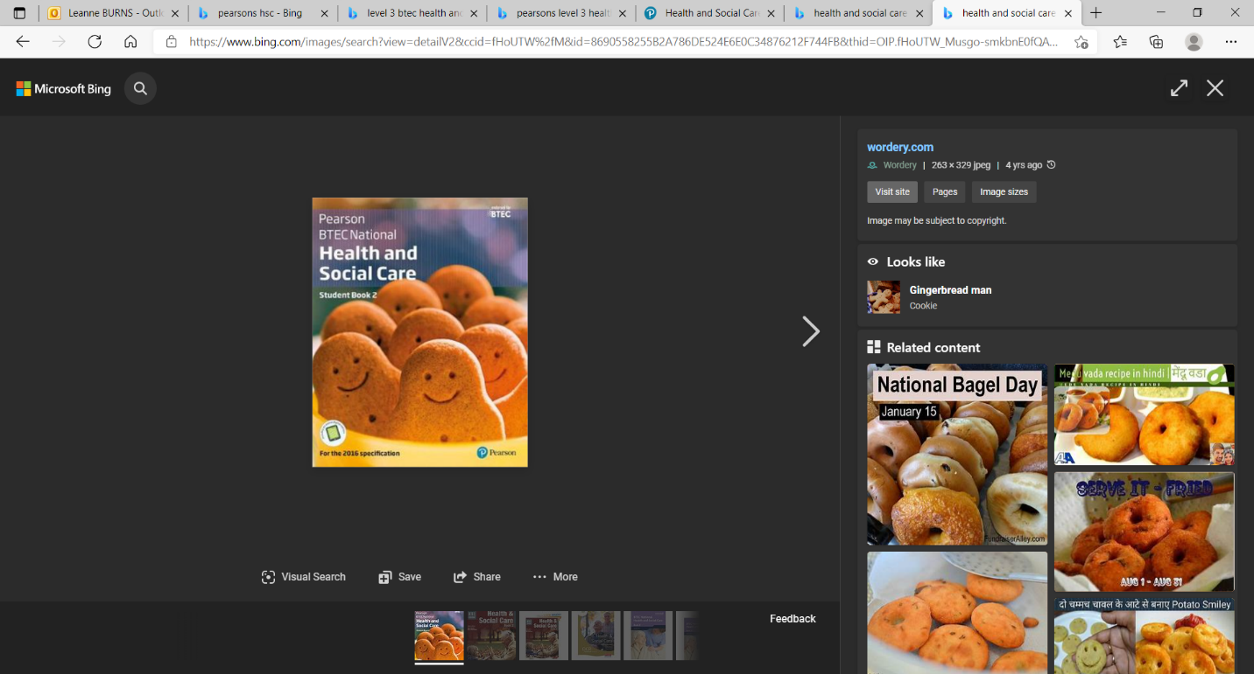
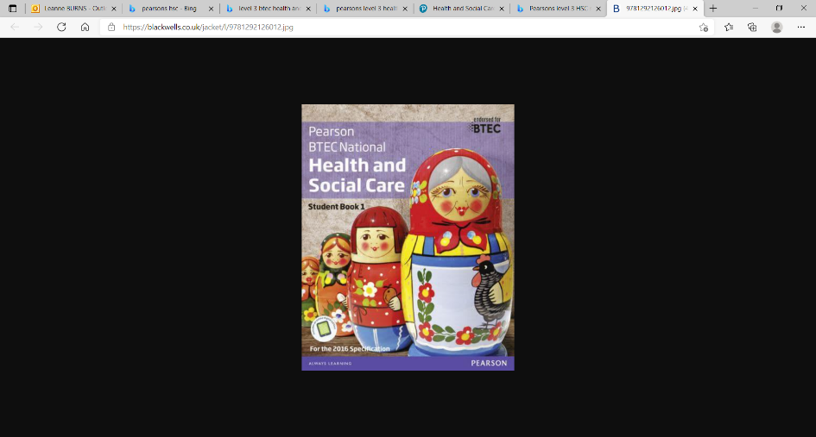

You do not need to purchase these books.

Resources you may choose to buy/look at (although these are entirely optional):
None. Keeping an eye on the news and keeping up to date with current affairs will help you.
Activities to be completed:

History of the NHS
The Beveridge Report, 1942
In 1942, a plan had been presented by William Beveridge, a senior civil servant, detailing key areas for post-war reconstruction, aimed at establishing a national system of welfare for the people. It identified ‘five giants’ that were to be overcome: want, disease, ignorance, squalor and idleness.
When the Beveridge Report first appeared, it was welcomed by all the parties. There was broad agreement that protection needed to be provided for all members of society, and so when Labour came to power in 1945, they implemented the proposals in this report, thereby establishing the welfare state, a system which all governments after 1951 accepted in its essentials. This common acceptance became known as consensus.
Giant | The 1945 Labour Government’s Solution
Want | To be ended by National Insurance. The National Insurance Act created a system whereby the government, employers and employees all paid for insurance which would pay out in the event of unemployment, sickness, maternity and retirement.
Disease | To be ended by a comprehensive health service. The National Health Service Act provided free medical and hospital treatment for all (the NHS).
Ignorance | To be ended by an effective education system. The Labour Party continued to support the Conservative’s 1944 Butler Education Act which provided free education within grammar schools, technical schools or secondary schools.
Squalor | To be ended by slum clearance and rehousing
Idleness | To be ended by full employment
The idealism that inspired the government’s welfare programme came at a heavy financial cost, which added to the financial burdens it inherited in 1945.
Write an extended piece of writing outlining the history of the NHS
Include sections on:
- Healthcare before the NHS
- When/ why the NHS was produced
- What the NHS does
- Significance of the NHS
- How is the NHS different in other countries

Approaches to promoting public health and well being
Promoting public health and well-being includes:
- Monitoring the health status of the community and identifying those most at risk, e.g. children, unemployed, older people, minority ethnic groups.
- Health surveillance programmes.
- Targeted education and health awareness and health promotion programmes.
- Socio-economic support to reduce health inequality between individuals and communities, e.g. winter fuel payments, free school meals, housing support.
- Improving access to health and care services.
- Co-ordinating national and local services.
- Disease registration to inform of health trends and for strategic health planning.
- Statutory duty to notify certain communicable diseases e.g. measles, tuberculosis (in this case COVID-19).
Task: Find examples of the British Government and relevant agencies putting these measures into practice; e.g. what have they done for those receiving free school meals? How have they identified those most at risk and supported them?

Task: Compare Britain’s response to at least one other country and its response to the pandemic. Assess the strengths and weaknesses in each approach to looking after public health.

Task: Look at least 3 news articles from a variety of sources and consider what they say about the British approach to the pandemic. Do you think it could have been improved? Justify your suggestions

Unit 1: Human Lifespan Development

Learners cover physical, intellectual, emotional and social development across the human lifespan, the factors affecting development and the effects of ageing. You will just be focusing on content covered in learning aim A: Human growth and development through the life stages

Task: Keywords and Definitions
Please research the meanings of these words. Please do not copy and paste, try to put them into your own words to show your understanding.

Keyword | Definition
Growth
Development
Centile Lines (percentiles)
Development norms
Milestone
Gross motor skills
Fine motor skills
Adolescence
Menopause
Life expectancy
Cognitive impairment
Abstract logical thinking
Egocentric thinking
Concrete logical thinking
Equilibrium
Disequilibrium
Self-concept (sense of identity)
Stranger anxiety

Task: what are the age ranges and key physical features of the life stages? What are the key difference between each life stage?

Life Stage | Age | Key Features
Birth and infancy | 0-2 years | Infants grow rapidly, at around 1 years old infants can walk, by 2 they can run.
Early childhood
adolescence
Early adulthood
Middle adulthood
Later adulthood

Task: Explain Piaget’s model of intellectual (cognitive development)
https://www.youtube.com/watch?v=IhcgYgx7aAA
Include:
- 3 facts about Piaget
- A brief description of the 4 stages of cognitive development
- Which life stages is this relevant to and why?

Task: Using this table and your general knowledge (you can research if you need to) what positive and negative events can affect a person's emotional and social development? I have included some examples. Aim to include at least 3 additional ones in each. Explain each point fully using extended writing.

 | Positive | Negative
Emotional Development | - A sense of security from caregivers | - Lack of love and affection
Social Development | - Opportunities to be independent | - Bad influences from peer groups

Activities to be completed:

Unit 2: Working in Health and Social Care

Learners cover the roles and responsibilities of health and social care (H&SC) practitioners. You will just be focusing on content covered in learning aim A: The roles and responsibilities of people who work in health and social care settings

Task: Keywords and Definitions
Please research the meanings of these words. Please do not copy and paste, try to put them into your own words to show your understanding.

Keyword | Definition
General Practitioner
Preventative care
Consultant
Nurse practitioner
Health screening
Antenatal care
Postnatal care
Supported housing
Policies
Procedures
Safeguarding
Self-help groups
Rehabilitation
Psychotherapy
Complementary therapies
Conventional medical treatment
Assistive technology
Domiciliary care
Halal
Kosher
Gluten
Informal care
Code of practice
Anti-discriminatory practice
Prejudice
Empowerment
Individualised care
Self esteem
Mulit-cultural society
Advocate

Task: Watch this clip about a career in nursing and complete the questions (you will get more information for the answers as the clip goes on).
https://vimeo.com/305430190

- What different people can you work with in nursing?
- What are the different places that you could work in?
- What does Charlotte think are the great things about nursing?
- What kind of skills and characteristics does she say she needs to use?
- What qualifications do you need? What ways can you enter into nursing?
- What challenges are there?
- What benefits are there?

Task: Research your local GP surgery

Name of the and location of the surgery
What different services do they provide?
I.e. alcohol, mental health etc.
What are the different methods of seeking support from them? I.e. phone, email etc.
Additional information

Task: Using unifrog research the entry requirements for each of these roles. What roles and responsibilities will they have? You will need to pick a specific type of each as there are so many areas you can go into.
https://www.unifrog.org/

General Practitioner- GP
Entry requirements
Salary range
Roles and responsibilities

Care Assistant
Entry requirements
Salary range
Roles and responsibilities

Support worker
Entry requirements
Salary range
Roles and responsibilities

Midwife
Entry requirements
Salary range
Roles and responsibilities

TASK: Watch this documentary: Caring and Sharing
https://www.bbc.co.uk/iplayer/episode/p06zhfvw/the-nine-to-five-with-stacey-dooley-series-1-2-caring-and-sharing
Review/synopsis: Write a summary about the documentary. Who, what, where, when, why? Include all key information of the story. Explain what was thought-provoking about it and the questions it led to. How did it make you feel?

Activities to be completed:

Task: Read this article by the King’s Fund and complete the task
The King's Fund is an independent charitable organisation working to improve health and care in England. Our vision is that the best possible health and care is available to all.
https://www.kingsfund.org.uk/blog/2020/04/health-social-care-covid-19-coronavirus

Review/synopsis: Write a summary about the article. Who, what, where, when, why? Include all key information of the story. Explain what was thought-provoking about it and the questions it led to. How did it make you feel? What impact is Covid 19 going to have on H&SC?

Task: What is the role of health promoters?
You will need to read through the following information and complete some research in order to explain the roles of the following organisations in maintaining the health of the population:
- World Health Organisation (WHO).
- Department of Health
- Public Health Agency
- Clinical Commissioning Groups (CCGs)
- Health professionals
Explain how each of the above has helped control the heath of your local area.

Extension Activity 1
Health and Social Care in the media
It is important to make the public realise about the issues which are prevailing in society relating to health and social care. One way in which public awareness is raised about health and social care in general and issues that exist within the health and social care sector is through the media.
Your task is to pick…
➢ x2 Films
➢ x1 Book
➢ x2 Documentaries
You will then need to write an essay with the following title: ‘Discuss the portrayal of Health and Social Care within the media’
You must watch/read the some of the examples on the previous slides you have picked and create notes to help with your essay. Consider the following:
• What issues, if any, are being raised in the stimulus?
• How does the stimulus present H&SC?
Is the stimulus informative/helpful and why?
• Are there any quotes/scenes etc that stand out to you and why?
• How effective is the stimulus in raising public awareness about H&SC/Issues

Films:
- Wonder - (PG) Inspiring story of a boy with facial differences who enters the fifth grade, attending a mainstream elementary school for the first time. Coping with being different. Coping with life/life events
- Hidden figures – (PG) Anti-discrimination. Care values
- Still Alice – (12A) Story of a woman living with Alzheimer's disease. Illness/Disorders
- My sister’s keeper – (12A) "The only way to save your daughter is to sacrifice her sister". Anna has never been given a choice: she was born to be her sister Kate's bone marrow donor and she has always given Kate everything she needs. Relationships/family/Ethics
- Three identical strangers – (12A) Identical triplets become separated at birth and adopted by three different families. Years later, their amazing reunion becomes a global sensation. Relationships/family
- Bohemian Rhapsody – (12A) Freddy Mercury defies stereotypes and convention to become one of history's most beloved entertainers. Lifestyle factors/social & cultural stereotypes
- Me before You – (12A) A young and quirky woman becomes a caregiver for a wealthy young banker left paralysed from an accident two years earlier. Life events/formal & informal care/disability
- The Children Act – (12A) Adam Henry has leukaemia. His doctors want to perform a blood transfusion but his parents are Jehovah’s Witnesses, and believe that having a blood transfusion is against biblical principles. Illness/ethics/relationships
- Sorry we missed you (15) Ricky and his family have been fighting an uphill struggle against debt since the financial crash. Social & cultural factors/income & wealth/life circumstances
- The Upside - (12A) The relationship between a wealthy man with quadriplegia and a recent unemployed ex-convict. Disability/relationships
- To the Bone – (15) Story of a young woman battling anorexia. Diet/Appearance
- The Theory of Everything (12A) The story of Stephen Hawking and his life following his diagnosis of a fatal illness. Disability/Relationships
- The Blind Side – 12A The story of Michael Oher, a homeless and traumatised boy who became an All-American football player and first-round NFL draft pick with the help of a caring woman. Social & cultural factors/income & wealth/life circumstances
- I, Daniel Blake – 15 After having suffered a heart attack, a 59 year old carpenter must fight the bureaucratic forces of the system in order to receive Employment and Support Allowance. Social and cultural factors/life circumstances

TV programmes:
- Saving Our Nurses – With a third of nurses looking for a new role, a new scheme based in a London hospital aims to cut the number of nurses leaving the profession. Care values/Health care services https://www.bbc.co.uk/iplayer/episodes/m000jygj/saving-our-nurses
- Babies : their wonderful world – BBC. Explores how the first 2 years of life shapes the adults we become. Infancy development/life stages
- The secret life of 4 and 5 year olds – Channel 4. Great for looking at childhood development/life stages (especially socialisation skills)
- Old people’s home for 4 year olds – Channel 4. How the company of 4 year olds helped to improve the mood, mobility and memory of the elderly. Life stages.
- Born to be different – Channel 4. The pressures and joys of bringing up a disabled child
https://www.channel4.com/programmes/born-to-be-different/ Disability/infancy and childhood/life events.
- Speech journey – You Tube. https://www.youtube.com/watch?v=jt7y1IM2jOM How children learn to talk from birth to 5 years old. Intellectual development
- Mum, Dad, Alzheimer’s and Me – You Tube. Real life story investigating the care of Alzheimer’s sufferers in the UK. https://www.youtube.com/watch?v=LprTLaO1AF0
Old age/disorders
- Louis Theroux, Extreme Love: Dementia – BBC 2 Sufferers and carers explore the struggle of living with dementia. Disorders/formal and informal care
https://www.bbc.co.uk/programmes/b01gvt26
- The restaurant that makes mistakes – Channel 4. Volunteers living with some form of dementia run a pop up restaurant in Bristol. Middle - Old age/disorders
- The big hospital experiment – BBC. A group of volunteers embark on a social experiment, with a shortage of staff, how can they help on the frontline of the NHS? Care values/Health care services
- Britain’s hidden hungry – BBC. Investigates the growing importance of charity foodbanks to thousands of hungry people across the UK by following the stories of three users of a foodbank. Diet and appearance.
- Supersize v Superskinny – Channel 4. Dieting and extreme eating lifestyles. Diet and appearance
- Rio Ferdinand: "Thinking Out Loud: Love, Grief and Being Mum and Dad" Talks at Google. https://www.youtube.com/watch?v=qgoRcxm5BUk Coping with life events
- Rio and Kate: becoming a step family. Rio Ferdinand’s fiancée Kate Wright integrates into the family as a step mum
https://www.bbc.co.uk/programmes/m000f9sg Coping with life events/family units
- Driven : The Billy Monger Story. The remarkable story of 18-year-old Billy Monger as he attempts to become the first ever amputee to race competitively in a single-seater racing car
https://www.bbc.co.uk/programmes/p06qx4gt Life events (unexpected)
- 24 hours in A & E – Channel 4. Emergency cases entering A & E. Life events/First Aid
https://www.channel4.com/programmes/24-hours-in-ae
- Health before the NHS – The road to recovery https://www.youtube.com/watch?v=1y7zeZPfD8k The shocking story of the health of Britain before the NHS. Care values/health care services
- Care – BBC drama https://www.youtube.com/watch?v=1EJXDk-B8h0 Discrimination/disability
- DIY S.O.S. https://www.bbc.co.uk/programmes/b006pnjk Friends, family and local trades help to transform the homes of families with special needs across Britain. Barriers to accessing services/physical barriers
- Crisis in Care: BBC Panorama https://www.bbc.co.uk/programmes/m0005jpf Panorama reveals the failings of our social care system, as our population gets older and more of us need help with day-to-day living. Old age/care services
- The Nine to Five with Stacey Dooley https://www.bbc.co.uk/iplayer/episode/p06zhfvw/the-nine-to-five-with-stacey-dooley-series-1-2-caring-and-sharing Stacey Dooley takes five teenagers to a care home for work experience. Types of support/voluntary support/old age
- Katie Piper: My beautiful face – recovery after acid attack. Self-esteem/self-confidence/ lifestyle
- Call the Midwife - BBC life events/childbirth/formal support
- Jesy Nelson - BBC 3 Little Mix star Jesy Nelson goes on a journey of rehabilitation as she opens up about abuse she has suffered at the hands of cyberbullies. Social/cultural factors that affect development

Books:
David Pelzer, A Child Called It – severe child abuse case
Davide Pelzer, A Man Named Dave – effects of childhood abuse
Adam Kay, This is Going to Hurt – secret diaries of a junior doctor
Brian Conaghan, The Weight of a Thousand Feathers – dilemma of a 17 year old
Alex Michaelides, The Silent Patient – psychological thriller
Richard Shepherd, Unnatural Causes – memoirs of a pathologist
Malala Yousafzai, I Am Malala: The Girl Who Stood Up for Education and was Shot by the Taliban
Angie Thomas, The Hate U Give – inequality, prejudice and police violence
Michael Newton, Savage Girls and Wild Boys: A History of Feral Children
Ray Jones, The Story of Baby P: Setting the record straight
Hope Daniels, Tainted Love – growing up in children’s homes
Jojo Moyes, Me before You – love, disability and relationships
Jen Pedro Roy, Good Enough – recovering from an eating disorder
Emma Healey, Elizabeth is Missing – psychological thriller of an older woman living with memory loss
Oliver Sacks, The Man who mistook his wife for a Hat – stories of patients with neurological disorders
Jennifer Niven, All the Bright Places – two teenager struggling with mental illness
Malorie Blackman, Pig Heart Boy – powerful story of friendship, loyalty and family
Meredith Russo, If I was your Girl – Transgender and bullying
John Green, The Fault in our Stars – a story of love and terminal illness
Dr Judith Rapoport, The Boy Who Couldn’t Stop Washing: Experience and Treatment of Obsessive Compulsive Disorder – the experience and treatment of OCD
Paul Kalanithi, When Breath becomes Air – autobiography based on a doctor with lung cancer
Henry Marsh, Do No Harm: Stories of Life, Death and Brain Surgery
Rachel Lippincott, Five Feet Apart – story of love illness
Henry Marsh, Admissions – life as a brain surgeon
Christie Watson, The Language of Kindness: A Nurse’s Story – life as a nurse
Suzi Brent, Nee Naw: Real Life Dispatches from Ambulance Control – working in one of the most busiest control rooms
Malorie Blackman, Noughts and Crosses – a story of love and race relations
Melvin Burgess, Junk – two runaway teenagers and drug addiction
Alexander Masters, Stuart: A Life Backwards – mental illness, crime and homelessness
Clare Mackintosh, After the End – love, marriage and parenthood
What to bring with you to the first lesson in September:
Folder
Pen
Highlighters
Sticky Notes

