**[Pre A Level Summer Reading: Origins of the Russian Revolution](http://www.orlandofiges.info/section1_OriginsoftheRussianRevolution/index.php)**

**Imperial Russia - the Failure of Reform**

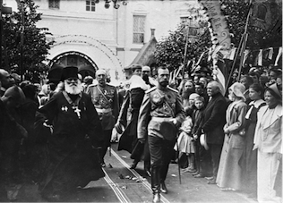Russia remained a relatively stable society until the final decades of the nineteenth century. The Tsarist Empire was untroubled by the revolutions that shook Europe's other monarchies in 1830 and 1848. Its huge army crushed the Polish uprisings of 1830 and 1863, the main nationalist challenge to the Tsar's Imperial rule, while its police hampered the activities of the small groups of radicals and revolutionaries, who were mostly driven underground.

Russia's failure to reform was a constant frustration for the liberal intelligentsia. It turned many into revolutionaries. Western ideas of representative government and civil rights made little headway in the ruling circles of the court, the centre of power until 1917.

The tsars ruled their sprawling empire with an ideology rooted in medieval Muscovy. According to his coronation oath, the tsar's sovereignty was absolute, unlimited by laws or parliaments, by bureaucrats or public opinion. His personal rule was guided only by his conscience before God. Conservatives insisted that autocracy was suited to the Russian national character, that a god-like tsar was needed to restrain the anarchic instincts of the people.

TASK:

1. Why was the Tsarist government able to crush opposition?
2. Who are the intelligentsia? Why were they unhappy with the Tsarist government?
3. Create a glossary of the following terms:

* Nationalist
* Revolutionary
* Intelligentsia
* Liberal
* Sovereignty
* Absolute power
* Bureaucrat
* Autocracy
* Conservative
* anarchic

**The Weakness of Society**

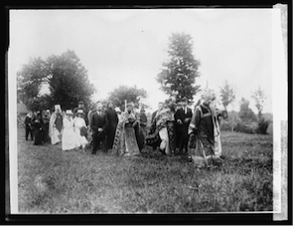The power of the state was only very weakly counter-balanced by an independent landed aristocracy. This was a major difference between Russia and Western Europe, where since feudal days the landowning nobles had limited the power of the monarchy. The Russian nobility was heavily dependent on military and civil service to the state for its position in society and landed wealth.

Nor were there many public institutions to challenge the autocracy. Most public bodies (organs of local self-government, scientific and artistic bodies) were in fact creations of the state. Even the senior leaders of the Orthodox Church were appointed by the tsar.

The Church retained a powerful hold over rural Russia, in particular. In many villages the priest was one of the few people who could read and write. Through parish schools the Orthodox clergy taught children to show loyalty, deference and obedience, not just to the Tsar and his officials but also to their elders and betters.

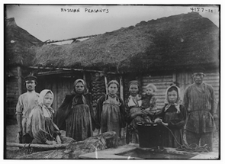Despite Alexander II's abolition of serfdom, its legacies continued to oppress the peasants after 1861. Most of the arable land remained the private property of the gentry landowners, who rented it out to the land-hungry peasants at rates that increased steeply in the later nineteenth century as the population rose. Legally the peasants were excluded from the sphere of written law, which protected property.

Their affairs were regulated by customary law within the village commune (mir or obshchina), which was dominated by the patriarchal culture of the peasant elders, mostly devoted to the 'Tsar-Batiushka' or paternal Tsar, until the turn of the twentieth century when a younger and more literate generation of communal leaders emerged. These peasant sons would play a vital role in the revolutions of 1905 and 1917.

Gentry magistrates dominated the administration of the countryside. Until as late 1904, they retained the power to have peasants publicly flogged for minor misdemeanours, such as rowdy drunkenness or trespassing on the landowner's land. It is difficult to overestimate the psychological impact of this corporal punishment - 43 years after the serfs had legally been 'freed'. Issues of human dignity were prominent in 1905 and 1917. The memory of serfdom was still fresh.

TASK:

1. Why did the nobility support the monarchy/state?
2. How did the state control the Church?
3. What happened in 1861?
4. Who owned the majority of the land in Russia?
5. Why was competition for land increasing across the nineteenth century?
6. What is the mir?
7. What figures led local village society?
8. What does paternal mean?
9. How were local village leaders changing?
10. Describe ways in which the peasants were not treated humanely.

**The Conditions of the Working Class**

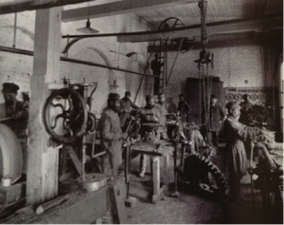  
Typical engineering workshop, Moscow, 1890s

Forced off the land, millions of peasants came into the towns, or worked in rural factories and mines. In the last half-century of the old regime the Empire's urban population grew from 7 to 28 million people.

Factory conditions were terrible. According to Count Witte, the Finance Minister in charge of Russia's industrialization until 1905, the worker 'raised on the frugal habits of rural life' was 'much more easily satisfied' than his counterpart in Europe or North America, so that 'low wages appeared as a fortunate gift to Russian enterprise'.

There was little factory legislation to protect labour. The two most important factory laws - one in 1885 prohibiting the night-time employment of women and children, and the other in 1897 restricting the working day to eleven and a half hours - had to be wrenched from the government. Small workshops were excluded from the legislation, although they probably employed the majority of the country's workforce, and certainly most of its female contingent.

Shopfloors were crammed with dangerous machinery: there were frequent accidents. Yet most workers were denied a legal right to insurance and, if they lost an eye or limb, could expect no more than a few roubles' compensation. Workers' strikes were illegal. There were no legal trade unions until 1905. Many factory owners treated workers like their serfs.

Russian workers were the most strike-prone in Europe during the 1900s. Three-quarters of the factory workforce went on strike in the revolutionary years of 1905-6.

TASK: How much did the population of Russia increase by?

Create a mindmap to describe factory conditions

**Was Nicholas II Fit to Rule?**

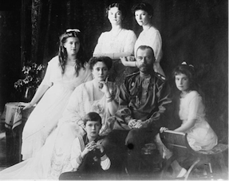

Throughout his reign Nicholas gave the impression of being unable to cope with the tasks of ruling a vast Empire in the grips of a deepening revolutionary crisis. True, only a genius could have coped with it. And Nicholas was certainly no genius. Had circumstances and his own inclinations been different, he might have saved his dynasty by moving away from autocratic rule towards a constitutional regime during the first decade of his reign, while there was still hope of appeasing the liberals and isolating the revolutionary movement. Nicholas had many of the personal qualities required to be a good constitutional monarch. In England, where one needed only to be a 'good man' in order to be a good king, he would have made an admirable sovereign. He was certainly no dimmer than his look-alike cousin, George V, who was a model of the constitutional king. Nicholas was mild-mannered, had an excellent memory and a perfect sense of decorum, all of which made him potentially ideal for the largely ceremonial tasks of a constitutional monarch. But Nicholas had not been born to that role: he was the Emperor and Autocrat of All the Russias. Family tradition and pressure from the crown's traditional allies compelled him not only to reign, but to rule.

TASK:

1. Create a family tree for the Tsar (go back to his grandmother)
2. Colour code the paragraph above into Nicholas II’[s strengths and weaknesses.