[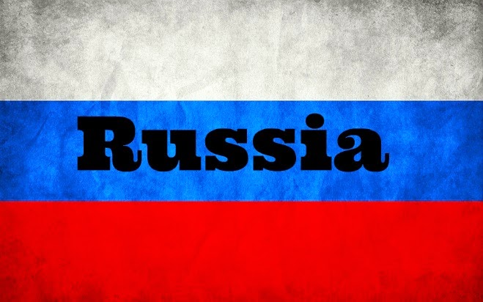](http://www.google.co.uk/url?sa=i&rct=j&q=&esrc=s&source=images&cd=&cad=rja&uact=8&ved=0CAcQjRxqFQoTCLX8zPnCh8YCFSGO2wod710A9g&url=http://news-dickinson.blogspot.com/2014/10/russian-flag-wallpaper.html&ei=FG95VbWiIaGc7gbvu4GwDw&bvm=bv.95277229,d.ZGU&psig=AFQjCNG0GwB26mWM_h8nD4CG2zSfjeSWFA&ust=1434108036750047)

Wallingford History Department

Russia in Revolution 1894-1924 A2 2024

QUICK QUIZ

How much do you already know about Russia?

1. What is the capital of Russia?

(a) Moscow (b) St Petersburg (c) Berlin (d) Warsaw

2. What is the currency used in Russia?

(a) Pound (b) Euro (c) Ruble (d) Potatoe

3. What is the current population of Russia?

(a) 42 million (b) 142 million (c) 242 million (d) 342 million

4. Which of these words means ‘Emperor’ in Russian

(a) Tsar (b) Czar (c) Tzar (d) Kaiser

5. Who was on the same side as Russia during World War One?

(a) France (b) USA (c) Germany (d) France

6. How many revolutions took place in Russia during 1917?

(a) One (b) Two (c) Three (d) Four

7. Which political group took over Russia by the end of 1917?

(a) Bolsheviks (b) Mensheviks (c) Communists (d) Liberals

8. Who was leader of Russia between 1917 and 1924?

(a) Stalin (b) Yeltsin (c) Lenin (d) Khrushchev

9. After the 1922, Russia was known as what until 1991?

(a) CCCP (b) USSR (c) CIS (d) Soviet Union (union of soviet socialist’s republic)

10. Which country did Russia not ally with during World War Two?

(a) USA (b) Japan (c) Germany (d) Britain

The key features of Russian politics, economy and society.

Russia was an autocracy with all the power in the hands of the tsar. The tsar believed he had the divine right to rule, that is, that he had been chosen by God to rule. This meant he could do what he liked without having to consult the people. There was no Parliament to represent the people’s views.

The tsar did have a collection of ministers that ran the various government departments, but it could not make the important decisions. There were thousands of civil servants such as tax collectors who carried out the day to day work of government. They were generally poorly paid, so this encouraged bribery and corruption.

The Russian people had little freedom. All unions of workers and strikers were forbidden, and newspapers and books were censored by the government. The tsar was determined to suppress all opposition through the Okhrana, his secret police. The secret police used spies and agents to root out anyone who was against the tsar and his system of government. Such opponents could be imprisoned or exiled too far off Siberia.

Russian society consisted of many different peoples or ethnic groups in the empire. At least twenty different ethnic groups made up Russia and for every 6 out of 10 people Russian was a foreign language. Many of these people resented being part of the empire especially since the rulers of Russia carried out a policy of Russification. This meant making non-Russians speak Russian, wear Russian clothes and follow Russian customs.

About 70% of the population were members if the official Orthodox Church. The Church was very closely linked to the tsar and supported his way of ruling. It taught that the tsar was head of the country and the Church – in other words, that he was God’s chosen representative on earth. The Orthodox Church was unpopular because large minorities belonged to other Churches and religions, and they resented its power and its privileges. For example, 9% of the population was Roman Catholic and 11% Muslim. Also, the orthodox church was very wealthy, which contrasted greatly with the poor lifestyle of the majority of the Russian people.

Russian agriculture was backward. Extensive tundra forest and desert meant not all the land was suitable for agriculture and the best arable farming was in the ‘Black earth region’. Old fashioned farming methods resulted in low food output and frequent famines. Even though Russia was rich in oil and minerals industrialisation did not happen until the end of the nineteenth century. Considering Russia’s size and resources its manufacturing output was still very low at the beginning of the twentieth century. Its size and undeveloped system of roads and railways together with the absence of an effective banking system, all restricted the growth of industry.

Complete the following three tasks using the information on the key features of Russian politics, economy and society. Do the tasks in the booklet.

Task one

True or false – is the following information true or false? If false, please correct it.

|  |  |
| --- | --- |
| Information | True/false |
| The Tsar had a government he ran the country with |  |
| Government officials were well paid so could be trusted |  |
| The Okhrana were the Tsar’s secret police |  |
| Russia was made up of at least 18 different ethnicities |  |
| Russia was proud she had so many differing ethnic groups |  |
| The Orthodox Church was the only church in Russia |  |
| Russian farmland was of good quality |  |
| Russia was rich in natural resources |  |
| Russia’s industrialisation was in line with that of other countries |  |
| Russia had excellent transport links |  |

Task two - define the following key words

|  |  |
| --- | --- |
| Key term | Definition |
| Tsar |  |
| Autocracy |  |
| Okhrana |  |
| Russification |  |
| Tundra |  |
| Orthodox Church |  |
| Industrialisation |  |
| Corruption |  |
| Exile |  |
| Siberia |  |

Task three - Your teacher has written an essay describing Russia. They are very proud of this; however, they may have made some mistakes. Read through, find the errors and correct them.

Russia was an autocratic ruled country with all power held by one woman: The Tsar. He believed that he had a divine right to rule, that is he had been chosen by god to rule and didn’t have to answer to anyone. However, the Tsar realised the importance of sharing power and did consult his government about important decisions. The government ministers were low paid and therefore there was a lot of corruption and bribery in government. The people in Russia had little freedom in terms of no unions, censorship and religion. The Tsar had his own secret police the Cheka who spied and could arrest and imprison people without trial and exile them to Florida.

Many different ethnicities made up Russia and the Tsar had a policy of Russification to make sure that people followed the culture of Russia. Most people belonged the Russian Orthodox Church, but there were also Jews, Catholics and Hindus in Russia at this time. A lot of people really resented the Church because it gave too much money to the poor.

Russian agriculture was incredibly poor because of old fashioned farming techniques. This often led to overproduction and food going off. Russia industrialised later than most countries. However excellent transport links across the country enabled the growth of their industry very quickly.

Correct the mistakes your silly History teacher has made in this essay.

If you have any questions about the Key features of Russia’s politics, economy or society please write them here for your History teacher to answer.

Read the information and use the pictures on the following pages to fill in the table below.

|  |  |
| --- | --- |
| Evidence of something that would make a country hard to rule | Evidence of this Russia in 1905 |
|  |  |

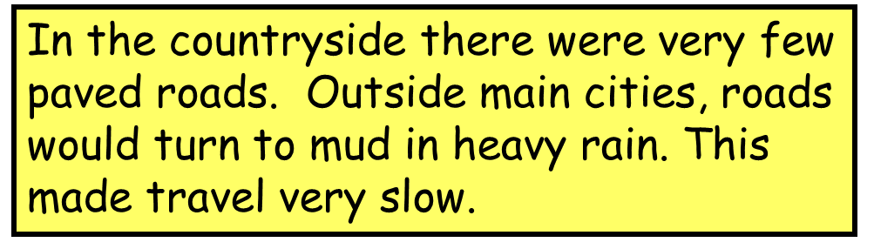

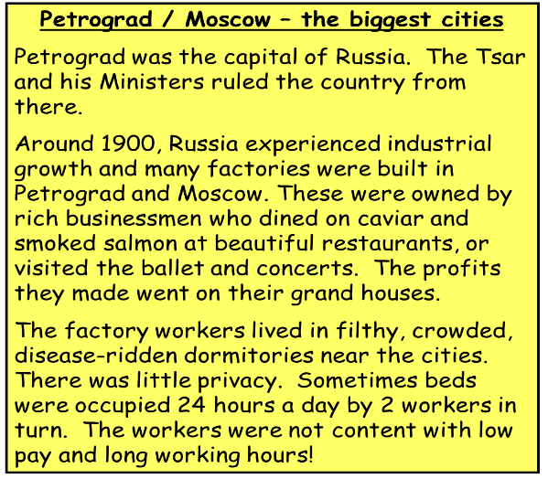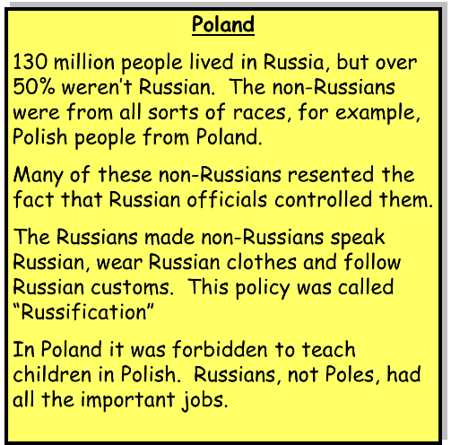

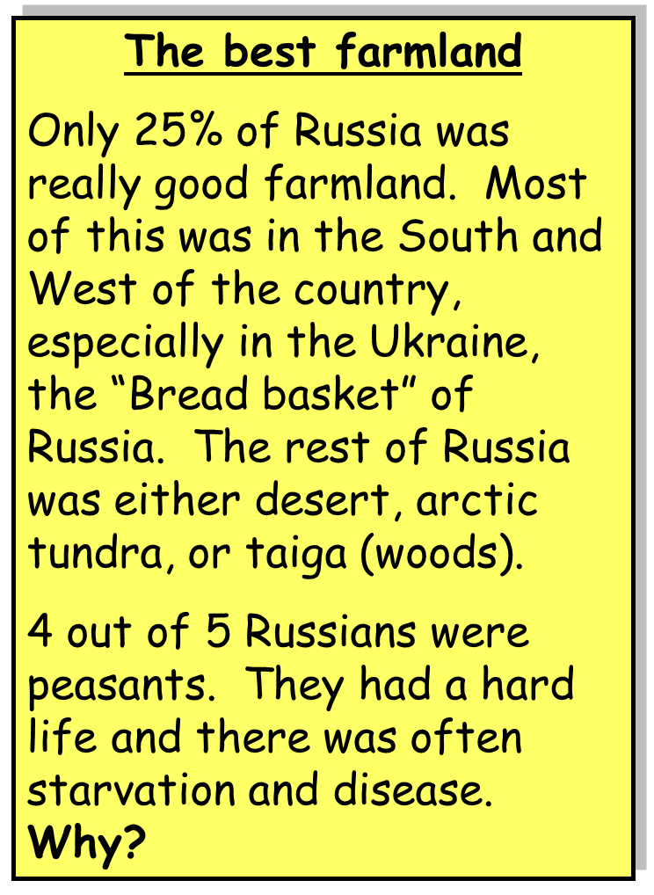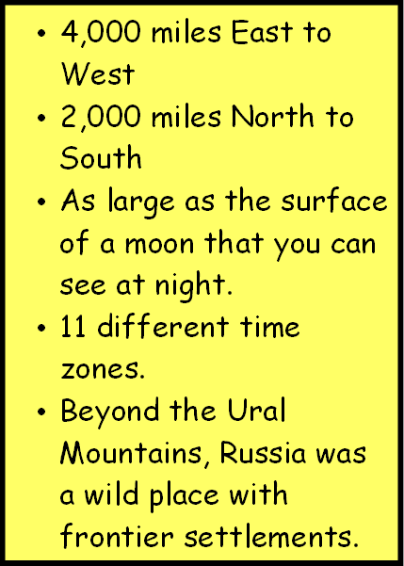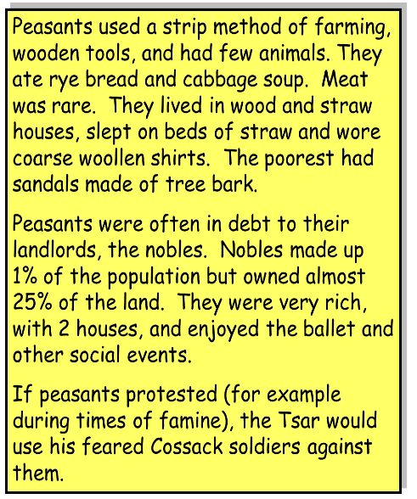

Web search – Use the internet to fill in the profiles for the three Russian leaders (just google their names, if possible do not use Wikipedia). You will be looking at the two leaders before our period starts as well as Nicholas II, but all this information will be relevant.

|  |  |
| --- | --- |
| Alexander II | 1855-1881 |
| Born |  |
| Crowned |  |
| Married |  |
| Important legislations passed |  |
| Personality |  |
| Opposition |  |
| Dies |  |

|  |  |
| --- | --- |
| Alexander III | 1845-1894 |
| Born |  |
| Crowned |  |
| Married |  |
| Important legislations passed |  |
| Personality |  |
| Opposition |  |
| Dies |  |

|  |  |
| --- | --- |
| Nicholas II | 1868-1918 |
| Born |  |
| Crowned |  |
| Married |  |
| Important legislations passed |  |
| Personality |  |
| Opposition |  |
| Dies |  |

Please write any questions or comments for your teacher in this box