Five Frames From…
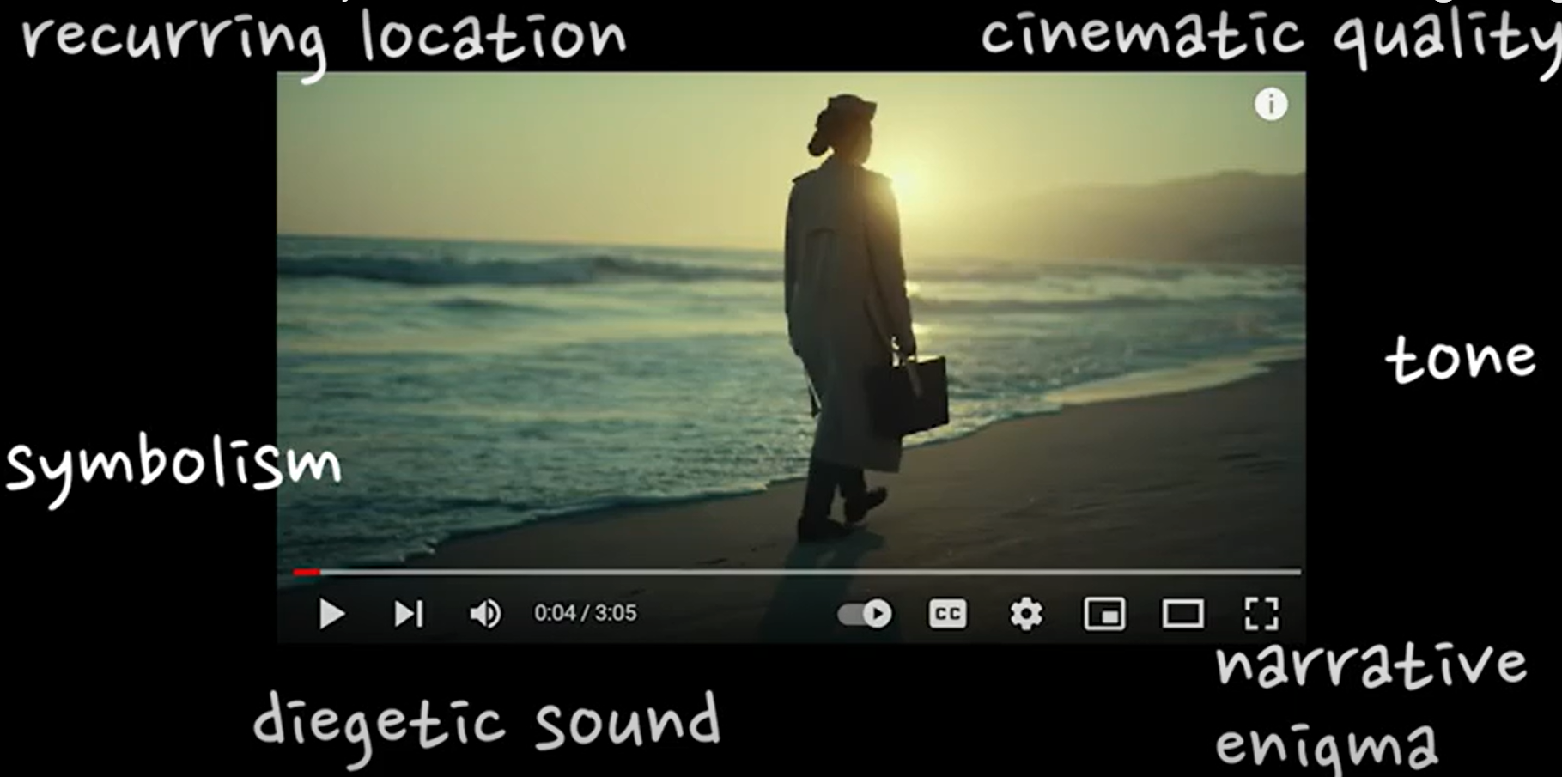 | Sound:  Camera Methods:  Editing:  Semiotics:  Theory:  Visual codes:

