**L14: NARRATIVE THEORIES**

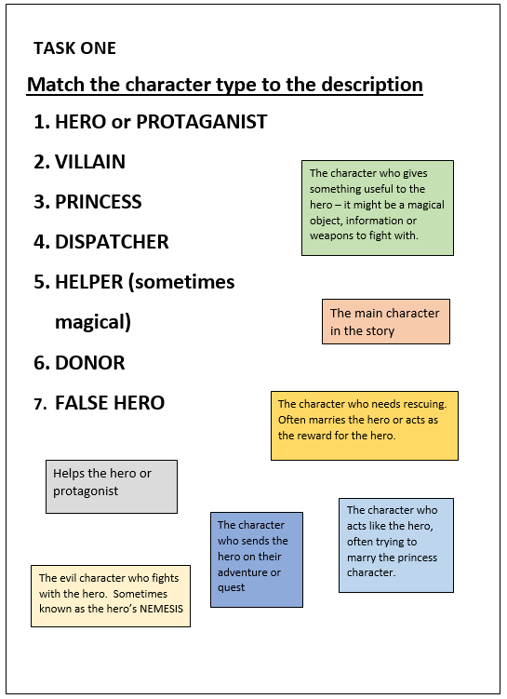

**L14: NARRATIVE THEORIES**

**Questions to answer whilst watching Paddington trailer**

1. Is Good and Evil a binary opposite in this trailer?
2. Explain your answer to number 1
3. Can you identify and describe examples of any other binary opposites in the trailer?

LONGER QUESTION: Do you think that Levi-Strauss’s theory is the best one for this trailer or would it be easier to write about Propp’s Character Types or Todorov’s theory of equilibrium? Explain your answer.

**Questions to answer whilst watching the Sainsbury’s advert**

1. In the Sainsbury’s advert, describe the equilibrium
2. Which of the following is the purpose of the ‘equilibrium’ section of the advert?
   1. To help the audience understand what is going on
   2. To help the audience get to know the characters
   3. To help the audience work out the situation
3. In the Sainsbury’s advert describe the disequilibrium
4. Why is this ‘abnormal’?
5. In the Sainsbury’s advert describe the new equilibrium

**Putting it all together…**

Watch Room 8 (winner of the Bafta short film awards 2014). As you watch, fill out the chart with your notes on each theory. Have a look again at the success criteria to help you develop your answers.

|  |  |
| --- | --- |
| **Levi- Strauss**  Binary Opposites |  |
| **Propp**  Character Types |  |
| **Todorov**  Equilibrium/ Disequilibrium/ New Equilibrium |  |