**Revision Guide**

**Component 1 Section A**

**MEDIA LANGUAGE**

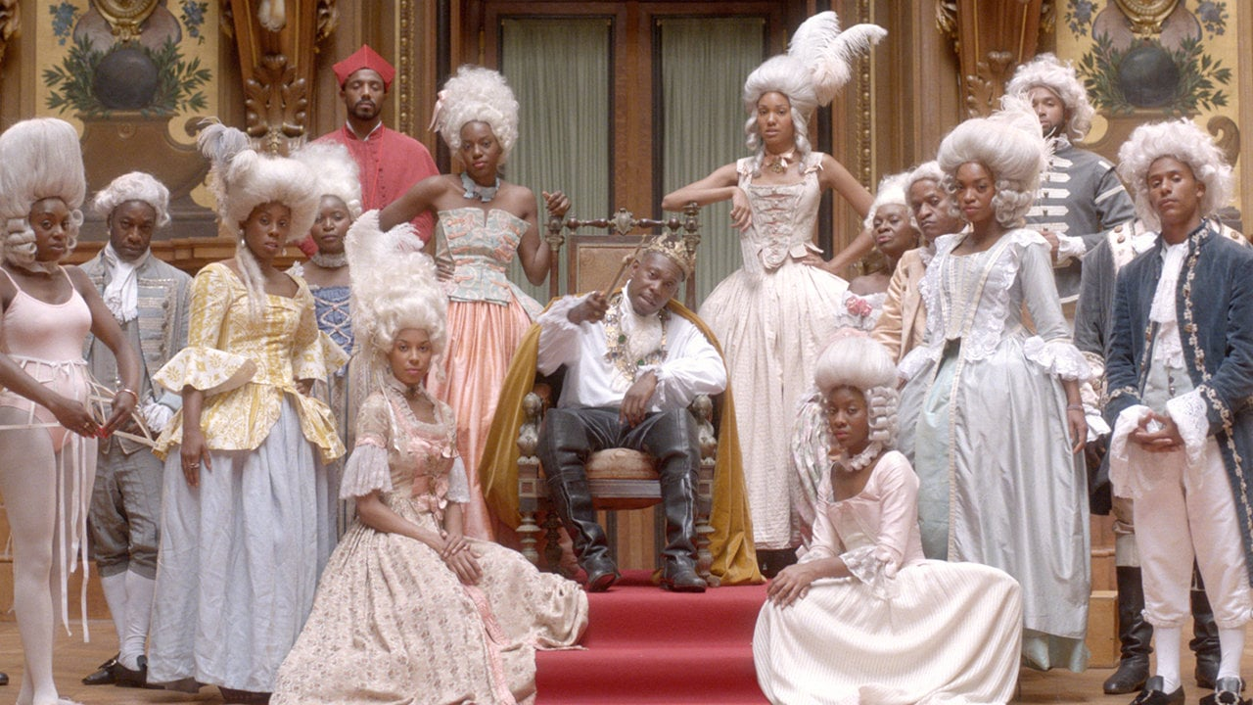

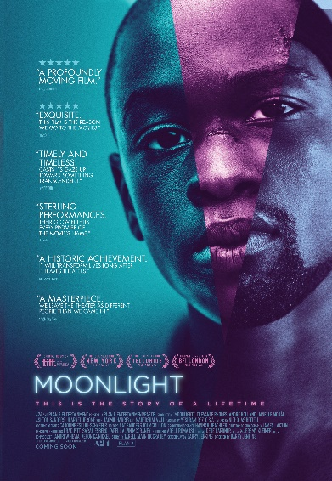 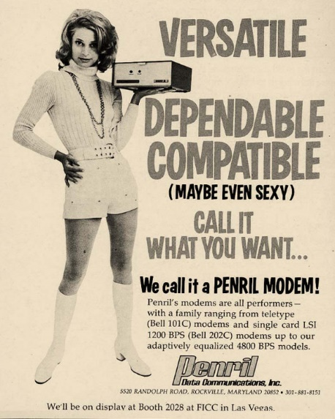 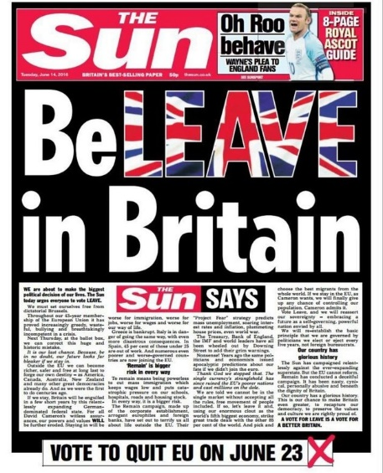

|  |
| --- |
| **THE MEDIA LANGUAGE QUESTION WILL BE BASED ON AN UNSEEN TEXT** |
| **Media Forms** |
| Advertising and marketing – including film posters (vintage or modern), print and AV adverts (vintage or modern or charity) |
| Music video – this could be performance or narrative or mixed |
| Newspapers – could be broadsheet or tabloid |

The table below will give you an understanding of the types of knowledge and understanding of the media forms. This should give you an understanding of the type of question that might be formed.

Sample questions

|  |  |
| --- | --- |
| Media Language  AS | How does media language communicate meaning in the Barnardo’s Believe in Me advertisement? |
| Media Language  AL | How does media language incorporate viewpoints and ideologies in these front pages of The Sun and The Daily Mail? |

|  |  |
| --- | --- |
| **Media Language** | **Media Forms** |
| How the different **modes** and **language** associated with different media forms communicate multiple **meanings** | Advertising and marketing  Music video  Newspapers |
| How the **combination** of elements of **media language** influence **meaning** | Advertising and marketing  Music video  Newspapers |
| How developing **technologies** affect media language | Music video  Newspapers |
| The **codes and conventions** of media forms and products, including the processes through which media language develops as **genre** | Advertising and marketing  Music video  Newspapers |
| The processes through which meanings are established through **intertextuality** | Advertising and marketing  Music video  Newspapers |
| How **audiences respond** to and **interpret** the above aspects of media language | Advertising and marketing  Music video  Newspapers |
| The significance of the **varieties** of ways  **intertextuality** can be used in the media | Advertising and marketing  Music video  Newspapers |
| The way media language incorporates **viewpoints**  and **ideologies** | Advertising and marketing  Music video  Newspapers |
| **Theories** |  |
| **Semiotics**  (including Barthes) | Advertising and marketing  Music video  Newspapers |
| **Structuralism**  (including Lévi-Strauss) | Advertising and marketing  Music video  Newspapers |
| **Other theory to consider** | |
| **Genre Theory – Neale**  **Narrative – Todorov**  **Postmodernism – Baudrillard** | |

**Sample question: How does media language incorporate viewpoints and ideologies in these front pages of *The Sun* and *The Daily Mail*?**

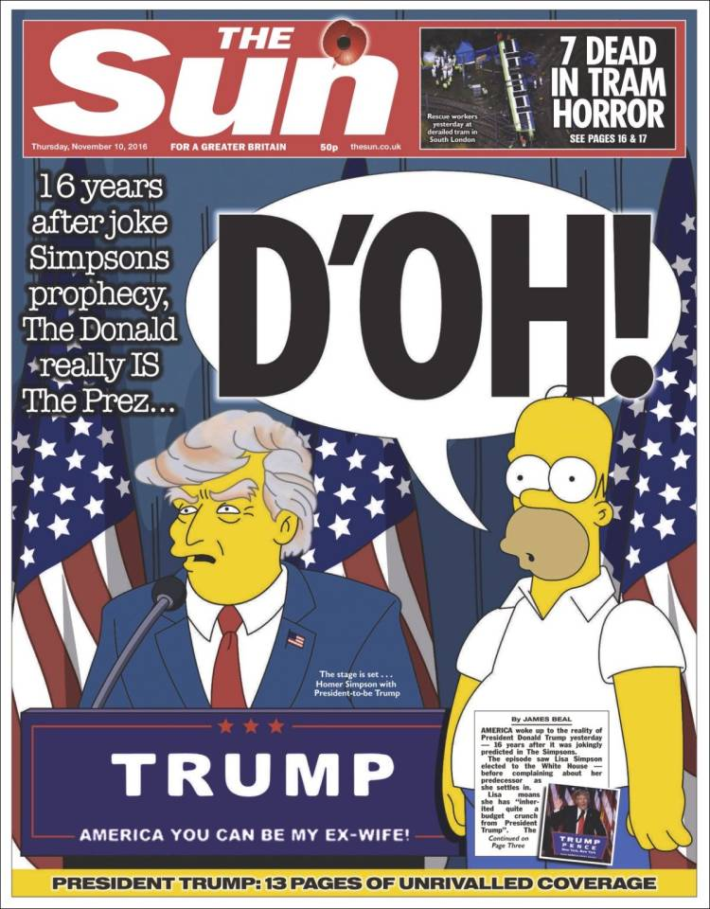

**Sample question: How does media language incorporate viewpoints and ideologies in these front pages of *The Sun* and *The Daily Mail*?**

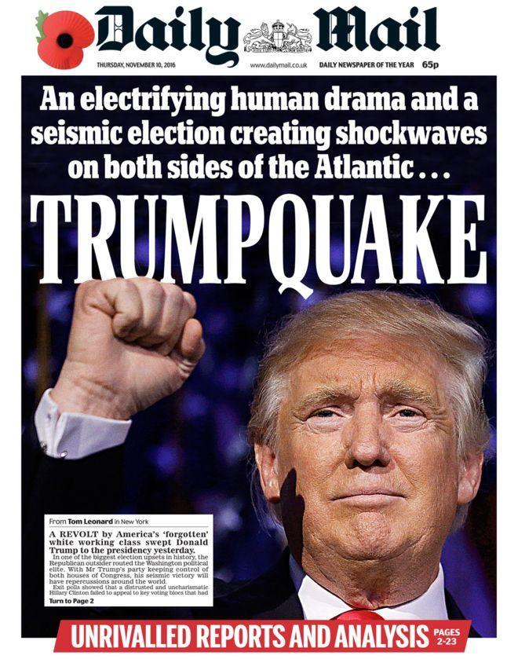

Mark scheme

|  |  |
| --- | --- |
|  | **AO2 1**  **Apply knowledge and understanding of the theoretical framework of media to**  **analyse media products** |
| **Band** |  |
| **5** | Excellent, consistent and accurate application of knowledge and understanding  of the theoretical framework to analyse the newspaper front pages  Analysis of the newspaper front pages is perceptive, detailed and is likely to be  informed by relevant theories |
| **4** | Good, accurate application of knowledge and understanding of the theoretical  framework to analyse the newspaper front pages  Analysis of the newspaper front pages is logical and may be informed by  relevant theories |
| **3** | Satisfactory, generally accurate application of knowledge and understanding of  the theoretical framework to analyse the newspaper front pages  Analysis of the newspaper front pages is reasonable and straightforward |
| **2** | Basic application of knowledge and understanding of the theoretical framework  to analyse the newspaper front pages, although this is likely to lack clarity,  relevance and accuracy  Analysis of the newspaper front pages is undeveloped and there may be a  tendency to simply describe features of the newspaper front pages |
| **1** | Minimal, if any, application of knowledge and understanding of the theoretical  framework to analyse the newspaper front pages, with significant inaccuracies,  irrelevance and a lack of clarity  Analysis of the newspaper front pages is superficial and generalised |

**Responses will explore examples of how media language constructs viewpoints and ideologies in The Sun, such as**

The front page is constructed around an intertextual reference to a popular TV text (The Simpsons) that is associated with humour and satire, incorporating a sense of mockery of the election outcome

The Sun conveys a viewpoint that the election result is unexpected and bizarre, by selecting and combining visual imagery and language from The Simpsons:

The dominant main image humorously juxtaposes Homer with Donald Trump, implying the surreal nature of the outcome

The dominant intertextual headline ‘D’oh’, Homer Simpson’s catchphrase,conveys a message that things have turned out unexpectedly and badly

The small image of Donald Trump in the same position as the cartoon Donald Trump reinforces the fact the election result is real

The use of informal language e.g. ’16 years after joke Simpsons prophecy, The Donald really IS the Prez’ reinforces the viewpoint that the result is not being taken seriously

The copy on the front page references The Simpsons predicting that a Trump presidency would be problematic for the USA, implying a viewpoint that the outcome is negative

The combination of these elements of media language conveys a less serious tone and potentially reflects a belief that the result will have a less ominous impact than some newspapers were predicting

This reflects The Sun's right-leaning political stance (broadly relating to the Republican Party in America)

**Responses will explore examples of how media language constructs viewpoints and ideologies in The Daily Mail, such as:**

The use of hyperbolic language in the headline establishes a clear viewpoint that the election result is of extreme importance and will have a dramatic impact on Britain as well as the USA

The selection of the main headline, ‘Trumpquake’, sensationalises the event and adopts an informal tone, reflecting the pre-election image of Trump as a populist businessman.

The use of extended metaphor (‘seismic’, ‘shockwaves’, ‘quake’, ‘swept’) reinforces the significance of the event, likening Trump's victory to a force of nature.

The use of emotive language (‘electrifying human drama’/’revolt by America's forgotten white working class’), engages the audience by humanising the political event, and presents the viewpoint that this is a positive outcome.

The selection of the main image anchors the use of language by representing Trump as a powerful, statesmanlike politician (slightly low angle camera shot, light shining on face,dominant position of the clenched fist).

The combination of these elements of media language conveys the viewpoint of The Daily Mail that Trump has achieved a popular and major success.

This reflects The Daily Mail's political ideology as a right-wing newspaper (broadly relating to the republican party in America)

The viewpoint that Trump won because he appealed to ‘America's forgotten white working class’ also positions the Daily Mail ideologically as supportive of this demographic, arguably appealing to their target audience of working class/ lower middle class reader

Both newspapers use media language to incorporate the viewpoint that the US election result is significant to Britain, reflecting the importance of the relationship between Britain and the USA in the post-Brexit context.

Explore how media language communicates meaning in the film poster for From Russia With Love.

|  |  |  |
| --- | --- | --- |
| AS | Theoretical framework | Analysis |
| 5  9-10 | Excellent, consistent and accurate application of knowledge and understanding | perceptive, detailed, informed by relevant theories |
| 4  7-8 | Good, accurate application of knowledge and understanding | logical, reasonably detailed, informed by relevant theories |
| 3  5-6 | Satisfactory, generally accurate | reasonable and straightforward |
| 2  3-4 | Basic lacks clarity, relevance and accuracy | undeveloped tendency to simply describe |
| 1  1-2 | Minimal significant inaccuracies, irrelevance and a lack of clarity | superficial and generalised |

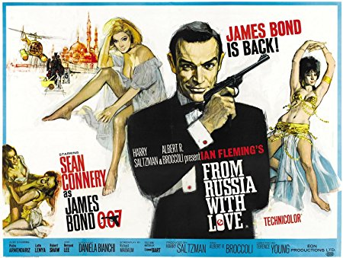

**Example 1**

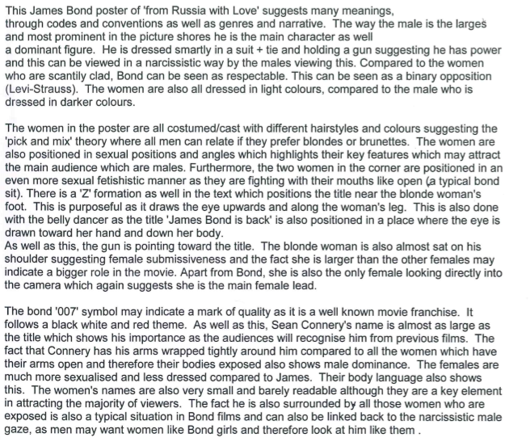

**Example 2**

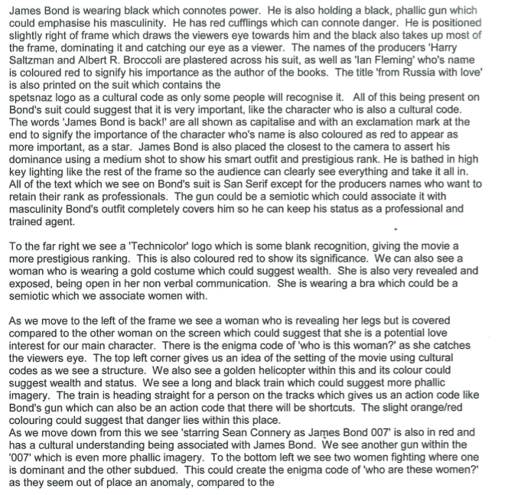

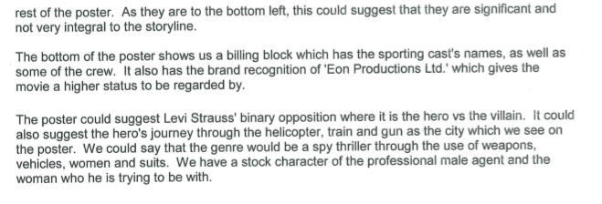

**Practice: Developing writing skills- MEDIA LANGUAGE**

Identify a dominant signifier

* Image of a girl in top left

Develop to include terminology

* There is an **iconic sign** of a girl at the top left of the text, the image is a **mid-shot** with faded colours.

Add theory and meaning for audience

* Using **Barthes levels of signification** this **connotes** to the audience that she is potentially the **protagonist**.

Can you suggest alternative meanings showing the text is polysemic

* The ghostly quality of the image could also **connote** themes of death giving a **polysemic** **reading** of the text

Give more detail

* She has a concerned facial expression and the direction of her **gaze** suggests she is searching for something.

There is an **iconic sign** of a girl at the top left of the text, the image is a **mid-shot** with faded colours. Using **Barthes levels of signification** this **connotes** to the audience that she is potentially the **protagonist**. The ghostly quality of the image could also **connote** themes of death giving a **polysemic** **reading** of the text. She has a concerned facial expression and the direction of her **gaze** suggests she is searching for something.

Relate to question

* Narrative

This acts as a **narrative code** creating **enigma** as the audience do not know what she is searching for

* Genre

This helps to establish the **genre** of the film as a thriller

* Layout and design/visual codes

The use of the pale colour creates **connotational conjunction** throughout the text

* Ideology

This subverts **normative gender roles** where women are often represented as passive (van Zoonen)

Refer to the glossary in the Independent Study section on iLearn. Keep practicing with a variety of texts – you never know you might choose the same one as the examiner!

The tables below detail the key questions you should have in your mind when approaching the Media Language question. It also details the features of media language you should feel confident when writing about the various media forms.

|  |  |
| --- | --- |
| **Advertising and marketing** | **Features of media language** |
| Consider the nature and purpose of this type of product.  What is being advertised/marketed?  Different types of products have different codes and conventions due to the difference in purpose.  Title of product/organisation/campaign/film?  Is the product (if appropriate) depicted? If so, how? If not, how is the product established?  The brand – is the product/organisation an established brand?  What are the key features of/association with the brand – brand values and identity?  What is the ‘concept’ of the advert? Is there a ‘unique selling point’? Consider contexts. | **Print elements of media language**  Codes and conventions Layout and design Composition  Images/photographs (camera shot type, angle, focus)  Font size, type of font (e.g. serif/sans serif), colour  etc.  Mise-en-scène – colour, lighting, location, costume/dress, hair/make-up as appropriate  Graphics, logos etc.  Language – slogan/tagline and any other copy included in the advertisement  Anchorage of images and text  Elements of narrative  **Moving Image elements of media language**  Codes and conventions  Camera work (framing – shot types, angle, position, movement etc.)  Editing – pace, type of edits, continuity/montage  Structure/narrative  Sound – music/dialogue/voiceover |

|  |  |
| --- | --- |
| **Music Video** | **Features of media language** |
| Consider the nature and purpose of this type of product – primarily a promotional device with the aim of selling the music/artist.  Usually feature elements of performance and narrative.  As a relatively new media form, music videos can often be viewed as postmodern products, employing elements such as bricolage.  Mainstream artists’ videos may reflect a clearly commercial purpose and feature high production values in comparison to those produced by independent artists whose videos may be more experimental.  Is the artist/band featured? As performer/s and/or in the narrative?  How does the music video establish the band/artist’s persona?  What is the ‘concept’ of the music video?  Consider contexts. | Codes and conventions – elements of performance/narrative/experimental features Camera work (framing – shot types, angle, position, movement etc.)  Editing – is this beat-matched? Elements of continuity/montage  How does the video interpret the music and/or  lyrics? Structure/narrative  Intertextuality  Sound  Mise-en-scene – colour, lighting, location, costume/dress, hair/make-up as appropriate |

|  |  |
| --- | --- |
| **Newspapers** | **Features of media language** |
| Consider the nature and purpose of this type of product – news, information-giving, constructing ‘reality’.  Broadsheet or tabloid – these each have specific conventions.  Consider the newspaper’s political leaning/stance. Point of view and ideology is particularly important to consider in relation to newspapers.  Masthead – what does the masthead suggest about the newspaper and its ‘brand identity’?  What stories are featured – are these hard/soft news stories or a combination? Consider news values and consider the reasons why these stories have been prioritised.  Does the front page or another page include advertising? This could lead into a discussion about how newspapers are funded.  Consider contexts. | Codes and conventions of news products/newspapers/type of newspaper  Layout and design of front page and other pages  Composition – positioning of headlines, images, columns etc. and combination of stories Images/photographs (camera shot type, angle, focus)  Font size, type of font (e.g. serif/sans serif) Mise-en-scène – colour, lighting, location,  costume/dress, hair/make-up as appropriate  Graphics, logos etc.  Language – headline, sub-headings, captions Copy included on the front page and other pages Anchorage of images and text  Elements of narrative  Point of view and ideology is particularly important to consider in relation to newspapers. |