**KEY WORDS**

* Semiotics: the study of signs and symbols and their use or interpretation.
* Sign: something that represents something else, broken down in to signifier and signified.
* Signifier: a representation of an idea or thing
* Signified: the thing or idea being represented
* Icon: a sign that resembles the thing or idea being represented or *signified*
* Index: a sign that has a link with the thing being represented or *signified*
* Symbol: a sign that has no obvious connection with the *signified*

**TASKS After watching video:**

**Which of the following are signs for a cat?**

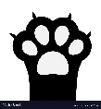 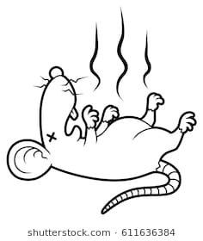 CAT 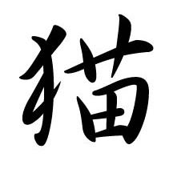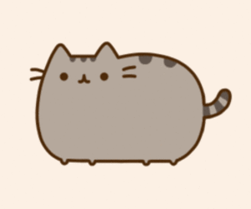

**Can you think of a sign for a cat that can’t be put on paper? Describe it below:**

**Who is the ‘Grand-daddy of modern semiotics’?**

1. Francine d’Sausage
2. Ferdinand de Saussure
3. Franklin D Roosevelt

**What are the two elements of a SIGN?**

**Who developed ideas of semiotics beyond written language?**

1. Charles Sanders Pearce
2. Colonel Sanders Chicken
3. Charles Saunders Pearson

**All of the following are signs for fire. Decide whether each one is an icon, a symbol or an index and label them appropriately**

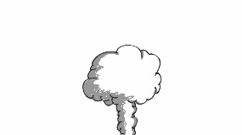 FIRE 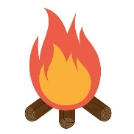

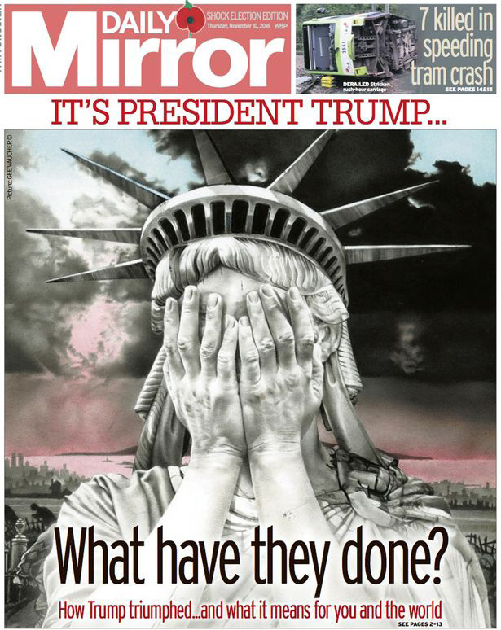

[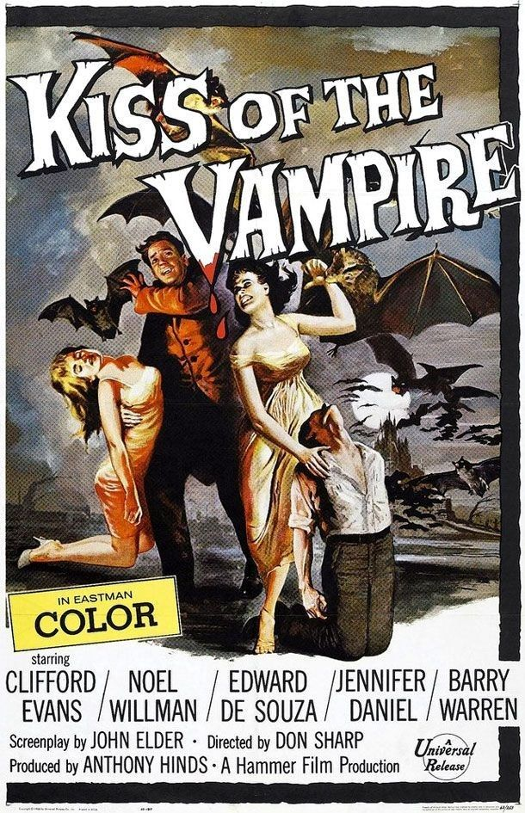](https://www.google.co.uk/url?sa=i&rct=j&q=&esrc=s&source=images&cd=&cad=rja&uact=8&ved=2ahUKEwjN8Y24sPHbAhUrJMAKHbvdDA0QjRx6BAgBEAU&url=https://www.pinterest.co.uk/pin/160159330482137754/&psig=AOvVaw0vB-fi86YiiOQHwnXjsizb&ust=1530104167168928)

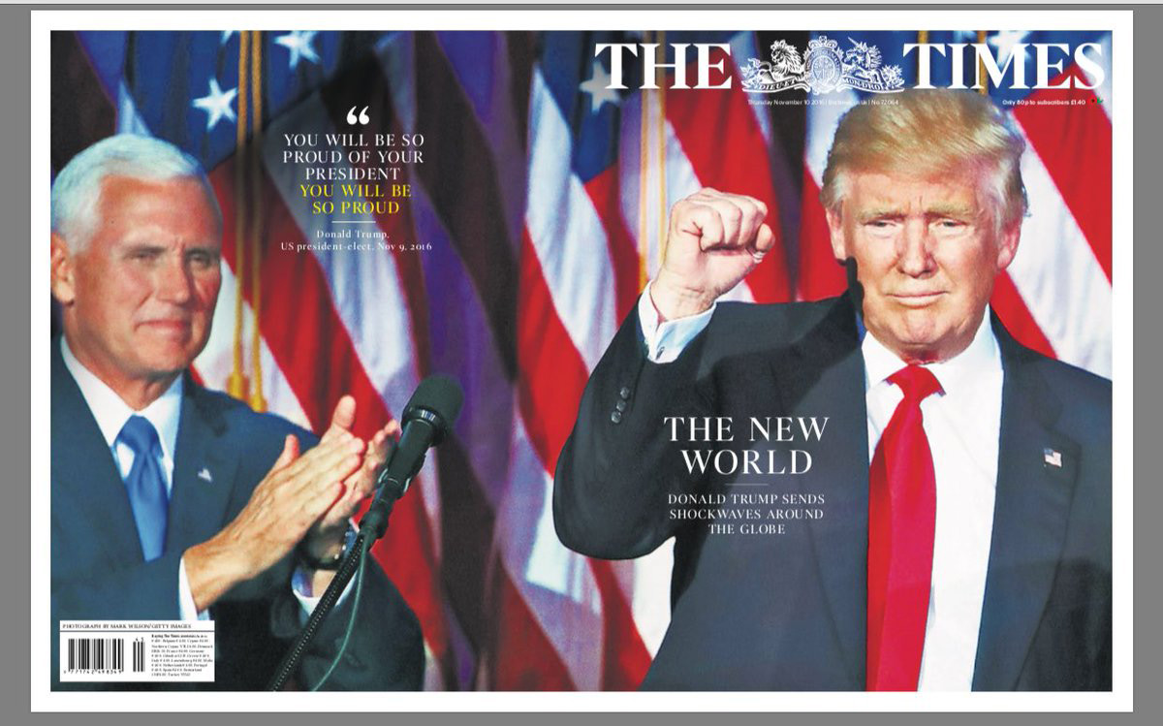

[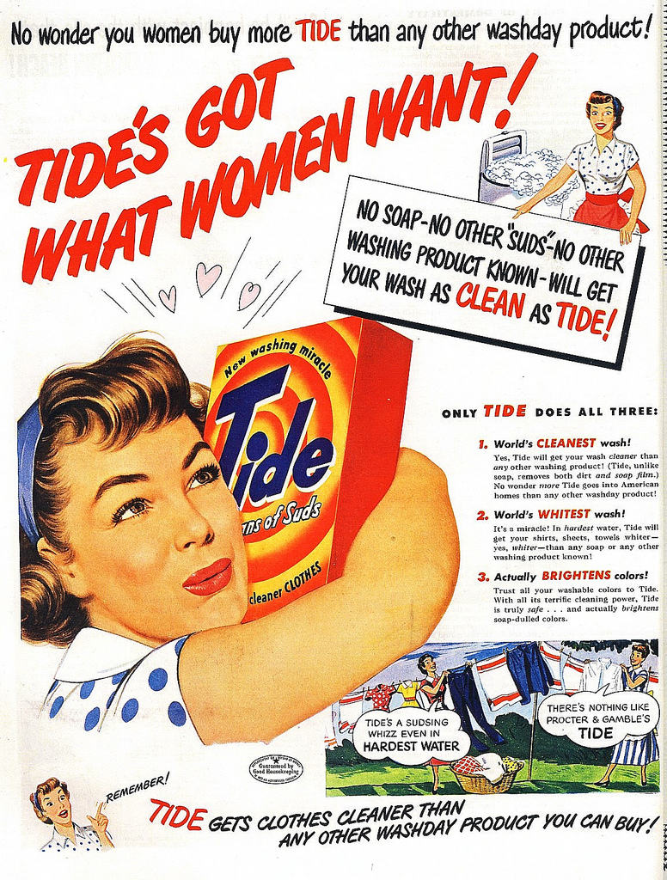](https://www.google.co.uk/url?sa=i&rct=j&q=&esrc=s&source=images&cd=&cad=rja&uact=8&ved=2ahUKEwjtwJzCr_HbAhUJAsAKHe39BdcQjRx6BAgBEAU&url=https://www.flickr.com/photos/sa_steve/3351147881&psig=AOvVaw3gCWPRqjr1KOC89rz-NuQi&ust=1530103913425599)