Five Frames From ‘Super. Human.’
Frame | Analysis
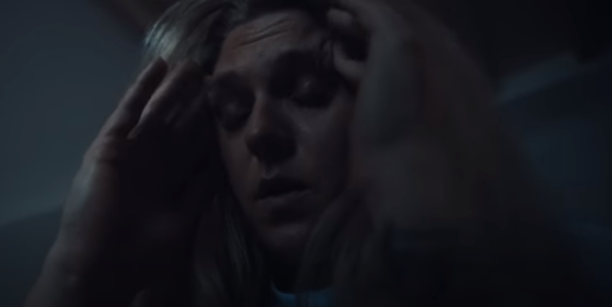 | Sound: Baby crying, lyrics start – mix of diegetic and non-diegetic sound. Mothers in particular can relate to the stress of being woken up early by your child  Camera Methods: Close-up, low angle. Relatable and we’re able to read the fed up codes of expression used  Editing: Simple cut from a shot of her back from the bed, to her face, to another athlete  Theory: Gerbner’s cultivation theory – defying the ‘othering’ we often see when disabled people are being represented  Visual codes: Codes of expression, she is clearly frustrated, tired and annoyed at being woken up early by the baby crying
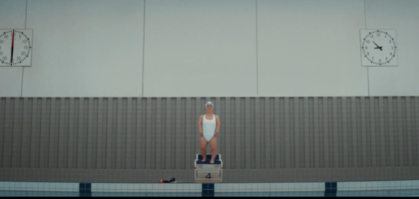 | Sound: Bells + percussion. Counting down and adding a dramatic sense to the shots  Camera Methods: Extreme long shot, but still at eye level with the swimmer. The vastness connotes something daunting and ominous, mirroring the idea of the pressure the Paralympians deal with.  Editing: Reverse shot between the swimmers, zooming in with each exchanging shot  Visual codes: Mise-en-scene is mostly uninteresting, it’s the blank wall of a swimming pool area and so even with the extreme long shot our focus is still on the athlete in the middle.  Could also consider codes of colour, everything is de-saturated and the swimmer is dressed in white, either connoting hope or vastness.
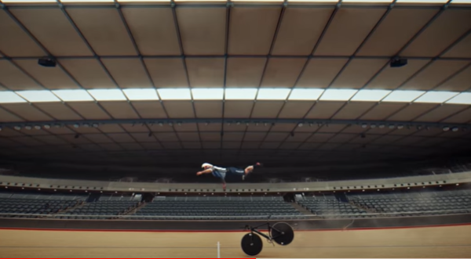 | Sound: Fades out from the song, faint shouting from the athlete  Camera Methods: extreme long shot, level with the Paralympian, shows once again the vastness and also emptiness of the stadium  Editing: slow motion, breaks up the previously fast paced cuts with it being slowed and shown for longer  Visual codes: mise-en-scene is completely empty, no other person with the athlete but they’re still practicing and working hard.  Codes of gesture, reaching out and trying to grab onto something, conveying a sense of panic and helplessness but also that’s exactly what we would do in that situation.
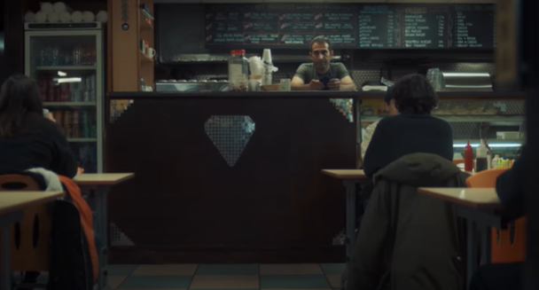 | Sound: Quiet, we’ve broken from the music and so this scene is significant from the others. Only faint diegetic sound of the café.  Camera Methods: Long shot from the café, as the audience we are positioned to be looking at it from the perspective of the athlete in the wheelchair, meaning we’re slightly below eye-level and so this makes something as simple as a café seem uninviting and slightly intimidating.  Editing: Cut between the woman and the café, breakup of the short, montage like shots that we saw before this scene started.  Theory: Arguably, Uses and Gratification theory of surveillance and information. We’re shown how even a simple day-to-day activity is being taken away from the Paralympian simply because of inconsideration of her disability. It’s almost a call for people that catering to all needs simply doesn’t take much effort but can offer accessibility to everybody
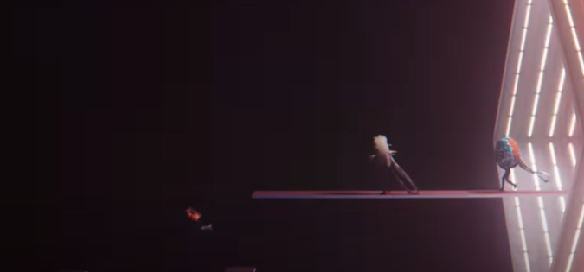 | Sound: Shouting/screaming, music after announcement that the Paralympics has been cancelled. Cartoonish feel from the various non-diegetic sound effects added  Camera Methods: Extreme long shot, matching the vast and void-feeling of the enigmatic space the runner is falling into.  Semiotics: Icon of the medals behind her, signifying achievements and victory, which juxtaposes her falling down into the void.  Visual codes: Mise-en-scene is confusing and surreal, causing an enigma as the audience question where she is. Her gesture of falling down, connotes an idea of ‘falling from greatness’ and crumbling from achievements, conveying disappointment and frustration that after all their hard work the Paralympians have to wait even longer to compete.

