**COM 1 SEC B – NEWSPAPERS**

ANALYSIS OF THE MIRROR

**ISSUE DATE: ______________**

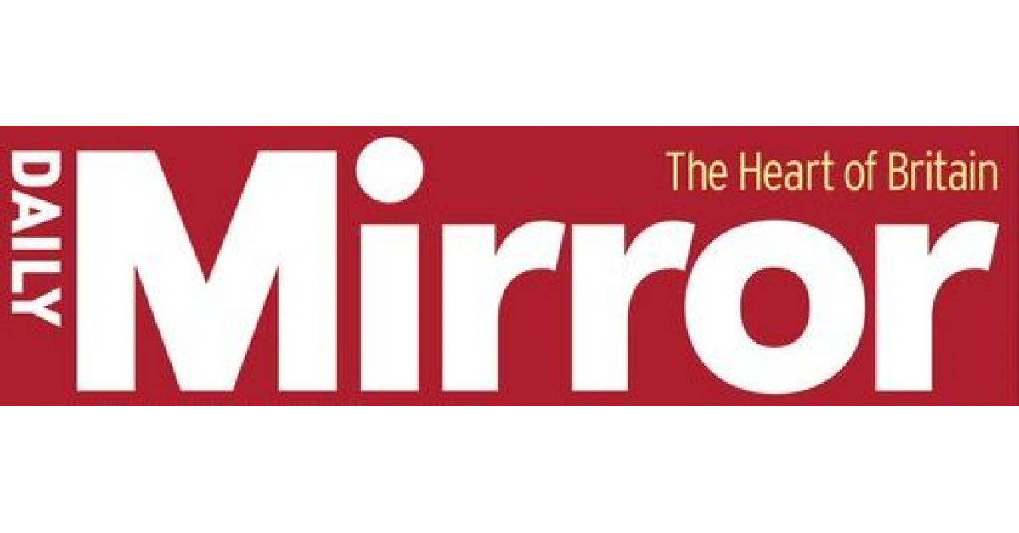

**Close analysis of the whole paper - Daily Mirror**

Below is a chart of particular ‘News Values’ which news editors often consider when deciding whether a story is suitable for publication or broadcast.

Use this as a guide for stories which you will see in your chosen copy of the Daily Mirror newspaper.

|  |  |
| --- | --- |
| **News Value** | **Effect** |
| ***Recency*** | Important ‘breaking news’. Breaking news is very competitive with newspapers keen to be the first to report things as they happen |
| ***Size / Threshold*** | The bigger the story, the more people it affects. |
| ***Continuity*** | An ongoing news event will continue to be reported on |
| ***Simplicity / Unambiguity*** | Simple stories which are easy to explain (celebrity deaths, Royal weddings and births, big sporting events) will be preferred to those which are more complex (foreign wars, economic stories, long-term court cases) |
| ***Elite nations or people*** | In the UK a story about the American president or an American social issue is more likely to be reported on than a story about less influential countries and their leaders  Elite people can range from royals to sports people, mega celebrities to influential politicians |
| ***Predictability*** | Events which may have an element of ‘predictability’ about them will be covered, such as large demonstrations, a major sporting event etc. Often these are reported on before the event takes place with journalists predicting a ‘likely’ outcome |
| ***Unexpectedness*** | Something out of the ordinary has more news value than something that happens every day |
| ***Negativity*** | Bad news is more likely to make the headlines than good news |
| ***Personality*** | A story about a celebrity or a ‘heroic’ member of the general public will have a human interest angle |
| ***Meaningfulness / Proximity*** | How close to home is the story, is there a local or national connection? |

**Front page - Daily Mirror**

* Why do you think the lead story has been chosen? Is it linked to any of the News Values on page one of this revision booklet?
* Does the front page lead story show the ideology of the Daily Mirror’s politics? (it is traditionally a left-wing newspaper and therefore would be in direct opposition of the Conservative government and seeks to promote the Labour Party’s opinions and position).
* What sort of language has been used to attract the reader? Is it formal or informal? Is the mode of address personal or impersonal (i.e. does it address the reader directly by personal involvement…’you’, ‘we’, ‘British’ etc.)?
* What is the ratio of image to text (does the image take up the majority of the page? Is there a limited amount of text in proportion?)?
* Are there any additional stories on the front page? If so, can they be linked to any particular News Value?
* Are there any enticements to buy the newspaper, such as special offers (‘win a holiday’, ‘free gift’ ‘special pull-out’ section etc.)? This is called the ‘plug’ or the ‘puff’

Task

What is the **lead story**?

Why do you think the **lead story** has been chosen?

Which **News Values** might apply to the lead story and how they can be identified?

Does the front page **lead story** show **the ideology** of the Daily Mirror’s politics?

*(It is traditionally a left-wing newspaper and therefore would be in direct opposition of the Conservative government and seeks to promote the Labour Party’s opinions and position)*

What sort of **language** has been used to attract the reader? Is it **formal or informal**? Is the **mode of address personal or impersonal** (i.e. does it address the reader directly by personal involvement…’you’, ‘we’, ‘British’ etc.)?

Provide brief examples of the use of language for all parts of the front page (not just the lead story)

What is the ratio of **image to text**? Does the image take up the majority of the page? Is there a limited amount of text in proportion to images used?

Provide brief examples and why you think the ratio might be in favour of image over text?

Are there any **additional stories** on the front page? If so, can they be linked to any particular **News Value**?

Briefly identify any additional stories – these may be just ‘headlines’ for stories found elsewhere inside the newspaper

Are there any **enticements** to buy the newspaper, such as special offers - ‘win a holiday’, ‘free gift’ ‘special pull-out’ section etc.? (This is called the **‘plug’ or the ‘puff’**). How much space do they take up in relation to the front page story?

What might be the **appeal** to the **target audience** for the Daily Mirror?

**Inside the Daily Mirror**

* What sort of stories can be found in the first half of the newspaper? Are they political, celebrity-led, general interest stories?
* Analyse the language and mode of address used in the ‘Editorial’ feature. This is traditionally written by the editor and reflects upon three or four stories found elsewhere in the newspaper, quite often the front page story will be included.
* The target audience for the Daily Mirror is traditionally ‘working class’, ‘left wing’ and ‘Labour-voting’ (or certainly anti-Conservative). Do any of the stories reflect this audience?
* What story or feature has been chosen for the centre pages? Why do you think this has been chosen and does it fit with the ideology of the newspaper? Don’t forget this is not necessarily a ‘political’ newspaper, and does also favour stories regarding celebrities, sport and entertainment, so this will also be included in their ideology.

Task

What sort of stories can be found in the first half of the newspaper? Are they **political, celebrity-led, general interest** stories?

Identify **three of these stories**, providing a brief synopsis of the story (about 50 words). Use the space in the box to an additional stories

1.

2.

3.

Analyse the **language and mode of address** used in the ‘**Editorial**’ feature. This is traditionally written by the editor and reflects upon three or four stories found elsewhere in the newspaper, quite often the front page story will be included.

The **target audience** for the Daily Mirror is traditionally ‘working class’, ‘left wing’ and ‘Labour-voting’ (or certainly anti-Conservative).

Which of the stories might reflect this audience?

Is there any link to the lead story?

What story or feature has been chosen for the **centre pages**?

Why do you think this has been chosen?

**Ideology**

**Find examples of where the Daily Mirror’s political ideology (left-leaning, socialist) might be evident. This might be in the front page, other articles, even advertising**

Task

Consider the newspaper as a whole for this area of **Ideology** – look at all aspects of it, particularly the lead story, Editorial and other features

**Letters page**

Locate the letters page - #Madeuthink: how might the opinions and views of the Daily Mirror’s readership reflect a similar ideology to the newspaper? Are there responses in favour of the newspaper’s political position, for example, or are there responses to stories regarding celebrities, sports stars or maybe the Royal family (tabloid newspapers do seem to be obsessed with the Royals!)

Are there a diverse range of responses within the letters section, or are they generally supporting the newspaper’s position on issues, events and stories? How might you apply Stuart Hall’s Reception Theory, with regards to ‘encoding/decoding’? Can we apply the concept of ‘accepted, negotiated and oppositional’ response?

Task

Which topics are **represented** within the letters sent to the newspaper? How might they reflect the newspaper’s **ideology** and how might they go against it?

**Entertainment**

Locate the Entertainment section – what sort of language, mode of address and position is used and taken? Are the stories regarding popular and well-known celebrities who the Daily Mirror target audience can readily recognise and respond to?

Task

Identify examples of how ‘**celebrity culture**’ is represented in the newspaper.

Are celebrities represented **positively or negatively**?

Which **theorist or theorists** might we apply to this area?

**Advertising**

What sort of advertising is placed within the newspaper? Is it for products which tie in with the target audience? Might it include adverts for home products like furniture, kitchen appliances, gardening etc? Are there adverts for holidays? If so, where? Do they fit with the Daily Mirror’s target audience? Are the adverts ‘family-orientated’?

Task

Identify particular adverts for **companies, products and services**

How might these adverts reflect the **target audience** for the Daily Mirror?

**Interactivity**

How might readers of the print version of the newspaper interact with the product? Locate pages or sections where readers might be able to write in, comment or take part – alongside the letters page, these might be ‘problem’ pages’, advice pages, crosswords, puzzles, quizzes, polls

Task

Identify examples of how the Daily Mirror reader can ‘**talk back**’ to the newspaper on its pages. How might this compare to **interacting online**?

**Sport**

The back pages are devoted to sport – how is this represented in terms of the sports represented? Is there more emphasis on football? Why might this be? Are the stories dominated by well-known football teams (e.g. the two Manchester clubs, Chelsea, Liverpool and Arsenal)? Why might this be?

Task

How much might one sport **dominate** the Sports section? Identify the number of articles featuring different sports.

If this sport is **football**, which teams are featured more than others for articles and images? Why do you think this might be?

What is the main sports story on the **back page**? Why do you think this has been chosen?

**Online version of the Daily Mirror**

<https://www.mirror.co.uk/>

Briefly compare the **print** edition of the Daily Mirror with its **online** version. Take notes below:

__________________________________________________________________________________________________________________________________________________________________________________________________________________________________________________________________________________________________________________________________________________________________________________________________________________________________________________________________________________________________________________________________________________________________________________________________________________________________________________________________________________________________________________________________________________________________________________________________________________________________________________________________________________________________________________________________________________________________________________________________________________________________________________________________________________________________________________________________________________________________________________________________________________________________________________________________________________________________________________________________________________________________________________________________________________________________________________________________________________________________________________________________________________________________________________________________________________________________________________________________________________________________________________________________________________________________________________________________________________________________________________________________________________________________________________________________________________________________________________________________________________________________________________________________________________________________________________________________________________________________________________________________________________________________________________________________________________________________________________________________________________________________________________________________________________________________________________________________________________________________________________________________________________________________________________________________________________________________________________

How does the **navigation bar** help the user?

**Task**

Click on the following pages found on the menu bar:

*Politics*

*Celebs*

*Royals*

Briefly identify the **contents** contained in each of the pages and include the following:

*Range of stories connected to the subject*

***News Values*** *which might be identified*

***Advertising or sponsorship*** *featured on the individual pages*

*Means of* ***interactivity*** *for the user (e.g. user comments)*

*Range of* ***multi-media platforms*** *available (e.g. video files, podcasts)*

How else might the readers of the Daily Mirror engage with the newspaper through **social media**?

How might this lead to further **interactivity** with the newspaper?

Which **theorists** might we include when considering the **audience interactivity** with news?