NAME OF THEORY: | Steve Neale, GENRE THEORY
What does this theory state? | Neale believes that films/television should include features that are similar, so the audience know it is a certain genre, such as horror or romance, but also include features that are different.
First example: | In the scene in the bar at the beginning of the episode, Danny, who has PTSD from his experience at war, looks like a tough guy, however, he is actually quite vulnerable. This shows the theory because the main genre is represented through his tough looks, but other features such as his PTSD and behaviours are other features. | 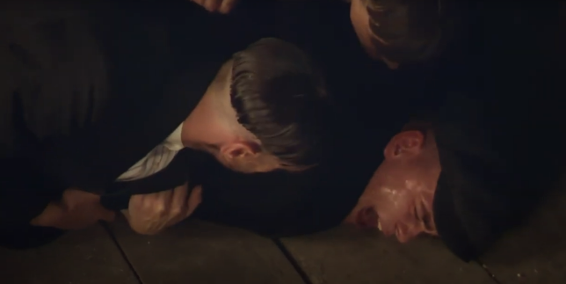
Second example: | In the scene when Arthur Shelby is being beaten up by the detective, this is quite a conventional feature of this particular genre, which includes lots of violence. This supports the theory because the show, as well as showing other features, it still includes traditional conventions of the genre. | 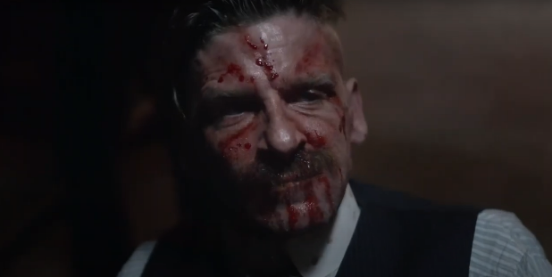
Third example: | The location that the show is set in is very industrial, dark and dull. This differs from some other period dramas, which is usually set in a luxurious setting, such as Downton Abbey, which is set in a stately house. However, the setting is conventional to a crime drama, therefore it supports the theory. | 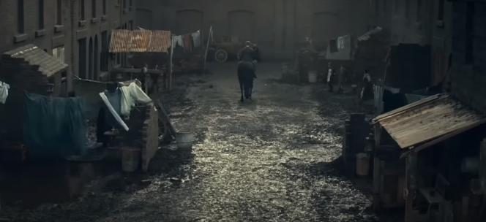
What conclusions can we draw from trying to apply this theory to Peaky Blinders? | We can conclude that Peaky Blinders does support Neale’s theory of genre because the show includes many traditional conventions of a period-crime drama, but it also includes many other features, which aren’t typical to a period-crime drama show.

