NAME OF THEORY:
Structuralism – Claude Levi-Strauss
What does this theory state? | The idea that text can be understood through an examination of their underlying structure, the idea that meaning is dependent on (and produced through) pairs of oppositions (binary opposite)
First example: | Tommy and the Peaky Blinders are the good guys and the rival gangs/ police force are the evil or villains. Both the men and women are dominant but not against each other. | 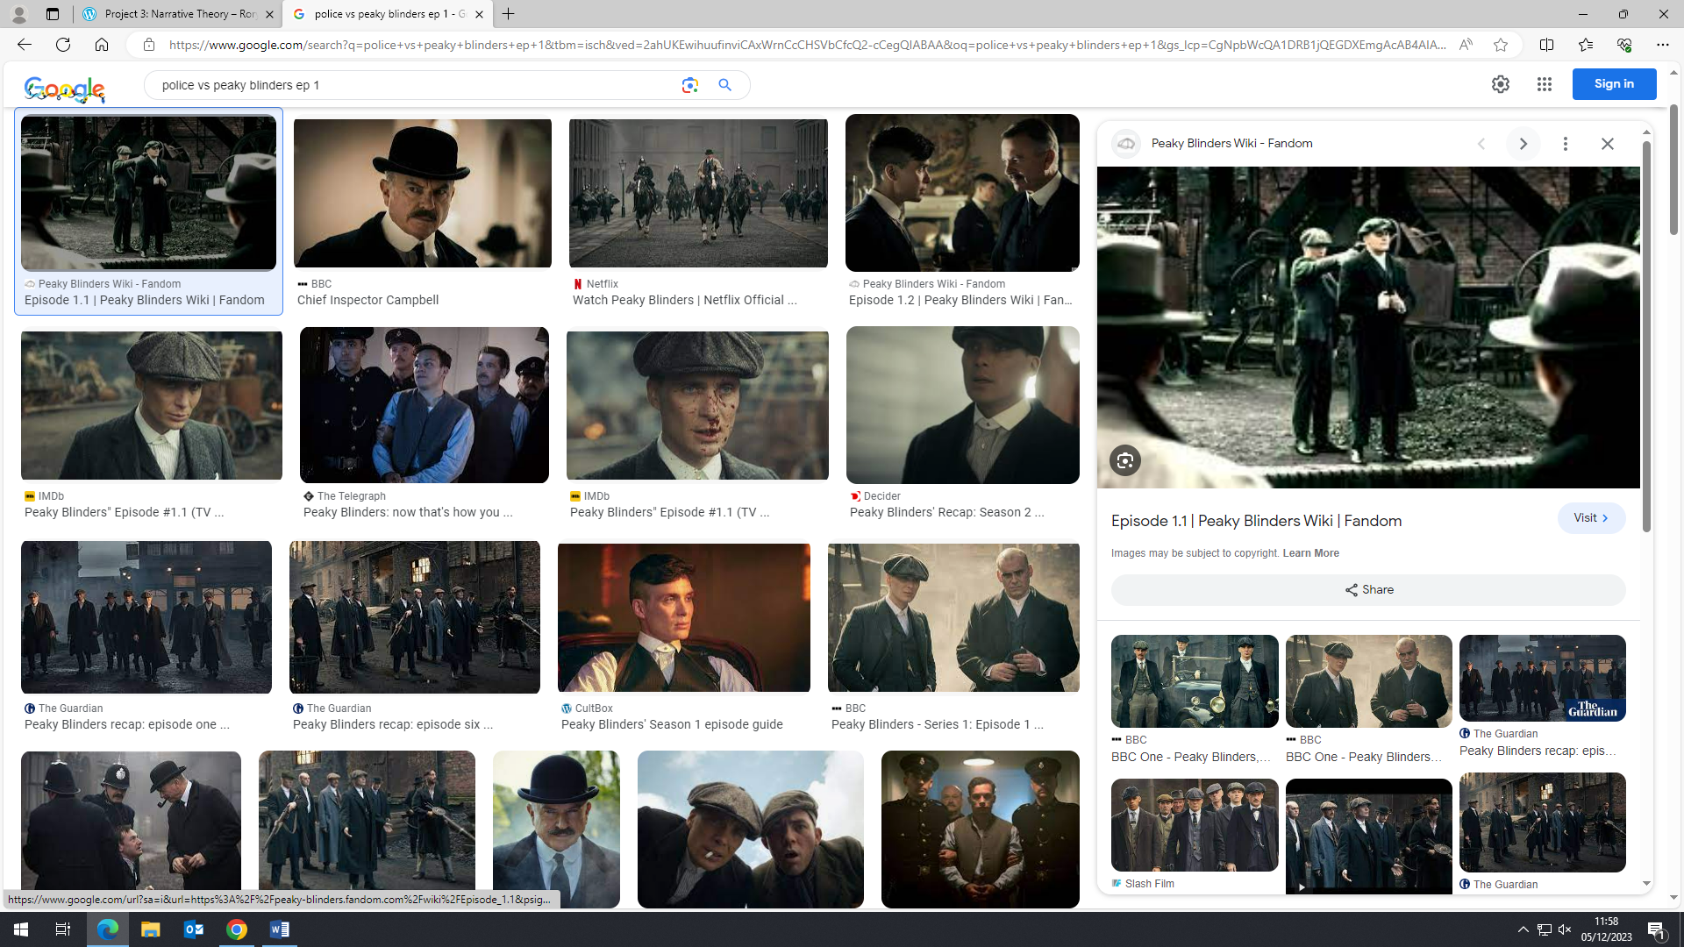
Second example: | The contrast between western genre and gangster genre has binary opposites. For example, the horses and western style pub contrast with the gangster lifestyle that is represented. | 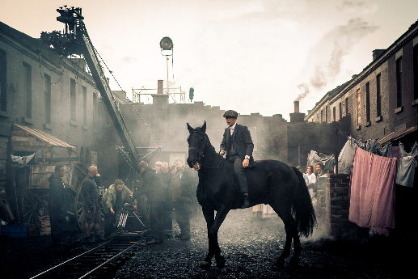
Third example: | Tommy Shelby is both good and bad which is shown when he gives money to a poor person. And bad was presented when he kept the guns. | 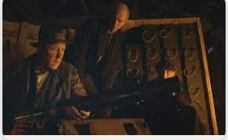
What conclusions can we draw from trying to apply this theory to Peaky Blinders? | To conclude the structuralism theory relates to peaky blinders as there are many binary oppositions that contrast the good vs evil and many other differences between characters.
Any other points of interest? | When grace enters the pub and attempts to get a job there but the manager thinks she is too nice, she shows him she can sing which relates to the men that come in and starts singing along with her. But she is also secretly working with the police against tommy. | 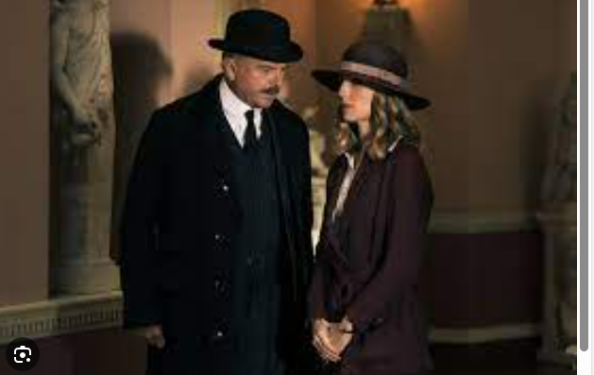
PEAKY BLINDERS: MEDIA LANGUAGE THEORY

