Homework due Friday 15th December
COM 2 SECTION A: TELEVISION IN THE GLOBAL AGE

Peaky Blinders and The Bridge
- Van Zoonen suggests that media representations often portray women as belonging to the family and domestic life and men to the social world of politics and work. How far does an analysis of Peaky Blinders and The Bridge support this claim? [30 marks]

TIMING: APPROX 50 MINS (ADD EXTRA TIME IF YOU ARE ENTITLED TO THIS)

TO HELP
Here are some pointers from the mark scheme I will be using:
Here are the top band descriptors
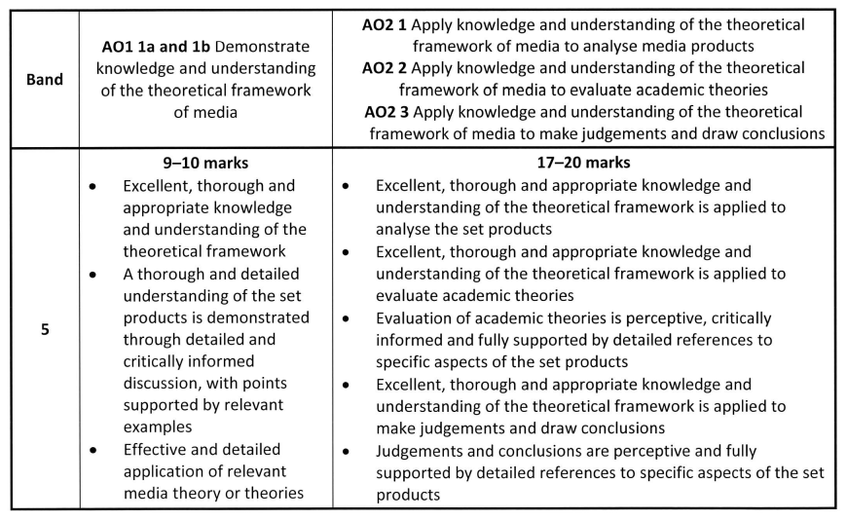

General expectations (copied from the mark scheme)
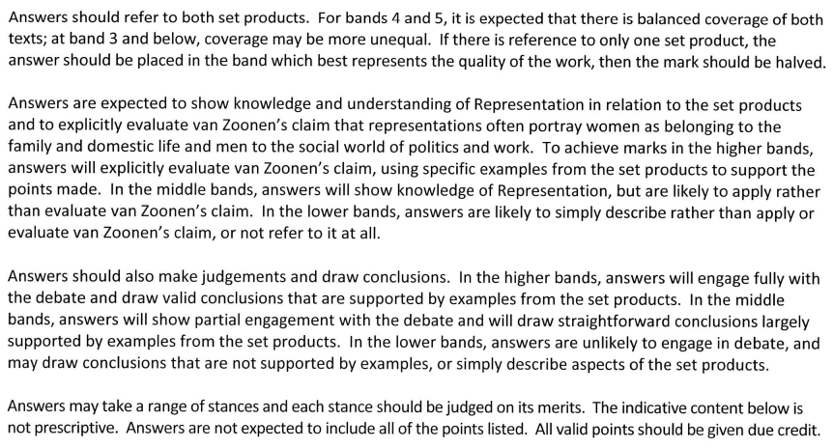

How you might write about The Bridge (in note form, from the indicative content)
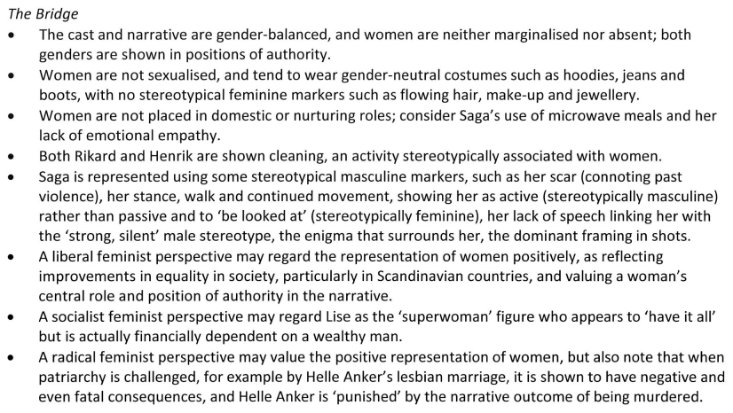

Use the above to help you get ideas for Peaky Blinders.

