|  |
| --- |
| Name: _______________________________________________ |
|  |
|  |
|  |
|  |
| **4Ds of Diagnosis, ICD and DSM Classification Systems** |
|  |
| **Date:** |
|  |
|  |
|  |
|  |
| **Time:** |
|  |
| **Total marks available:** |
|  |
| **Total marks achieved:** ______ |
|  |
|  |
|  |
|  |
|  |
|  |
|  |
|  |
|  |
|  |
|  |
|  |
|  |
|  |
|  |
|  |
|  |
|  |
|  |
|  |
|  |
|  |
|  |
|  |
|  |
|  |

**4 Ds - Questions**

**Q1.**

Victoria is upset as she finds it hard to leave the house as she is scared of birds. Whenever she leaves the house she is highly anxious in case a bird is nearby, and she has previously run across the road without looking for cars to avoid a bird.

Victoria is unable to work because of her fear of birds, causing her to feel upset as she cannot buy her children toys. This has led to her having suicidal thoughts and feeling that her children would be better off without her.

(a)  Describe how distress **and** danger could be used to diagnose Victoria as having a mental health disorder.

**(3)**

.............................................................................................................................................

.............................................................................................................................................

.............................................................................................................................................

.............................................................................................................................................

.............................................................................................................................................

.............................................................................................................................................

.............................................................................................................................................

.............................................................................................................................................

.............................................................................................................................................

.............................................................................................................................................

.............................................................................................................................................

.............................................................................................................................................

(b)  Explain **one** weakness of using danger to diagnose mental health disorders.

**(2)**

.............................................................................................................................................

.............................................................................................................................................

.............................................................................................................................................

.............................................................................................................................................

.............................................................................................................................................

.............................................................................................................................................

**(Total for question = 5 marks)**

**Q2.**

Lena cannot go to work due to her anxiety. She has also stopped going out with her friends once a week and does not like people visiting her at home. She has recently seen a psychiatrist who has diagnosed her with a mental disorder.

(a)  Define the term 'dysfunction' as it is used to diagnose Lena's mental disorder.

**(1)**

.............................................................................................................................................

.............................................................................................................................................

.............................................................................................................................................

(b)  Explain **two** weaknesses of using 'dysfunction' to diagnose Lena's mental disorder.

**(4)**

1 ..........................................................................................................................................

.............................................................................................................................................

.............................................................................................................................................

.............................................................................................................................................

.............................................................................................................................................

.............................................................................................................................................

2 ..........................................................................................................................................

.............................................................................................................................................

.............................................................................................................................................

.............................................................................................................................................

.............................................................................................................................................

.............................................................................................................................................

**(Total for question = 5 marks)**

**Q3.**

In your studies of clinical psychology, you will have learned about classification systems for mental health.

(a)  Define the term 'reliability' in relation to classification systems used for diagnosing mental health.

**(1)**

.............................................................................................................................................

.............................................................................................................................................

.............................................................................................................................................

(b)  Explain **two** reasons why classification systems for mental health may not be valid.

**(4)**

1 ..........................................................................................................................................

.............................................................................................................................................

.............................................................................................................................................

.............................................................................................................................................

.............................................................................................................................................

.............................................................................................................................................

.............................................................................................................................................

2 ..........................................................................................................................................

.............................................................................................................................................

.............................................................................................................................................

.............................................................................................................................................

.............................................................................................................................................

.............................................................................................................................................

.............................................................................................................................................

**(Total for question = 5 marks)**

**Q4.**

Philip is a psychology student. His friend has just been diagnosed with a mental health disorder using a classification system, such as the DSM or ICD. Philip is concerned about the reliability of the diagnosis following his lessons in psychology.

Explain whether Philip should be concerned about the reliability of his friend's diagnosis.

**(4)**

.............................................................................................................................................

.............................................................................................................................................

.............................................................................................................................................

.............................................................................................................................................

.............................................................................................................................................

.............................................................................................................................................

.............................................................................................................................................

.............................................................................................................................................

.............................................................................................................................................

.............................................................................................................................................

.............................................................................................................................................

.............................................................................................................................................

.............................................................................................................................................

.............................................................................................................................................

**(Total for question = 4 marks)**

**Q5.**

Rachel is concerned that her friend, Alice, may have a mental disorder. Alice has started to talk to herself in public. She has also stopped going out with her friends to avoid other people looking at her and embarrassing her friends.

Alice will only eat white food, and she refuses to go out in the day light because she feels it will cause her to catch fire. She has started to think that she has supernatural powers, such as being able to turn into a bat.

Discuss the diagnosis of mental disorders in terms of deviance and dysfunction. You must make reference to the context in your answer.

**(Total for question = 8 marks)**

.............................................................................................................................................

.............................................................................................................................................

.............................................................................................................................................

.............................................................................................................................................

.............................................................................................................................................

.............................................................................................................................................

.............................................................................................................................................

.............................................................................................................................................

.............................................................................................................................................

.............................................................................................................................................

.............................................................................................................................................

.............................................................................................................................................

.............................................................................................................................................

.............................................................................................................................................

.............................................................................................................................................

.............................................................................................................................................

.............................................................................................................................................

.............................................................................................................................................

.............................................................................................................................................

.............................................................................................................................................

.............................................................................................................................................

.............................................................................................................................................

.............................................................................................................................................

.............................................................................................................................................

.............................................................................................................................................

.............................................................................................................................................

.............................................................................................................................................

.............................................................................................................................................

.............................................................................................................................................

.............................................................................................................................................

.............................................................................................................................................

.............................................................................................................................................

.............................................................................................................................................

.............................................................................................................................................

.............................................................................................................................................

.............................................................................................................................................

.............................................................................................................................................

.............................................................................................................................................

.............................................................................................................................................

.............................................................................................................................................

.............................................................................................................................................

.............................................................................................................................................

.............................................................................................................................................

.............................................................................................................................................

.............................................................................................................................................

.............................................................................................................................................

.............................................................................................................................................

.............................................................................................................................................

.............................................................................................................................................

.............................................................................................................................................

.............................................................................................................................................

.............................................................................................................................................

**DSM, ICD – reliability and validity**

**Q6 (1).**

(a)  Describe how the ICD is used as a classification system for mental health.

**(4)**

.............................................................................................................................................

.............................................................................................................................................

.............................................................................................................................................

.............................................................................................................................................

.............................................................................................................................................

.............................................................................................................................................

.............................................................................................................................................

.............................................................................................................................................

.............................................................................................................................................

.............................................................................................................................................

.............................................................................................................................................

.............................................................................................................................................

.............................................................................................................................................

.............................................................................................................................................

(b)  Explain **one** strength of using the ICD as a classification system for mental health.

**(2)**

.............................................................................................................................................

.............................................................................................................................................

.............................................................................................................................................

.............................................................................................................................................

.............................................................................................................................................

.............................................................................................................................................

**(Total for question = 6 marks)**

**Q6 (2).**

(a)  Describe how the DSM is used as a classification system for mental health.

**(2)**

.............................................................................................................................................

.............................................................................................................................................

.............................................................................................................................................

.............................................................................................................................................

.............................................................................................................................................

.............................................................................................................................................

(b)  Explain **one** strength of using the DSM as a classification system for mental health.

**(2)**

.............................................................................................................................................

.............................................................................................................................................

.............................................................................................................................................

.............................................................................................................................................

.............................................................................................................................................

.............................................................................................................................................

 (b)  Explain **one** weakness of using the DSM as a classification system for mental health.

**(2)**

.............................................................................................................................................

.............................................................................................................................................

.............................................................................................................................................

.............................................................................................................................................

.............................................................................................................................................

.............................................................................................................................................

**(Total for question = 6 marks)**

**Q7.**

Assess the validity of diagnoses of mental health disorders through the use of classification systems.

**(8)**

**(Total for question = 8 marks)**

**Q8.**

If a person visited two different psychiatrists, they might receive two different diagnoses of their medical condition.

Assess the reliability of mental disorder diagnosis using research evidence.

**(Total for question = 8 marks)**

**Q9.**

Alba has recently been diagnosed with a mental health disorder using a classification system. She has presented with a number of symptoms including losing interest in everyday life, altered sleep patterns and an inability to express her emotions. She also occasionally has angry outbursts.

Alba's psychiatrist has diagnosed her with schizophrenia. Her mother disagrees and thinks Alba has a different mental health disorder and wants her to see another psychiatrist who is from the same culture as Alba.

To what extent are classification systems a reliable and valid way of diagnosing mental health disorders?

You must make reference to the context in your answer.

**(20)**

**(Total for question = 20 marks)**

**Mark Scheme**

Q1.

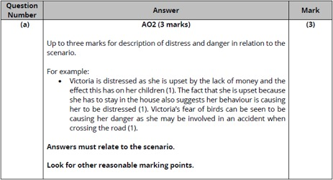

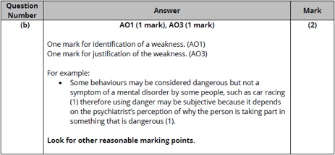

**Q2.**

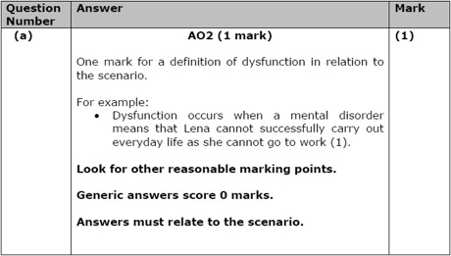

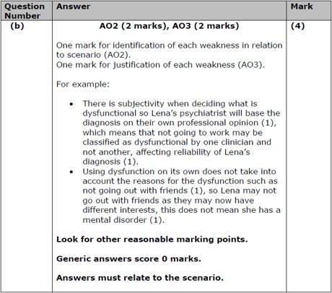

**Q3.**

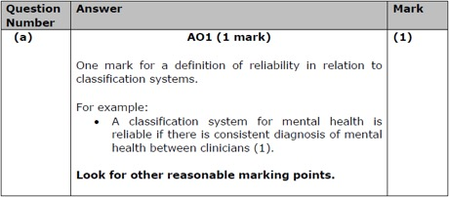

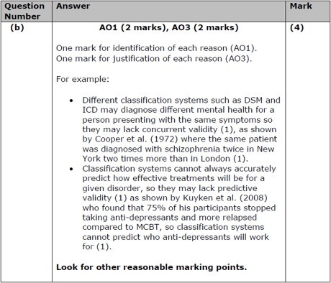

**Q4.**

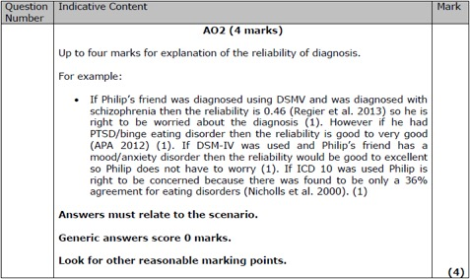

**Q5.**

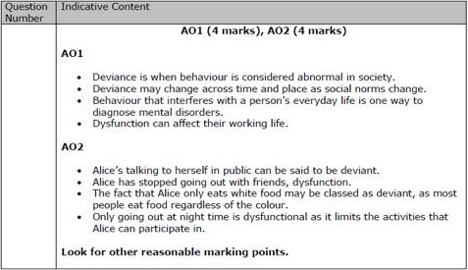

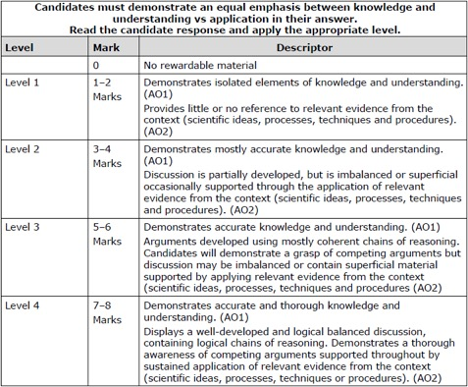

**Q6.**

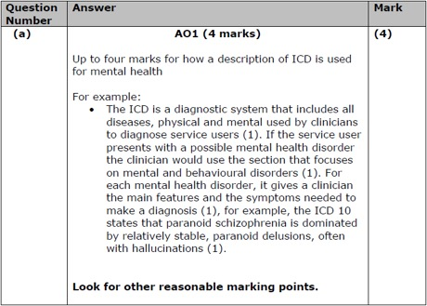

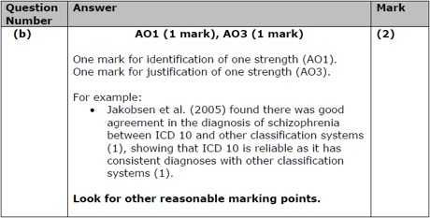

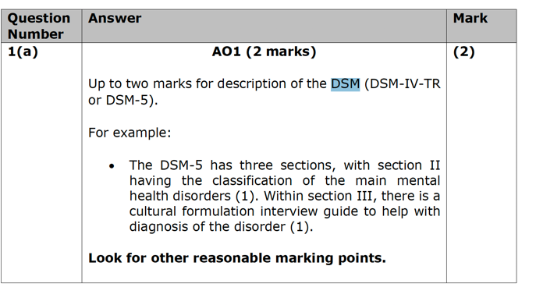

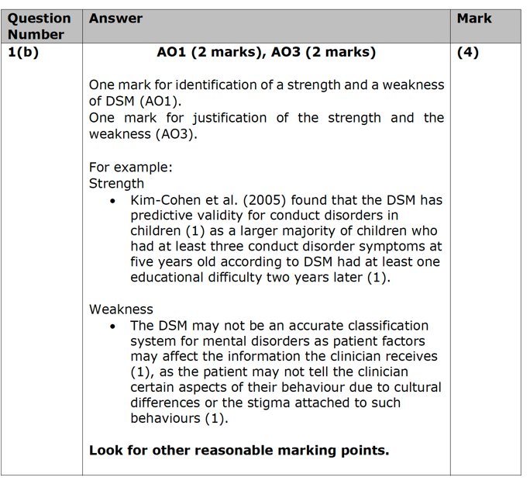

**Q7.**

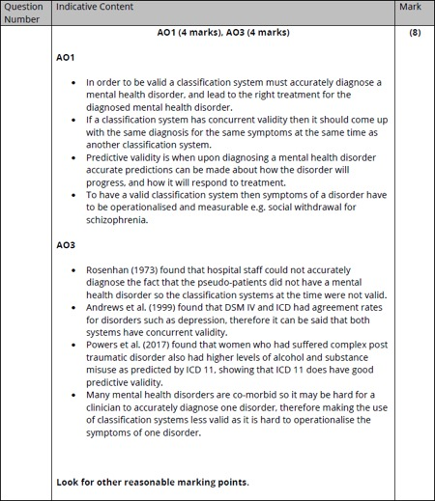

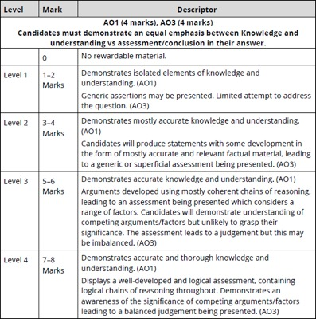

**Q8.**

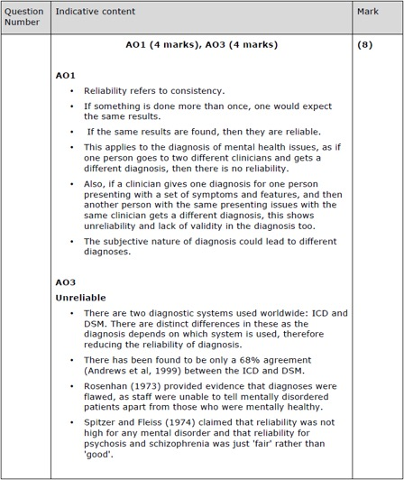

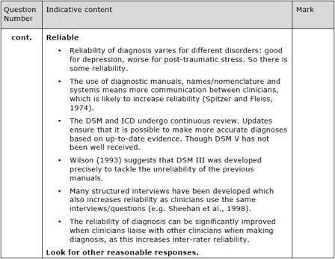

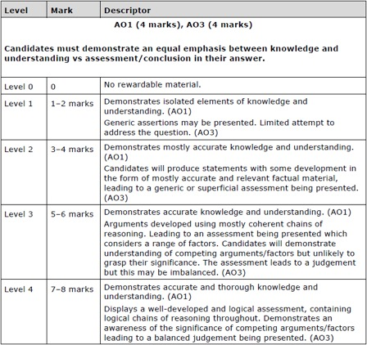

**Q9.**

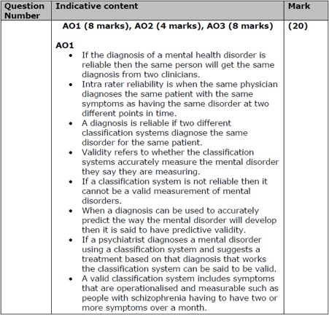

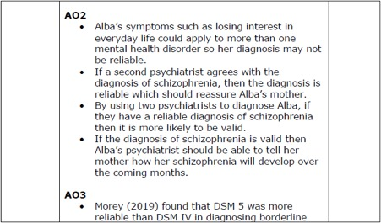

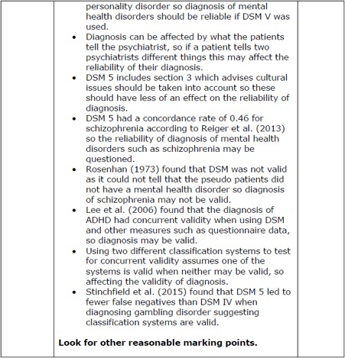

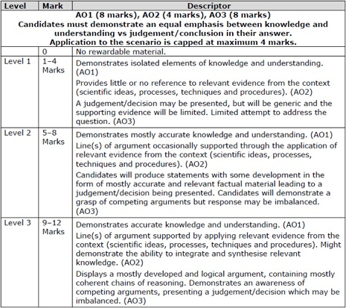

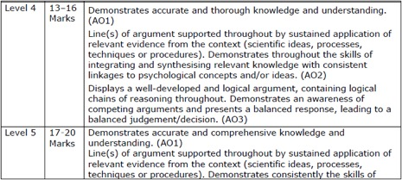

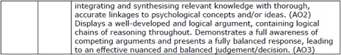

**Examiner's Report**

Q1.

(a)

Most candidates were able to answer this AO2 question well and gain at least 2 out of the 3 marks. They were able to identify relevant aspects from the scenario and apply them to danger and distress. Some answers did define danger and distress without linking the definitions to the context. The vast majority of the answers covered both danger and distress, showing that candidates had clearly read the question, with very few writing about one of the other methods used to diagnose mental health disorders.

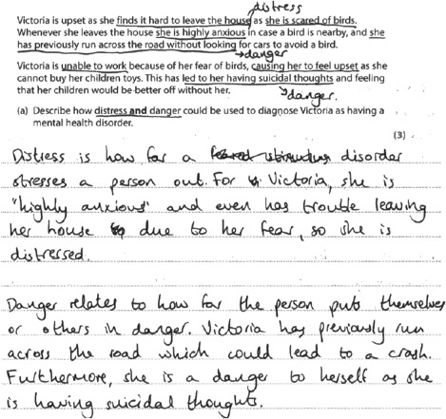

**Results Plus: Examiner Comments**

This gains all three marks for describing distress and danger in relation to the context.   
  
Danger is linked to the context in terms of how Victoria is highly anxious and has trouble leaving the house. Danger is linked in two way, to her running across the road and possibly leading to a crash, and her suicidal thoughts so she is a danger to herself.

(b)

Most answers were able to gain the AO1 mark for identifying a weakness of using danger to diagnose mental health disorders, with subjectivity being the most common weakness written about. However, it was only the better answers that were able to offer some justification of the weakness and so gain the AO3 mark. Some answers used the scenario for the previous question to try and explain the weakness, which was not a requirement of this question, but was an acceptable way to gain the AO3 mark if it was done in enough detail.

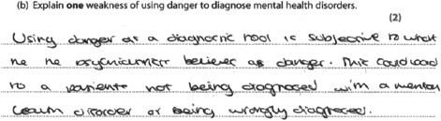

**Results Plus: Examiner Comments**

This answer got both available marks, 1 mark for danger being subjective because it is what the psychiatrist believes danger is. This is then explained in terms of wrong diagnosis.

**Results Plus: Examiner Tip**

Include justification in explain questions in order to gain all the available marks.

**Q2.**

(a) Most candidates gained this AO1 mark, clearly defining dysfunction and applying it to the context.

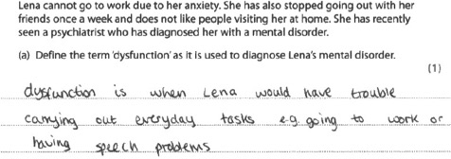

**Results Plus: Examiner Comments**

This gains a mark for clearly defining dysfunction and linking it to specific details from the mark scheme.

(b) This question required candidates to identify two weaknesses in relation to the scenario, AO2, and then justify those weaknesses. The very best answers were able to do this. Some answers did identify the weaknesses but then failed to justify those weaknesses. However, many answers did not apply their weaknesses to the context, giving generic answers.

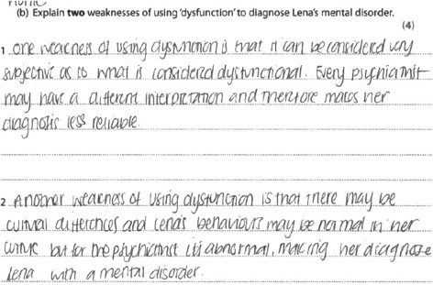

**Results Plus: Examiner Comments**

This scores 0 marks as it is generic. The name Lena is not enough.

**Results Plus: Examiner Tip**

When the question requires application candidates should take details from the context given.

**Results Plus: Examiner Comments**

This gets 3 marks. It gets 2 marks for the first weakness. 1 mark for identifying that people have different perceptions of what they deem dysfunctional and a further mark for justifying this with the point about retired people not seeing not going to work as dysfunctional but for Lena it could be seen as dysfunctional. 1 mark for the second weakness for identifying that her behaviour may not be due to her mental illness such as not going out with her friend may be because she is too busy.

**Results Plus: Examiner Tip**

Candidates should justify their strengths or weaknesses to gain the AO3 mark on explain questions.

**Q3.**

**(a)**  This question required candidates to write a definition of reliability in relation to classification systems AO1.

The best answers gave an accurate definition and related it to classification systems and so gained the mark. Some answers were vague and did not mention what was consistent or did not link to classification systems for mental health.

Some answers were about validity rather than reliability.

**Results Plus: Examiner Comments**

This response receives a mark for an accurate definition of reliability in relation to classification systems used to diagnose mental health.

Total: 1 mark

**(b)**  This question assessed AO1 and AO3, asking for two reasons why classification systems were not valid.

The use of Rosenhan was popular, as was cultural differences. The better answers that used cultural differences were able to use examples. However, some answers that used cultural differences stated that they were not considered by the classification systems.

The best answers were able to identify two reasons and then justify those reasons, often through the use of relevant research. Weaker answers were able to identify two reasons but often did not justify those reasons and so did not gain the AO3 marks.

Some answers were repetitive, stating the same reason twice. Some answers did confuse reliability and validity.

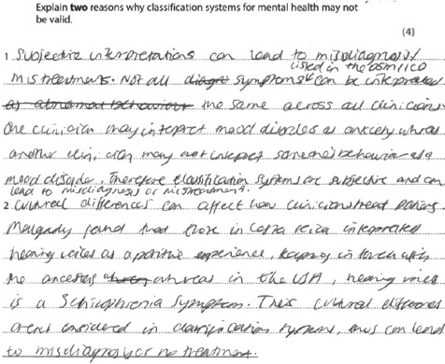

**Results Plus: Examiner Comments**

Marks are given for:

First reason

Second reason

Total: 4 marks

**Results Plus: Examiner Tip**

When asked to explain a reason, offer a full justification to gain the AO3 mark.

**Q4.**

The better responses focused their answer on reliability, and explained throughout their answer whether Phillip should be concerned. Most responses showed good knowledge about the reliability of DSM and ICD, however this was an A02 question and candidates did not apply their answers to the context throughout, thereby limiting the amount of marks they could gain. Candidates often used the results of studies in relation to the reliability of DSM or ICD which was very positive. The weaker responses simply evaluated the reliability of DSM and ICD without any reference to the context, so these answers were generic. Some candidates confused reliability and validity.

**Results Plus: Examiner Comments**

This gains 0 marks.

The candidate has not referred to the context within the answer.

**Results Plus: Examiner Comments**

Candidates need to refer to the context within the answer, in this case explaining why Phillip should or should not be concerned.

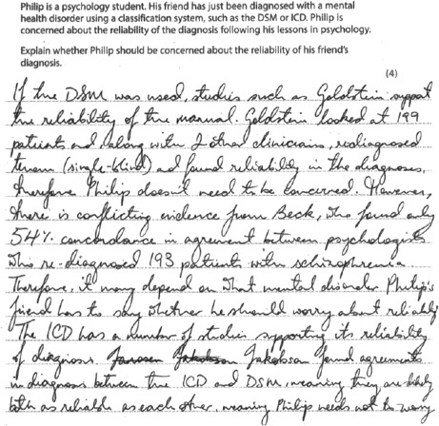

**Results Plus: Examiner Comments**

This gains 3 marks.

1 mark for Goldstein clearly linked to the context in the next sentence.

1 mark for Beck clearly linked to the context in the next sentence.

1 mark for the last sentence as it is clearly linked to the context.

**Q5.**

This essay provided a range of responses, with candidates seeming to engage with the context. The better responses were able to apply the entire context in a sustained way, referring to both deviance and dysfunction. They were also able to apply some behaviours to both deviance and dysfunction showing accurate knowledge and understanding of how some behaviours could be classed as both.

Weaker responses were able to apply the context in a partially developed manner, often not going beyond stating specific behaviours were deviant or dysfunctional without reasoning why they were. Some candidates showed limited knowledge and understanding of the two terms, often getting them mixed up.

Some candidates did not focus on the question, either writing about all the four Ds, writing about DSM, or what mental disorder Alice had.

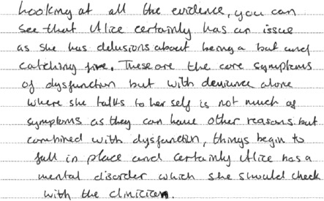

**Results Plus: Examiner Comments**

This is level 3; 6 marks.

The candidate demonstrates accurate knowledge and understanding - sometimes this is merged with the A02. The A02 uses coherent chains of reasoning, showing both sides of the argument and is supported by applying relevant evidence from the context.

**Results Plus: Examiner Tip**

On discuss essays include detail from the context.

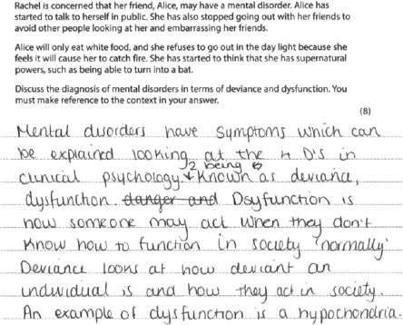

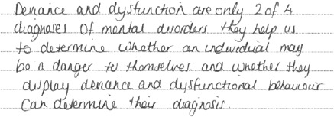

**Results Plus: Examiner Comments**

This is level 1; 2 marks.

The knowledge and understanding is isolated, as there are inaccuracies within the essay. The A02 is only partially developed.

**Results Plus: Examiner Tip**

Candidates should not use the same term when defining a term.

**Q6.**

(a)  This question required a description of how ICD is used for mental health. The best answers described how it is used, though most answers did not write enough to gain all the marks available. Most answers were able to gain at least 1 mark for an example. The weakest answers repeated the question saying that it was used for mental health.

(b)  This question required AO1 for identifying a strength and AO3 for then justifying the strength. The most common strength was based on the fact it is cross cultural. The best answers were able to justify the strength, however, most answers did not add any justification.

**Q7.**

This essay required candidates to demonstrate their knowledge and understanding of the validity of classification systems as well as assess the validity of classification systems. The AO1 knowledge and understanding was better than the AO3 assessment. Better answers were able to demonstrate both. Many answers failed to offer assessment which went beyond some development of form, with some answers just making statements about whether classification systems were valid and failing to develop these in any way.

**Q8.**No Examiner's Report available for this question

**Q9.**

This essay required candidates to demonstrate their knowledge and understanding, AO1, apply that to the context, AO2, and offer arguments that lead to judgements (AO3). Many answers showed accurate knowledge and understanding of the classification systems or reliability and validity in terms of diagnosis. The best answers were able to apply this throughout to relevant evidence from the context. The best answers were able to offer well-developed logical chains of reasoning throughout. However, the AO3 was often only partially developed.

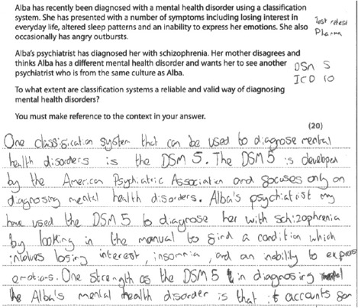

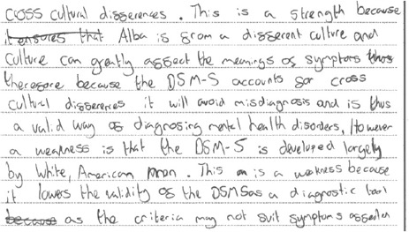

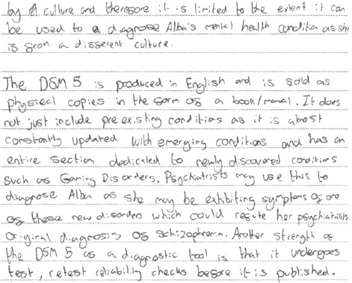

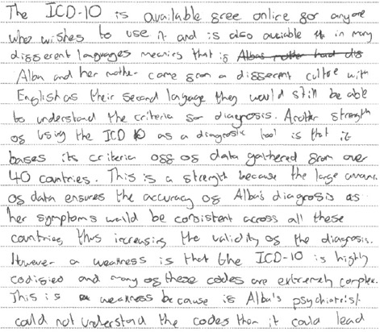

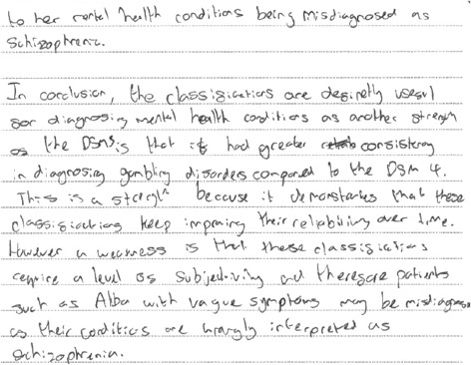

**Results Plus: Examiner Comments**

This is level 5,18 marks. The AO1 is level 4, it is accurate and thorough in terms of the classification systems. The AO2 is level 5. There is sustained application of relevant evidence throughout the essay. The AO3 is level 5. There is a well-developed logical argument, a full awareness of competing arguments with judgements throughout, though the final conclusion is not linked to reliability or validity explicitly.