# Skewness

There are 3 types of frequency distribution that you need to know:

For each of the distributions below state:

* what kind of skew / distribution you have
* identify the position of the mean/median/mode
* explain what the graph tells us about the frequency distribution of the data shown

1.

What kind of distribution/skew is this?

……………………………………

Label the positions of the mean, median and mode

What does tell us about the distribution of the age of Nobel prize winners?

………….………….………….…………….………….…………….……………….………….………….………….…….………….………….………….

………….………….………….…………….………….…………….……………….………….………….………….…….………….………….………….

2.

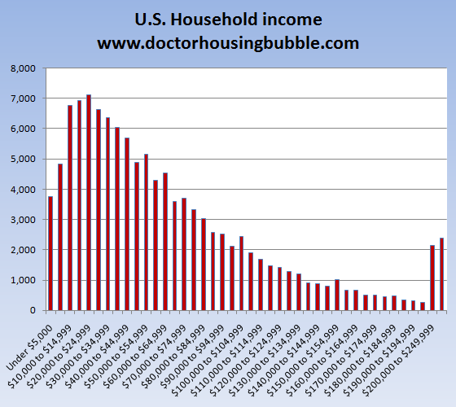

What kind of distribution/skew is this? ……………………………………

Draw the (rough!) positions of the mean, median and mode

What does tell us about the distribution of US household income?

………….………….………….…………….………….…………….……………….………….………….………….…….………….………….………….

………….………….………….…………….………….…………….……………….………….………….………….…….………….………….………….

3.

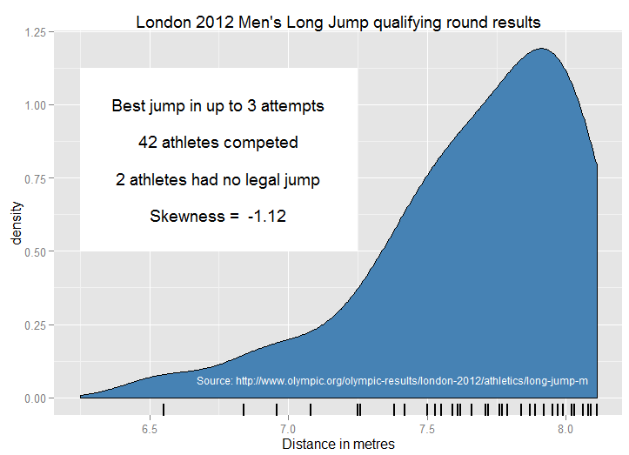

What kind of distribution/skew is this?

……………………………………

Draw the (rough!) positions of the mean, median and mode

What does tell us about the distribution of the Men’s Long Jump qualification results?

………….………….………….…………….………….…………….……………….………….………….………….…….………….………….………….

………….………….………….…………….………….…………….……………….………….………….………….…….………….………….………….