# Learning Theories and Attachment

Put these terms into the correct place on the diagram:

* + Neutral Stimulus (NS)
  + Unconditioned Stimulus (UCS)
  + Unconditioned Response (UCR)
  + Conditioned Stimulus (CS)
  + Conditioned Response (CR

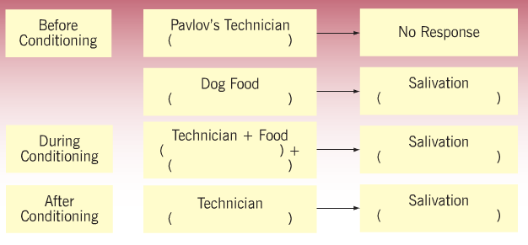

**Applying Classical Conditioning to Attachment**

|  |  |  |
| --- | --- | --- |
| **Pavlov’s dog is now a baby** | **The bell is now the mother** | **The dog food is now milk** |

**Task: Complete the diagram below to demonstrate the process of classical conditioning for attachment. Either draw pictures or write the name of what should appear in each section.**

|  |
| --- |
| **Write a short summary of how children form attachments through Classical Conditioning,** |
|  |
|  |
|  |
|  |
|  |
|  |
|  |
|  |

# Attachment: Learning Theory Notes

You should use the digital book for this work. See the VLE and SatchelOne for login information.

## A01 - description

* Read ‘The specification says’ section
* Check the Lifelines – make sure you scan these to understand the reading
* Make structured notes from these headings. You need to be able to clearly describe how each learning theory explains human attachment. Ensure you use each **term in bold** from the text:
  + Classical conditioning
  + Operant conditioning
  + Secondary Drive reduction
* Wally Extension – see the E link in the Digital Book on the Dozier et al. (2009) study

## A03 – Evaluation

Use the table below to guide you to reading through and making evaluation notes.

Use Point-Relevance-Conclude when doing A03 notes.

|  |  |
| --- | --- |
| **Strengths** | **Weaknesses** |
|  | Counter evidence – animal studies |
|  | Counter evidence – human studies |
| Conditioning is involved in attachment | Counterpoint – babies aren’t passive in attachment development |
| eXtra – Social Learning Theory |  |

## Quiz, Apply It

* Complete the quiz to test your understanding
* Do the Apply It questions and check your answers