# 3.2.1 Correlational research

## Description of correlation - Adapted from Simply Psychology (Saul McLeod)

Correlation is a measure of the extent to which two variables are related. If an increase in one variable tends to be associated with an increase in the other, then this is known as a positive correlation.

If an increase in one variable tends to be associated with a decrease in the other, then this is known as a negative correlation. An example would be height above sea level and temperature. As you climb the mountain - it gets colder.

When there is no relationship between two variables this is known as a zero correlation.

A correlation can be shown in a scatter graph - plotting the data of one variable against the data for the other on a graph.

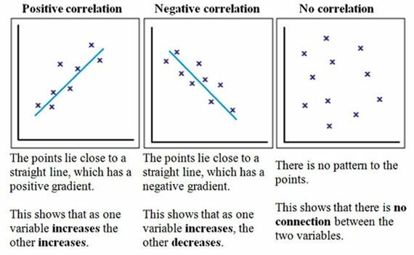

When you draw a scatter graph it doesn't matter which variable goes on the x-axis and which goes on the y-axis. In correlations we are always dealing with paired scores, so the values of the 2 variables taken together will be used to make the diagram. Decide which variable goes on each axis and then simply put a cross at the point where the 2 values coincide.

## What are correlations used for?

Correlations are often used where we cannot do experiments for ethical or practical reasons. For example, we might be able to look at the link between the amount of violence watched on T.V. and aggressive behaviour in adolescence.

Another area where correlation is widely used is in the study of intelligence with research to test the strength of the association between the IQ levels of identical and non-identical twins.

## Drawing conclusions from correlations

If there is a relationship between two variables, we draw conclusions about:

* Concurrent validity (correlation between a new measure and an established measure).
* Test-retest reliability (are measures consistent over time).
* Inter-rater reliability (do observers agree consistently).
* Predictive validity (the measure predicts something will happen – e.g. more dopamine leads to more schizophrenic like symptoms)

## Correlation Coefficients

Instead of drawing a scatter graph a correlation can be expressed numerically as a coefficient, ranging from -1 to +1.

The correlation coefficient (r) indicates the extent to which the pairs of numbers for these two variables lie on a straight line. Values over zero indicate a positive correlation, while values under zero indicate a negative correlation

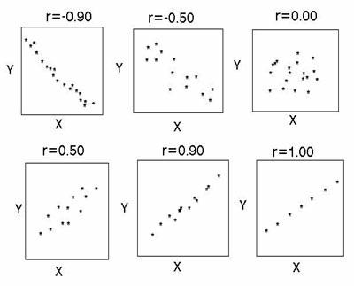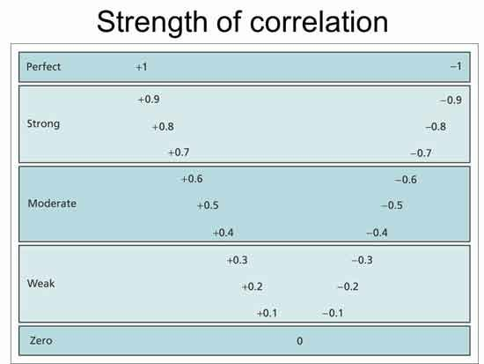

## Differences between Experiments & Correlations

* An experiment isolates and manipulates the independent variable to observe its effect on the dependent variable and controls the environment in order that extraneous variables may be eliminated.
* Experiments establish cause and effect. A correlation establishes the relationships between variables.
* An experiment tests the effect that an independent variable has upon a dependent variable, but a correlation looks for a relationship between two variables. This means that the experiment can predict cause and effect (causation) but a correlation can only predict a relationship.

## Evaluation of correlations

### Strengths

* As quantitative data is used, the correlation can be repeated to test reliability
* Correlations can be statistically tested to see if they are significant
* Correlations are ethical compared to other research methods such as laboratory, field experiments as ethical issues rarely arise from the use of secondary data
* You can use a correlation, when it is unethical or impractical to run an experiment E.g. you can’t conduct an experiment on whether smoking causes lung cancer.
* Previously existing/secondary data can be used to save time and cost of primary research
* It is a precursor to experimental work as it is an inexpensive/ethical tool before costly research
* Correlation allows the researcher to clearly and easily see if there is a relationship between variables. This can then be displayed in a graphical form.

### Weaknesses

* We can’t establish causation. We can’t say that watching TV violence has caused aggression.
* Other variables, apart from the variable being measured, may impact a correlation
* When data is collected by questionnaire or physiological measures, correlations can change daily
* Questionnaires that use correlational data can be subject to social desirability
* Correlation does not allow us to go beyond the data that is given. Just because there is a correlation between homework and grades doesn’t mean doing 6 hrs of it will get you an A!

# Correlation Mind Maps

Follow the text to build an A3/A4 mind map on correlations.

Use diagrams / colours etc in your mind map.

A starting point is below:

Make sure you have covered these elements – use examples!

1. **Description:** Positive, Negative, Zero; Scatter graphs

2. **Uses of Correlation**

3. **Drawing conclusions from correlations:** Validity and Reliability

4. **Correlation Coefficients:** Definition & numerical range (-1 to +1); what the coefficient (r) represents

5. **Experiments vs. Correlations**

6. **Strengths & Weaknesses of Correlations**: 2-3 strengths, 2-3 weaknesses

# Exercises on Spearman’s Rank and Correlation

1. A researcher hypothesised there would be a correlation between maths ability and music ability. She gave students two tests (/20 for each) - the results are shown below.

|  |  |  |  |  |  |  |  |  |
| --- | --- | --- | --- | --- | --- | --- | --- | --- |
| Maths ability | 20 | 5 | 16 | 17 | 1 | 4 | 4 | 12 |
| Music ability | 17 | 6 | 12 | 12 | 7 | 7 | 3 | 10 |

A) Draw an appropriate graph for this data

B) Write a summary of the findings.

1. Work out the correlation of this data (assume the hypothesis is that the more you fear going to hell, the less corrupt you will be):

|  |  |  |  |  |  |  |  |  |
| --- | --- | --- | --- | --- | --- | --- | --- | --- |
| Corruption level | 3 | 10 | 18 | 17 | 7 | 11 | 2 | 19 |
| Fear of going to hell | 10 | 6 | 4 | 4 | 2 | 3 | 18 | 6 |

BTW – while this isn’t the actual data, someone in the US has done this study!

A) Draw an appropriate graph for this data

B) Write a summary of the findings.

1. Work out the correlation for this data:

|  |  |  |  |  |  |  |  |  |  |  |
| --- | --- | --- | --- | --- | --- | --- | --- | --- | --- | --- |
| **Age** | 15 | 26 | 10 | 9 | 15 | 20 | 18 | 11 | 8 | 20 |
| **Score** | 95 | 71 | 83 | 91 | 102 | 87 | 93 | 100 | 104 | 94 |

A) Draw an appropriate graph for this data

B) Write a summary of the findings.