# **A short version of the love quiz**

*Question 1: Which of the following best describes your parents’ relationships with each other?*

(a) My parents had a caring relationship and are affectionate with each other.

(b) My parents appear to have a good enough relationship with each other but are not especially affectionate.

(c) My parents have a reasonable relationship and are sometimes affectionate towards each other.

*Question 2: Which of the following best describes your relationship with your mother?*

(a) My mother treats me with respect and is accepting and not demanding. She is confident about herself

(b) My mother is humorous, likable and respected by others. She treats me with respect.

(c) My mother treats me with respect but is sometimes cold and rejecting.

*Question 3: Which of the following best describes your relationship with your father?*

(a) My father is sometimes affectionate but can be unfair.

(b) My father is caring, affectionate and humorous.

(c) My father is reasonably caring.

*Question 4: Select the statement that best describes your experiences of intimacy.*

(a) I find that others are reluctant to get as close as I would like.

(b) I find it relatively easy to get close to others and am comfortable depending on them and having them depend on me.

(c) I am somewhat uncomfortable being close to others; I find it difficult to trust them completely, difficult to allow myself to depend on them.

*Question 5: Select the statement that best describes your experiences of intimacy.*

(a) I don’t often worry about being abandoned or about someone getting too close to me.

(b) I often worry that my partner doesn’t really love me or won’t want to stay with me.

(c) I am nervous when anyone gets too close, and often romantic partners want me to be more intimate than I feel comfortable being.

*Question 6: Select the statement that best describes your experiences of intimacy.*

(a) I enjoy relationships but am generally quite self-sufficient.

(b) I have been lucky in love and most of my relationships are rewarding. I still like the people I was involved with.

(c) At times I wish I could just melt into someone so we could get beyond our separateness.

*Question 7: Select the statement that best describes your attitudes towards love.*

(a) The kind of head-over-heels love that is depicted in novels and in the movies does not exist in real life.

(b) It is easy to fall in love and I frequently find myself beginning to fall in love, though I am not sure that it really is love.

(c) Love is a positive and real experience.

*Question 8: Select the statement that best describes your attitudes towards love.*

(a) It is rare to find a person one can really fall in love with.

(b) In some relationships romantic love never fades.

(c) Most of us could love many people equally well, there is no ‘one true love’.

*Question 9: Select the statement that best describes your attitudes towards love.*

(a) I think that romantic feelings do wax and wane.

(b) Romantic feelings wax and wane but at times they reach the intensity experienced at the start of a relationship.

(c) Intense romantic love is common at the start of a relationship but rarely lasts

Q1-3 – Part A 🡪 current / most important relationship (here, parental)

Q4-6 – Part B 🡪 romantic experiences

Q7-9 – Part C 🡪 attachment type

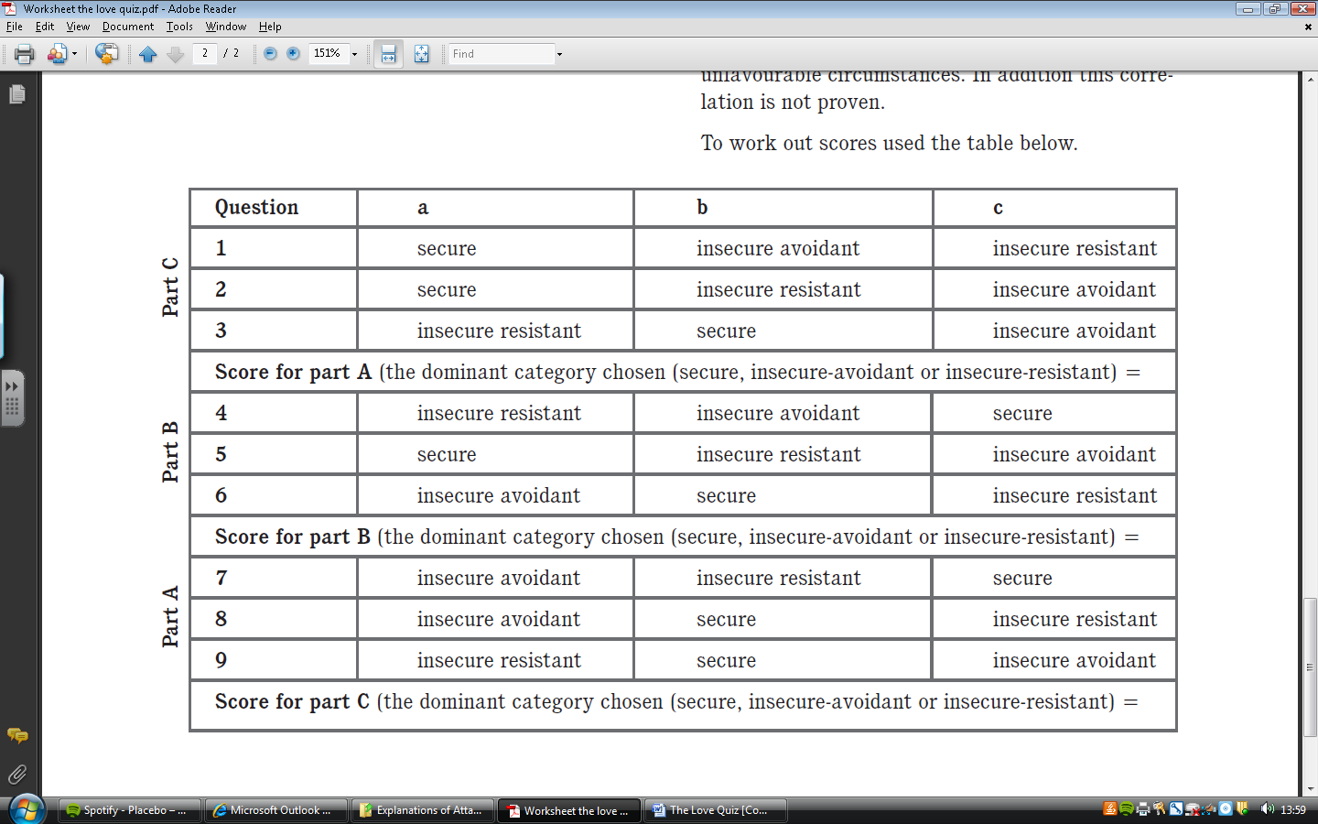**Scoring:**