**The Role of Marketing Activity**

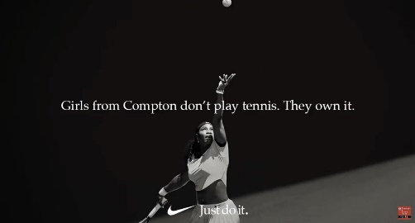Watch the video named ‘**The role of marketing - why does so much get spent on marketing?’** in the **Two Teachers YouTube channel ‘Business Studies’ playlist** and answer the following questions.

<http://www.youtube.com/c/TwoTeachers>

**Pre-video activities – Before you watch the video complete the two activities below:**

1. **Explain in your own words what you think marketing is all about (see if your opinion changes after watching the video).**
2. **Coca Cola spend approximately 10% of their sales revenue on marketing every year. Justify why you think they spend so much money on marketing and what you think they might want to achieve from this?**

**Video activities – Answer the following questions once you have watched the video:**

1. **Explain and compare the 3 purposes of marketing identified in the video and rank them in order of importance**
2. **Choose a business of your choice and create a plan for a marketing campaign that could compete with Nike’s ‘**[**Dream Crazy Campaign’**](https://www.youtube.com/watch?v=ekZRoSCINLA)**. Within your plan you should answer the following:**
3. **What is your chosen business?**
4. **What are the aims and purpose of your marketing campaign? Support your choices with valid reasons.**
5. **Who is the target market for the marketing campaign and why?**
6. **What type of adverts or promotions are you going to have and why?**
7. **How will your chosen adverts or promotions help you to achieve your marketing aims and purpose? Ensure you justify your responses.**

.