Q1.
A psychologist investigated whether productivity levels are affected by the amount of sleep a person gets. The psychologist concluded that participants assessed themselves as more productive after eight hours’ sleep than after four hours’ sleep. Other previous research has also shown that having more sleep has a positive effect on problem-solving skills.
In a follow-up study, the psychologist designed an experiment to investigate further the effect of sleep duration on problem solving. They randomly selected 20 students from a local university. There were two conditions:
Condition 1 – the students were invited to a university sleep laboratory and were allowed to sleep for six hours. Fifteen minutes after waking, each student was timed to see how long it took them to solve 10 simple mathematical problems, correctly.
Condition 2 – the same 20 students were invited back to the sleep laboratory a week later. This time they were allowed to sleep for two hours. Fifteen minutes after waking, each student was again timed to see how long it took them to solve a different set of 10 simple mathematical problems, correctly.
Identify one extraneous variable that could have affected the results of the follow-up study.
Suggest why it would have been important to control this extraneous variable and how the psychologist could have controlled it.
_______________________________________________________________________
_______________________________________________________________________
_______________________________________________________________________
_______________________________________________________________________
_______________________________________________________________________
_______________________________________________________________________
_______________________________________________________________________
_______________________________________________________________________
_______________________________________________________________________
(Total 3 marks)
Q2.
Two groups of participants took part in a memory experiment. The researcher read 20 words to the participants.
• Participants in Group A had to write down the words immediately after they had heard them.
• Participants in Group B had to write down the words after they had read a book for one minute.
The researcher noticed that:
• participants in Group A generally recalled words from the beginning and the end of the list
• participants in Group B generally recalled words from the beginning of the list only.
(a) Outline what is meant by standardisation and suggest one way standardisation could have been used in this experiment.
___________________________________________________________________
___________________________________________________________________
___________________________________________________________________
___________________________________________________________________
(2)
(b) Outline what is meant by randomisation and suggest one way randomisation could have been used in this experiment.
___________________________________________________________________
___________________________________________________________________
___________________________________________________________________
___________________________________________________________________
(2)
(Total 4 marks)
Q3.
A researcher was interested in the relationship between the number of hours a course was taught using a computer program and the satisfaction of the students on the course.
As part of his research he conducted a pilot study as follows. A topic from a business studies course was divided into 10 equal one-hour sessions.
Eleven students who were matched for their high level of interest in business studies took part in the study.
All 11 students completed all 10 hours of the topic. They were taught either completely online, with a combination of online teaching and classroom teaching, or just in a classroom.
Each student was allocated a letter, from A to K randomly. This determined the number of hours they studied online and the number of hours they studied in a classroom. The combinations are shown in Table 1.
Table 1: The numbers of hours each student (labelled A – K) studied the topic online and in a classroom with a teacher

 | A | B | C | D | E | F | G | H | I | J | K
Number of online hours | 10 | 9 | 8 | 7 | 6 | 5 | 4 | 3 | 2 | 1 | 0
Number of classroom hours | 0 | 1 | 2 | 3 | 4 | 5 | 6 | 7 | 8 | 9 | 10
(a) Explain why it was important to match the students on their high level of interest in business studies.
___________________________________________________________________
___________________________________________________________________
___________________________________________________________________
___________________________________________________________________
(2)
(b) Suggest one other variable for which the researcher should have matched the students. Explain how this might have affected the satisfaction scores if it was not controlled.
___________________________________________________________________
___________________________________________________________________
___________________________________________________________________
___________________________________________________________________
(2)

(c) Outline one benefit of allocating the students randomly to the different numbers of online hours and classroom hours as seen in Table 1.
___________________________________________________________________
___________________________________________________________________
___________________________________________________________________
___________________________________________________________________
(2)
(d) The sample used in this pilot study was an opportunity sample. Briefly explain how using a stratified sample when the final study is conducted might be an improvement to the design.
___________________________________________________________________
___________________________________________________________________
___________________________________________________________________
___________________________________________________________________
___________________________________________________________________
(3)
(e) The researcher designed a questionnaire to collect data from the students about how satisfied they felt when they had completed the course.
Give an example of an appropriate question that the researcher might use to collect qualitative data on the questionnaire.
___________________________________________________________________
___________________________________________________________________
(1)
(f) Briefly explain one problem the researcher might have in analysing the qualitative data collected from the questionnaires.
___________________________________________________________________
___________________________________________________________________
___________________________________________________________________
___________________________________________________________________
(2)
(g) Outline one ethical issue that should have been taken into account when carrying out the questionnaire.
___________________________________________________________________
___________________________________________________________________
(1)

In order to analyse all the responses to the questionnaire, each response was given a score by the researcher. The maximum score on the questionnaire was 20, where a score of 0 meant dissatisfied and a score of 20 meant very satisfied. The following data was collected by the researcher.
Table 2: The numbers of hours each student (labelled A – K) studied the topic online and the satisfaction scores of each student.

 | A | B | C | D | E | F | G | H | I | J | K
Number of online hours | 10 | 9 | 8 | 7 | 6 | 5 | 4 | 3 | 2 | 1 | 0
Satisfaction scores | 5 | 6 | 8 | 7 | 10 | 12 | 13 | 15 | 17 | 19 | 19
(h) Using the data in Table 2 and the graph paper provided below, draw an appropriate scattergram. Fully label your display.

(4)
(i) What conclusion might the researcher draw, based on the results of the study? (2)
___________________________________________________________________
___________________________________________________________________
___________________________________________________________________
___________________________________________________________________
(j) The researcher looked at the mode and median satisfaction scores of the students. Calculate these two descriptive statistics.
___________________________________________________________________
___________________________________________________________________
___________________________________________________________________
___________________________________________________________________
(2)
(k) Explain why the median would be more suitable than the mode to represent the average score for satisfaction for the students.
___________________________________________________________________
___________________________________________________________________
___________________________________________________________________
___________________________________________________________________
(2)
(l) Another researcher looked at the data for the satisfaction scores and commented that they suggested a negative skew in the data.
Look at the following sets of descriptive statistics from a different study. Which of the sets (A or B or C) would indicate a negative skew in the distribution of the data?
Shade one box only.

A | Mean: 7.3, median: 7.5, mode: 7.0
B | Mean: 7.3, median: 10.5, mode: 16
C | Mean: 7.3, median: 6.5, mode: 5
(1)
(Total 24 marks)

Mark schemes
Q1.
[AO2 = 3]
Award marks as follows:
1 mark for a suggestion of an appropriate variable, eg difficulty of the mathematical problems, quality of the sleep gained, environmental conditions (eg room temperature, other distractions in the room etc), boredom/fatigue/practice.
Accept other appropriate suggestions.
1 mark for an explanation of why it should be controlled, eg if the mathematical problems in one condition were easier than those in the other condition then participants would record a quicker time due to the relative difficulty of the mathematical problems and not the amount of sleep they got.
1 mark for a practical description of how it could be controlled, eg the researcher would need to standardise the 20 mathematical problems to ensure they are of similar difficulty and then allocate 10 to each condition.
Note: these three marks should match so that the variable that has been identified is then explained and dealt with providing a coherent response.
[3]
Q2.
(a) [AO1 = 1 AO2 = 1]
Outline content
1 mark for an outline of standardisation – ways in which procedures/materials/instructions within an investigation are kept the same for all participants.
Accept alternative wording.
Possible application:
1 mark for one way in which standardisation could have been used in this experiment.
Possible ways:
• the same word list for both groups/conditions
• the same order of words for all participants
• the same instructions for all participants in the same group
• the same timings for all participants in the same group
• the same room for each condition
• the same book for all participants in Group B.
Accept other valid ways.
2
(b) [AO1 = 1 AO2 = 1]
Outline content
1 mark for an outline of randomisation – the use of ‘chance’ in setting up the investigation.
Possible application
1 mark for one way in which randomisation could have been used in this experiment.
Possible ways:
• the order of words in the list should have been decided randomly
• the allocation of participants to each condition/group should have been decided randomly.
Accept other valid ways.
2
[4]
Q3.
(a) [AO2 = 2]
2 marks for a clear explanation of why it was important to match the students for this variable.
1 mark for a limited or muddled explanation, or for an answer without application.
Content:
• level of interest could affect their satisfaction scores so needs to be controlled; matching students’ levels of interest in business studies keeps this participant variable constant.
2
(b) [AO2 = 2]
1 mark for a suggestion of an appropriate variable – interest in using computers (e.g., for studying), past experience of using computers (e.g., for studying), disability issues, prior knowledge of this business studies topic.
Accept other appropriate suggestions.
1 mark for an explanation of how it might relate to satisfaction scores.
2
(c) [AO2 = 2]
2 marks for a clear outline of one benefit of random allocation in this situation.
1 mark for a limited or muddled explanation, or for an answer without application.
Relevant points:
• removal of researcher bias in determining which participant has the most to least number of online hours
• increased validity as the researcher will not be biased in how students are allocated
• removal of participant bias as each participant has the same chance of having a particular number of online hours as any other participant.
2
(d) [AO3 = 3]
3 marks for a clear and coherent explanation of how stratified sampling would improve the design.
2 marks for some explanation of how stratified sampling would improve the design.
1 mark for a muddled / limited explanation.
Content:
• stratified sampling ensures each identified sub group of the whole target population of possible participants is represented in the sample so generalisation of the results to the target population is more valid than if the participants were just available at the time of asking
• stratified sampling is an improvement because people who are identified by opportunity are likely to be present at same time, doing similar things, possibly of similar personality types etc which may limit representativeness of sample.
Accept other appropriate explanation points.
3
(e) [AO2 = 1]
1 mark for a question which would generate qualitative data: what did you like / dislike about the online / classroom lessons?
Accept any appropriate question or item that generates qualitative data.
1
(f) [AO2 = 2]
2 marks for a clear and coherent explanation of a possible problem.
1 mark for a muddled / limited explanation.
Possible problems:
• analysis of qualitative data relies on interpretation by the researcher which could be inaccurate / biased / subjective
• qualitative data may not be easy to categorise / collate into a sensible number of answer types
• the researcher could be left with lots of individual responses that cannot be summarised.
Do not accept answers which simply identify a problem with no further appropriate elaboration e.g. ‘hard to analyse’, ‘time consuming’.
2
(g) [AO2 = 1]
1 mark for an outline of an appropriate ethical issue that would be relevant when using a questionnaire: issues such as anonymity, protection from harm, treating with respect, parental consent.
Possible issues:
• the students should be treated with respect by explaining that their answers will be kept confidential
• the students must be assured that they can withdraw their answers if they want to
• the students must be told exactly what the researcher was trying to find out about the relationship between satisfaction and the way information was delivered.
Answer must be an outline and not just a name or term.
1
(h) [AO2 = 4]
Award 1 mark for each of the following points.
Content:
• appropriate title, including reference to (negative) relationship and the two variables
• axis 1 – number of online hours and suitable scale 0-10
• axis 2 – satisfaction score and suitable scale 0-20
• accurate plotting of 11 points on scattergram.
No penalty for drawing a line of best fit.
If display is not a scattergram award max 1 mark if title is appropriate.
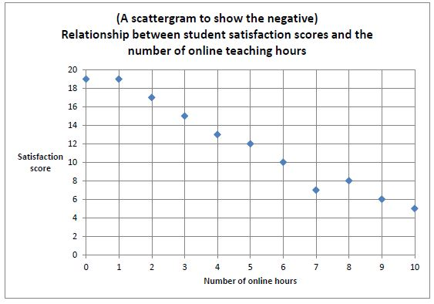
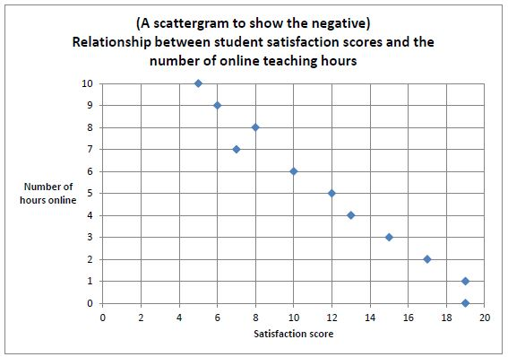
4
(i) [AO2 = 2]
1 mark for saying there is a negative relationship / correlation (between the number of online hours and satisfaction scores).
1 mark for further detail e.g. the more hours they have online the less they are satisfied with the course (or vice versa), however this does not indicate a cause and effect relationship.
Accept other valid conclusions.
2
(j) [AO2 = 2]
1 mark for the mode = 19
1 mark for the median = 12
2
(k) [AO2 = 2]
2 marks for a clear and coherent explanation.
1 mark for a muddled or limited explanation.
• The median is more representative than the mode because the mode is at the top end of the set of scores, whereas more of the scores are numerically closer to the median.
Accept other explanations, for example, in terms suitability in relation to ordinal data vs nominal data.
2
(l) [AO1 = 1]
1 mark for B
1
[24]

